**Daily Scrum or Standup Meeting**

Team name: Team 8

Scrum Master: Sally D.

Date: 4/2/2020

|  |  |  |  |
| --- | --- | --- | --- |
|  |  |  |  |
| **Team Member** | **What did you do since the last scrum?** | **What do you plan to do before the next scrum?** | **What obstacles do you have?** |
| Sally D. | Completed static item page functionality, looked into relative routing. | Finish all static things that I can, and hopefully the api’s are done and I can begin to connect my static pages to those. | Other classwork  Work  Quarantine |
| Connor G. | Nothing Really. Looked over my Issues. Didn’t make much progress, was working on other classes. Power supply died on my computer so I had to get a new one. | Get 2 of my user Stories done this weekend/before the next standup. Maybe 3 if I’m really feeling it. | CoronaVirus. Other classes with hwk(OS). Personal issues. Idk motivation in general :( |
| Hunter H. | Image uploading, items API. | Profile page, permissions. | 3 major projects due in 2 days; motivation; compilers. |
| Colton H. | Facility the joining auction process.  Bidding system backend. | Possibly work on front end helpers functions.  Promote Debugging paths to Production quality.  Whatever Hunter says to do.  Begin working on Pagination | API framworking syntax  front end interface expectations.  Compliers |
| Jace L.  (updated) | Prettying up the add item pages, making sure it works properly with everything.  Sanitized the inputs more | Make sure you can get to the add Item page, Connect it to the items api.  Possibly start on the items grouping api | Not knowing what else needs to be done on my tasks.  Waiting for several things |

# Burndown

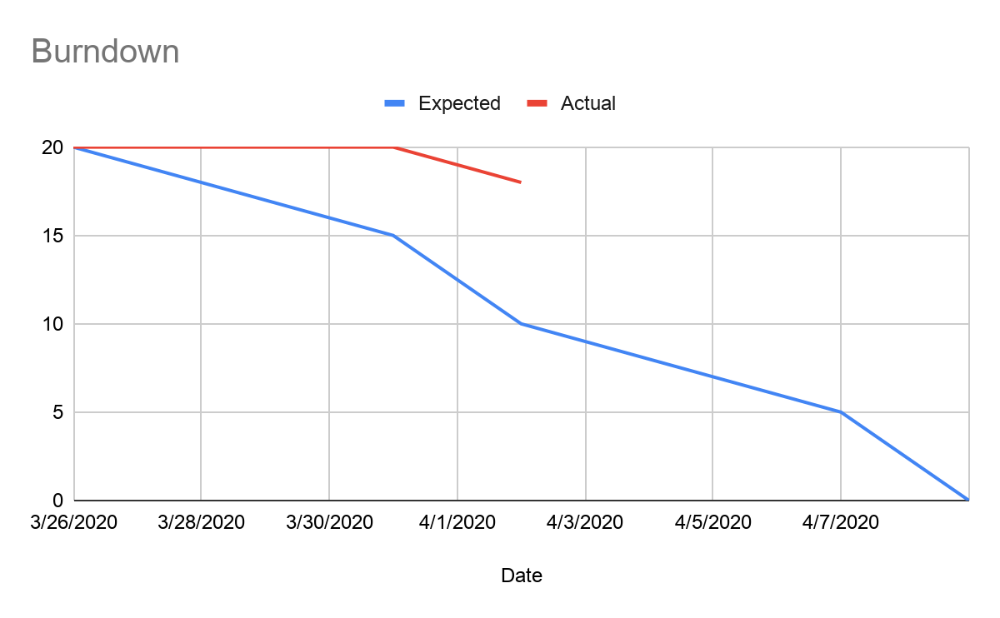

# 

# 

# 

# Screenshot of your project board

