**Daily Scrum or Standup Meeting**

Team name: Team 8

Scrum Master: Sally D.

Date: 4/7/2020

|  |  |  |  |
| --- | --- | --- | --- |
|  |  |  |  |
| **Team Member** | **What did you do since the last scrum?** | **What do you plan to do before the next scrum?** | **What obstacles do you have?** |
| Sally D. | Set up nested and dynamic routers, and connected my static pages to the api. | Finish up item bidding functionality and make the join an auction static page. | Stress  Other classwork |
| Connor G. | Was able to get help and almost finish the admin settings page, just need to finish hooking up API stuff to it. | Finish up the Admin settings page, Work on the last issue assigned to me and get it finished before thursday. Create an auction page. | CoronaVirus. Other classes with hwk(OS). Personal issues. Idk motivation in general :( |
| Hunter H. | New auction routes, items api, permissions. | Profile page, qr code, gorilla gluing things together. | motivation; **compilers**. |
| Colton H. | Promote Debugging paths to Production quality.  Whatever Hunter says to do.  Begin | Introduce the Permissions check into the available routes. Make group skeletons for the various Permissions. | API framworking syntax  front end interface expectations.  Compliers |
| Jace L. | Started making sure the add items page is in the right place | Make sure you can get to the add Item page, Connect it to the items api.  Add an ability to make sure you are an admin | Not knowing what else needs to be done on my tasks.  Waiting for several things  Other school work |

# Burndown

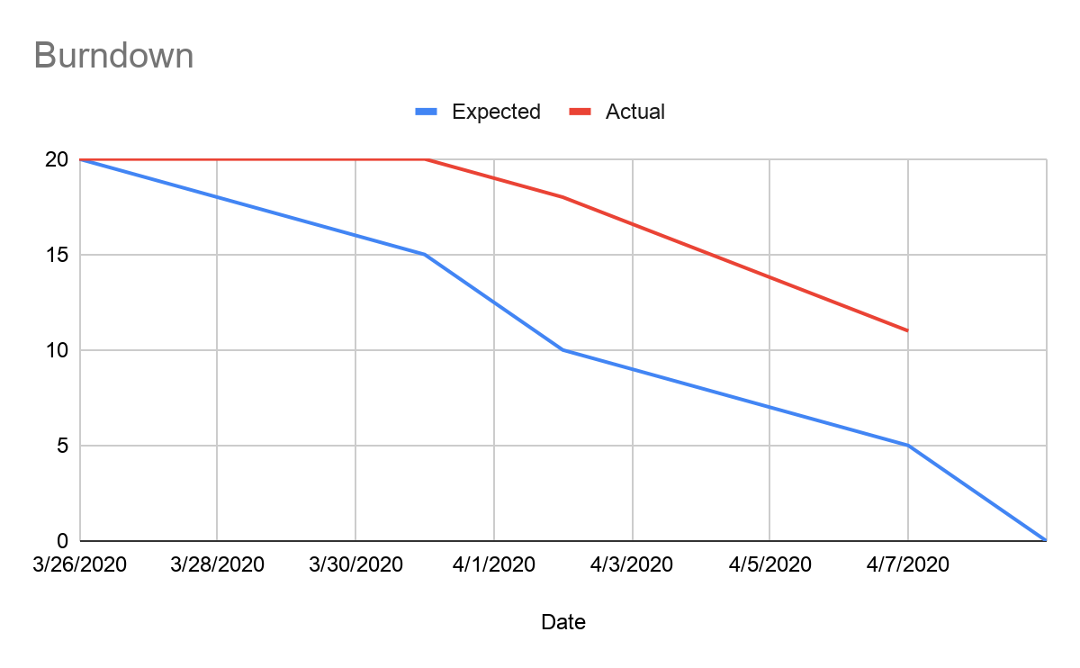

# 

# 

# 

# Screenshot of your project board

