**Daily Scrum or Standup Meeting**

Team name: Team 8

Scrum Master: Sally D.

Date: 3/31/2020

|  |  |  |  |
| --- | --- | --- | --- |
|  |  |  |  |
| **Team Member** | **What did you do since the last scrum?** | **What do you plan to do before the next scrum?** | **What obstacles do you have?** |
| Sally D. | -Complete item page with bid functionality | Finish more static pages, and hopefully the api’s are done and I can begin to connect my static pages to those. | Distractions of working at home…  Work |
| Connor G. | Nothing Really. Looked over my Issues. Didn’t make much progress, was working on other classes. :( | Hopefully get one of my user stories done if I’m not overwhelmed by other classes. | CoronaVirus. Other classes with hwk(OS). Personal issues. Idk motivation in general :( |
| Hunter H. | More of the Auctions API. | Finish the Auctions API, finish the profile page. | Lack of motivation |
| Colton H. | Get the binding api working  figure out how to test this sucker (postman)  Talk to Jace & Sally about making sure the calls are usable.  Have the Bib api routes working | Possibly work on front end helpers functions.  Facility the joining auction process.  Bidding system backend. | API framworking syntax  front end interface expectations.  Compliers |
| Jace L. | Prettying up the add item pages, making sure it works properly with everything | Make sure you can get to the add Item page, Check the data fields and make sure they are sanitized. Connect it to the items api when it works. | Not knowing what else needs to be done on my tasks. |

# Burndown

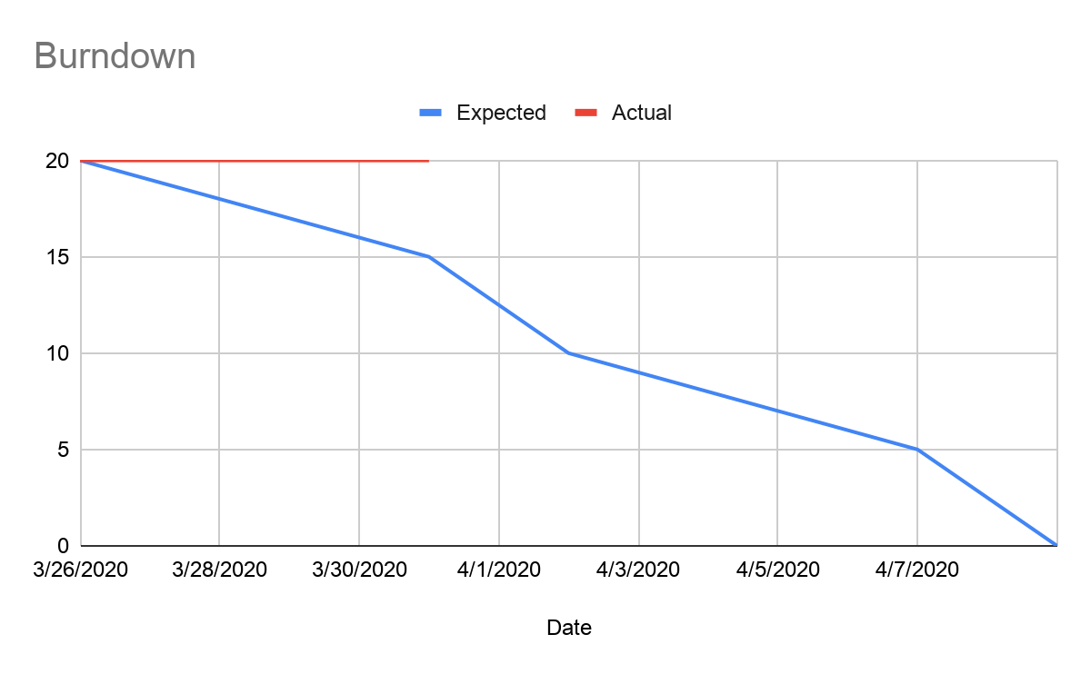

# 

# 

# 

# Screenshot of your project board

