

INVESTMENT MEMORANDUM
7001 and 7007-7181 W. Broward Blvd, Plantation, FL

Credit Committee: Underwriting Team:
Date:
Table of Contents

Transaction Overview

Deal Facts
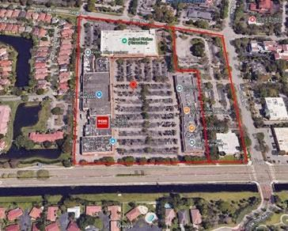
Address: 7001 and 7007-7181 W. Broward Blvd,
Plantation, FL
Property Type:
Loan Type:
Loan Amount:
Term:
Interest Rate:
Origination Fee:
Exit Fee:
Lien:
Minimum Interest:
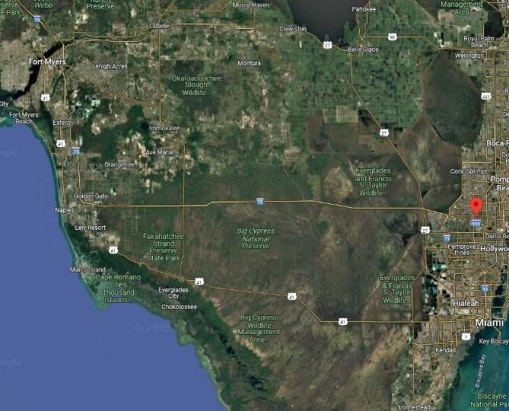
Extension Option:
Source:

Leverage Ratios
FB LTC (at-Closing):
LTC (at-Maturity):
LTV (at-Closing):
LTV (at-Maturity):
LTPP:
Debt Yield (Fully Drawn):

Sponsor Information
None

(None)

Collaborative Ventures:
(None)

Collaborative Venture – Property Map:
None

Sources and Uses
The sources and uses below highlight the total capital stack of the project, which includes the Loan in its entirety.

Fairbridge Sources and Uses

Sources and Uses
None

%

Capital Stack at Closing
None

None

None

Fairbridge Disbursement at Loan Closing

Loan at Closing
Disbursements at Closing
(+) Payoff Existing Debt: | $ None
(+) Broker Fee: | $ None
(+) Origination Fee: | $ None
(+) Closing Costs (Title): | $ None
(+) Lender Legal: | $ None
(+) Borrower Legal: | $ None
(+) Misc: | $ None
Total Disbursements: | $ None
(-) Sponsor's Equity at Closing: | $ None
Fairbridge Release at Closing: | $ None

Loan Terms

Property Information

Property Overview
None

Active Litigation

Property Images

Zoning/ Entitlements

None

Maps

Location Overview
The subject property is strategically positioned within Broward County, Florida, one of the most dynamic and economically robust markets in the southeastern United States.

Market Overview

The Plantation retail market operates within a robust economic environment supported by strong regional fundamentals in Broward County.

Third Party Report Analysis

None

None

Financial Information/Ratios

Construction Budget

None

Loan-to-Cost
The Underwriting Team has estimated the project’s Loan-to-Cost (“LTC”) based on the calculation below.

Property Value
None
None

Exit Strategy

Estimated Taxes, Insurance, and Foreclosure Timeline
Florida operates under a judicial foreclosure system. We estimate a 12-18 month timeline from initial default to final judgment.

Default Interest Scenario
None

Assumptions
None

Risks and Mitigants

–

Mitigant:

–

Mitigant:

Deal Highlights

• The retail center currently generates approximately $1.8 million in annual cash flow.

• The Sponsorship team, led by Steven Hudson and Charles Ladd Jr., has a combined net worth exceeding $320 million.

• The Loan has been sized to a conservative 40% LTV at closing (41% fully drawn) and 57% LTC.

Due Diligence
Lender’s Counsel: None
Borrower’s Counsel: None
Appraisal: Jay Hertzbach
Property Condition Assessment: None
DeJong Background Check: None
Environmental: AST FLORIDA ENVIRONMENTAL INC
Site Visit: None

