

INVESTMENT MEMORANDUM
{{ cover.property_address }}

Credit Committee: Underwriting Team:
Date:
Table of Contents

Transaction Overview

Deal Facts
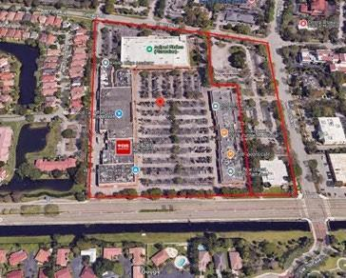
Address: 7001 and 7007-7181 W. Broward Blvd,
Plantation, FL
Property Type: {{ deal_facts.property_type }}
Loan Type: {{ deal_facts.loan_purpose }}
Loan Amount: {{ deal_facts.loan_amount }}
Term: {{ loan_terms.term }}
Interest Rate: {{ loan_terms.interest_rate }}
Origination Fee: {{ loan_terms.origination_fee }}
Exit Fee: {{ loan_terms.exit_fee }}
Lien: {{ loan_terms.lien_position }}
Minimum Interest: {{ loan_terms.minimum_interest }}
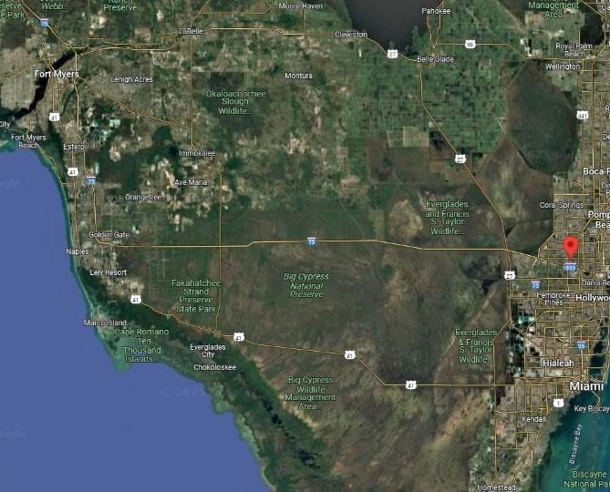
Extension Option: {{ loan_terms.extension_option }}
Source: {{ deal_facts.source }}

Leverage Ratios
FB LTC (at-Closing): {{ leverage.fb_ltc_at_closing }}
LTC (at-Maturity): {{ leverage.ltc_at_maturity }}
LTV (at-Closing): {{ leverage.ltv_at_closing }}
LTV (at-Maturity): {{ leverage.ltv_at_maturity }}
LTPP: {{ leverage.ltpp }}
Debt Yield (Fully Drawn): {{ leverage.debt_yield_fully_drawn }}

{{ transaction_overview.narrative }}

Sponsor Information
{% for row in sponsor_table %}
{{ row.entity }} | Profit: {{ row.profit_pct }} | Units: {{ row.membership_interest }} | Capital: {{ row.capital_interest or '-' }} | {{ row.capital_pct or '-' }}
{% endfor %}
Totals: Profit {{ sponsor_total_profit_pct }} | Units: {{ sponsor_total_membership }} | Capital: {{ sponsor_total_capital_pct }}

| Metric | Value |
|---------------------------|-------------------------------------------|
| Combined Net Worth | {{ guarantor_financials.combined_net_worth }} |
| Combined Cash Position | {{ guarantor_financials.combined_cash_position }} |
| Combined Securities | {{ guarantor_financials.combined_securities }} |
| Lender Min Net Worth Req | {{ guarantor_financials.lender_min_net_worth }} |
| Lender Min Liquidity Req | {{ guarantor_financials.lender_min_liquidity }} |
| Guarantee Type | {{ guarantor_financials.guarantees }} |

{% for principal in principal_financials %}
| {{ principal.name }} | {{ principal.title }} | {{ principal.company }} |
| Credit Score: {{ principal.credit_score }} ({{ principal.credit_score_date }}) |
| Net Worth: {{ principal.net_worth }} |
| Liquid Assets: {{ principal.liquid_assets }} |
| SREO: {{ principal.sreo_property_count }} properties, {{ principal.sreo_total_value }} value |
{% endfor %}

Equity Partner: {{ equity_partner.name }}
{{ equity_partner.description }}
Partnership History: {{ equity_partner.partnership_history }}

| Metric | Value |
|-------------------------|-------|
| Effective Gross Income | {{ financial_information.updated_income_statement.effective_gross_income }} |
| Operating Expenses | {{ financial_information.updated_income_statement.total_operating_expenses }} |
| Expense Ratio | {{ financial_information.updated_income_statement.expense_ratio }} |
| Net Operating Income | {{ financial_information.updated_income_statement.noi }} |

({{ loan_issues_disclosure }})
{% for issue in loan_issues_income_producing %}
• {{ issue.asset_name }} – {{ issue.location }}
{{ issue.description }}
{% endfor %}

Collaborative Ventures:
({{ collaborative_ventures_disclosure }})

{% for venture in collaborative_ventures_list %}
• {{ venture.name }} – {{ venture.location }}
{{ venture.description }}
{% endfor %}

Collaborative Venture – Property Map:
{{ collaborative_ventures.property_map }}

Sources and Uses
The sources and uses below highlight the total capital stack of the project, which includes the Loan in its entirety.

Fairbridge Sources and Uses

Sources and Uses
Sources:
{% for src in sources_list %}
{{ src.name }}: {{ src.amount }}
{% endfor %}
Total Sources: {{ sources_total }}
Uses:
{% for use in uses_list %}
{% if use.name %} {{ use.name }}: {{ use.amount }} {% endif %}
{% endfor %}
Total Uses: {{ uses_total }}

| Scenario | Loan Amount | Property Value | LTV |
|-------------|-------------|----------------|-----|
| LTPP | {{ financial_information.ltv_metrics.ltpp.loan_amount }} | {{ financial_information.ltv_metrics.ltpp.property_value }} | {{ financial_information.ltv_metrics.ltpp.ltv_pct }} |
| At Closing | {{ financial_information.ltv_metrics.at_closing.loan_amount }} | {{ financial_information.ltv_metrics.at_closing.property_value }} | {{ financial_information.ltv_metrics.at_closing.ltv_pct }} |
| As Complete | {{ financial_information.ltv_metrics.as_complete.loan_amount }} | {{ financial_information.ltv_metrics.as_complete.property_value }} | {{ financial_information.ltv_metrics.as_complete.ltv_pct }} |

As-Is NOI: {{ financial_information.debt_yield.as_is_noi }}
Debt Yield at Closing: {{ financial_information.debt_yield.at_closing_pct }}
Debt Yield Fully Drawn: {{ financial_information.debt_yield.fully_drawn_pct }}

| Component | {{ financial_information.dcf_valuation.component }} |
| DCF Value | {{ financial_information.dcf_valuation.value }} |
| Value/SF | {{ financial_information.dcf_valuation.value_per_sf }} |
| DCF Term | {{ financial_information.dcf_valuation.dcf_term_years }} years |
| Year 1 NOI | {{ financial_information.dcf_valuation.year_1_noi }} |
| Terminal Cap | {{ financial_information.dcf_valuation.terminal_cap_rate }} |
| Discount Rate | {{ financial_information.dcf_valuation.discount_rate }} |

Land Value: {{ financial_information.total_property_value.land_value }}
Retail Value: {{ financial_information.total_property_value.retail_value }}
Total Value: {{ financial_information.total_property_value.total }}

{{ closing_funding_and_reserves.narrative }}

{{ closing_funding_and_reserves.table }}

Fairbridge Disbursement at Loan Closing

Loan at Closing
Disbursements at Closing
(+) Payoff Existing Debt: | $ {{ closing_disbursement.payoff_existing_debt }}
(+) Broker Fee: | $ {{ closing_disbursement.broker_fee }}
(+) Origination Fee: | $ {{ closing_disbursement.origination_fee }}
(+) Closing Costs (Title): | $ {{ closing_disbursement.closing_costs_title }}
(+) Lender Legal: | $ {{ closing_disbursement.lender_legal }}
(+) Borrower Legal: | $ {{ closing_disbursement.borrower_legal }}
(+) Misc: | $ {{ closing_disbursement.misc }}
Total Disbursements: | $ {{ closing_disbursement.total_disbursements }}
(-) Sponsor's Equity at Closing: | $ {{ closing_disbursement.sponsors_equity_at_closing }}
Fairbridge Release at Closing: | $ {{ closing_disbursement.fairbridge_release_at_closing }}

Loan Terms
{{ loan_terms.narrative }}

Property Information

Property Overview
{{ property_overview.narrative }}

Active Litigation
{% if active_litigation.exists %}
{{ active_litigation.narrative }}
{% endif %}

Property Images
{{ images.property_photos }}
Zoning/ Entitlements
{% if zoning_entitlements.exists %}
{{ zoning_entitlements.narrative }}
{% endif %}

Maps

{{ images.location_map }}
{{ images.market_map }}
{{ images.site_plan }}
{{ images.zoning_map }}

Location Overview
{{ location_overview.narrative }}

Market Overview

{{ market_overview.narrative }}

Third Party Report Analysis
{{ third_party_reports.appraisal.narrative }}
{{ third_party_reports.environmental.narrative }}
{{ third_party_reports.pca.narrative }}

{{ comps.narrative }}

{{ comps.table }}

Financial Information/Ratios

Construction Budget

{{ construction_budget.narrative }}

Loan-to-Cost
The Underwriting Team has estimated the project’s Loan-to-Cost (“LTC”) based on the calculation below.

{{ LTC.table }}

{{ financial_info.income_statement_table }}
{{ financial_info.dcf_table }}

Property Value
{{ property_value.narrative }}
{{ property_value.table }}

Exit Strategy
{{ exit_strategy.narrative }}
Estimated Taxes, Insurance, and Foreclosure Timeline
{{ foreclosure_assumptions.narrative }}

Default Interest Scenario
{{ default_interest_scenario.table }}

Assumptions
{{ default_interest_scenario.assumptions_narrative }}

- Default Date: {{ foreclosure_analysis.default_interest_scenario.assumptions.default_date }}
- Foreclosure Timeline: {{ foreclosure_analysis.default_interest_scenario.assumptions.foreclosure_timeline_months }} months
- Default Interest Rate: {{ foreclosure_analysis.default_interest_scenario.assumptions.default_interest_rate }}
- Loan Balance at Default: {{ foreclosure_analysis.default_interest_scenario.assumptions.loan_balance_at_default }}
- Monthly Tax: {{ foreclosure_analysis.default_interest_scenario.assumptions.monthly_tax_payment }}
- Monthly Insurance: {{ foreclosure_analysis.default_interest_scenario.assumptions.monthly_insurance_payment }}
- Legal Fees: {{ foreclosure_analysis.default_interest_scenario.assumptions.total_legal_fees }}

Metrics at Foreclosure:
- Balance: {{ foreclosure_analysis.default_interest_scenario.metrics.balance_at_foreclosure }}
- Property Value: {{ foreclosure_analysis.default_interest_scenario.metrics.property_value }}
- LTV: {{ foreclosure_analysis.default_interest_scenario.metrics.ltv_at_foreclosure }}
- Net Property Value: {{ foreclosure_analysis.default_interest_scenario.metrics.net_property_value }}
- Discounted LTV: {{ foreclosure_analysis.default_interest_scenario.metrics.discounted_ltv }}

Risks and Mitigants
{% for risk in risks_and_mitigants.items %}
{{ risk.title }} – {{ risk.risk_description }}

Mitigant: {{ risk.mitigation }}
{% endfor %}

Deal Highlights
{% for highlight in deal_highlights.items %}
{{ highlight.title }}

• {{ highlight.description }}

{% endfor %}

Due Diligence
Lender’s Counsel: {{ due_diligence.lenders_counsel }}
Borrower’s Counsel: {{ due_diligence.borrowers_counsel }}
Appraisal: {{ due_diligence.appraisal_firm }}
Property Condition Assessment: {{ due_diligence.pca_firm }}
DeJong Background Check: {{ due_diligence.background_check }}
Environmental: {{ due_diligence.environmental_firm }}
Site Visit: {{ due_diligence.site_visit }}
Report Provider: {{ credit_report.report_provider }}
Report Date: {{ credit_report.report_date }}
Subject: {{ credit_report.subject_name }}

