

INVESTMENT MEMORANDUM
{{ cover.property_address }}

Credit Committee: Underwriting Team:
Date:
Table of Contents

Transaction Overview

Deal Facts
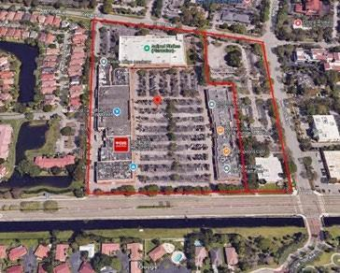
Address: 7001 and 7007-7181 W. Broward Blvd,
Plantation, FL
Property Type: {{ deal_facts.property_type }}
Loan Type: {{ deal_facts.loan_purpose }}
Loan Amount: {{ deal_facts.loan_amount }}
Term: {{ loan_terms.term }}
Interest Rate: {{ loan_terms.interest_rate }}
Origination Fee: {{ loan_terms.origination_fee }}
Exit Fee: {{ loan_terms.exit_fee }}
Lien: {{ loan_terms.lien_position }}
Minimum Interest: {{ loan_terms.minimum_interest }}
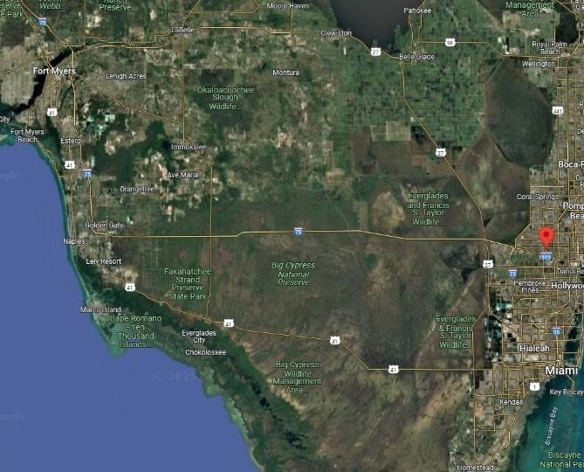
Extension Option: {{ loan_terms.extension_option }}
Source: {{ deal_facts.source }}

Leverage Ratios
FB LTC (at-Closing): {{ leverage.fb_ltc_at_closing }}
LTC (at-Maturity): {{ leverage.ltc_at_maturity }}
LTV (at-Closing): {{ leverage.ltv_at_closing }}
LTV (at-Maturity): {{ leverage.ltv_at_maturity }}
LTPP: {{ leverage.ltpp }}
Debt Yield (Fully Drawn): {{ leverage.debt_yield_fully_drawn }}

{{ transaction_overview.narrative }}

Sponsor Information
{{ sponsor.table }}
{% for sponsor in sponsors %}
{{ sponsor.overview }}

{{ sponsor.principals }}

{{ sponsor.financial_profile }}

{{ sponsor.track_record }}
{% endfor %}

({{ loan_issues.disclosure_statement }})
{% for issue in loan_issues.income_producing %}
• {{ issue.asset_name }} – {{ issue.location }}
{{ issue.description }}
{% endfor %}

Collaborative Ventures:
({{ collaborative_ventures.disclosure_statement }})

{% for venture in collaborative_ventures.items %}
• {{ venture.name }} – {{ venture.location }}
{{ venture.description }}
{% endfor %}

Collaborative Venture – Property Map:
{{ collaborative_ventures.property_map }}

Sources and Uses
The sources and uses below highlight the total capital stack of the project, which includes the Loan in its entirety.

Fairbridge Sources and Uses

Sources and Uses
{{ sources_and_uses.table }}

%

Capital Stack at Closing
{{ capital_stack.table }}

{{ closing_funding_and_reserves.narrative }}

{{ closing_funding_and_reserves.table }}

Fairbridge Disbursement at Loan Closing

Loan at Closing
Disbursements at Closing
(+) Payoff Existing Debt: | $ {{ closing_disbursement.payoff_existing_debt }}
(+) Broker Fee: | $ {{ closing_disbursement.broker_fee }}
(+) Origination Fee: | $ {{ closing_disbursement.origination_fee }}
(+) Closing Costs (Title): | $ {{ closing_disbursement.closing_costs_title }}
(+) Lender Legal: | $ {{ closing_disbursement.lender_legal }}
(+) Borrower Legal: | $ {{ closing_disbursement.borrower_legal }}
(+) Misc: | $ {{ closing_disbursement.misc }}
Total Disbursements: | $ {{ closing_disbursement.total_disbursements }}
(-) Sponsor's Equity at Closing: | $ {{ closing_disbursement.sponsors_equity_at_closing }}
Fairbridge Release at Closing: | $ {{ closing_disbursement.fairbridge_release_at_closing }}

Loan Terms
{{ loan_terms.narrative }}

Property Information

Property Overview
{{ property_overview.narrative }}

Active Litigation
{% if active_litigation.exists %}
{{ active_litigation.narrative }}
{% endif %}

Property Images
{{ images.property_photos }}

Zoning/ Entitlements
{% if zoning_entitlements.exists %}
{{ zoning_entitlements.narrative }}
{% endif %}

Maps

{{ images.location_map }}
{{ images.market_map }}
{{ images.site_plan }}
{{ images.zoning_map }}

Location Overview
{{ location_overview.narrative }}

Market Overview

{{ market_overview.narrative }}

Third Party Report Analysis
{{ third_party_reports.appraisal.narrative }}
{{ third_party_reports.environmental.narrative }}
{{ third_party_reports.pca.narrative }}

{{ comps.narrative }}

{{ comps.table }}

Financial Information/Ratios

Construction Budget

{{ construction_budget.narrative }}

Loan-to-Cost
The Underwriting Team has estimated the project’s Loan-to-Cost (“LTC”) based on the calculation below.

{{ LTC.table }}

{{ financial_info.income_statement_table }}
{{ financial_info.dcf_table }}

Property Value
{{ property_value.narrative }}
{{ property_value.table }}

Exit Strategy
{{ exit_strategy.narrative }}
Estimated Taxes, Insurance, and Foreclosure Timeline
{{ foreclosure_assumptions.narrative }}

Default Interest Scenario
{{ default_interest_scenario.table }}

Assumptions
{{ default_interest_scenario.assumptions_narrative }}

Risks and Mitigants
{% for risk in risks_and_mitigants.items %}
{{ risk.title }} – {{ risk.risk_description }}

Mitigant: {{ risk.mitigation }}
{% endfor %}

Deal Highlights
{% for highlight in deal_highlights.items %}
{{ highlight.title }}

• {{ highlight.description }}

{% endfor %}

Due Diligence
Lender’s Counsel: {{ due_diligence.lenders_counsel }}
Borrower’s Counsel: {{ due_diligence.borrowers_counsel }}
Appraisal: {{ due_diligence.appraisal_firm }}
Property Condition Assessment: {{ due_diligence.pca_firm }}
DeJong Background Check: {{ due_diligence.background_check_firm }}
Environmental: {{ due_diligence.environmental_firm }}
Site Visit: {{ due_diligence.site_visit_team }}

