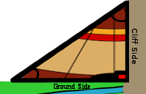**Description:** Chief SohCahToa from the Pythagorean tribe has requested your help in figuring how big and what angle to make their houses. The teepees of the Pythagorean tribe are known for their right triangles. The teepees are made up of one **Vertical Side** (The Cliff), one **Horizontal** Side (The Ground), and the **Hypotenuse** (The Skins). Recently, his tribe has lost their mathematician, and thus you were hired to create a program that would do the task for them.

**Program: Chief SohCahToa**

**Task:** Create a program that prompts the user to enter the information they currently have. This information includes the **known Hypotenuse or Side Length and known Angle.** There must be a **minimum of two entries, an Angle and a side length** in order to solve for the whole triangle. We want the answers in **Degrees**, **NOT Radians**.

**Note:** To convert Radians to Degrees use the Math.toRadians() from the Math Class

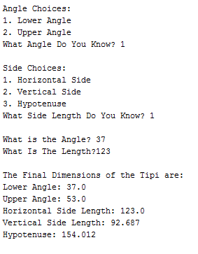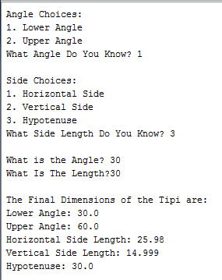**Statements Required:** Input, Output, Loop Control, Decision Making, Math Class

**Sample Output:**