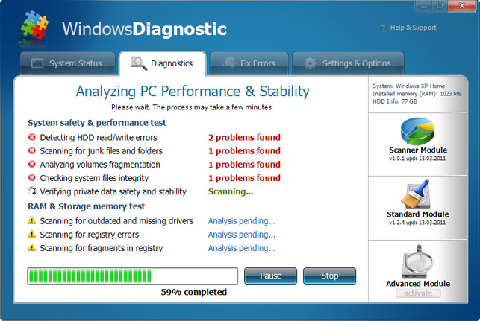

Direct Link: <http://www.2-spyware.com/images/parasites/snapshot/windows-diagnostic.jpg>

Site: <http://www.2-spyware.com/remove-windows-diagnostic.html>

Wireframe:

