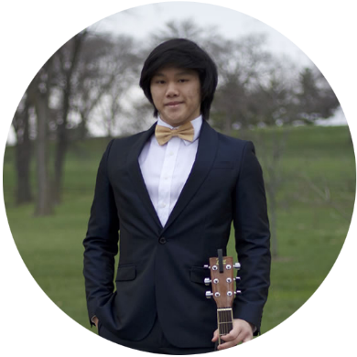

Expertise

**Coding**

* **Millard Public Schools:** 2 Years of Comp. Design and Coding Courses
* **Knowledgeable Languages**
  + HTML / HTML5
  + CSS / SCSS
  + JavaScript
  + jQuery (Plugin)

**Millard North High School:** 2014 — 2018

* **GPA:** 3.724/3.293 (W/UW)
* **International Baccalaureate DP:** Diploma Recipient
* **Cardistry Club:** Founder & President — 2015
* **Clubs Attended:** Chess / Math / Robotics / Theatre

**East Los Angeles Community College:** 2018 — Present

* **Transfer Admission Guarantee (TAG) Program:** ETA 2019

**Independent Studies**

* **Udacity Online Courses**
  + 1 Semester in Website Development — 2017
  + 1 Semester in Android Basics — 2017
* **Code.org**
  + Hour of Code — 2013

Education

Graphic Designer // Video Editor // Website Developer

Christian Linh-Son Nguyen

**Software & Programs Proficient In**

* **Adobe**
  + After Effects CS4 / CS6
  + Brackets
  + Fireworks CS6
  + Flash Professional CS6 / (Animate) CC
  + InDesign CS5 / CS6
  + Photoshop CS6 / CC
* **Autodesk**
  + Inventor
* **Google**
  + SketchUp Pro 2016 / 2018
* **Microsoft**
  + Office 2009 / 2011 / 2013 / 2016
* **Sony**
  + Vegas Pro 11 / 13 / 14 / 15

**Trinh Tran Attorney at Law:** January 2010 – Present

* **Worked in Mailing Management & Advertising**

**Optimum Data Incorporated:** June 2016 – August 2017

* **Network Technician**
* **Worked in Package Preparation & Shipment**

**Hy-Vee:** June 2018 – August 2018

* **Worked as Night Stock**

Work Experience



(402) 706 - 9318

cnguyen8144@gmail.com

**Chemistry**

* **Selected College Major**
  + I was introduced to the very basics of Chemistry by my junior high School teacher, Sarah Morrison, at that time was typically much earlier than other students in my school district. Having that interest planted within me it finally flourished in my latter years of high school as I challenged the IB Diploma Program. It was in IB Chemistry HL II that I found passion for this subject whilst learning rudimentary Medicinal & Organic Chemistry.

**Computer Science**

* **Favoured Pastime & Optional Work**
  + I have always been interested in Website Development. My first introduction to Website Development was the slight real-time modifications I would make to websites using Google's Inspect Element Tool. From there I learned more of the languages from school and online sources that eventually branched to CSS, JS, and jQuery.

**Anaesthesiology**

* **Desired Field of Study**
  + Medicinal & Organic Chemistry combined with my endless desire to help those in need has led me to this occupational line of study.

Interests

**Sarah Morrison**

* **Junior High School Science Teacher**
  + 5300 George B. Lake Pkwy, Elkhorn, NE 68022

**Joe Turco**

* **CEO & President of Optimum Data Incorporated**
  + 5066 South 111th Street, Omaha, NE 68137

References