**Rastena issues - 06/05/2025**

1. Log out > Pretty print format shows - High priority
2. Login form > Difficulty occurs when entering the email address
3. My profile > Name > Multi Language acceptance (minor)
4. Backend->user management->Filter using date->It would be good to add a column named Date to the listing table
5. My Profile > “No deals found“ > Style the design
6. Admin->create user->Hide create option(because of duplicate entries generation)
7. Login ->using Post a deal->on the OTP pop-up, the cursor
8. Preview page > It would be better to give an info message regarding the Deal creation submission

10.Create deal->Preview->text not visible while hovering over the button

11.Create deal->End date->Adjust the position of the error messagecou

13. My Profile->Logout->It will be good to replace the current icon image with the logout icon image

12. Filters > “No subcategories available” is not showing (My deals, Threads, and deal listing) - Priority

13.Home > Popular brands > Logo should fit in the screen

14. Comment section > Menu > Center-align the each menus

<https://jam.dev/c/e9a16c0b-fef1-4d11-885d-d13d0cdd877d>

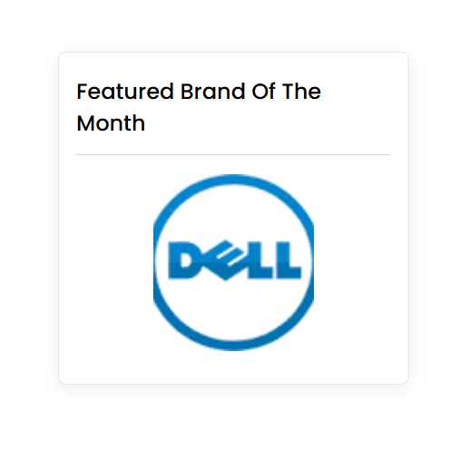

15. Product listing->Price dropdown ->dropdown filter overlaps your logo section

<https://jam.dev/c/0ce619ac-e373-4b8d-9c2e-08d1db6f4958>

20.Product listing->Price dropdown->The selected value need show as active in dropdown ->suggestion->html

21:Product listing->Once the user applies the filter, it would be good to automatically hide the filter section and display the filtered results.->suggestion

22. Mobile > Filters > Selected category is not showing as selected

23:Product detail->Comment->Like ->The thumb needs color change - Priority

24 . Thread > Description > Remove Validation - High priority

25 . Coupon > Like and dislike > Functionality issue - High priority (Add Active class)

26. Deal alert > Email is not received- High priority

27. admin->Coupon > database warning error shows when searching. High priority

28. User and admin mail > Change the Instagram icon

29. Comment poster should not be able to edit or delete the comment

30. The product detail should be opened in a new tab

31. Admin mail > Subject > Duplicate shows

32 Admin mail->correct the subject name according to the form submission

33. Backend Template issues

34.Backend->Home->cms->Deals You may have missed Section->Sub Category/Deal->The given data not get saved on the backend

35. Admin panel > Threads > Edit form > Deal is not listed in the form.High priority

36. My profile > Phone number > 2 error message shows when trying to enter an invalid phone number

37.18. Mobile > Filter > Selection is not showing after filtering

38.14. My deals > Filter issues > check the scenario > <https://jam.dev/c/d8ed3db5-949b-4435-a04a-ed66b1ff334f>

39.Create deal->Text editor->Bullet points->Not working (Backend and frontend) - Priority

40.backend->Home cms->Deals field->Increase the length of the field

41. Circle -> should show title and placeholder - Priority

42. Deal detail page > Comment section > Search name and sort section is not showing- High priority

43. Clicking on the thread user should be redirected to the comment section of the product detail page. -High priority

44. User -> post a deal -> option for a user to create a brand

45. Give export option in user deal listing, user thread listing

46.Home -> cms -> manual option-> deal should searchable ->

47. User management > status > All option missing -Priority

**07/05/2025**

1:backend->user list->userdeal list->user comment list->The username cannot be searched

(main comment and reply list)

2. Home > Slider > Issues

> When adding multiple sliders, only one slider is shown

> Deal that contains the container is only shown in the first slide

> Home->slider-> hide the bell icon

> Home ->slider->Do not show the navigation arrows if only one slider image is present-

> Clicking on the deal should open it in a new tab

3. Product detail page > Comment section > Search and sorting > It would be better to change the Placeholder color - Suggestion

4. Product detail page >Comment section > Search > Add close mark and auto load the results

5. Sort > Selected menu is not highlighted

4. Thread: form > What is the use of the description field in the thread form(now it is not shown anywhere)- Clarification

5. Home->Brands->image not updated and looping issue.

6. Broken links

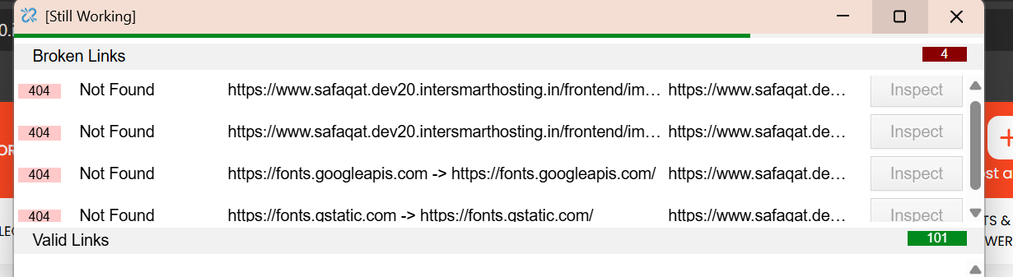

7. Post a deal > Unable to Preview

8. Filter > Brands are not displayed as selected