US 20022004

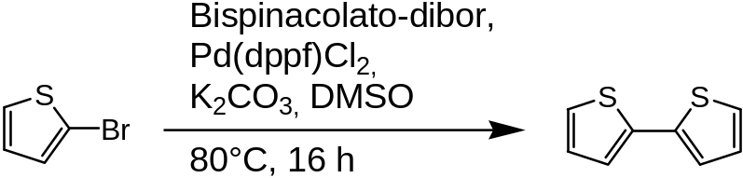

Yield 49%

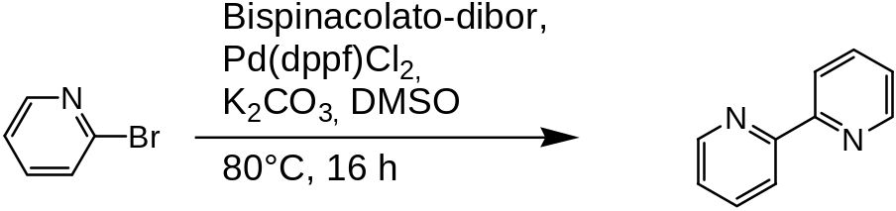

Probably only reisolated educt, waiting for mass spectra.

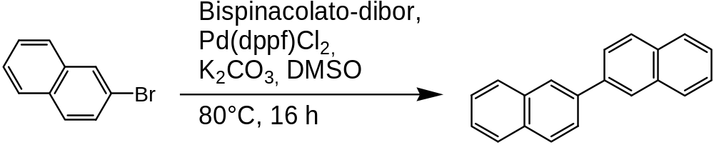
Yield 76%.

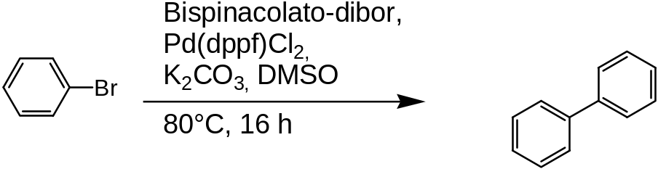
Yield ? Can´t find it in Marc´s lab journal. :-(

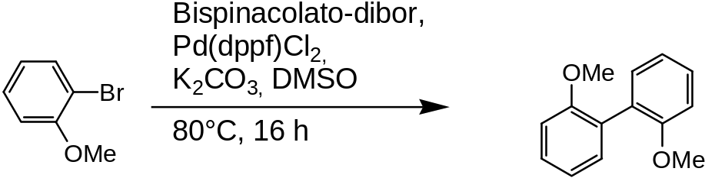
Yield 29%, reisolated product 57%.

Lots of analytic during the week…

