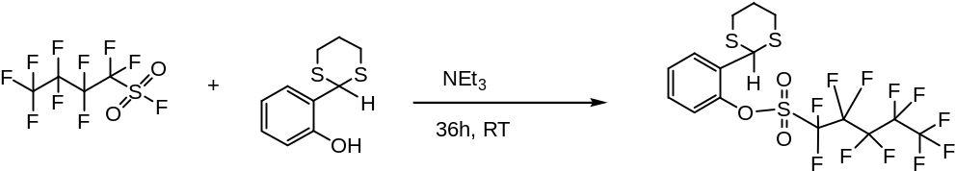

This doesn’t work, nmr doesn’t show much and gcms shows only starting material, so we will use this route instead:

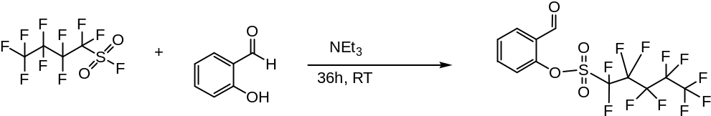

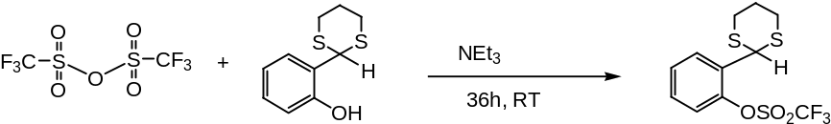

then….

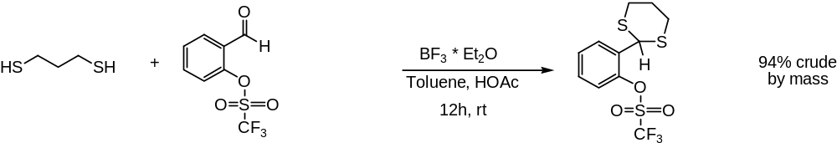

purifing product as we speak, nmr shows about 86% conversion

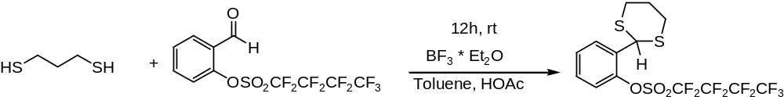

nmr shows full conversion. Didn’t determine a yield because the flask was cracked and some product was lost. .

