Some more test:

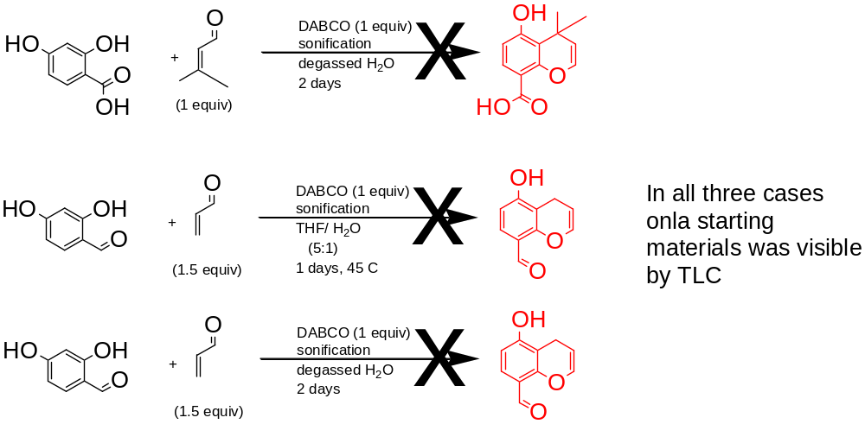

And diels-alders:
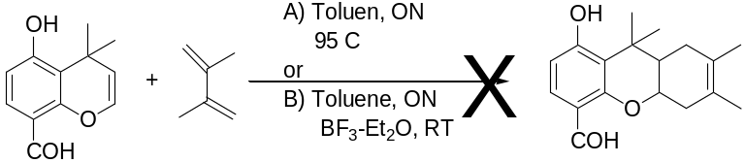

-it was a bit optimistic, but a received the more reactive pentadiene and I’m gonna give it a shot next week...

Another benzaldyde via vilsmeier:

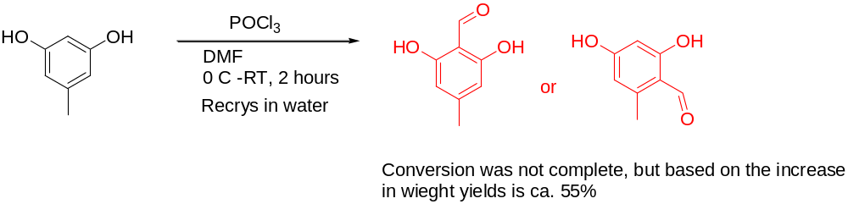

- both isomers are usefull….

