Friday´s report US11092003

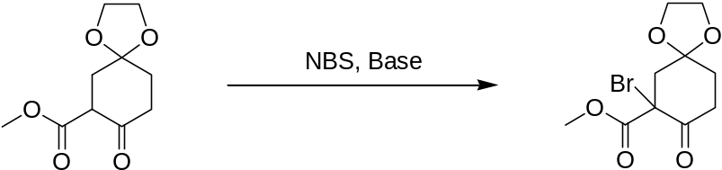

I have tried various bases and conditions in order to improve the yield of the bromide:
Base | Solvent | Other Conditions | Observations | yield
NEt₃ | CH₂Cl₂ | heating | The TLC still showed an educt spot after 1.5 days at room temperature. After heating for 5 h, conversion seemed to have improved. NMR spectrum of the crude product looks promising. | Yields not yet determined
NEt₃ | NEt₃ + CH₂Cl₂ (for dissolving the NBS) | - | TLC is a mess, no product visible | Yields not yet determined
DABCO | CH₂Cl₂ | - | Fastest reaction, was complete after 1.5 days. NMR spectrum of the crude product looks promising. | Yields not yet determined
Hünig-Base | CH₂CL₂ | heating | Slow, product is formed, but also two byproducts – I´m hoping for better conversion after heating. | Yields not yet determined

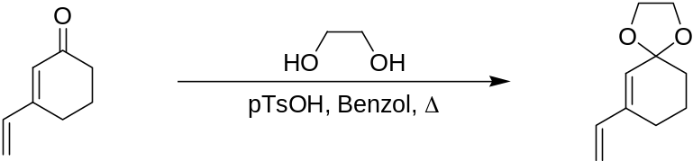

reaction still running…

