I.

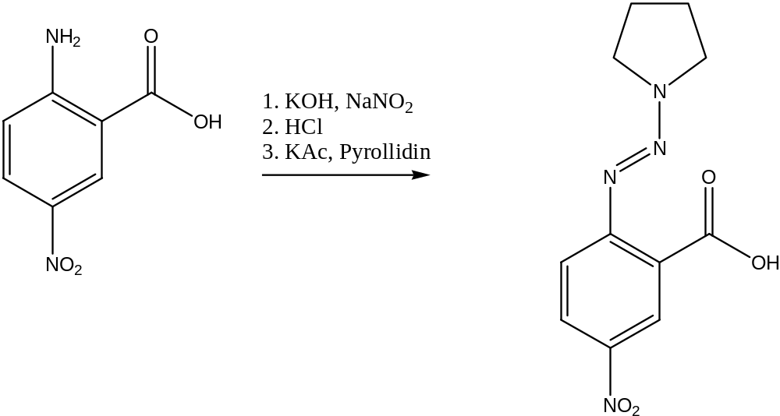
Workup: only filtrated and washed with water. Then dried over P₂O₅ in vacuum.
Yield: 67 %.
Very nice NMR, no side-product or educt.

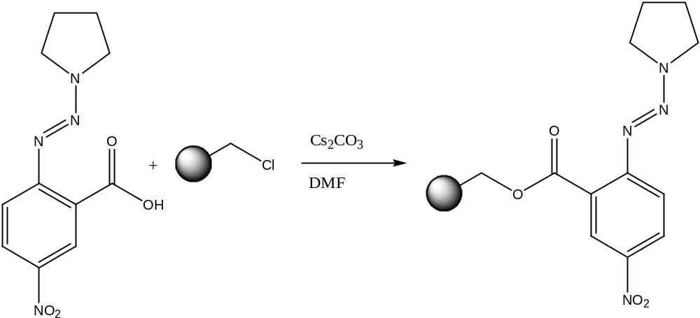

Nice yellow resin. I think, the coupling was successful.

II.

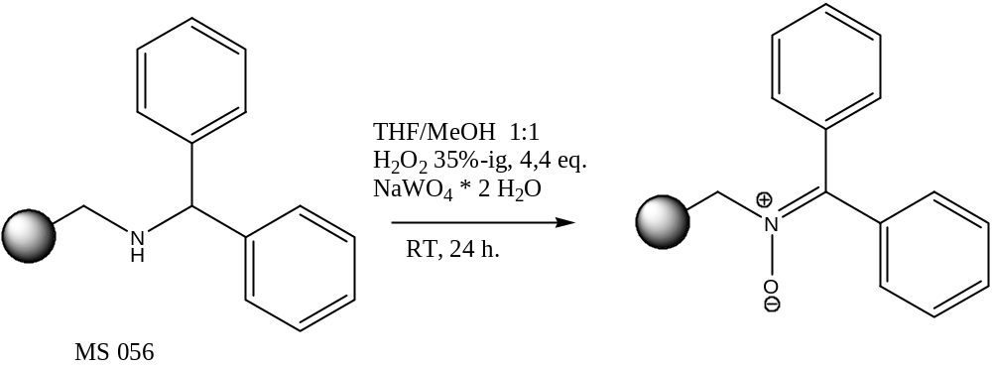

I tried to synthesize a nitrone after the article of Rück-Braun. I don’t know if it was successful

III.

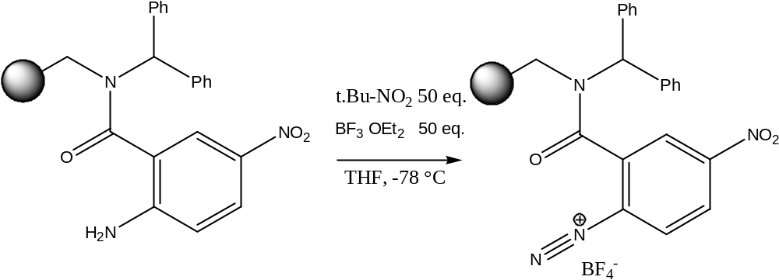

??????????????????????????????????


Alaaf!

