How to prepare a video file for rtsp streaming on Windows
version 1.0

Revision history
Version | Description | Author | Date
1.0.0 | First version | Alexander Epstine | Jun 22, 2024

Video files often contain incorrect codec information, missing timestamps, or other corrupted information. This document describes how to fix this issue.

1. Open VLC media player and select menu Media/Convert / Save
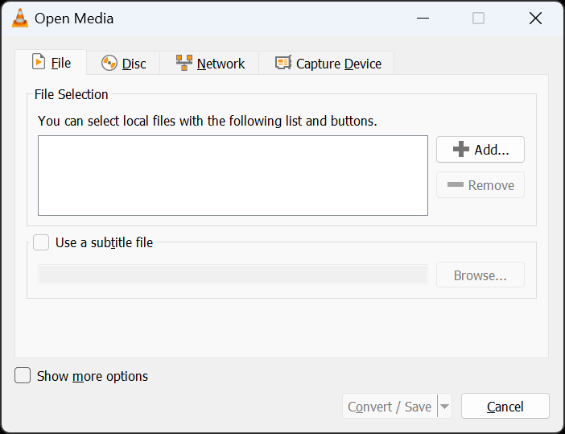

2. Press Add button and select movie file to convert
3. Press Convert / Save button
4. Select Video – H.264 + MP3 (MP4) profile
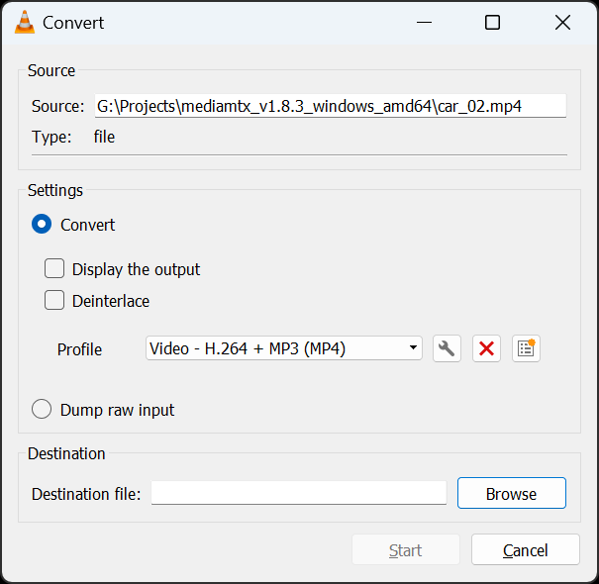

5. And press settings (with wrench icon) button.
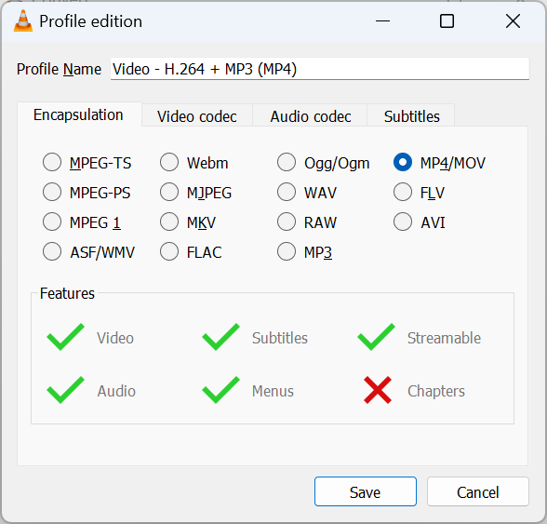

Select Video codec tab and set fps that you want.
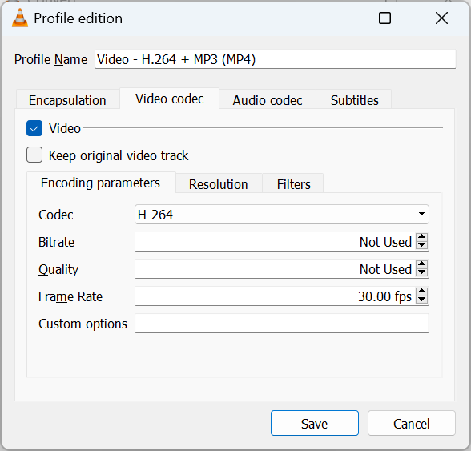
Press Save button.
6. Press Brtowse button and select distanation file.
7. Prtess Start button.
8. You have to install ffmpeg from the official web site:
https://ffmpeg.org/download.html
9. Once the process is complete, open Command Prompt or PowerShell.
10. ffprobe -i <your video file name>
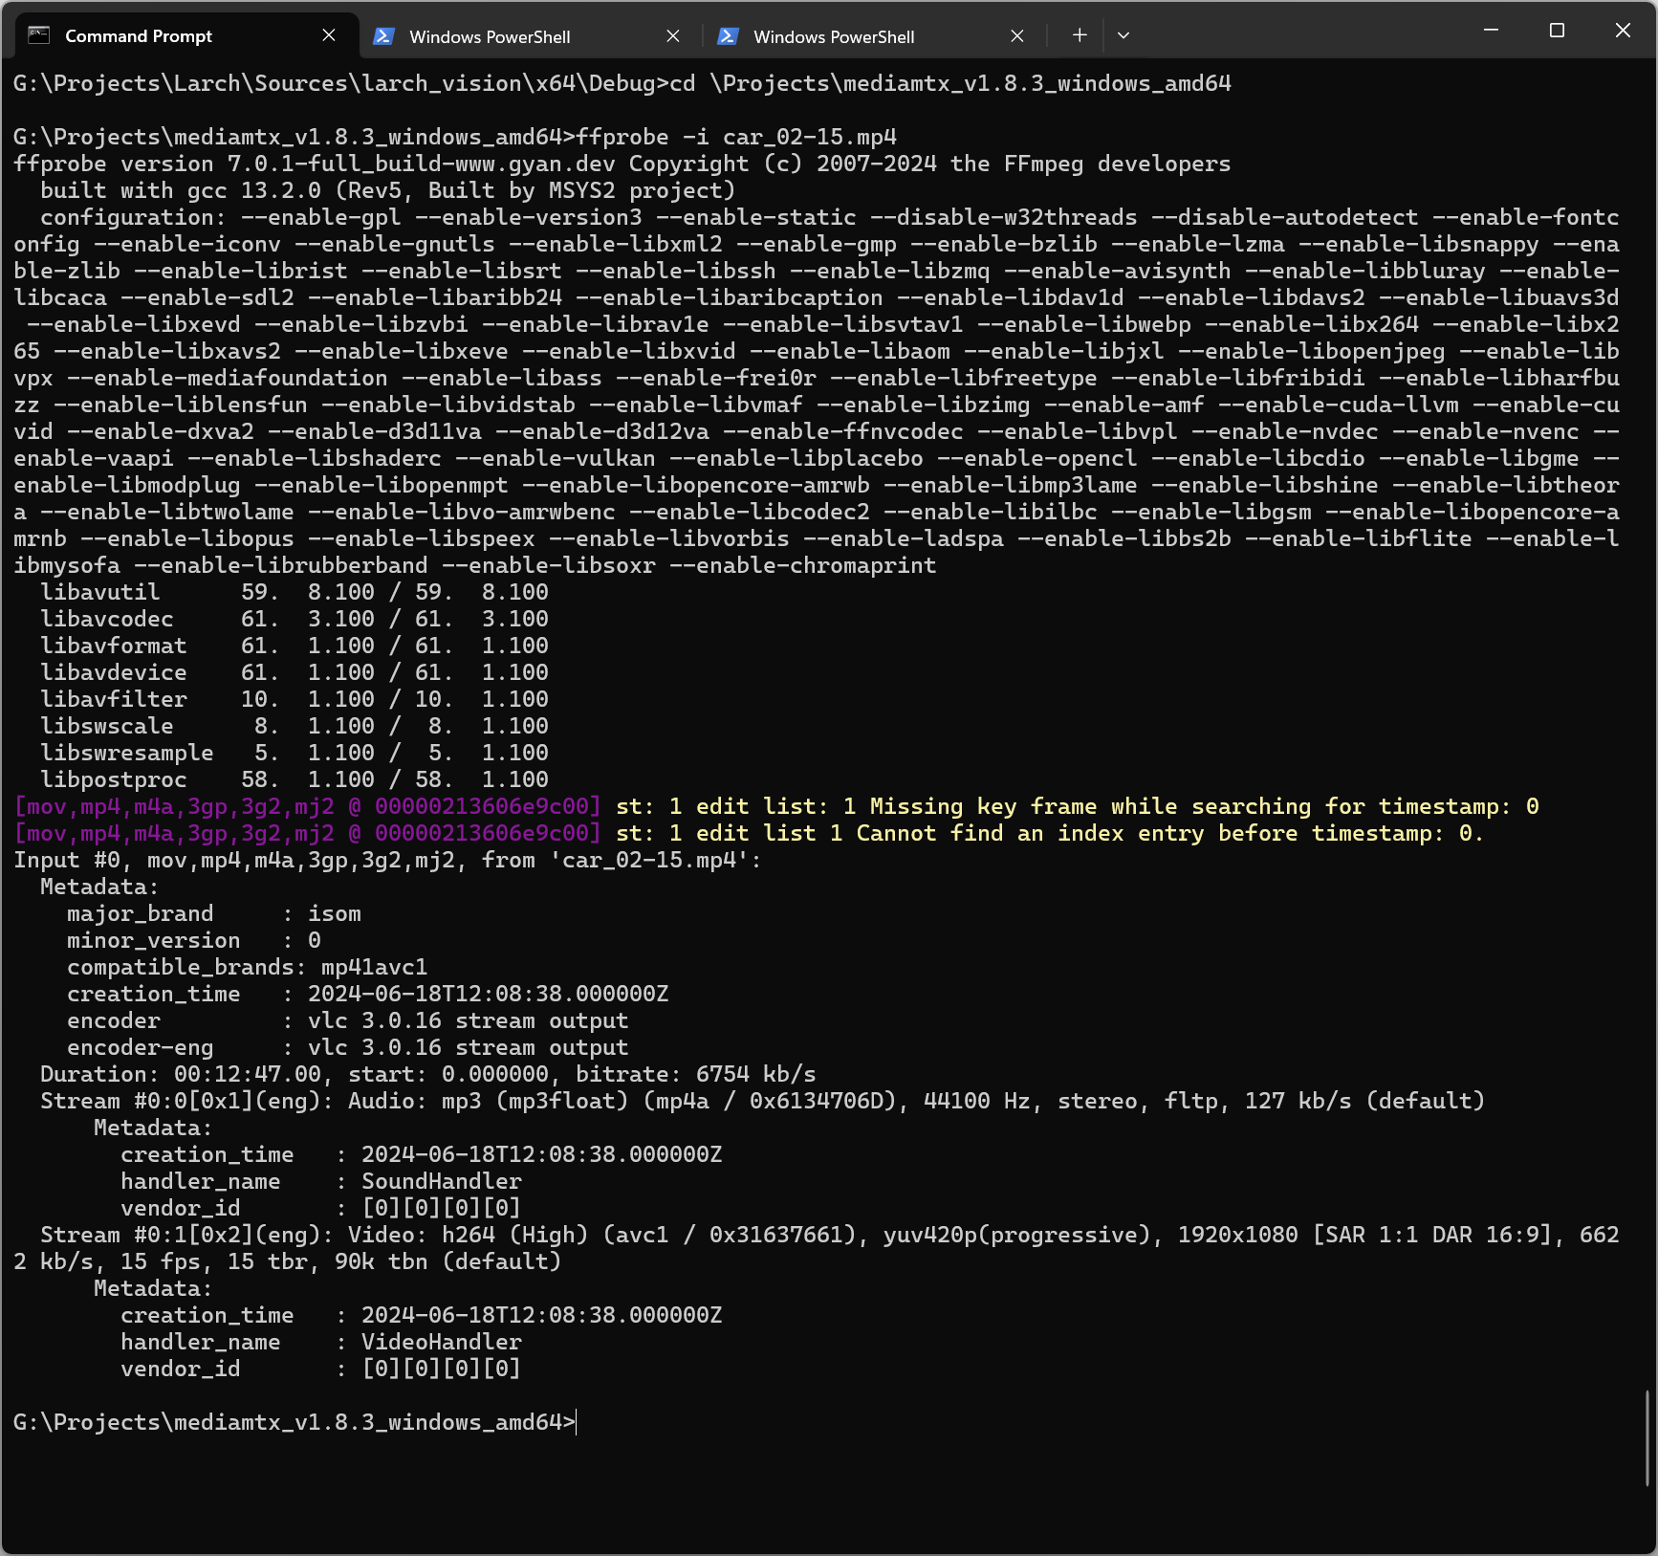
11. ffmpeg -i <your video file name> output.mp4
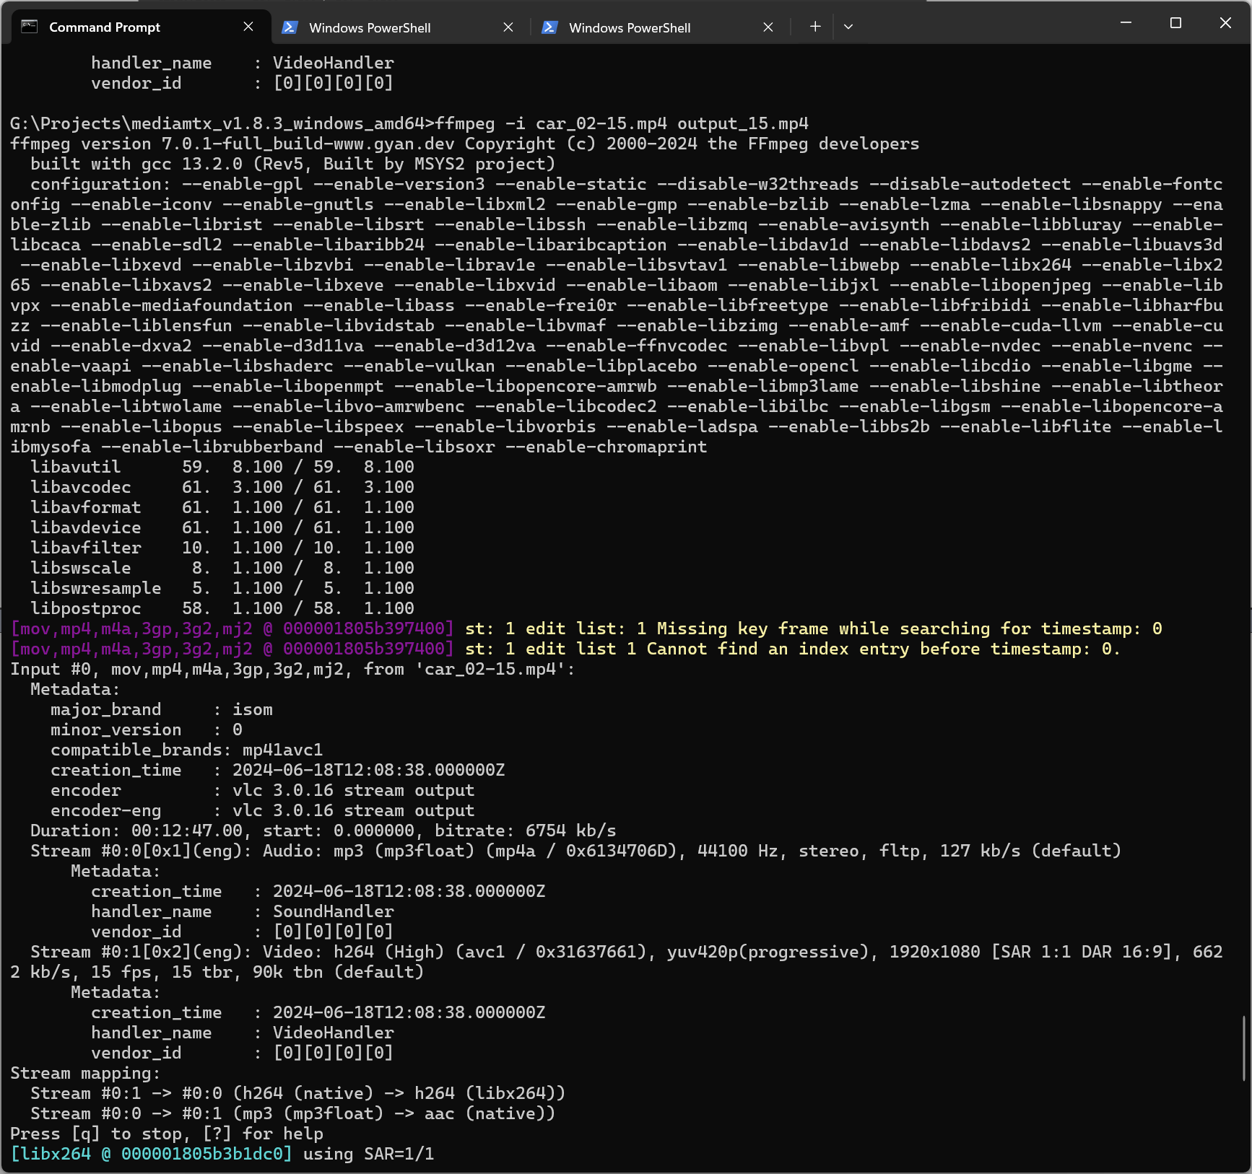
12. That’s all. You have a file with correct timestamps, audio/video codecs and now you can use this movie file with rtsp server.

