# Project Structure

## Solution Structure

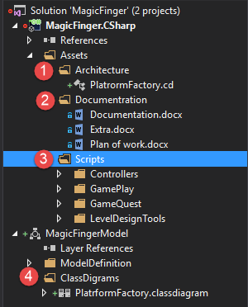

1. Architecture of code in class diagrams
2. Documentation of current progress goals, tasks, bugs, etc.
3. Implemented script realization
4. UML Class diagrams for Architecture.