**Representation**

def __init__(self):  
 self._dictIn = {} – dictionary of dictionaries  
 self._dictOut = {} - – dictionary of dictionaries  
 self._dictCosts = {} – dictionary with pairs as keys   
 self._vertices = 0  
 self._edges = 0

**Specification**

Class DoubleDictGraph provides the following methods:

def __init__(self)

Constructs a graph without vertices or arcs.

def vertices(self)

Returns the number of vertices.

def edges(self)

Returns the number of edges.

def is_edge(self,x, y)

Checks whether or not there is an arc between x and y.

def is_vertice(self,n)

Checks whether or not n is a vertex.

def add_vertex(self)

Adds a new vertex to the graph.

def remove_vertex(self, vertex)

Removes the vertex n from the graph.

Precondition: n is a vertex .

def add_edge(self, x, y, cost)

Adds an edge to the graph.

Precondition: x and y are existent vertices and the edge x-y doesn’t exist.

def remove_edge(self, x, y)

Removes an edge from the graph.

Precondition: x-y is an edge.

def get_vertices(self)

Returns a list of all vertices.

def get_in_degree(self, vertex)

Returns the in degree of a given vertex.

Precondition: vertex is in the graph.

def get_out_degree(self, vertex)

Returns the out degree of a given vertex.

Precondition: vertex is in the graph.

def parse_outbound(self, vertex)

Returns the list of outbound neighbors of a given vertex.

Precondition: vertex is in the graph.

def parse_inbound(self, vertex)

Returns the list of inbound neighbors of a given vertex.

Precondition: vertex is in the graph.

def get_cost(self, x, y)

Returns the cost of a given edge.

Precondition: x and y are vertices in the graph.

def modify_cost(self,x, y,newValue)

Changes the cost of a given edge.

Precondition: the edge is in the graph.

def copy(self)

Returns a deep copy of the graph.

def get_costs(self):

Returns the dictionary of costs.

External functions:

def loadGraphs(graph, filename)

Loads a graph from a text file in the memory.

def storeGraph(graph, filename)

Stores a graph from memory to a text file

def generateRandomGraph(vertices, edges)

Returns a random generated graph with a given number of vertices and edges

**Examples**

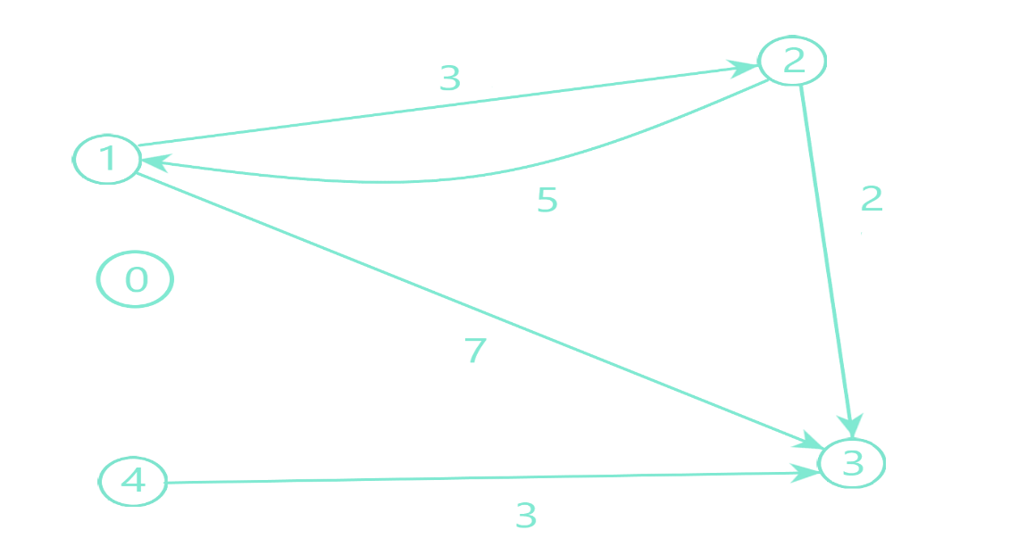

For this graph the initial values will be:

self._dictIn = {

self._vertices = 5  
self._edges = 5

self._dictCosts = {

(1, 2) : 3,

(1, 3) : 7,

(2, 1) : 5,

(2, 3) : 2,

(4, 3) : 3

}

self._dictIn = {

0 : {}

1 : {0 : 2}

2 : { 0 : 1}

3 : {0 : 1, 1 : 2, 2:4}

4: {}

}

self._dictOut = {

0 : {}

1 : {0 : 2, 1 : 3}

2 : {0 : 1, 1 : 3}

3: {}

4 : {0 : 3}

}

0 : {}

1 : {0 : 2}

2 : { 0 : 1}

3 : {0 : 1, 1 : 2, 2:4}

4: {}

}

For the same graph if I call add_vertex method:

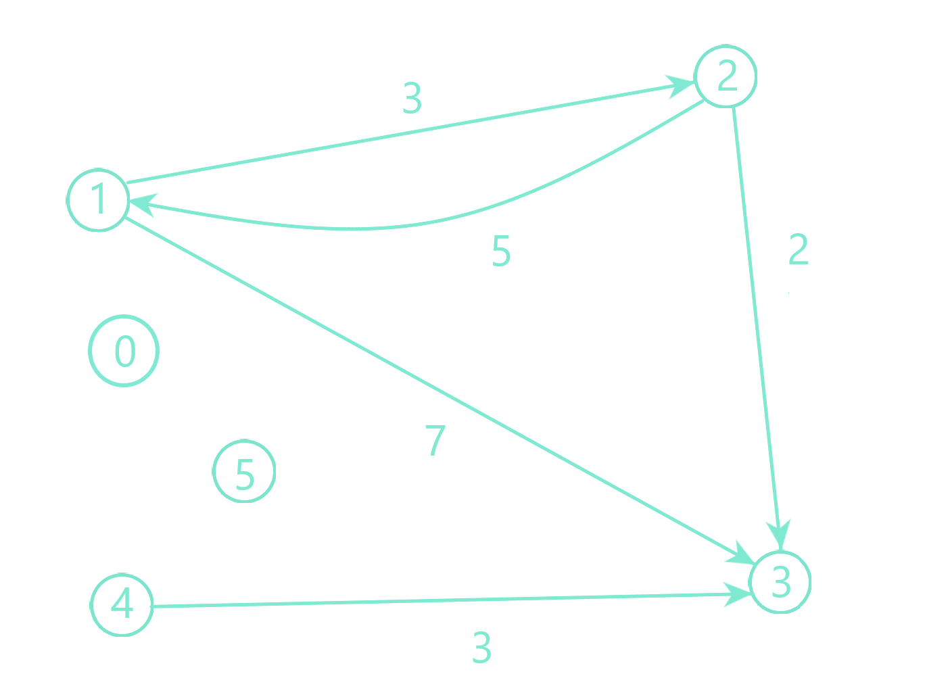

self._dictOut = {

0 : {}

1 : {0 : 2, 1 : 3}

2 : {0 : 1, 1 : 3}

3: {}

4 : {0 : 3},

5 : {}

}

self._dictIn = {

0 : {}

1 : {0 : 2}

2 : { 0 : 1}

3 : {0 : 1, 1 : 2, 2:4}

4: {},

5: {}

}

self._dictCosts = {

(1, 2) : 3,

(1, 3) : 7,

(2, 1) : 5,

(2, 3) : 2,

(4, 3) : 3

}

self._vertices = 6  
self._edges = 5