<https://github.com/ComanacDragos/ToyLanguageCompiler>

**Statement: Considering a small programming language (that we shall call mini-langauge), write 3 small programs in this language.**

**Deliverables: p1.* , p2.*, and p3.* and p1err.*  -  small programs written in your programming language  (p1, p2, p3  should be lexically correct; p1err should contain 2 types of lexical errors).**

**For example:**

**p1 and p2: compute de max/min of 3 numbers; verify if a number is prime, compute gcd of 2 numbers, compute the solutions for a 2nd order equation, aso**

**p3: compute the sum of n numbers, computer the max/min of n numbers**

**Statement**: Considering a small programming language (that we shall call mini-language), you have to write a scanner (lexical analyser)

Task 1: Minilanguage Specification

Deliverables:

Lexic.txt (file containing mini language lexic description; see example)

token.in (containing the list of all tokens corresponding to the minilanguage)

Syntax.in - the syntactical rules of the language

**Statement:** Implement the Symbol Table (ST) as the specified data structure, with the corresponding operations

**Statement:** Implement a scanner (lexical analyzer): Implement the scanning algorithm and use ST from [lab 2](https://moodle.cs.ubbcluj.ro/mod/assign/view.php?id=2614) for the symbol table.

**Input:**Programs p1/p2/p3/p1err and token.in (see [Lab 1a](https://moodle.cs.ubbcluj.ro/mod/assign/view.php?id=2546))

**Output:**PIF.out, ST.out, message “lexically correct” or “lexical error + location”

**Language specification**

letter ::= "a"|"b"|...|"z"|"A"|...|"Z"

digit ::= "0"|"1"|"2"|...|"9"

non_zero_digit ::= "1"|"2"|...|"9"

symbols ::= "_"

unary_operator ::= "!"

binary_operator ::= "+" | "-" | "*" | "/" | "^" | "%"

| "and" | "or"

| ">" | "<" | ">=" | "<="| "!=" | "=="

operator ::= "=" | unary_operator | binary_operator

separators ::= "[" | "]" | "{" | "}" | ";" | "space" | "newline"

identifier ::= letter{letter|digit|symbol}\{0,255\} //at most 256 characters

number ::= non_zero_digit{digit}

const_int ::= ("+"|"-")?number | "0"

const_float ::= ("+"|"-")?(number|"0")"."(digit{digit})

const_character ::= "'"character"'"

character ::= letter|digit|symbol

const_string ::= \"string\"

string ::= {character|\s}

const_bool ::= "true" | "false"

reserved_words ::= "if"

| "while"

| "bool"

| "char"

| "int"

| "string"

| "float"

// Syntax

program ::= statement_list

statement_list ::= statement | statement statement_list

statement ::= simple_statement | compund_statement

simple_statement ::= (assignment_statement

| iostatement

| declaration_statement)";"

compound_statement ::= if_statement | while_statement

simple_type ::= "bool"

| "char"

| "int"

| "string"

| "float"

array_type ::= simple_type"["number"]"

type ::= simple_type | array_type

constant ::= const_int

| const_float

| const_character

| const_string

| const_bool

expression ::= constant

| identifier

| identifier"["number"]"

| expression binary_operator expression

| unary_operator expression

| "("expression")"

declaration_statement ::= type identifier

| type identifier"="expression

iostatement ::= ("<<"identifier) | (">>"expression)

assignment_statement ::= identifier "=" expression

if_statement ::= if "("expression")" "{"statement_list"}" ["else" "{"statement_list"}"]

while_statement ::= while "("expression")" "{"statement_list"}"

Atom

----------

identifier

constant

int

char

bool

string

float

>>

<<

while

if

else

and

or

!

+

-

*

/

%

>

<

>=

<=

!=

==

=

;

[

]

{

}

(

)

.

^

p1

#computes the maxium

int a=9;

int b=6;

if(a>b){

>>"a is the maximum";

}else{

>>"b is the maximum";

}

p2

#computes the gcd

int a=9;

int b=6;

while(a!=b){

if (a>b){

a=a-b;

}

if (a<b){

b=b-a;

}

}

>>a." is the gcd";

p3

#prints the square of the elements of an array

int[256] a;

int i=0;

int n;

<<n;

while (i<n){

<<a[i];

i=i+1;

}

i=0;

while (i<n){

>>"square of",a[i]," is ",a[i]^2;

i=i+1;

}

p4

1a=9;

@b=6;

if (a>b){

>>"a is the maximum

}else{

>>"b is the maximum"

}

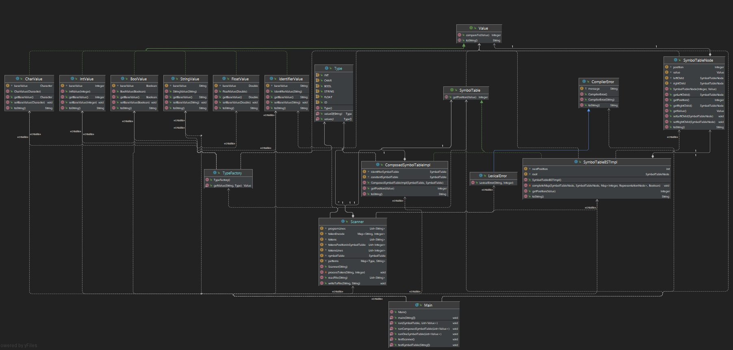**Implementation**

Symbol table details:

Value  
// default implementation: compares lexicographically the string representation of the Value with  
// the string representation of the otherValue. If the representations are equal 0 is returned  
// If the Value representation is less than otherValue representation a negative value is returned  
// otherwise a positive value is returned  
default Integer compareTo(Value otherValue)  
  
BoolValue, CharValue, FloatValue, IdentifierValue, IntValue, StringValue are implementing Value  
and each have a baseValue and their representation according to the specification  
  
SymbolTableNode has the following attributes  
 Integer position; // position in the symbol table  
 Value value; // the value in the symbol table  
 SymbolTableNode leftChild; // reference to the leftChild  
 SymbolTableNode rightChild; // reference to the rightChild  
  
public interface SymbolTable {  
 /*  
 Returns the position of the value if the value exists,  
 otherwise it inserts the value and returns the new position  
 */  
 Integer getPosition(Value value);  
}  
  
public class SymbolTableBSTImpl implements SymbolTable and has the following attributes  
 int nextPosition = 0; // represents the position of the next value to be inserted  
 SymbolTableNode root; // represents the root of the tree  
  
  
ComposedSymbolTableImpl implements SymbolTable and has 2 symbol tables  
 SymbolTable identifierSymbolTable; // for identifiers  
 SymbolTable constantSymbolTable; // for constants

Scanner details:

class Scanner

//program split by newline

List<String> programLines;

//map which encodes each token that can appear in the program

Map<String, Integer> tokenEncode;

//tokens of the program -- first column of PIF

List<String> tokens;

//the position of each token in the symbol table -- second column in PIF

List<Integer> tokensPositionInSymbolTable;

//the line of each token in the program -- third line in PIF

List<Integer> tokensLines;

SymbolTable symbolTable = new SymbolTableBSTImpl();

//patterns corresponding to each constant and ID

Map<Type, String> patterns;

Receives the program and outputs the FIP and SymbolTable to a directory corresponding to the program name

- program and tokens are read from file

- each line is split by the set of simple operators and by the white spaces that are followed

by at least 2 quotes

- empty lines are removed

- look ahead is applied to create composed tokens

- the token is processed

- FIP and Symbol table are written to files

public Scanner(String program)

Receives a token and a line

PIF is represented by the 3 lists: tokens, tokensLines, tokensPositionInSymbolTable

Classifies the token and adds it to the PIF otherwise it throws a LexicalError at the given line

- if the token is an operator separator or reserved word it is added to the PIF with the given line

and the position -1

- if it is an id or a constant it is added to the PIF with the corresponding type (id or constant)

and to the Symbol table according to the pattern that the token matches

- otherwise a lexical error is thrown

private void processToken(String token, Integer line)

//read the lines from a file

public List<String> readFile(String file)

//write to a file the content

public void writeToFile(String file, String content)

Types corresponding to the types of values in the symbol table

public enum Type

Type factory that generates the corresponding Value class given a token and a type

public class TypeFactory

**Testing**

Input:

int a=9;  
int b=6;  
if(a>b){  
 >>"a is the maximum";  
}else{  
 >>bbbb+"b is the maximum" ;  
}  
  
  
 >>0.0  
  
 >>1.3  
 <<=0.1  
 >>+0.001  
 >>-3  
 >>-11111.1  
 !=  
 <=  
 >=  
 ==  
 ^  
 !a%bbb  
-'a'  
!"aa aa"

Output:

FIP:

token,position,line  
int,-1,1  
id,0,1  
=,-1,1  
constant,1,1  
;,-1,1  
int,-1,2  
id,2,2  
=,-1,2  
constant,3,2  
;,-1,2  
if,-1,3  
(,-1,3  
id,0,3  
>,-1,3  
id,2,3  
),-1,3  
{,-1,3  
>>,-1,4  
constant,4,4  
;,-1,4  
},-1,5  
else,-1,5  
{,-1,5  
>>,-1,6  
id,5,6  
+,-1,6  
constant,6,6  
;,-1,6  
},-1,7  
>>,-1,10  
constant,7,10  
>>,-1,12  
constant,8,12  
<<,-1,13  
=,-1,13  
constant,9,13  
>>,-1,14  
constant,10,14  
>>,-1,15  
constant,11,15  
>>,-1,16  
constant,12,16  
!=,-1,17  
<=,-1,18  
>=,-1,19  
==,-1,20  
^,-1,21  
!,-1,22  
id,0,22  
%,-1,22  
id,13,22  
-,-1,23  
constant,14,23  
!,-1,24  
constant,15,24

ST:

position,value,parent,sibling  
0,a,-1,-1  
1,9,0,2  
2,b,0,1  
3,6,1,-1  
4,"""a is the maximum""",3,-1  
5,bbbb,2,-1  
6,"""b is the maximum""",4,-1  
7,0.0,6,15  
8,1.3,7,11  
9,0.1,8,-1  
10,0.001,9,-1  
11,-3,7,8  
12,-11111.1,11,-1  
13,bbb,5,-1  
14,'''a''',12,-1  
15,"""aa aa""",6,7

Error program:

a=9;  
a+012  
b='aa';  
if (a>b){  
 >>"a is the maximum  
}else{  
 >>"b is the maximum"  
}

Output: Lexical error at line: 2 for token: '012'