Growth pattern visualizations for all growth measures in children 0-12 years, TARGet Kids! and 2004 Pelotas cohorts

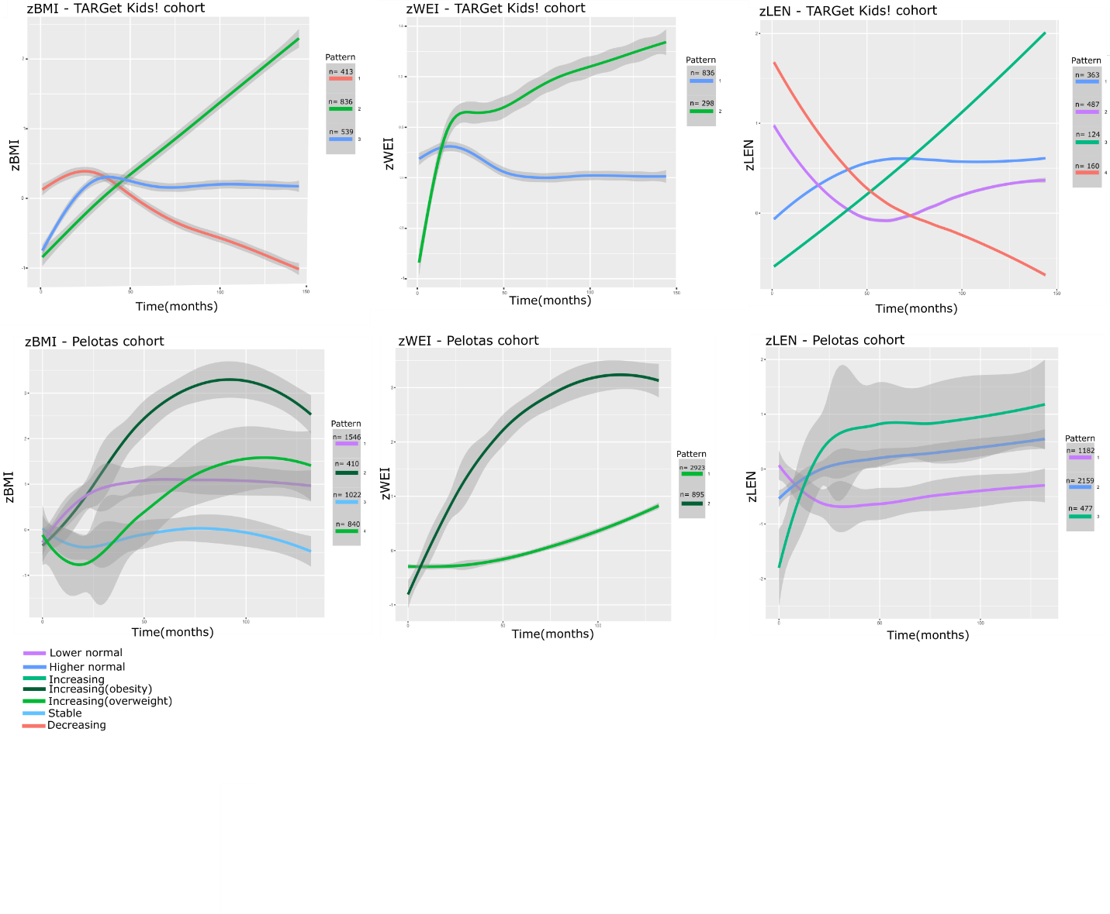

Growth pattern visualizations for all growth measures in children 0-50 months, TARGet Kids! and 2004 Pelotas cohorts

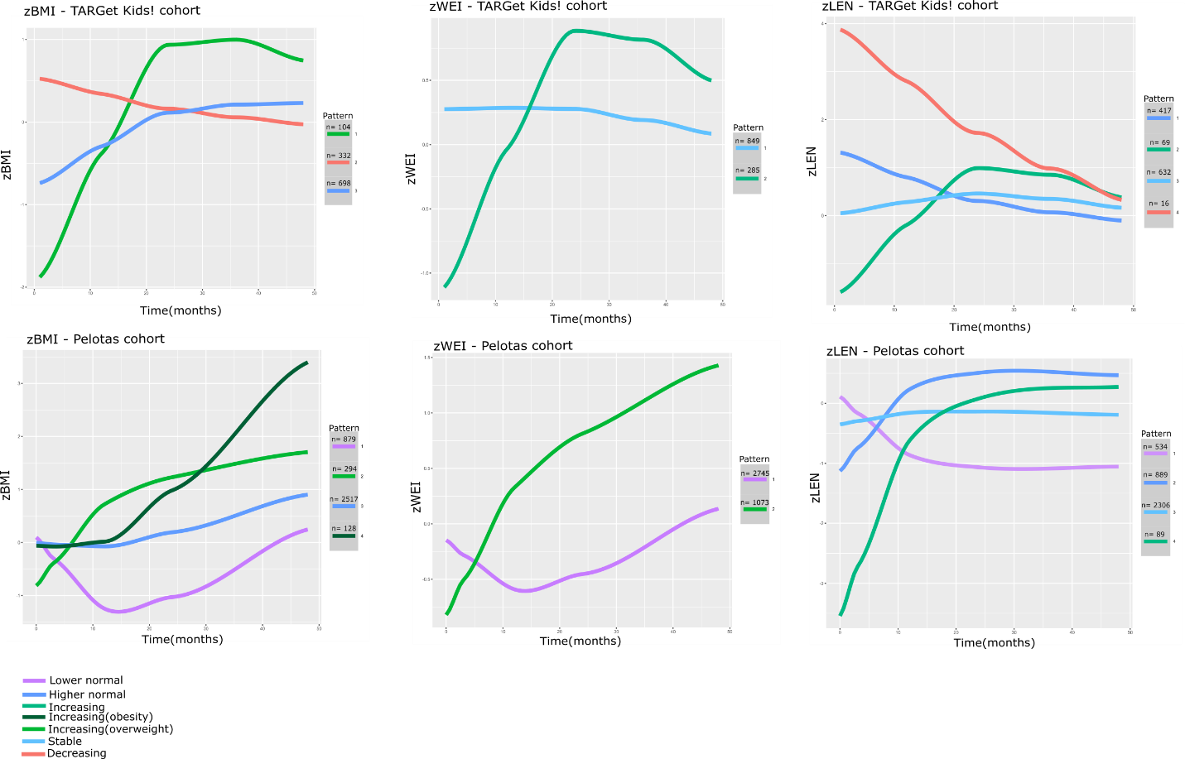

The 10 most informative features for zbmi, zwei and zlen ordered by importance for TARGet Kids! (plots i-iii) and Pelotas (iv-vi) cohorts. Both Catch22 and trajectory features specific to growth (TFSG) total n=159 features were included.

