Test

1. To acquire the environment data separately

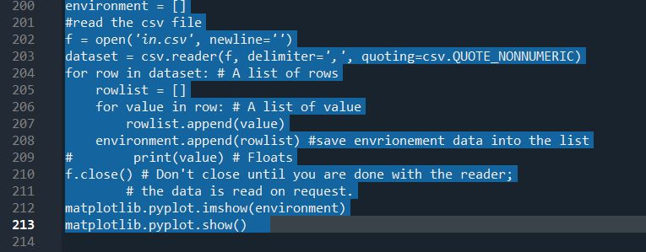

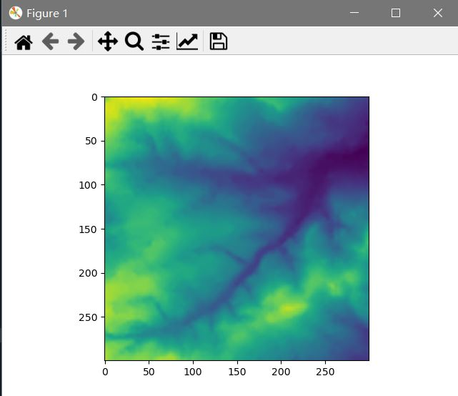

2. To print the restricted 100 coordinates, scraping on the web (data.html)

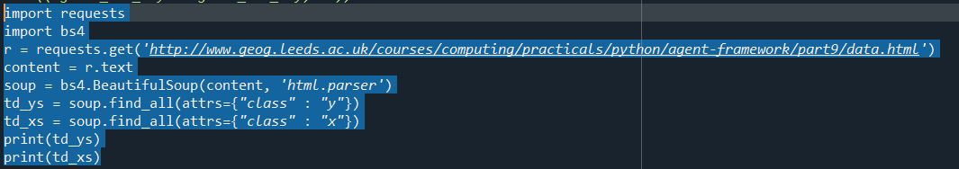

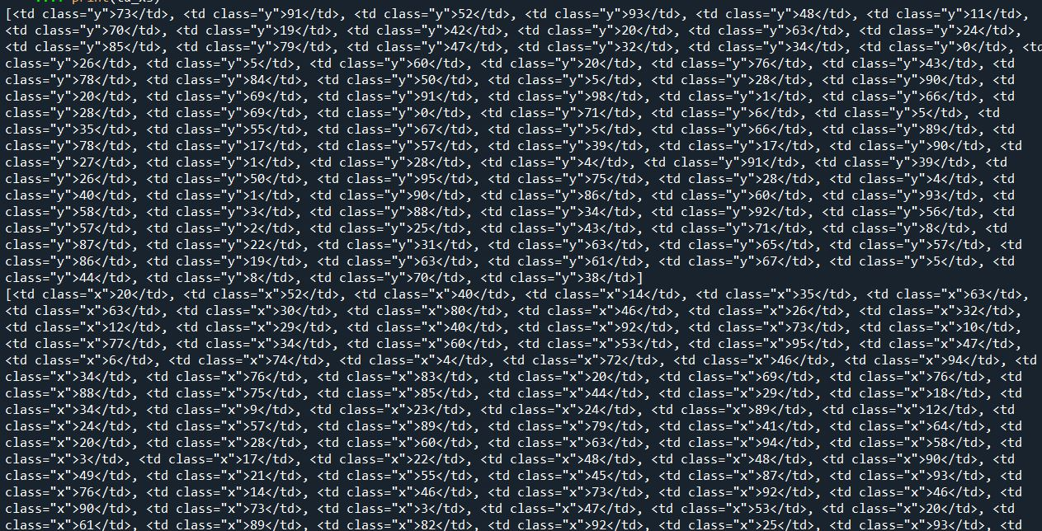

3. To print the coordinates of wolf and sheep, recording sheep were killed by wolves and to print the stores in each frame. The frame number will be printed at the end of run.

