LOGICAL DATA MODEL SPECIFICATION
Cane360 MVP
Entity relationships, data ownership, integrity rules, and implementation boundaries
Version: 0.1 - Logical baseline
Source: Cane360 MVP Product Requirements v0.1
Market: Zimbabwe; Hippo Valley, Mkwasine, and Triangle pilot
Scope: Modules 1-6; responsive online web MVP
Prepared: 11 August 2026
Status: Ready for product and engineering review

Model objective. Define the minimum durable data structure needed to prove what happened in each field, trace every controlled input to application or resolution, and support monthly payroll from verified work evidence.

Document purpose
This specification turns the approved product requirements into a logical entity-relationship model. It defines domain entities, identifiers, cardinalities, lifecycle ownership, derived values, tenant boundaries, audit strategy, and the invariants that the database and API must enforce.
It is intentionally technology-aware but not a physical schema. PostgreSQL, PostGIS, Entity Framework Core mappings, indexes, partitions, column types, and migration scripts are the next engineering design step.

Document map
Section | Use
1-3 | Model scope, conventions, and the top-level domain map.
4-7 | Entity catalogues for farm/crop, labour/payroll, inventory, and finance/mill.
8-12 | Cross-cutting approvals, evidence, state, integrity, formulas, security, and history.
13-15 | Aggregate boundaries, PostgreSQL/PostGIS handoff, and implementation validation items.

1. Scope and modelling decisions

1.1 Locked product boundaries
Area | Logical model decision
Tenant | A tenant represents one grower customer. The model permits multiple farms later, while an MVP invariant limits the tenant to one active farm.
Users and actors | Application users are separate from named operational people. A manager can enter a supervisor or storekeeper attestation without implying that person logged in.
Farm and store | One active farm and one store per farm in MVP. Historical or inactive records remain addressable.
Crop cost object | CropCycle is the mandatory operational and cost-allocation anchor for labour, applied inputs, and directly allocated expenses.
Inventory truth | StockMovement is the immutable stock ledger. Field application is separate from store issue and is the control point for consumption and cost.
Payroll truth | A versioned monthly PayrollRun is built from approved evidence. The grower approves a specific version; later material edits invalidate that approval.
Money | All MVP money is USD. Currency and exchange-rate entities are not exposed in v0.1.
Mill records | Weighbridge tickets and grower statements are evidence records only; division-of-proceeds accounting remains out of scope.

1.2 Explicit exclusions from the model
- General ledger, chart of accounts, journal entries, accounts payable/receivable, tax, VAT, and statutory payroll.
- Multi-farm worker sharing, cooperative tenancy, mill portals, transport scheduling, and direct mill or payment APIs.
- Offline synchronization, device queues, conflict resolution, AI, IoT, satellite imagery, and equipment maintenance.
- Fuel as an MVP catalogue category. The inventory model can support it later without a structural redesign.

1.3 Design stance
The model favours explicit operational events over mutable totals. Quantities on hand, unaccounted input, payroll balances, and crop-cycle costs are derived from posted source records. Materialised summaries may be introduced for performance, but they are never the authoritative source.

2. Modelling conventions
Convention | Rule
Identifiers | Every entity has an opaque logical identifier, recommended as UUID. Human-readable codes remain tenant-scoped alternate keys.
Tenant ownership | Every farm-owned entity resolves to tenant_id. Direct tenant_id storage is recommended on high-volume or security-sensitive tables even when derivable.
Natural keys | Natural identifiers such as field code, national ID, ticket reference, and payroll period receive explicit scoped uniqueness rules; they are not primary keys.
Time | event_date/event_at records when work happened; created_at records when it was entered. Approval, posting, and reversal timestamps are separate.
People | created_by_user_id identifies the authenticated user. Operational person fields identify issuer, recipient, supervisor, worker, or confirmer.
Statuses | State is owned by the aggregate root. Child lines cannot independently claim a state that contradicts the root.
History | Approved, posted, paid, or closed records are not overwritten. Corrections reverse or supersede originals and preserve the chain.
Soft archive | Reference/master records may be archived. Posted operational records are retained and cannot be hard-deleted through the application.
Quantities | Quantity always pairs with a unit. Conversion is permitted only through configured item/unit rules; display rounding never changes stored precision.
Money | Money stores amount and USD currency assertion. Financial calculations use fixed decimal precision and defined rounding at component and total levels.

2.1 Common metadata contract
Farm-owned aggregates should carry the following metadata directly or through a shared persistence convention:
- id; tenant_id; status; created_at; created_by_user_id; last_changed_at; last_changed_by_user_id.
- event_date or event_at where an operational event occurs separately from entry time.
- operational_person_id and operational_role when the authenticated user records on another person's behalf.
- source reference and evidence links where source sheets, receipts, photos, or statements support the record.
- superseded_by_id, reversal_of_id, or CorrectionRecord link when a material record is corrected.

2.2 Relationship notation
Notation | Meaning
1 | Exactly one related record is required.
0..1 | The relationship is optional and permits at most one record.
1..* | At least one child is required before the parent can post or close.
0..* | Any number of children may exist, including none.
MVP max 1 active | The logical model permits history/future growth; a filtered uniqueness rule enforces the current product boundary.

3. Domain overview
The top-level model keeps commercial/security identity separate from farm operations. Farm is the operational ownership root; CropCycle is the production and cost root; Activity connects agronomy, labour, and inventory evidence.
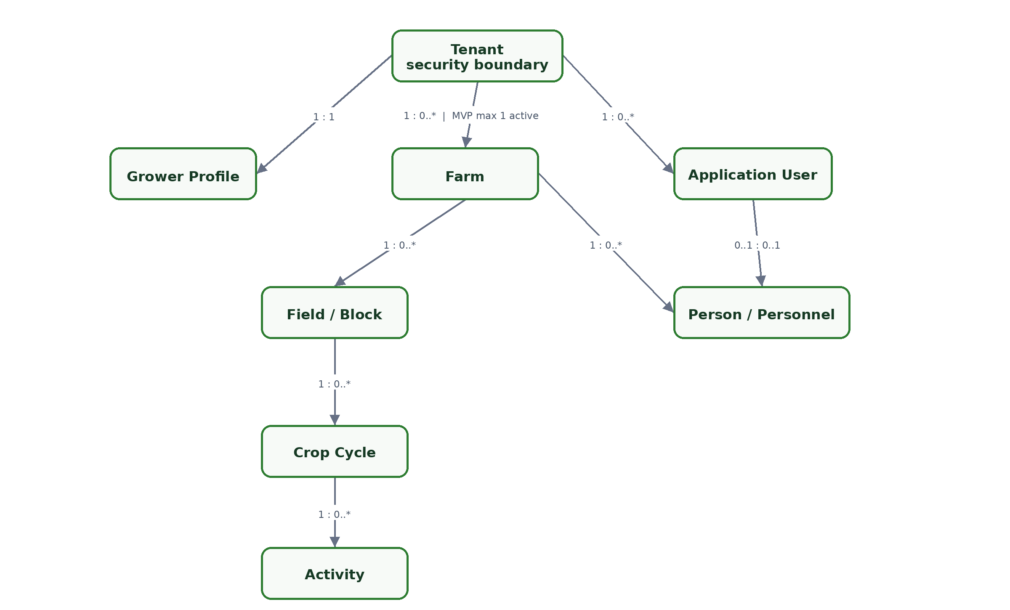
Figure 1. Core tenant, farm, field, crop-cycle, and activity relationships.

3.1 Domain ownership
Domain | Aggregate roots | Authoritative outputs
Identity and farm | Tenant, Farm, Field, CropCycle | Tenant isolation, farm setup, field register, crop history.
Activities and labour | Activity, Attendance, WorkRecord | Field diary, work evidence, verified piece quantities.
Inventory control | StockReceipt, InputRequest, StockIssue, InputApplication, StockCount | Stock ledger, input trace, unaccounted quantity, stock variance.
Payroll | PayrollPeriod, PayrollRun, WorkerAdvance | Approved payroll version, payslip data, payment records, advance balance.
Finance and mill | OperationalTransaction, Budget, WeighbridgeTicket, GrowerStatement | Direct cost, budget comparison, cost per hectare/tonne, mill evidence.
Cross-cutting | ApprovalDecision, EvidenceDocument, ControlException, AuditEvent | Approval proof, evidence chain, exception resolution, immutable audit trail.

3.2 Central joins
- CropCycle is the central join for activity, verified labour, confirmed input application, direct expense allocation, harvest result, and cost reporting.
- Person is the central operational actor. WorkerProfile extends a Person; TenantMembership connects an ApplicationUser to the person represented in a tenant.
- OperationalCostPosting is a controlled projection from approved payroll, confirmed input application, and posted direct expenses. It is not a general ledger.
- EvidenceLink, ApprovalDecision, ControlException, CorrectionRecord, and AuditEvent are cross-cutting records whose subject references must be constrained by application and persistence rules.

4. Identity, farm, field, and crop entities
Entity | Purpose | Logical keys and attributes | Relationships / constraints
Tenant | Commercial and security boundary for one grower customer. | id; tenant_code; status; provisioned_at | Owns memberships, farm data, settings, audit events. MVP permits one active Farm.
GrowerProfile | Grower/customer details and owner contact context. | tenant_id (1:1); legal/display name; contacts | Exactly one active profile per Tenant; owner Person may be linked.
ApplicationUser | Authenticated identity independent of any single tenant. | id; identity_provider_subject; email; status | Joins tenants through TenantMembership; cannot be used as an operational actor without the represented Person link.
TenantMembership | User access and security role within a tenant. | tenant_id + user_id; security_role; status; person_id? | Unique active user/tenant pair. Grower and manager permissions derive here.
Farm | Operating farm owned by the tenant. | id; tenant_id; farm_code; name; status; location | MVP filtered uniqueness limits one active Farm per Tenant. Owns Store, Field, Person, Worker, Supplier.
Person | Named farm person used for operational attribution. | id; farm_id; display name; phone?; active dates | May represent owner, manager, supervisor, storekeeper, issuer, recipient, or worker; login is optional.
PersonRoleAssignment | Time-bounded operational role held by a Person. | person_id; role_code; effective_from/to; is_primary | One active primary farm manager per Farm; multiple supervisors/storekeepers are allowed.
Store | Single physical inventory store for the farm. | id; farm_id; code; name; status | Exactly one active Store per Farm in MVP; owns stock movements and counts.
Field | Sugarcane field/block and area reference. | id; farm_id; code; name; status; declared_ha; mapped_ha; reporting_area_source | Active code unique within Farm; many CropCycles; geometry is optional.
FieldBoundaryVersion | Versioned geographic boundary and calculated area. | field_id; version_no; geometry; source; calculated_ha; effective_at | One current version at a time; invalid geometry cannot be current; original imports remain traceable.
FieldLineProfile | Standardised row/line context for piece work. | field_id; standard_line_length_m; estimated_line_count; numbering scheme | At most one active profile per Field; WorkScope can reference line ranges or work sections.
CropVariety | Configurable sugarcane variety reference. | id; tenant/global scope; code; name; active status | Referenced by CropCycle; archived varieties remain valid in history.
CropCycle | Plant-cane or ratoon production period and central cost object. | id; field_id; cycle_type; ratoon_no?; variety_id; dates; status; expected yield | Only one Active or Ready-for-harvest cycle per Field. New operations prohibited after Closed.
HarvestResult | Actual harvest closure values required for cost per tonne. | crop_cycle_id (1:1); harvest_date; actual_tonnes; source/evidence | Required before a harvested cycle can calculate cost/tonne; correction preserves prior result.
FarmSetting | Tenant/farm configuration with effective dates. | farm_id; setting_key; typed value; effective_from/to | Controls thresholds, tolerances, approval assignment, late-entry limits, and reference behaviour; changes are audited.

4.1 Key field and crop invariants
- Field declared area and mapped area are independent. reporting_area_source selects the denominator used by all cost/area reports and must be shown in report output.
- CropCycle.cycle_type = Ratoon requires ratoon_no. Plant cane must not carry a ratoon number.
- Operational Activity, WorkRecord, InputApplication, and directly allocated expenses require a CropCycle in an operational state.
- Archiving a Field never hides its historical cycles, activities, stock applications, labour, or costs.

5. Activity, labour, advance, and payroll entities
Labour evidence begins with attendance and an activity-linked WorkRecord. Supervisor verification and manager confirmation are distinct facts even when the manager enters both. A payroll run consumes only eligible evidence and freezes a version for grower approval.
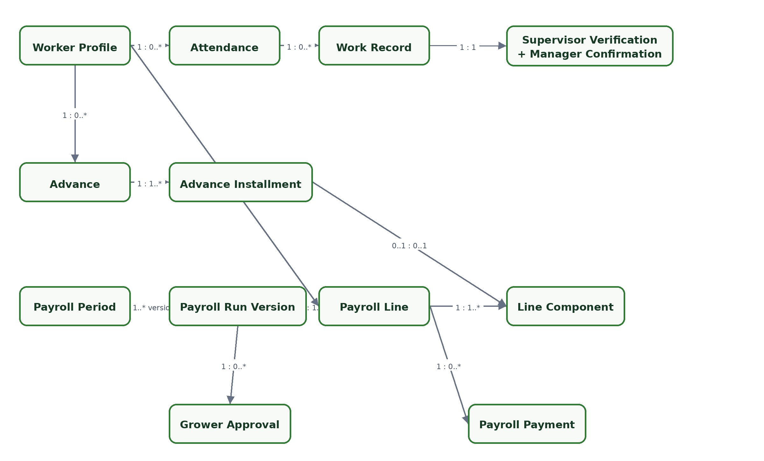
Figure 2. Verified work evidence through monthly payroll and payment.
Entity | Purpose | Logical keys and attributes | Relationships / constraints
ActivityType | Configurable kind of field work and measurement rules. | id; code; name; planned/unplanned flags; quantity basis | Referenced by Activity and InventoryApplicationRule; archive instead of delete.
Activity | Planned or unplanned work against a field and active crop cycle. | id; crop_cycle_id; field_id; type_id; planned/actual dates; status; supervisor_person_id | Owns work evidence and input workflow. Field must match CropCycle.field_id.
WorkerProfile | Paid worker attributes extending a farm Person. | person_id (1:1); employment type; national_id_cipher/hash/mask; active dates | Worker belongs to one Farm. National ID hash unique within Farm, subject to authorised correction flow.
WorkerRate | Effective-dated pay rule for daily, monthly, hectare, line, or optional overtime basis. | worker_id or role/activity scope; basis; USD rate; effective dates | No overlapping active rates for the same scope. WorkRecord stores the applied rate snapshot.
Attendance | Present/absent record for a worker on a work date. | worker_id + work_date; status; field_id if present | Unique worker/date. Present requires one Field; absent cannot have paid WorkRecord.
WorkRecord | Worker participation and calculated work evidence. | attendance_id; activity_id; pay basis; quantity; unit; applied rate; amount; status | Activity field must equal Attendance.field_id. Multiple activities allowed only in that same field/date.
WorkScope | Line range or named section used to prevent duplicate piece claims. | work_record_id; scope type; start/end line or section code | Overlapping scope for the same Activity is blocked or routed to an authorised exception.
WorkVerification | Two-stage evidence for labour and piece quantity. | work_record_id (1:1); supervisor_person_id/verified_at; manager_user_id/confirmed_at | Supervisor attestation is operational, not login approval. Both stages required for piece work.
WorkerAdvance | Approved amount recoverable from future payroll. | id; worker_id; amount; approved_at; status; outstanding amount (derived) | Defaults to three instalments; schedule changes require grower approval and reason.
AdvanceInstallment | Planned recovery in a specific payroll period. | advance_id; sequence; due period; scheduled amount; status | Installments sum to advance amount. Balance reduces only when an approved payroll component posts.
PayrollPeriod | Monthly payroll calendar and lock boundary. | farm_id; period_start/end; status | Unique month/period per Farm. Closing locks included attendance/work evidence.
PayrollRun | Versioned payroll calculation submitted to the grower. | period_id; version_no; status; calculated/submitted timestamps; totals | Unique version per period. A material edit creates/recalculates a new version and invalidates current approval.
PayrollLine | One worker result within a payroll run version. | run_id + worker_id; gross; deductions; net; evidence hash/status | Unique worker per run. Must reconcile to line components and eligible evidence.
PayrollLineComponent | Earning, addition, deduction, advance recovery, or adjustment. | line_id; type; source reference; quantity/rate; amount; sign | Source is unique within a run to prevent double inclusion. Advance component links one installment.
PayrollPayment | Cash or mobile-money settlement against a payroll line. | line_id; method; amount; date; status; provider/reference/recipient? | Many payments support part-payment. Total posted payment cannot exceed net pay without authorised correction.
PaymentAcknowledgement | Evidence that a cash/mobile payment was acknowledged or confirmed. | payment_id (1:1); acknowledgement status; person/date; evidence link | Cash requires acknowledgment status; mobile money requires provider, recipient, transaction reference, date, and status.

5.1 Payroll eligibility rule
Eligibility. A PayrollLineComponent may draw from a WorkRecord only when attendance is Present, field allocation is valid, required verification is complete, the work has not already been consumed by another payroll version, and no blocking exception remains.

5.2 Version and lock behaviour
- PayrollRun version_no is immutable once submitted. Recalculation after a material edit produces a new version or returns the current draft to a pre-submission state.
- ApprovalDecision identifies the exact PayrollRun version approved by the grower. It cannot float to a newer version.
- Closing PayrollPeriod locks the included Attendance, WorkRecord, WorkerRate snapshot, advance posting, and approved payroll version.
- Corrections after closure use authorised reopening or a later-period adjustment; the original line and payment evidence remain visible.

6. Inventory and field-application entities
Inventory uses two connected but distinct truths: the store ledger records where stock moved; the field-application chain records whether issued input arrived, was used, returned, lost with approval, or remains unaccounted for.
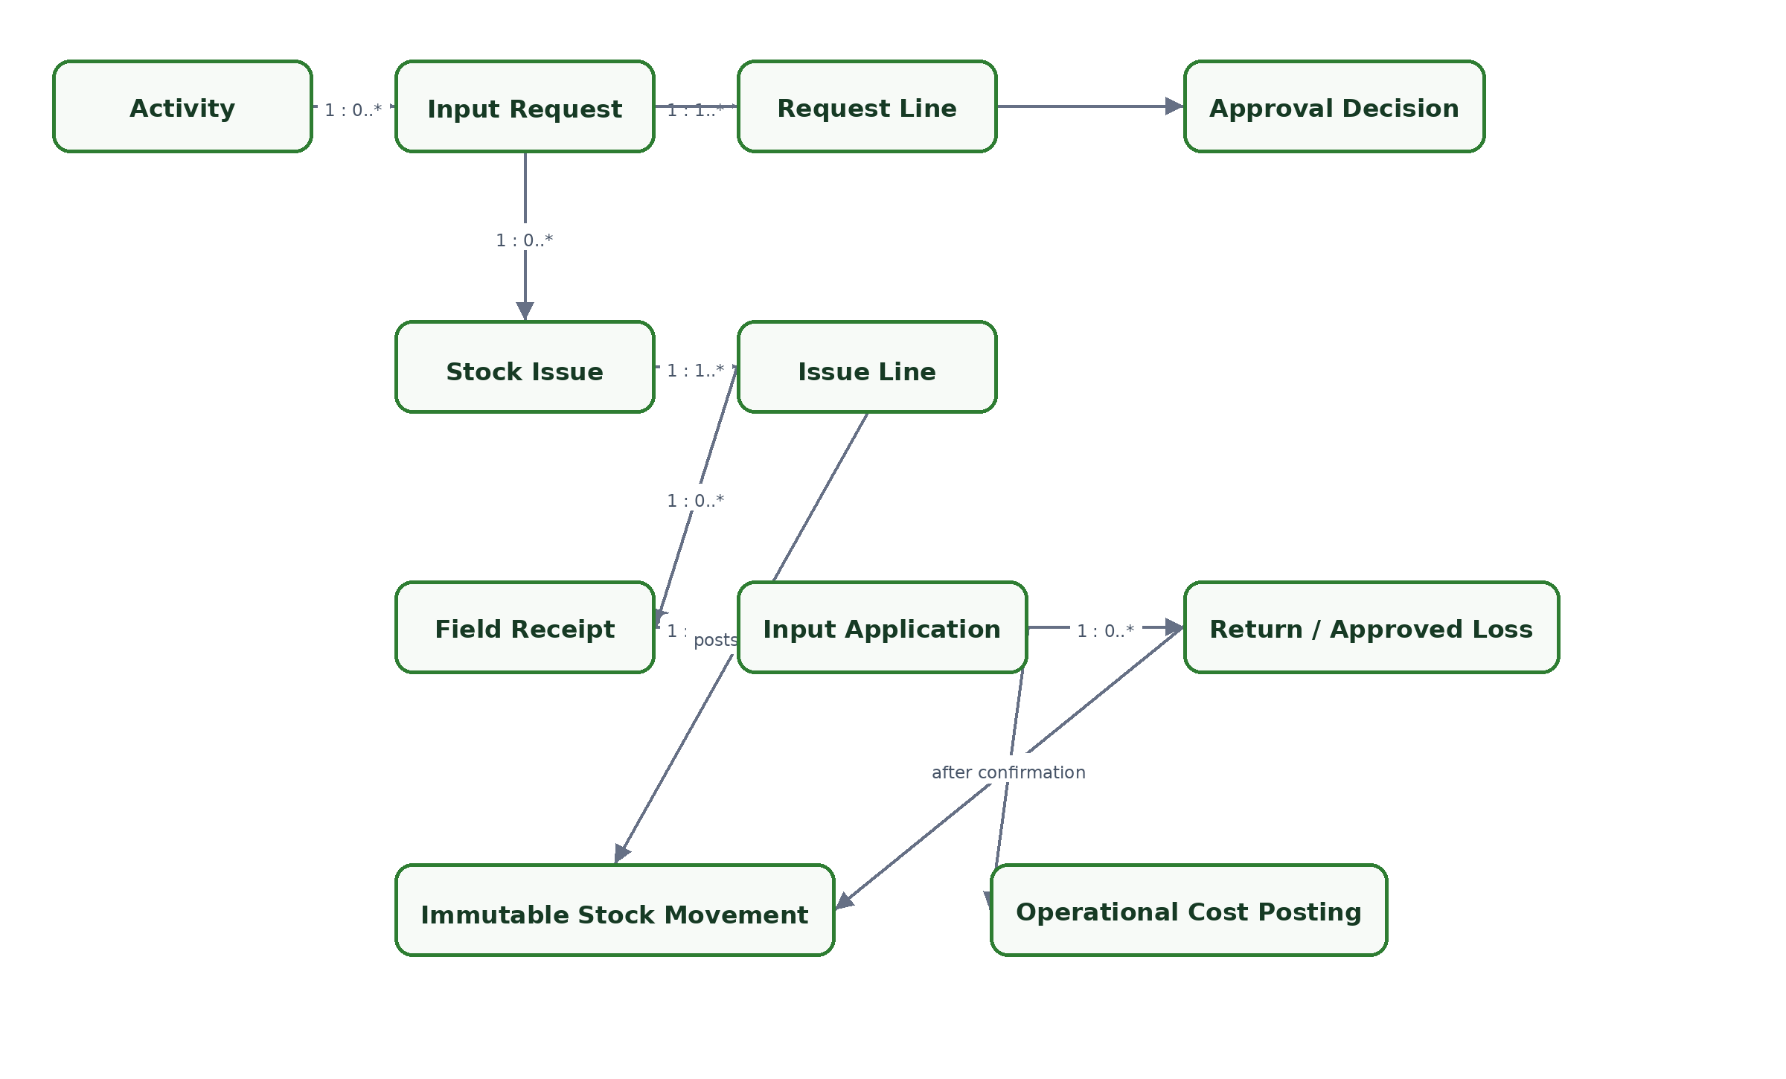
Figure 3. Input request-to-application trace and posting points.
Entity | Purpose | Logical keys and attributes | Relationships / constraints
UnitOfMeasure | Reference unit for stock, application, area, and work quantities. | id; code; dimension; decimal precision; active status | Conversions require explicit same-dimension rules; historical records retain original unit.
InventoryItem | Controlled farm input. | id; farm_id; item code; name; category; stock unit; costing method; reorder level | Code unique within Farm; negative stock disabled; archived items remain reportable.
InventoryApplicationRule | Planned rate and tolerance for an item/activity combination. | item_id; activity_type_id; rate quantity/unit; area basis; tolerance; effective dates | No overlapping current rule for the same scope. Variance uses the rule effective on activity date.
Supplier | Farm-scoped source of purchased inputs. | id; farm_id; code/name; contacts; active status | Referenced by receipts and operational transactions; never owns stock.
InventoryLot | Optional batch/lot and expiry identity. | item_id; lot code; expiry; supplier/source | Unique within Item/Store when used. MVP may allow unbatched items by configuration.
StockReceipt | Goods-received document header. | id; store_id; supplier_id; receipt date; source reference; status | Owns one or more lines. Posting creates receipt StockMovement rows.
StockReceiptLine | Received item, lot, quantity, and unit cost. | receipt_id; line no; item/lot; quantity/unit; USD unit cost | Positive quantity/cost. Reversal, not overwrite, after posting.
InputRequest | Activity-linked request for planned inputs. | id; activity_id; requested_by; date; status; approval level | Must reference active CropCycle through Activity; owns one or more lines.
InputRequestLine | Requested item and planned quantity/rate. | request_id; item; quantity/unit; planned rate; estimated USD cost | Unique item/rule per line scope; available stock and variance shown at approval.
StockIssue | Approved handover from store for an activity. | id; request_id; store_id; issue date; issuer/recipient Person; status | Cannot post without valid approval. One request may be fulfilled by multiple issues.
StockIssueLine | Actual item/lot quantity issued. | issue_id; request_line_id; item/lot; quantity/unit; issue unit cost | Cannot exceed approved remaining quantity or available stock. Posting creates an issue StockMovement.
FieldReceipt | Operational confirmation that issued stock reached the field. | id; issue_id; field/cycle/activity; received date; recipient; status | Field/cycle/activity must match request chain; captures discrepancy timing and reason.
FieldReceiptLine | Quantity received for an issue line. | field_receipt_id; issue_line_id; received quantity/unit | Cumulative received cannot exceed posted issued quantity without correction approval.
InputApplication | Confirmed application event for an activity. | id; activity_id; application date; area/lines; supervisor verification; manager confirmation; status | May consolidate eligible receipts for the same activity. Confirmation is the input-consumption and cost-posting control point.
InputApplicationLine | Applied/returned/lost accounting for a received input line. | application_id; receipt_line_id; applied qty; returned qty; approved loss qty; rate variance | Applied <= received. Unaccounted is derived across related issue/receipt/application/return/loss records.
StockReturn | Return header acknowledged by the store. | id; issue/application reference; return date; sender/receiver; status | Stock increases only when the return is posted as received by the Store.
StockReturnLine | Returned item/lot and quantity. | return_id; issue line/application line; item/lot; quantity/unit | Cannot exceed eligible unapplied quantity. Posting creates a return StockMovement.
InventoryLoss | Approved damaged, expired, spilled, or otherwise lost quantity. | id; source line; quantity; reason; status; approval | Requires grower ApprovalDecision. Posts a loss cost category and never restores stock.
StockCount | Physical count event at a store cut-off. | id; store_id; count date/time; status; counted by; approved by | One cut-off snapshot; closing requires every included line to be resolved or accepted.
StockCountLine | Expected, counted, and variance quantity per item/lot. | count_id; item/lot; expected; counted; variance | Expected is reproduced from StockMovement at cut-off. Variance does not change stock by itself.
StockAdjustment | Authorised stock correction arising from count or exceptional review. | id; store/item/lot; quantity delta; reason; source count?; status | Grower approval required. Posting creates an adjustment StockMovement.
StockMovement | Append-only authoritative inventory ledger entry. | id; store/item/lot; movement type; signed quantity; unit; event/posting dates; source type/id; reversal_of? | Never edited or deleted after posting. Stock on hand is the sum of posted movements by store/item/lot.

6.1 Quantity reconciliation
Control formula. Unaccounted quantity = posted issued quantity - confirmed applied quantity - posted returned quantity - approved loss quantity. A non-zero balance keeps the control chain open and blocks normal Activity closure.

6.2 Required posting boundaries
Event | Ledger effect | Crop-cost effect
Stock receipt posted | Positive StockMovement. | None; inventory asset/value only.
Stock issue posted | Negative StockMovement. | None; issue is not consumption.
Field application confirmed | No new store movement. | OperationalCostPosting for applied quantity at locked issue cost.
Return received by store | Positive StockMovement. | Reverses/avoids cost for returned quantity.
Loss approved | No additional store movement if already issued; otherwise appropriate loss movement. | Loss/variance OperationalCostPosting, separate from normal input application.
Stock adjustment posted | Signed StockMovement. | Adjustment/variance cost treatment according to approved reason.

7. Finance, cost, budget, and mill entities
Cane360 records operational money and produces crop-cycle cost views without becoming a statutory accounting system. A controlled cost projection prevents input or labour costs from being counted twice.
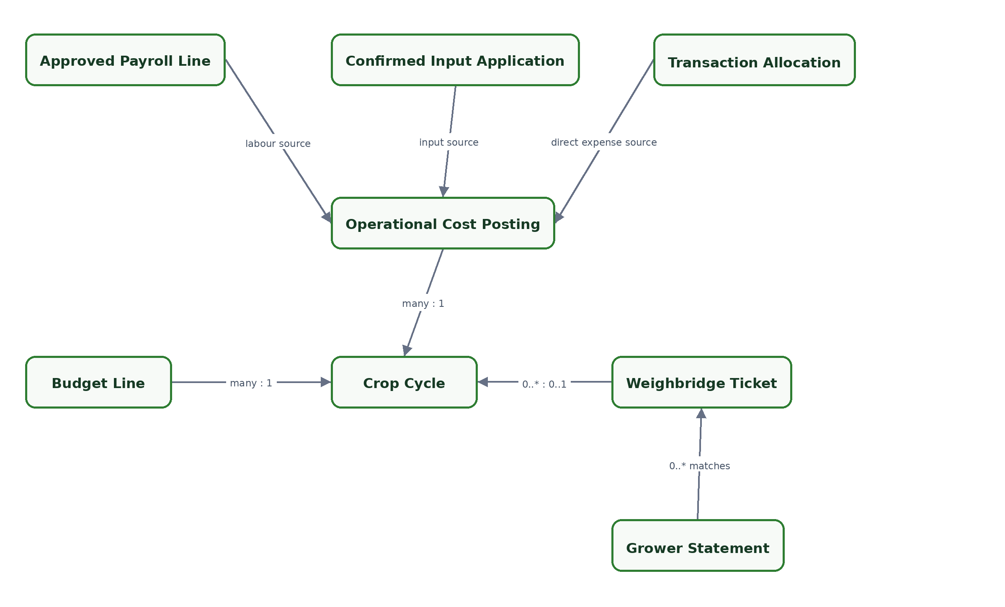
Figure 4. Crop-cycle cost sources and limited mill evidence.
Entity | Purpose | Logical keys and attributes | Relationships / constraints
OperationalTransaction | Simple USD income or expense record. | id; farm_id; type; category; event date; payee/payer; amount; source reference; status | Not a journal entry. Posted transactions may be allocated to a CropCycle and corrected by reversal.
TransactionAllocation | Allocation of a transaction amount to field/crop cycle or farm overhead. | transaction_id; crop_cycle_id?; field_id?; amount; category | Allocations sum to transaction amount. Crop-cycle allocations create OperationalCostPosting for expenses.
Budget | Farm or crop-cycle operating budget for a period/cycle. | id; farm_id; crop_cycle_id?; period; status; version | One approved active version per scope; prior versions retained.
BudgetLine | Budget amount by cost category and optional activity/item scope. | budget_id; category; scope reference; USD amount | Used only for budget-versus-actual; never creates cost.
OperationalCostPosting | Append-only crop-cycle cost projection from approved source events. | id; crop_cycle_id; category; USD amount; source type/id; posting date; reversal_of? | Unique active posting per source/component prevents duplication. Sources: payroll component, confirmed application line, transaction allocation, approved loss/adjustment.
Mill | Reference mill for weighbridge and statement context. | id; code; name; location; active status | Ticket reference uniqueness is scoped to Mill.
WeighbridgeTicket | Manual delivery/weighbridge evidence. | id; mill_id; ticket reference; date; gross/tare/net tonnes; field/cycle?; status | Unique mill/ticket reference. Net tonnes required; field/cycle optional until documents are validated.
GrowerStatement | Uploaded statement plus manual summary totals. | id; mill_id; period; statement reference; total tonnes; total USD amount; match status | Stores EvidenceDocument; detailed division-of-proceeds logic excluded.
StatementTicketMatch | Manual or assisted association of ticket to statement. | statement_id + ticket_id; matched tonnes/amount?; status; reason | Ticket cannot be counted twice in the same statement; variances remain visible.

7.1 Cost source precedence
Cost category | Authoritative source | Posting trigger
Labour | Approved PayrollLineComponent linked to eligible WorkRecord evidence. | Grower approval of the exact PayrollRun version.
Applied input | Confirmed InputApplicationLine valued from its issue/receipt cost basis. | Manager application confirmation after supervisor verification.
Direct expense | Posted TransactionAllocation. | OperationalTransaction posting.
Approved loss/variance | Approved InventoryLoss or StockAdjustment. | Grower approval and posting.

7.2 Non-duplication rule
OperationalCostPosting must carry a stable source identity. A source component can have at most one unreversed posting for the same crop cycle and category. Corrections create reversing and replacement postings; reports sum active postings rather than re-reading mutable operational totals.

8. Cross-cutting approval, evidence, exception, correction, and audit entities
Entity | Purpose | Logical keys and attributes | Relationships / constraints
ApprovalDecision | Immutable decision against an exact subject/version. | id; tenant_id; subject type/id/version; decision; approver user/person; role; timestamp; reason; supersedes? | Used for exceptional input request, loss/adjustment, payroll run, and authorised reopening. Subject-specific policy validates the approver role.
EvidenceDocument | Tenant-protected file metadata in object storage. | id; tenant_id; storage key; filename; media type; size/hash; uploaded by/at; classification | No public guessable URL. Access is authorised and audited; bytes are immutable after acceptance.
EvidenceLink | Links evidence or source-sheet reference to a domain record. | evidence_id?; subject type/id; evidence role; source-sheet reference; captured date | Supports activity, issue, application, payroll acknowledgement, receipt, ticket, statement, and correction evidence.
ControlException | Actionable block, escalation, warning, or information finding. | id; tenant_id; subject type/id; code; severity; opened/resolved dates; status; resolution | May be rule-generated or authorised. Blocking exceptions prevent the configured transition; resolution is audited.
CorrectionRecord | Explicit link between original and correcting/reversing records. | id; tenant_id; original type/id; correction type/id; reason; authorised by/at | Original remains immutable. Correction chain must be acyclic and traceable.
AuditEvent | Append-only security and operational audit event. | id; tenant_id; event type; subject type/id; user; operational person; timestamp; correlation id; change summary | Covers create/change, transitions, approvals, reversals, exports, login, support access, and sensitive-data access.
GeneratedDocument | Repeatable document output such as payslip, cash register, or export. | id; tenant_id; document type; subject/version; generated by/at; filter snapshot; evidence document id | Must identify source version and filters; generation/export creates AuditEvent.

8.1 Polymorphic subject rule
ApprovalDecision, EvidenceLink, ControlException, CorrectionRecord, AuditEvent, and OperationalCostPosting use logical subject/source references in this model. During physical design, the team must choose one of two enforceable patterns: module-specific foreign-key tables, or a registered aggregate-reference table that prevents dangling IDs. Unconstrained free-text type/id pairs are not acceptable.

8.2 Approval policy matrix
Subject | Normal approver | Escalated approver | Critical constraint
Planned input request within tolerance | Farm manager | Grower may also approve | Approval must precede posted issue.
Above-plan/tolerance input request | None | Grower | Manager may submit but cannot self-authorise.
Inventory loss/write-off/adjustment | None | Grower | Reason and quantity/value impact required.
Payroll run version | None | Grower | Approval binds exact version; manager cannot approve.
Closed-period/cycle correction | Policy-defined submission | Grower or authorised support according to case | Reopen/correction event and reason must be audited.

9. Cardinality and uniqueness catalogue
ID | Constraint | Enforcement expectation
LDM-001 | Tenant has at most one active Farm in MVP. | Filtered unique constraint plus service rule.
LDM-002 | Farm has exactly one active Store in MVP. | Filtered unique constraint; setup transaction.
LDM-003 | Farm has exactly one active primary manager assignment. | Filtered unique constraint on PersonRoleAssignment.
LDM-004 | Field code is unique within Farm while active. | Normalised alternate key; archive-aware uniqueness.
LDM-005 | A Field has at most one CropCycle in Active or Ready-for-harvest state. | Filtered unique constraint and transition check.
LDM-006 | Worker national ID fingerprint is unique within Farm. | Encrypted value plus deterministic fingerprint; authorised correction path.
LDM-007 | Attendance is unique by Worker and work date. | Unique constraint.
LDM-008 | A present worker has one Field allocation on a date. | Attendance owns field; WorkRecord activity field equality check.
LDM-009 | Piece WorkScope does not overlap within the same Activity scope. | Exclusion/range constraint where feasible; otherwise transactional validator.
LDM-010 | PayrollPeriod is unique by Farm and monthly date range. | Unique constraint plus non-overlapping-period check.
LDM-011 | PayrollRun version is unique within PayrollPeriod. | Unique period/version key.
LDM-012 | PayrollLine is unique by Run and Worker. | Unique constraint.
LDM-013 | Item code is unique within Farm; stock is non-negative by Store/Item/Lot. | Alternate key; transactional posting guard.
LDM-014 | StockIssueLine cannot exceed approved outstanding request or stock. | Serializable/locked posting transaction.
LDM-015 | FieldReceipt cumulative quantity cannot exceed issued quantity. | Aggregate check during receipt/correction posting.
LDM-016 | Applied quantity cannot exceed field-received quantity. | Database check plus aggregate validation.
LDM-017 | Returned plus applied plus approved loss cannot exceed issued quantity. | Aggregate invariant across control chain.
LDM-018 | Weighbridge ticket reference is unique within Mill. | Normalised mill/ticket alternate key.
LDM-019 | OperationalCostPosting has one active posting per source/category/cycle. | Unique active source projection key.
LDM-020 | Posted StockMovement, AuditEvent, and approval decisions are immutable. | Restricted database permissions and application policy; reversal-only update path.

10. State ownership and transition dependencies
Aggregate | Core states | Transition dependencies
CropCycle | Draft; Active; Ready for harvest; Harvested; Closed; Cancelled | Activate only if no competing cycle. Harvest requires result. Closed rejects new operations.
Activity | Draft; Planned; In progress; Awaiting verification; Manager confirmation; Completed; Closed; Cancelled | Close only when labour verified and all controlled input quantities resolved.
InputRequest | Draft; Requested; Approved; Rejected; Cancelled | Above tolerance requires grower approval; approval version precedes issue.
StockIssue | Draft; Posted/Issued; Partially received; Received; Corrected/Cancelled | Posting requires stock and approval; posted issue corrected by reversal.
InputApplication | Draft; Applied; Awaiting verification; Manager confirmation; Closed; Exception; Corrected | Applied <= received; supervisor verification precedes manager confirmation; close requires zero unaccounted or approved resolution.
StockCount | Draft; In progress; Review; Approved; Posted; Closed | Adjustment is separate; count does not change stock until approved posting.
PayrollPeriod | Open; Calculating; Submitted; Approved/Rejected; Payment in progress; Paid/Part-paid; Closed | Grower approval binds run version; close locks sources and requires configured payment/exception completion.
WorkerAdvance | Draft; Approved; Active; Recovered; Written off/Cancelled | Schedule adjustment requires approval; recovery posts only through approved payroll.
ControlException | Open; Acknowledged; Pending approval; Resolved; Superseded | Blocking subject transition remains disabled until a valid resolution exists.

10.1 Temporal dependency checks
- event_date may precede created_at; if the delay exceeds two calendar days, late_entry_reason is mandatory.
- Application confirmation more than 48 hours after work date is flagged and requires reason.
- No WorkRecord may enter a submitted/approved payroll if it changed after the run evidence snapshot without recalculation.
- FarmSetting, WorkerRate, and InventoryApplicationRule use the version effective on the operational event date, not entry date.
- A correction cannot backdate itself into a closed aggregate without an ApprovalDecision authorising reopen or adjustment handling.

11. Derived values and calculation ownership
Derived value | Definition | Authoritative inputs
Stock on hand | Sum of posted signed StockMovement quantities. | Store, Item, Lot, posting cut-off.
Unaccounted input | Issued - applied - posted returned - approved loss. | Issue, application, return, loss records in one trace chain.
Application rate | Confirmed applied quantity / verified area or configured line basis. | Application line, Activity actual coverage, effective application rule.
Piece pay by line | Manager-confirmed lines x applied USD rate per standard line. | WorkRecord, WorkVerification, WorkerRate snapshot.
Advance outstanding | Approved advance - posted payroll recoveries - approved settlements/write-offs. | Advance and line components.
Payroll net | Earnings + additions - deductions. | PayrollLineComponent signed amounts.
Total crop-cycle cost | Active labour + applied input + direct expense + approved variance cost postings. | OperationalCostPosting.
Cost per hectare | Total crop-cycle cost / selected reporting hectares. | Cost postings and Field reporting-area choice.
Cost per tonne | Total crop-cycle cost / actual harvested tonnes. | Cost postings and HarvestResult; unavailable before actual tonnes.
Stock count variance | Counted quantity - movement-derived expected quantity at cut-off. | StockCountLine and StockMovement.
Activity capture delay | created_at - event date/time. | Operational record timestamps.

11.1 Rounding and missing denominators
- Store base quantities and money at configured fixed precision. Apply rounding once per defined calculation boundary and retain the unrounded source quantity where needed.
- If reporting hectares or actual tonnes are absent or zero, cost per hectare/tonne is Not available; it is never displayed as zero.
- A displayed unit conversion must identify the source unit and rule. Conversion rounding cannot alter stock-control reconciliation.

12. Tenant, privacy, and audit model

12.1 Tenant isolation
- All farm-owned foreign-key paths must remain within the same Tenant. The API does not trust a client-supplied tenant identifier without authenticated membership.
- Cross-tenant identifiers return no usable data and do not reveal whether the record exists.
- Platform support access creates a TenantMembership-like time/purpose-bound context and an AuditEvent visible to authorised administrators.
- Background jobs, exports, file access, and report caches carry tenant context explicitly.

12.2 Sensitive data
Data | Storage/display policy | Audit requirement
National ID | Encrypted value; deterministic tenant/farm-scoped fingerprint for duplicate detection; masked display by default. | Full-value access, export, correction, and decryption attempt.
Mobile-money number | Encrypted or strongly protected; masked except where payment preparation needs the full value. | Full display/export and payment record changes.
Evidence files | Private object storage key; content hash; tenant-authorised signed access only. | Upload, download, replace/supersede, and access denial where appropriate.
Audit/change summaries | Exclude secrets and full sensitive values; store field-level change indication or protected snapshot reference. | Audit store itself is append-only and access-controlled.

12.3 Audit event minimum
Each event records tenant, subject type/id/version, action, authenticated user, operational person when different, event time, request/correlation identifier, reason, and a safe change summary. AuditEvent does not replace domain history; it proves that the domain event or correction occurred.

13. Aggregate and transaction boundaries
Boundary | Must be atomic | Can be eventual / projected
Farm setup | Tenant/Farm creation, first manager membership/role, one Store. | Search index and dashboard readiness.
Crop activation | Field state check and CropCycle activation. | Timeline/report refresh.
Activity completion | Required verification checks and close decision. | Diary/read model update.
Stock receipt/issue/return/adjustment posting | Document state, lines, StockMovement rows, available-stock guard, reversal links. | Dashboard and exception projection.
Field application confirmation | Application quantities, verification, unaccounted check, and cost-posting command/outbox. | Cost report refresh if an outbox is used.
Payroll approval | Approval against exact run version, component totals, advance recovery posting intent, period state. | Generated payslips and reports.
Payment posting | Payment amount/status and acknowledgement requirements. | Printable register/export.
Correction | Authorisation, reversal/replacement records, source links, and audit event intent. | Recomputed dashboards and reports.

13.1 Recommended aggregate roots
Use aggregate roots that match the workflow command and invariant boundary: Farm, Field, CropCycle, Activity, StockReceipt, InputRequest, StockIssue, InputApplication, StockCount, WorkerAdvance, PayrollPeriod/PayrollRun, OperationalTransaction, Budget, WeighbridgeTicket, and GrowerStatement. Avoid a single Farm aggregate that loads every child record.

13.2 Concurrency
- All mutable aggregate roots carry an optimistic concurrency token/version.
- Stock posting additionally serialises or locks the relevant Store/Item/Lot balance key to prevent oversubscription.
- Approval commands compare subject version and fail if the subject changed after review.
- Long-running file/report work uses an outbox/job pattern; the domain commit does not wait for document rendering.

14. PostgreSQL and PostGIS physical-design handoff
The following decisions belong in the physical schema design, but this logical model establishes their acceptance criteria.
Topic | Recommended direction | Acceptance check
Keys | UUID primary keys; scoped alternate keys; explicit foreign keys including tenant-safe composites where useful. | No dangling or cross-tenant relationship.
PostGIS | FieldBoundaryVersion geometry as validated Polygon/MultiPolygon in WGS84 (SRID 4326); compute geodesic hectares consistently. | Invalid/self-intersecting boundary cannot become current; declared/mapped areas remain separate.
Active uniqueness | PostgreSQL partial unique indexes for active farm/store/manager/cycle and current configuration versions. | Database rejects competing active records.
Line overlap | Use numeric-range/exclusion constraint for standard line ranges if the agreed WorkScope representation supports it. | Concurrent duplicate/overlapping piece claims are blocked.
Sensitive fields | Application/envelope encryption plus deterministic scoped fingerprint for national ID duplicate checks. | No plaintext in database logs, indexes, telemetry, or exports.
Stock ledger | Append-only StockMovement with signed decimal quantity and source/reversal keys; balance view/materialisation as optimisation only. | Balance reproduces exactly at a historic cut-off.
Money | numeric/decimal with explicit scale; no binary floating point. | Payroll and cost totals reproduce across API/report runs.
Temporal rules | Effective date ranges for rates/settings/rules; exclusion or validator prevents overlap. | Event-date lookup returns exactly one applicable version.
Polymorphic links | Prefer module-specific FK tables or a registered aggregate reference; never unvalidated type/id text. | Deleting/archiving a subject cannot orphan approvals/evidence/audit.
Outbox | Transactional outbox for report refresh, document generation, notifications, and blob finalisation. | Domain commit and side effects are recoverable and idempotent.

14.1 Suggested schema/module boundaries
Module | Primary entity families
identity | Tenant, GrowerProfile, ApplicationUser, TenantMembership.
farm | Farm, Person, roles, Store, Field, boundary, line profile, CropVariety, CropCycle, HarvestResult, settings.
activities | ActivityType, Activity, Evidence links, Activity exceptions.
labour | WorkerProfile, WorkerRate, Attendance, WorkRecord, WorkScope, WorkVerification, advances.
inventory | Items, units, rules, supplier, lots, receipts, requests, issues, field receipt/application, returns/losses, counts, movements.
payroll | PayrollPeriod, run versions, lines/components, approvals, payments, generated payslips/registers.
finance | Operational transactions/allocations, budgets, cost postings, Mill, tickets, statements/matches.
audit | ApprovalDecision where shared, ControlException, CorrectionRecord, AuditEvent, export/generation events.

15. Validation and decision register
ID | Decision to validate | Proposed build default | Validation evidence
DATA-01 | Worker national ID exception/correction process. | Required; encrypted plus fingerprint; grower-authorised correction. | Review pilot worker registers and onboarding exceptions.
DATA-02 | Line-range versus named work-section capture. | Support both; line ranges preferred where numbering is reliable. | Observe weeding records across three pilot areas.
DATA-03 | Inventory batch/expiry requirement by item category. | Optional lot; required by item configuration. | Inspect fertiliser/chemical store practice.
DATA-04 | Application unit conversions and tolerance source. | Per item/activity rule with effective dates; no universal conversion. | Validate actual application sheets and units.
DATA-05 | Inventory costing method. | Moving weighted average for pilot; lock application cost at confirmation. | Compare with growers' current input-cost method.
DATA-06 | Partial issue, field receipt, application, and return frequency. | Allow one-to-many partial events throughout the control chain. | Walk through real issue/application scenarios.
DATA-07 | Cash acknowledgement evidence. | Status plus named witness/recipient and optional signed sheet photo. | Review current cash payroll process.
DATA-08 | Mobile-money provider/reference uniqueness. | Provider plus transaction reference warning/unique rule within Farm. | Inspect historical payment references.
DATA-09 | Weighbridge ticket fields and gross/tare/net availability. | Require mill, reference, date, and net tonnes; other weights optional. | Obtain anonymised tickets when available.
DATA-10 | Grower statement matching granularity. | Manual statement totals and optional ticket links; no DOP formula. | Obtain anonymised statements when available.
DATA-11 | Farm overhead allocation to crop cycles. | Do not allocate automatically in MVP; report separately unless explicitly allocated. | Product-owner decision after first cost review.
DATA-12 | Closed-period correction authority. | Grower approval; audited platform support only for technical recovery. | Confirm operating policy before pilot go-live.

15.1 Engineering readiness checklist
- Product owner approves the entity names, MVP invariants, and proposed defaults in DATA-01 through DATA-12.
- Engineering converts this model into a physical PostgreSQL/PostGIS schema with column types, foreign keys, partial unique indexes, range constraints, and migration order.
- API design assigns command/query ownership to the aggregate boundaries in Section 13 and specifies idempotency for posting commands.
- QA derives database-level tests for LDM-001 through LDM-020 and end-to-end tests for the three golden paths.
- UX flows preserve the same state ownership and explicitly show event date, entry time, operational actor, approval, exception, and correction context.

15.2 Traceability to MVP outcomes
Outcome | Primary entities | Proof generated
Better crop records | Field, CropCycle, Activity, Attendance, WorkRecord, EvidenceLink, HarvestResult. | Field diary with actual dates, named actors, late-entry flag, evidence, work, inputs, and cost history.
Reduced input leakage | InputRequest/Line, ApprovalDecision, StockIssue/Line, FieldReceipt/Line, InputApplication/Line, Return, Loss, StockMovement, ControlException. | Full request-to-application trace, unaccounted quantity, application-rate variance, stock-count variance, and resolution evidence.
Reliable payroll records | WorkerProfile, Attendance, WorkRecord/Scope/Verification, Advance/Installment, PayrollPeriod/Run/Line/Component, ApprovalDecision, Payment. | Monthly payroll tied to valid attendance and verified work, exact grower-approved version, advance recovery, payment record, and acknowledgement.

Next design artifact. Use this logical model to create the screen-by-screen UX flows for the crop-record, input-accountability, and payroll golden paths. Every screen flow should reference the aggregate state and validation rule it changes.

Approval record
Role | Name | Decision | Date / notes
Product owner / founder |  | Pending
Pilot grower representative |  | Pending
Pilot farm-manager representative |  | Pending
Engineering lead |  | Pending
Design lead |  | Pending

