COMFORTER MAKWEYA

Assessment

Cross-functional diagrams: general business use
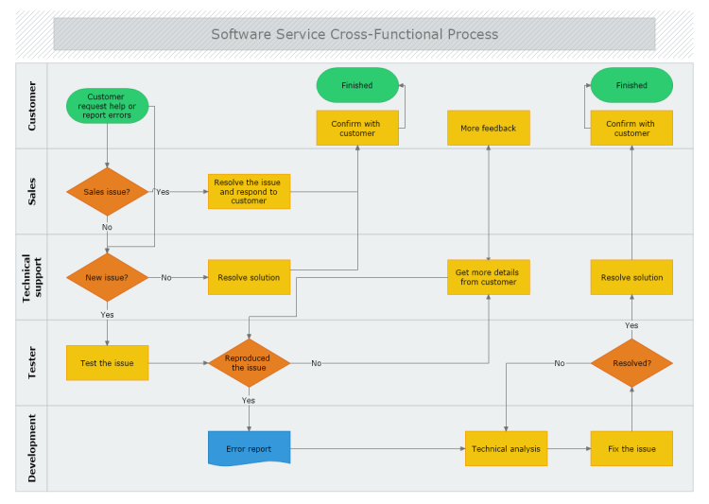
Cross-functional diagrams can be used for a large number of business purposes. Examples are improving an already existing process within the company or implementing a new process and distributing the activities amongst the personnel. They can also be used for precise scheduling of the company’s activities or working projects, like in the example below:

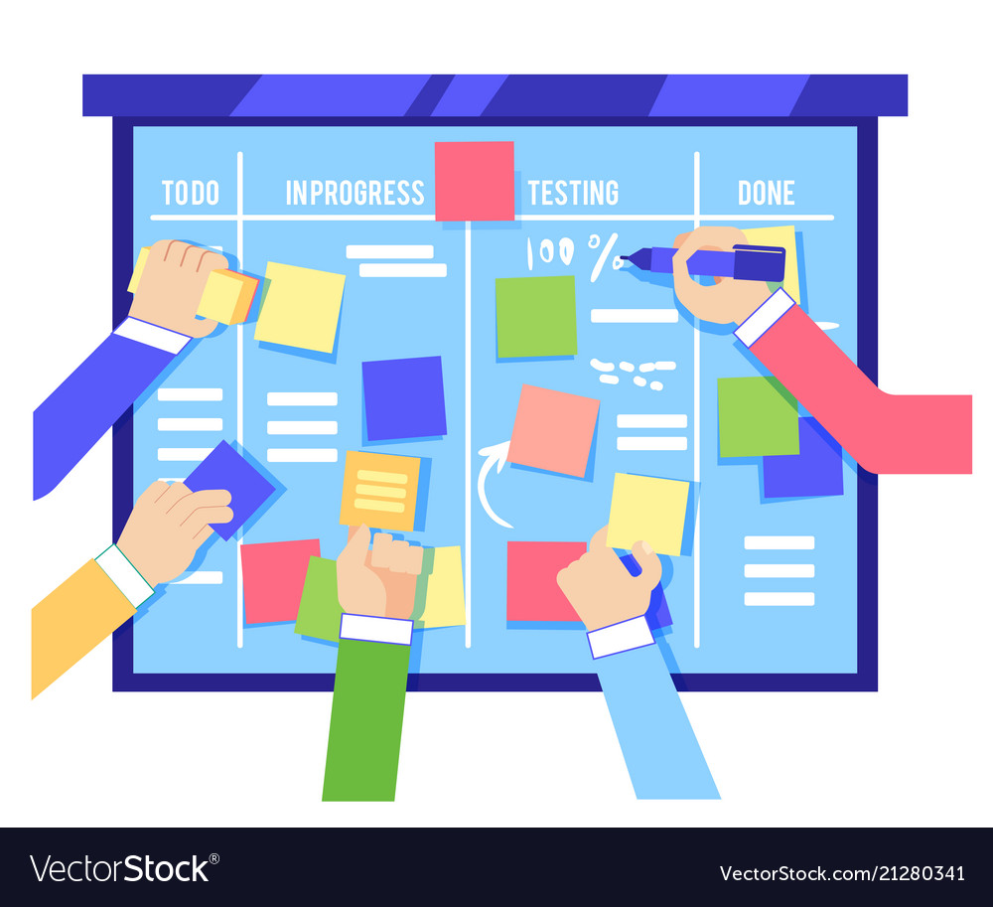

Scrum Board
A Scrum Board is a tool that helps teams make Sprint Backlog items visible. The board can take many physical and virtual forms but it performs the same function regardless of how it looks. The board is updated by the Team and shows all items that need to be completed for the current Sprint.

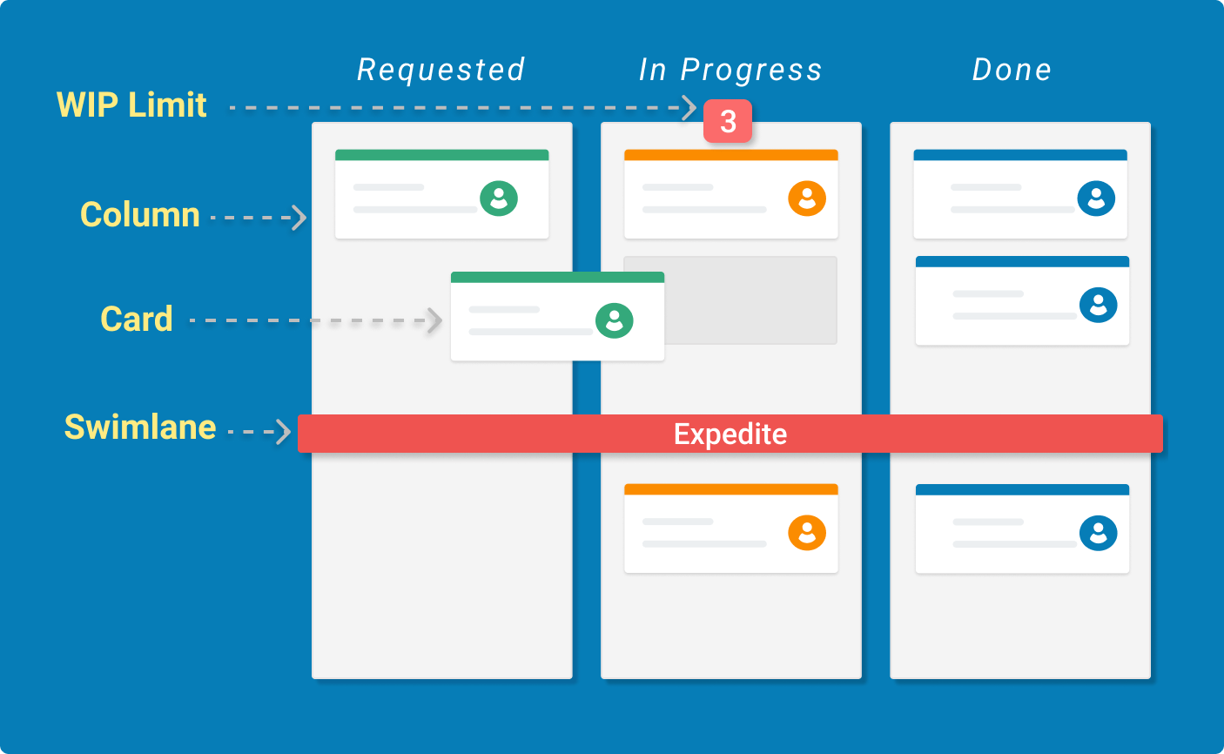

A kanban board is an agile project management tool designed to help visualize work, limit work-in-progress, and maximize efficiency (or flow). Kanban boards use cards, columns, and continuous improvement to help technology and service teams commit to the right amount of work, and get it done!

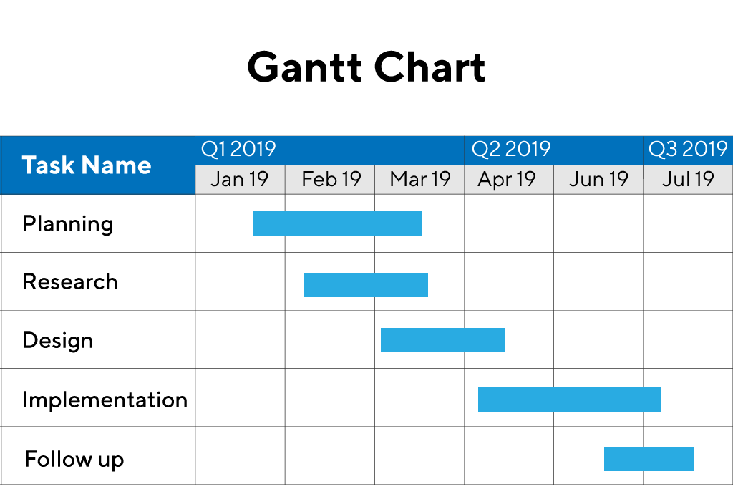
A Gantt chart, commonly used in project management, is one of the most popular and useful ways of showing activities (tasks or events) displayed against time. On the left of the chart is a list of the activities and along the top is a suitable time scale. Each activity is represented by a bar; the position and length of the bar reflects the start date, duration and end date of the activity.

