目录
File & folder 3
Test case 3
C查阅工具 6
常用文件 6
头文件关系 8
Code analysis 8
soc_new_request 8
init_ip_request 9
dma_populate_request 10
soc_allocate 10
dma_init_context 11
create_context_dma_inst 11
create_context_dma3 12
soc_get_context_pointer 13
ip_request_t 13
dma_context_t 14
DMA3_CONTEXT 14
dma3_reg_check_reset 15
RE32 16
dma3_reg_check_complement_32bit 16
WRE32 18
Register 18
中断工作流程 18
dma3_setup_int(dma3_context); 18
dma3_setup_hw 19
Register definition 21
DMA3_TCD_SADDR 21
DMA3_TCD_SOFF 22
DMA3_TCD_ATTR 23
DMA3_TCD_NBYTES 24
DMA3_TCD_SLAST 26
DMA3_TCD_DADDR 28
DMA3_TCD_CITER 29
DMA3_TCD_DOFF 30
DMA3_TCD_DLAST 31
DMA3_TCD_BITER 32
DMA3_TCD_CSR 34
DMA3_CH_SBR 37
DMA3_CH_CSR 39
DMA3_CH_PRI 40
DMA3_GRPRI 41
Makefile 42
Testbench overview knowledge 43
Module description 44
TCD 44
Channel preemption 45
Scat/gather 46
Example 46
Channel linking 46
Example 47

变量定义

CAPI 地址
/home/imxrt700_verif1/richard_nxa28190/V_SS_RT700_SOC_TB_1.16/testbench/blocks/soc_tb/testbench/instances_v/cm33_ahb_reporter_inst.sv

cm33_cprint_regs_base = `CM33_CPRINT_REGS_BASE;
cm33_cprint_cmd_addr = cm33_cprint_regs_base + `CPRINT_CMD_OFFSET;
cm33_cprint_arg_addr = cm33_cprint_regs_base + `CPRINT_ARG_OFFSET;
cm33_cprint_rsp_addr = cm33_cprint_regs_base + `CPRINT_RSP_OFFSET;

/home/imxrt700_verif1/richard_nxa28190/V_SS_RT700_SOC_TB_1.16/testbench/blocks/soc_tb/tool_data/sray/mem_map/ capi.mem_map

`define CM33_CPRINT_REGS_BASE 'h3000FFE0
`define CPRINT_ARG_OFFSET 'h08
`define CPRINT_CMD_OFFSET 'h00
`define CPRINT_RSP_OFFSET 'h08

Testbench/comon_blocks/v_ip_capi/tool_data/compiler/include/capi_mmp.h

#define CPRINT_CMD (*((vcommand_t*)((CPRINT_REGS_BASE)+(CPRINT_CMD_OFFSET))))
#define CPRINT_ARG (*((vuint8_t*)((CPRINT_REGS_BASE)+(CPRINT_ARG_OFFSET))))
#define CPRINT_RSP (*((vuint8_t*)((CPRINT_REGS_BASE)+(CPRINT_RSP_OFFSET))))

MBOX 地址

GPIO example
/home/imxrt700_verif1/richard_nxa28190/V_SS_RT700_SOC_TB_1.16.1.1/testbench/blocks/soc_tb/testbench/top_defines_v/mem_map.v

#define RGPIO_DRV_PIN_PIN_MBOX (RGPIO_TBCOMM_BASE + RGPIO_DRV_PIN_PIN_TBCOMM_OFFSET )

RGPIO_TBCOMM_BASE
testbench/instances_v/rgpioc_drv_inst.sv:

`define RGPIOC_DRV_WRAPPER_INST(num) \
rgpio_driver_monitor #(.RGPIO_TBCOMM_BASE(`RGPIO``num``_TBCOMM_BASE), \
.RGPIO_WIDTH(`RGPIO``num``_WIDTH)) \
rgpioc``num``_drv_wrapper( \
.ipg_stop (`RGPIO``num``_STOP), \
.ipg_wait (`RGPIO``num``_WAIT), \
.ipg_other_plat_stop (`RGPIO``num``_STOP_other), \
.ipg_other_plat_wait (`RGPIO``num``_WAIT_other), \
.tb_ipg_clk (`RGPIO``num``_TB_IPG_CLK), \
.gpio_port (`RGPIO``num``_PORT_IF.vip), \
.gpio_ovr_port (`RGPIO``num``_OVR_PORT_IF.vip) \
);

`PP_REPEAT(`NUM_RGPIO_INSTS, RGPIOC_DRV_WRAPPER_INST)

testbench/blocks/soc_tb/tool_data/sray/mem_map

gpio_params.mem_map:
`define RGPIO0_TBCOMM_BASE `GPIO0_TBCOMM_BASE

tbcomm.mem_map:
`define GPIO0_TBCOMM_BASE 'h0040*152

RGPIO_DRV_PIN_PIN_TBCOMM_OFFSET

tool_data/sray/mem_map/rgpio.mem_map:82:

`define RGPIO_DRV_PIN_PIN_TBCOMM_OFFSET 'h0

command 定义
Testbench/comon_blocks/v_ip_capi/tool_data/compiler/include/capi_mmp.h

#define CPRINT_NOP (0x00)
#define CPRINT_TRIGGER_SET (0x01)
#define CPRINT_TRIGGER_GET (0x02)
#define CPRINT_MB_PUT8 (0x03)
#define CPRINT_MB_GET8 (0x04)
#define CPRINT_MB_PUT16 (0x05)
#define CPRINT_MB_GET16 (0x06)
#define CPRINT_MB_PUT32 (0x07)
#define CPRINT_MB_GET32 (0x08)
#define CPRINT_MB_PUT64 (0x09)
#define CPRINT_MB_GET64 (0x0A)
#define CPRINT_RESERVED_0C (0x0B)
#define CPRINT_RESERVED_0D (0x0C)
#define CPRINT_RESERVED_0E (0x0D)
#define CPRINT_RESERVED_0F (0x0E)
#define CPRINT_FLAG_SET (0x0F)
#define CPRINT_FLAG_CLEAR (0x10)
#define CPRINT_FLAG_WAIT (0x11)
#define CPRINT_FLAG_CHECK (0x12)
#define CPRINT_DEBUG (0x13)
#define CPRINT_TRACE (0x14)
#define CPRINT_INFO (0x15)
#define CPRINT_WARN (0x16)
#define CPRINT_ERROR (0x17)
#define CPRINT_FATAL (0x18)
#define CPRINT_SHOW8 (0x19)
#define CPRINT_SHOW16 (0x1A)
#define CPRINT_SHOW32 (0x1B)
#define CPRINT_SHOW64 (0x1C)
#define CPRINT_SHOWA (0x1D)
#define CPRINT_PRINTF (0x1E)
#define CPRINT_RESERVED_1F (0x1F)
#define CPRINT_RESERVED_20 (0x20)
#define CPRINT_RESERVED_21 (0x21)
#define CPRINT_R8 (0x22)
#define CPRINT_R16 (0x23)
#define CPRINT_R32 (0x24)
#define CPRINT_R64 (0x25)
#define CPRINT_INFO_RE8 (0x26)
#define CPRINT_INFO_RE16 (0x27)
#define CPRINT_INFO_RE32 (0x28)
#define CPRINT_INFO_RE64 (0x29)
#define CPRINT_INFO_REM8 (0x2A)
#define CPRINT_INFO_REM16 (0x2B)
#define CPRINT_INFO_REM32 (0x2C)
#define CPRINT_INFO_REM64 (0x2D)
#define CPRINT_INFO_RRE8 (0x2E)
#define CPRINT_INFO_RRE16 (0x2F)
#define CPRINT_INFO_RRE32 (0x30)
#define CPRINT_INFO_RRE64 (0x31)
#define CPRINT_INFO_RREM8 (0x32)
#define CPRINT_INFO_RREM16 (0x33)
#define CPRINT_INFO_RREM32 (0x34)
#define CPRINT_INFO_RREM64 (0x35)
#define CPRINT_INFO_RELU8 (0x36)
#define CPRINT_INFO_RELU16 (0x37)
#define CPRINT_INFO_RELU32 (0x38)
#define CPRINT_INFO_RELU64 (0x39)
#define CPRINT_INFO_RELS8 (0x3A)
#define CPRINT_INFO_RELS16 (0x3B)
#define CPRINT_INFO_RELS32 (0x3C)
#define CPRINT_INFO_RELS64 (0x3D)
#define CPRINT_ERROR_RE8 (0x3E)
#define CPRINT_ERROR_RE16 (0x3F)
#define CPRINT_ERROR_RE32 (0x40)
#define CPRINT_ERROR_RE64 (0x41)
#define CPRINT_ERROR_REM8 (0x42)
#define CPRINT_ERROR_REM16 (0x43)
#define CPRINT_ERROR_REM32 (0x44)
#define CPRINT_ERROR_REM64 (0x45)
#define CPRINT_ERROR_RRE8 (0x46)
#define CPRINT_ERROR_RRE16 (0x47)
#define CPRINT_ERROR_RRE32 (0x48)
#define CPRINT_ERROR_RRE64 (0x49)
#define CPRINT_ERROR_RREM8 (0x4A)
#define CPRINT_ERROR_RREM16 (0x4B)
#define CPRINT_ERROR_RREM32 (0x4C)
#define CPRINT_ERROR_RREM64 (0x4D)
#define CPRINT_ERROR_RELU8 (0x4E)
#define CPRINT_ERROR_RELU16 (0x4F)
#define CPRINT_ERROR_RELU32 (0x50)
#define CPRINT_ERROR_RELU64 (0x51)
#define CPRINT_ERROR_RELS8 (0x52)
#define CPRINT_ERROR_RELS16 (0x53)
#define CPRINT_ERROR_RELS32 (0x54)
#define CPRINT_ERROR_RELS64 (0x55)
#define CPRINT_W8 (0x56)
#define CPRINT_W16 (0x57)
#define CPRINT_W32 (0x58)
#define CPRINT_W64 (0x59)
#define CPRINT_INFO_WR8 (0x5A)
#define CPRINT_INFO_WR16 (0x5B)
#define CPRINT_INFO_WR32 (0x5C)
#define CPRINT_INFO_WR64 (0x5D)
#define CPRINT_INFO_WRM8 (0x5E)
#define CPRINT_INFO_WRM16 (0x5F)
#define CPRINT_INFO_WRM32 (0x60)
#define CPRINT_INFO_WRM64 (0x61)
#define CPRINT_INFO_WRE8 (0x62)
#define CPRINT_INFO_WRE16 (0x63)
#define CPRINT_INFO_WRE32 (0x64)
#define CPRINT_INFO_WRE64 (0x65)
#define CPRINT_INFO_WREM8 (0x66)
#define CPRINT_INFO_WREM16 (0x67)
#define CPRINT_INFO_WREM32 (0x68)
#define CPRINT_INFO_WREM64 (0x69)
#define CPRINT_RMW8 (0x6A)
#define CPRINT_RMW16 (0x6B)
#define CPRINT_RMW32 (0x6C)
#define CPRINT_RMW64 (0x6D)
#define CPRINT_INFO_RMWR8 (0x6E)
#define CPRINT_INFO_RMWR16 (0x6F)
#define CPRINT_INFO_RMWR32 (0x70)
#define CPRINT_INFO_RMWR64 (0x71)
#define CPRINT_ERROR_WR8 (0x72)
#define CPRINT_ERROR_WR16 (0x73)
#define CPRINT_ERROR_WR32 (0x74)
#define CPRINT_ERROR_WR64 (0x75)
#define CPRINT_ERROR_WRM8 (0x76)
#define CPRINT_ERROR_WRM16 (0x77)
#define CPRINT_ERROR_WRM32 (0x78)
#define CPRINT_ERROR_WRM64 (0x79)
#define CPRINT_ERROR_WRE8 (0x7A)
#define CPRINT_ERROR_WRE16 (0x7B)
#define CPRINT_ERROR_WRE32 (0x7C)
#define CPRINT_ERROR_WRE64 (0x7D)
#define CPRINT_ERROR_WREM8 (0x7E)
#define CPRINT_ERROR_WREM16 (0x7F)
#define CPRINT_ERROR_WREM32 (0x80)
#define CPRINT_ERROR_WREM64 (0x81)
#define CPRINT_ERROR_RMWR8 (0x82)
#define CPRINT_ERROR_RMWR16 (0x83)
#define CPRINT_ERROR_RMWR32 (0x84)
#define CPRINT_ERROR_RMWR64 (0x85)
#define CPRINT_INFO_WAIT_RE8 (0x86)
#define CPRINT_INFO_WAIT_RE16 (0x87)
#define CPRINT_INFO_WAIT_RE32 (0x88)
#define CPRINT_INFO_WAIT_RE64 (0x89)
#define CPRINT_INFO_WAIT_REM8 (0x8A)
#define CPRINT_INFO_WAIT_REM16 (0x8B)
#define CPRINT_INFO_WAIT_REM32 (0x8C)
#define CPRINT_INFO_WAIT_REM64 (0x8D)
#define CPRINT_ERROR_WAIT_RE8 (0x8E)
#define CPRINT_ERROR_WAIT_RE16 (0x8F)
#define CPRINT_ERROR_WAIT_RE32 (0x90)
#define CPRINT_ERROR_WAIT_RE64 (0x91)
#define CPRINT_ERROR_WAIT_REM8 (0x92)
#define CPRINT_ERROR_WAIT_REM16 (0x93)
#define CPRINT_ERROR_WAIT_REM32 (0x94)
#define CPRINT_ERROR_WAIT_REM64 (0x95)
#define CPRINT_BSET8 (0x96)
#define CPRINT_BSET16 (0x97)
#define CPRINT_BSET32 (0x98)
#define CPRINT_BSET64 (0x99)
#define CPRINT_BCLR8 (0x9A)
#define CPRINT_BCLR16 (0x9B)
#define CPRINT_BCLR32 (0x9C)
#define CPRINT_BCLR64 (0x9D)
#define CPRINT_BINV8 (0x9E)
#define CPRINT_BINV16 (0x9F)
#define CPRINT_BINV32 (0xA0)
#define CPRINT_BINV64 (0xA1)
#define CPRINT_RERR8 (0xA2)
#define CPRINT_RERR16 (0xA3)
#define CPRINT_RERR32 (0xA4)
#define CPRINT_RERR64 (0xA5)
#define CPRINT_WERR8 (0xA6)
#define CPRINT_WERR16 (0xA7)
#define CPRINT_WERR32 (0xA8)
#define CPRINT_WERR64 (0xA9)

// EXIT simulation commands
#define CPRINT_PASS (0xAA)
#define CPRINT_FAIL (0xFF)

// -----------------------------------------------------------------------------
// end CPRINT memory map
// -----------------------------------------------------------------------------

#endif // CAPI_MMP_H

变量类型宏定义
Testbench/blocks/soc_tb_tool_data/compiler/include/capi_soc.h

typedef uint8_t command_t;

#ifndef AARCH64
typedef uint32_t address_t;
#else
typedef uint64_t address_t;
#endif

typedef uint8_t err_cnt_t;

typedef uint16_t trigger_t;
typedef uint16_t flag_t;
typedef uint16_t mailbox_t;
typedef uint16_t tbcomm_t;

typedef uint8_t trigger_status_t;
typedef uint8_t flag_status_t;
typedef uint8_t mailbox_status_t;

V
testbench.cm33_ahb_reporter

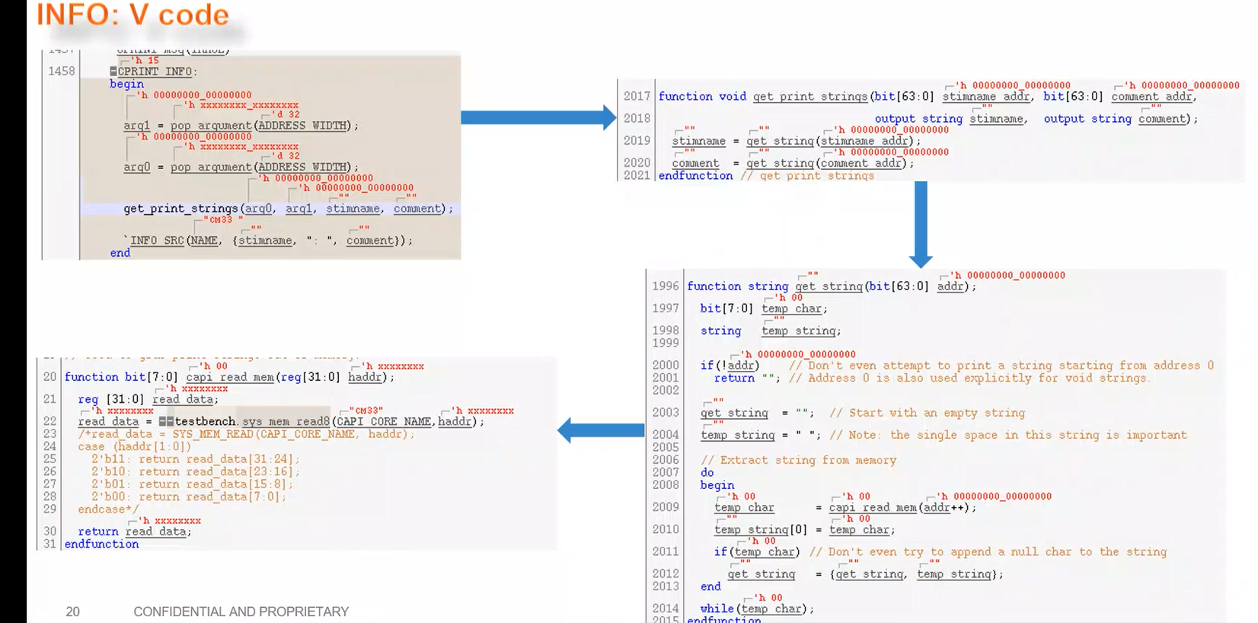

C

RE8, WR8等函数的定义在
Testbench/common_blocks/v_ip_capi/tool_data/compiler/include/capi_api.h

#define WR32(address, write_data) capi_wr32((vuint32_t*)&(address), (uint32_t)(write_data))
#define WRM32(address, write_data, mask) capi_wrm32((vuint32_t*)&(address), (uint32_t)(write_data), (uint32_t)(mask))
#define WRE32(address, write_data, expect_data) capi_wre32((vuint32_t*)&(address), (uint32_t)(write_data), (uint32_t)(expect_data))
#define WREM32(address, write_data, expect_data, mask) capi_wrem32((vuint32_t*)&(address), (uint32_t)(write_data), (uint32_t)(expect_data), (uint32_t)(mask))
#define RMW32(address, write_data, mask) capi_rmw32((vuint32_t*)&(address), (uint32_t)(write_data), (uint32_t)(mask))
#define RMWR32(address, write_data, mask) capi_rmwr32((vuint32_t*)&(address), (uint32_t)(write_data), (uint32_t)(mask))
#define WAIT_RE32(address, expect_data, read_attempts) capi_wait_re32((vuint32_t*)&(address), (uint32_t)(expect_data), (uint16_t)(read_attempts))
#define WAIT_REM32(address, expect_data, mask, read_attempts) capi_wait_rem32((vuint32_t*)&(address), (uint32_t)(expect_data), (uint32_t)(mask), (uint16_t)(read_attempts))
#define BSET32(address, mask) capi_bset32((vuint32_t*)&(address), (uint32_t)(mask))
#define BCLR32(address, mask) capi_bclr32((vuint32_t*)&(address), (uint32_t)(mask))
#define BINV32(address, mask) capi_binv32((vuint32_t*)&(address), (uint32_t)(mask))
#define RERR32(address) capi_rerr32((vuint32_t*)&(address))
#define WERR32(address, write_data) capi_werr32((vuint32_t*)&(address), (uint32_t)(write_data))

MB_PUT8
MB_PUT8 (RGPIO_DRV_PIN_PIN_MBOX, pin); //0
MB_PUT8 (RGPIO_DRV_PIN_VALUE_MBOX, value); //0
MB_PUT8 (RGPIO_DRV_PIN_WAIT_MBOX, in_wait); //0
MB_PUT8 (RGPIO_DRV_PIN_STOP_MBOX, in_stop); //0
MB_PUT8 (RGPIO_DRV_PIN_OTHER_PLAT_MBOX, other_plat); //0
MB_PUT32(RGPIO_DRV_PIN_LATENCY_MBOX, latency); //0
MB_PUT8 (RGPIO_DRV_PIN_TOGGLE_MBOX, toggle); //0
MB_PUT32(RGPIO_DRV_PIN_CYCLES_MBOX, cycles); //0
MB_PUT8 (RGPIO_DRV_PIN_ACK_MBOX, ack);//1
MB_PUT8 (RGPIO_DRV_PIN_OVR_MBOX, ovr); //0

void MB_PUT8(mailbox_t mailbox, uint8_t write_data)
{ _capi_mb_put8(mailbox, write_data);
}

#ifndef _capi_mb_put8
MB_PUT8 (RGPIO_DRV_PIN_PIN_MBOX, pin); //0
这个函数做了如下几件事：
- CPRINT_ARG 地址CAPI 地址所指向的内容中写入数据mailbox（RGPIO_DRV_PIN_PIN_MBOX）RGPIO_TBCOMM_BASE
- CPRINT_ARG 地址CAPI 地址所指向的内容中写入数据write_data（pin）
- CPRINT_CMD地址所CAPI 地址指向的内容中写入数据 command: CPRINT_MB_PUT8 (0x3) command 定义

#define _capi_mb_put8(mailbox, write_data) \
do \
{ CAST_ASSIGN(CPRINT_ARG, mailbox, mailbox_t); \ 实参解析
CAST_ASSIGN(CPRINT_ARG, write_data, uint8_t); \
CAST_ASSIGN(CPRINT_CMD, CPRINT_MB_PUT8, command_t); \ command 定义
NOTIFY_TE_MB_PUT8((mailbox_t)(mailbox), (uint8_t)write_data); \
} while(0)
#endif // _capi_mb_put8

// Note: this macro assumes you provide a non-volatile type so that it can
// leave the RHS of the assignment non-volatile, and that there is a
// corresponding volatile type to use for the LHS.
#define CAST_ASSIGN(address, data, the_type) \
do \
{ CAST((address), v##the_type) = ((the_type)(data)); \
} while(0)
#define CAST(address, the_type) (*((the_type*)(&(address))))

V+类型的目的是给类型前面加上volatile，编译器处理的时候不会优化这个变量
// Convenience macros for type recasting
// C coding note: you can not wrap the_type argument with parenthesis as you
// would for most macro arguments. Wrapping the type would result in code
// like this: (*(((vuint8_t)*)&(address))), which separates the_type from
// the asterisk *, which transforms the cast into a multiplication.

typedef volatile mailbox_t vmailbox_t;

CAST_ASSIGN(CPRINT_ARG, mailbox, mailbox_t);
#define CPRINT_CMD (*((vcommand_t*)((CPRINT_REGS_BASE)+(CPRINT_CMD_OFFSET))))
#define CPRINT_ARG (*((vuint8_t*)((CPRINT_REGS_BASE)+(CPRINT_ARG_OFFSET)))) CAPI 地址
#define CPRINT_RSP (*((vuint8_t*)((CPRINT_REGS_BASE)+(CPRINT_RSP_OFFSET))))

本函数传入三个变量：CAPI CPRINT_ARG地址，数据mailbox，参数类型mailbox_t
宏展开就就变成:
*(vmailbox_t)(& CPRINT_ARG) = mailbox_t(mailbox)
1. 最终目的是向地址CPRINT_ARG所指向的memory中写入数据mailbox
2. v+ mailbox_t, 目的是将mailbox_t类型 + volatile。

WRM32
写入数据，然后
比较写入值跟读取值两者mask对应位的数据是否一直
- 向地址address指向的内存中写入write_data
- 从address中读出对应的内容
- 2获取的值跟mask进行位与操作，write_data跟mask进行位与操作。两者比较，一致则pass，否则fail

#define WRM32(address, write_data, mask) capi_wrm32((vuint32_t*)&(address), (uint32_t)(write_data), (uint32_t)(mask))

void capi_wrm32(vuint32_t* address, uint32_t write_data, uint32_t mask)
{ _capi_wrm32(*address, write_data, mask);
}

#define _capi_wrm32(address, write_data, mask) _capi_wrmx(32, (address), (write_data), (mask))

#ifndef _capi_wrmx
#define _capi_wrmx(x, address, write_data, mask) \
do \
{ uint_t(x) actual_data; \
VUCAST(x, (address)) = (uint_t(x))(write_data); \
actual_data = VUCAST(x, (address)); \
NOTIFY_TE_WRM##x((address_t)&(address), (uint_t(x))(write_data), actual_data, (uint_t(x))(mask)); \
if((actual_data & (uint_t(x))(mask)) == ((uint_t(x))(write_data) & (uint_t(x))(mask))) \
SUCCESS(); \
else \
{ NOTIFY_TB_CA##x##x##x(CPRINT_ERROR_WRM##x, (address_t)&(address), (uint_t(x))(write_data), actual_data, (uint_t(x))(mask)); \
FAILURE(); \
} \
} while(0)
#endif // _capi_wrmx

BSET32
设置对应bit的值
- 从address中取内容，大小为32bit
- 取出的内容与mask进行按位与操作
- 2中修改后的值写入address对应内存

#define BSET32(address, mask) capi_bset32((vuint32_t*)&(address), (uint32_t)(mask))

void capi_bset32(vuint32_t* address, uint32_t mask)
{ _capi_bset32(*address, mask);
}

#define _capi_bset32(address, mask) _capi_bsetx(32, (address), (mask))

WAIT_REM32
规定次数内，读取数据，判断这个数据对应mask位跟expect_data 的mask位数据是否一致

#define WAIT_REM32(address, expect_data, mask, read_attempts) capi_wait_rem32((vuint32_t*)&(address), (uint32_t)(expect_data), (uint32_t)(mask), (uint16_t)(read_attempts))

void capi_wait_rem32(vuint32_t* address, uint32_t expect_data, uint32_t mask, uint16_t read_attempts)
{ _capi_wait_rem32(*address, expect_data, mask, read_attempts);
}

#define _capi_wait_rem32(address, expect_data, mask, read_attempts) _capi_wait_remx(32, (address), (expect_data), (mask), (read_attempts))

#define _capi_wait_remx(x, address, expect_data, mask, read_attempts) \
do \
{ uint_t(x) actual_data; \
uint16_t count=0; \
uint16_t info_count=CAPI_POLLING_INFO; \
do \
{ actual_data = VUCAST(x, (address)); \
if(!--info_count) \
{ NOTIFY_TB_CA##x##x##x##16(CPRINT_INFO_WAIT_REM##x, (address_t)&(address), actual_data, (uint_t(x))(expect_data), (uint_t(x))(mask), count+1); \
info_count = CAPI_POLLING_INFO; \
} \
} while(((++count < (uint16_t)(read_attempts)) || !(uint16_t)(read_attempts)) && ((actual_data & (uint_t(x))(mask)) != ((uint_t(x))(expect_data) & (uint_t(x))(mask)))); \
NOTIFY_TE_WAIT_REM##x((address_t)&(address), actual_data, (uint_t(x))(expect_data), (uint_t(x))(mask), count); \
if(((actual_data & (uint_t(x))(mask)) == ((uint_t(x))(expect_data) & (uint_t(x))(mask))) && ((count <= (uint16_t)(read_attempts)) || !(uint16_t)(read_attempts))) \
{ NOTIFY_TB_CA##x##x##x##16(CPRINT_INFO_WAIT_REM##x, (address_t)&(address), actual_data, (uint_t(x))(expect_data), (uint_t(x))(mask), count); \
SUCCESS(); \
} \
else \
{ NOTIFY_TB_CA##x##x##x##16(CPRINT_ERROR_WAIT_REM##x, (address_t)&(address), actual_data, (uint_t(x))(expect_data), (uint_t(x))(mask), count); \
FAILURE(); \
} \
} while(0)

汇编
https://muzico.gitee.io/niao/15701134073849.html#toc_9

Ldr
https://blog.csdn.net/u012351051/article/details/125957204

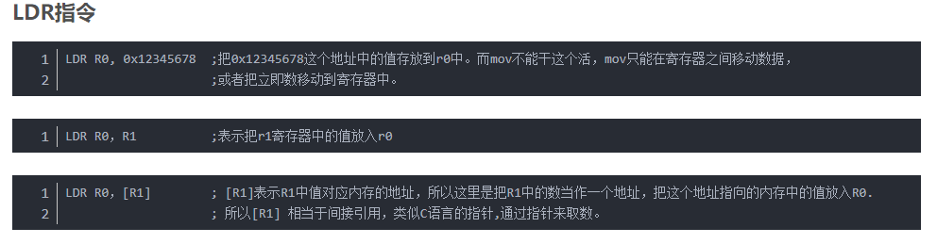
[] 的作用类似C中的*， 例[R1], 就是将R1的值作为一个地址进行操作

Str
https://www.cnblogs.com/lifexy/p/7171719.html

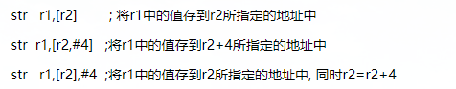

案例
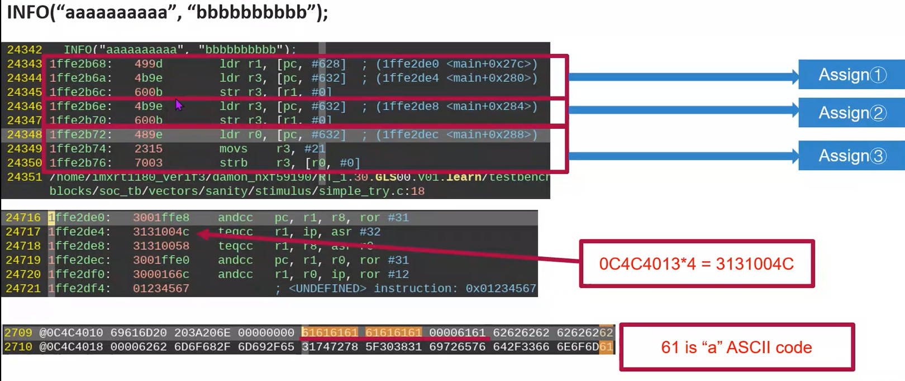
以assign1为例：
- Ldr r1, [pc,#628] // PC+628这个地址0x1ffe2de0(PC=当前指令地址+2=0x1ffe2b68+2)，对应的值传给R1，R1=0X3001ffe8
- Ldr r3, [pc,#632] //PC+632这个地址0x1ffe2de4对应的值传给r3，r3=0x3131004c.(这个地址中存储了0xaaaaaaaa)
- Str r3, [R1] //r3的值传入R1这个地址所指定的memory中，即0x3131004c 写入到地址0x3001ffe8对应的内存中

编译原理

https://www.cnblogs.com/33debug/p/6545136.html

