Contents
Revision 2
Introduction 3
How to create a ticket 3
PDM site 3
Get BOM info 3
Create ticket in PDM 4
Rules for create a ticket 5
How to close/Reject a ticket 6
Closed a ticket 7
Reject a ticket 7
Useful tips 8
Check all the ticket 8
Ticket need to be validated 8
Ticket still in process 9
Check the ticket info 9
Re-assign the soc owenr 10

Revision
Revision | Date & Author | ChangeLog
V1.0 | 2022/9/2, Richard | Initial version

Introduction
This document describes how to raise/close ticket by PDM. The ticket is used to track the design issue, meanwhile, it can also be used to reflect soc verification team’s workload.
Typically, the ticket raise/close process should be:
- Soc verification owner create a ticket, the generated ticket number prefix is “TKT”, the ticket state is “Resolving”
- Soc design owner get the ticket, after resolving the issue, design owner will handle the ticket, PDM system will automatically generate a ticket prefix with “DFT”(Soc verification don’t need to care about this), and a ticket prefix with “RES” will be send back to soc verification owner
- Soc verification owner get the ticket prefix with “RES”, if the ticket was already fixed then close it, otherwise reject it back to Soc design owner

How to create a ticket

PDM site
https://designpdm.nxp.com/

Get BOM info
Chose the issue related BOM tag in pi.bom
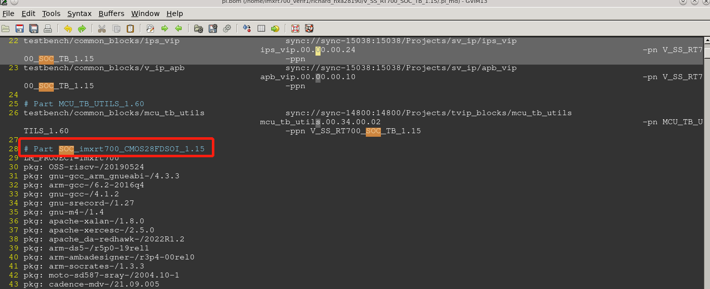
Search the tag in PDM
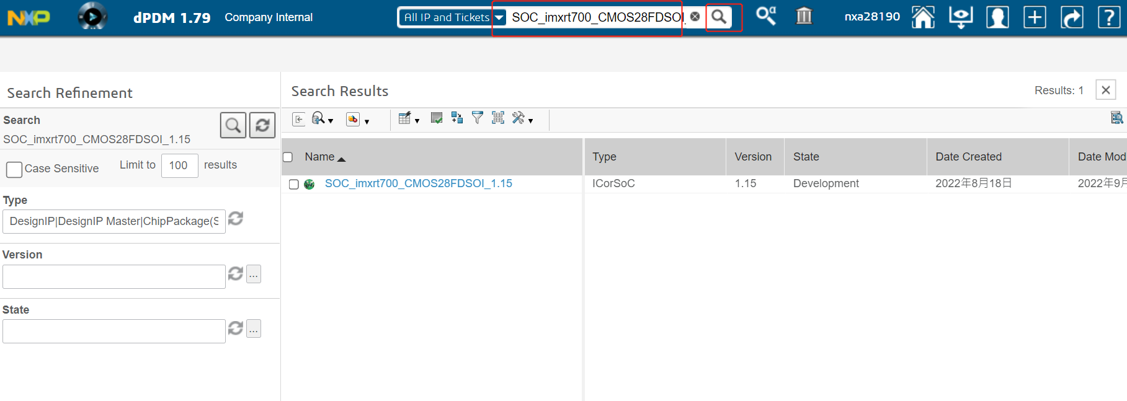

Create ticket in PDM
Chose the selected tag, click “Created Issue”
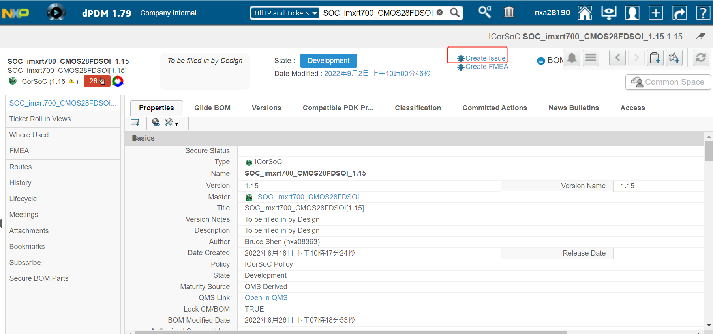
Fill the information, then click “Done”, a new ticket with prefix “TKT” will be generated.
How to fill the information, please refer Rules for create a ticket
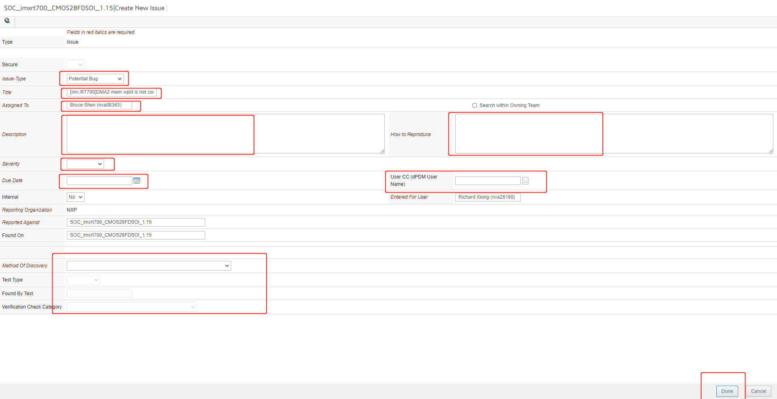

Rules for create a ticket
- Title
Ticket title should be easy to get what the issue is, the title content:
[Platform]Module: <Bug Summary> possibility
1) Platform: MX6DQ_SD, MX6DL_SD, etc
2) Module: DMA, UART, etc
3) Bug Summary: The info should be simple and describe the bug as clearly as we can;
4) Possibility: The frequency of the issue occurs.
Eg: [imx.RT700]DMA2 tcd_mem wlpd is not connect, will cause access TCD register failed. 100%

- Description
- BUG DETAIL DESCRIPTION:
Describe this bug clearly, and you can also add partial log.
- REPRODUCE STEPS:
1.
2.
...
Describe the steps to reproduce this bug.
Please include all necessary conditions, such as test environment, testbench version
- EXPECTED RESULTS:
Normal test results or expected case results
- POSSIBILITY: %

- Affects Versions
Testbench version, RTL version , etc

- Regression From Version
If this is regression bug please specify previous tested version.

How to close/Reject a ticket
Chose the ticket, click the pen symbol
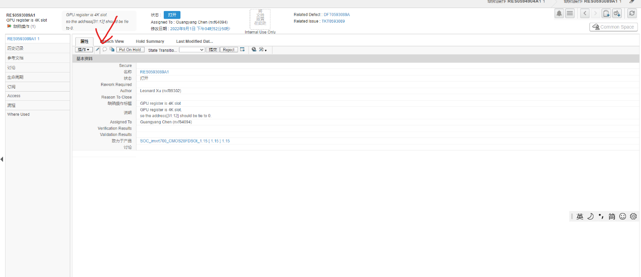

Fill in some information, then click “Done”
- If want to close a ticket, write information such as “fixed on version V1.15”,
- If want to reject a ticket, write information such as “issues not fixed/new issues included”
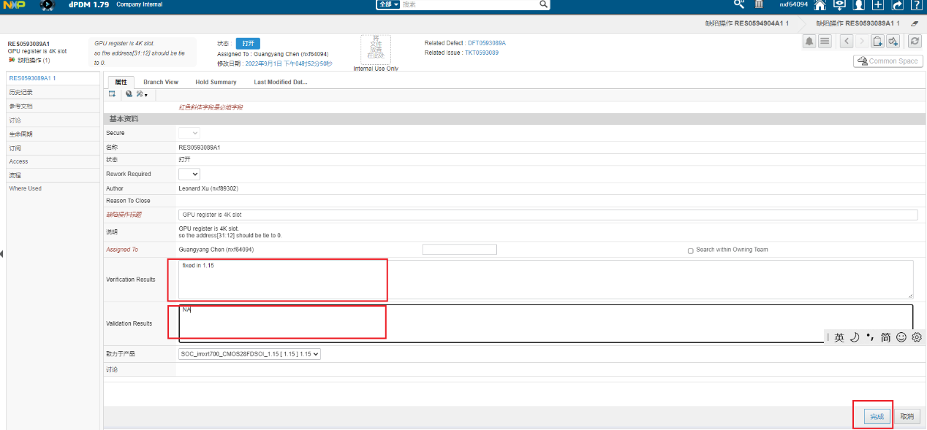
Chose a reason about why to close this ticket
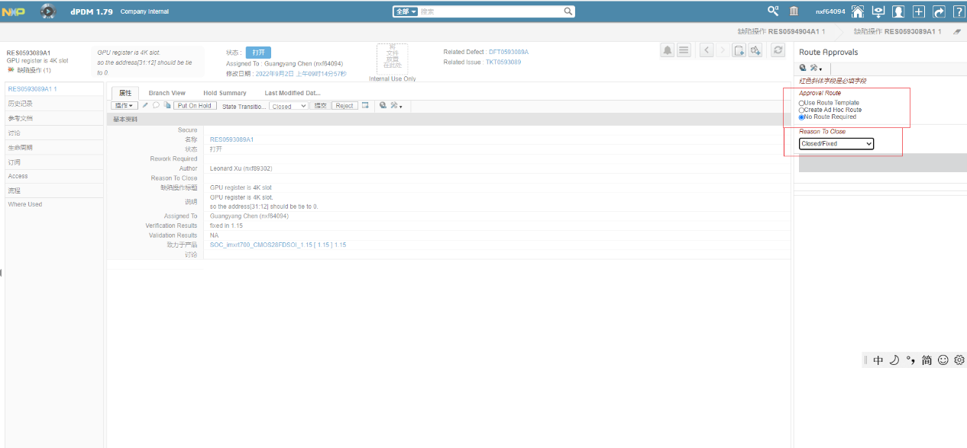

Closed a ticket
Change status as closed, then click submit
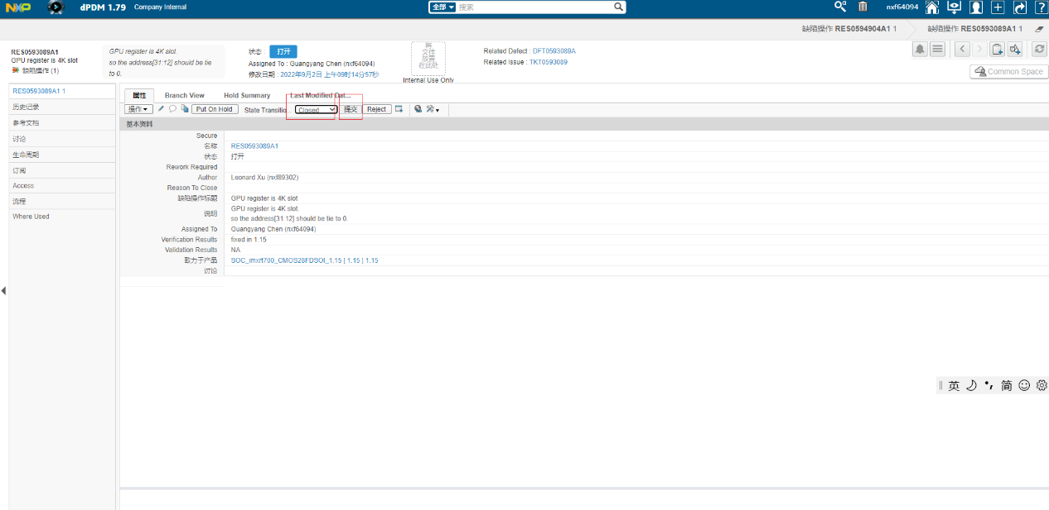

Reject a ticket
No need to trans the ticket state, just click “Reject”
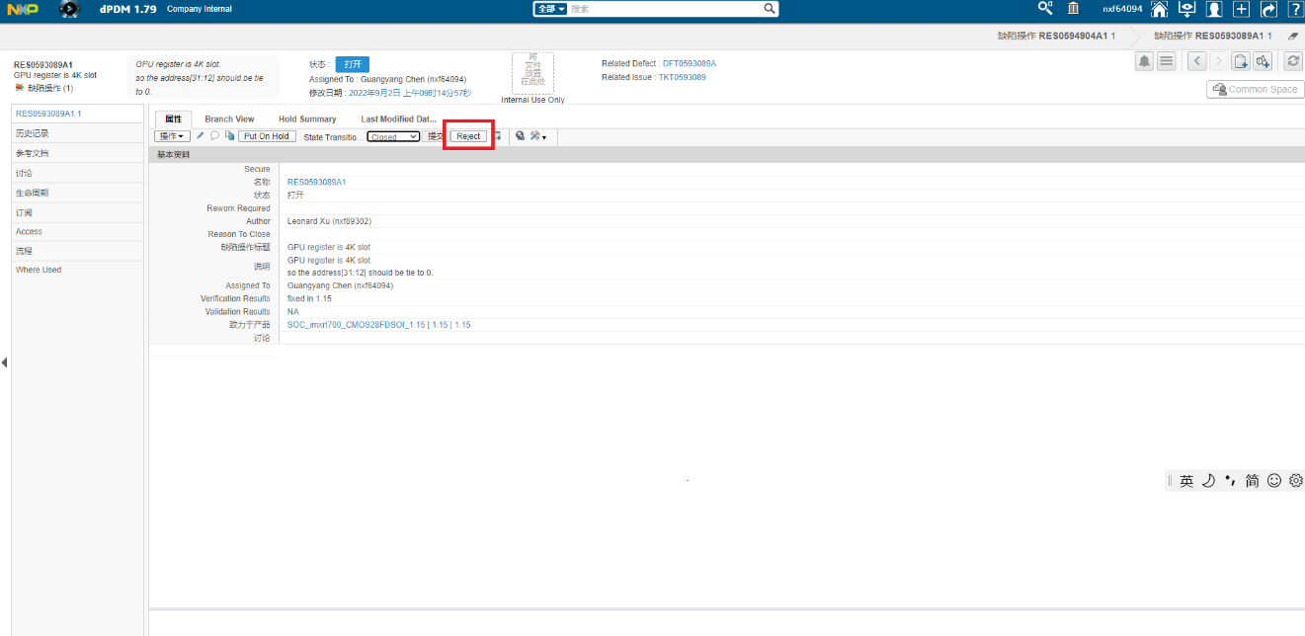

Useful tips

Check all the ticket

Ticket need to be validated
Click the House symbol to check the ticket need to be handled by soc verification owner.
The ticket number prefix should be “RES”
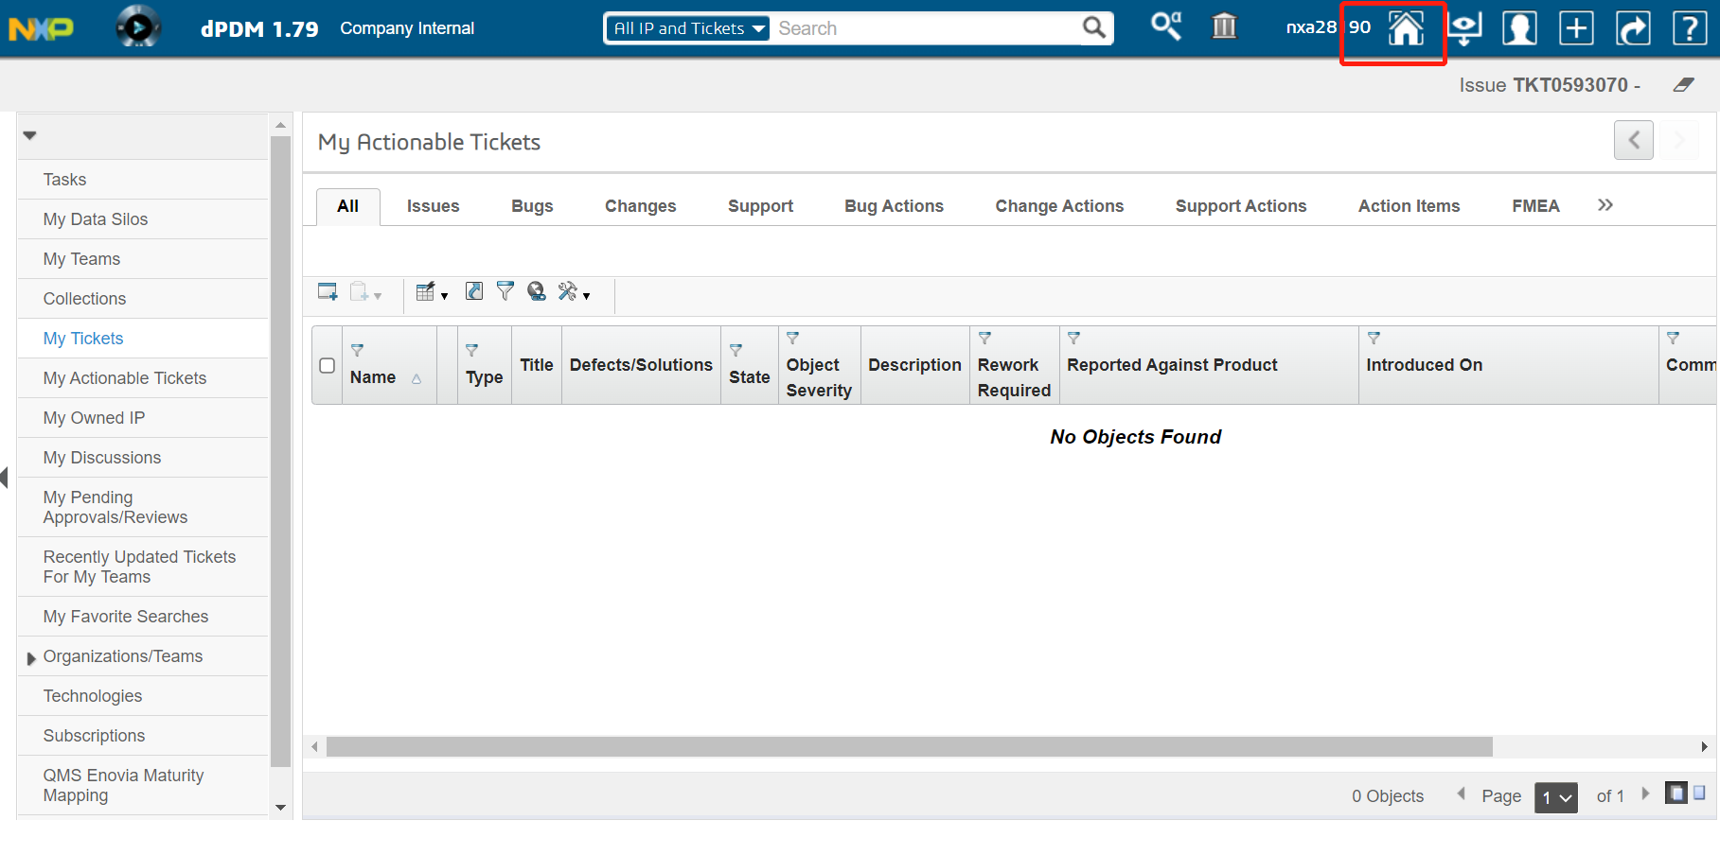

Ticket still in process
Click “My ticket” to check all the ticket still in process
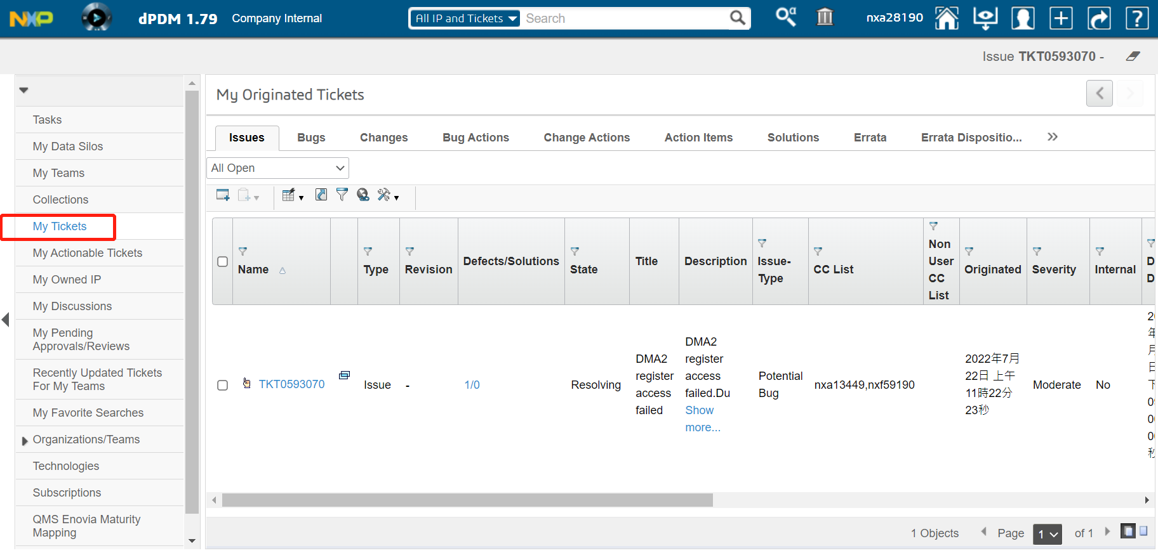

Check the ticket info
Enter 1 ticket, click the “Issue tree view button”
- State transition
Means the ticket status
- Assigned to
Means who is handling this ticket now
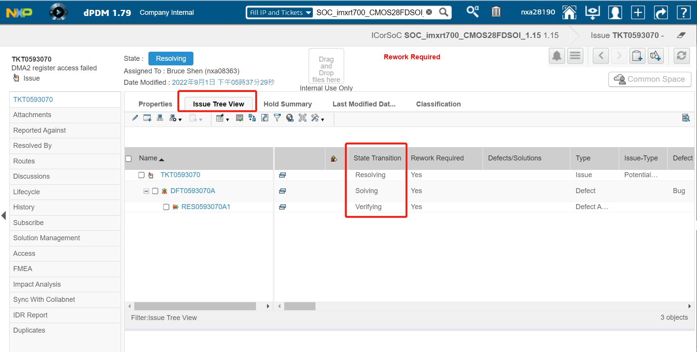

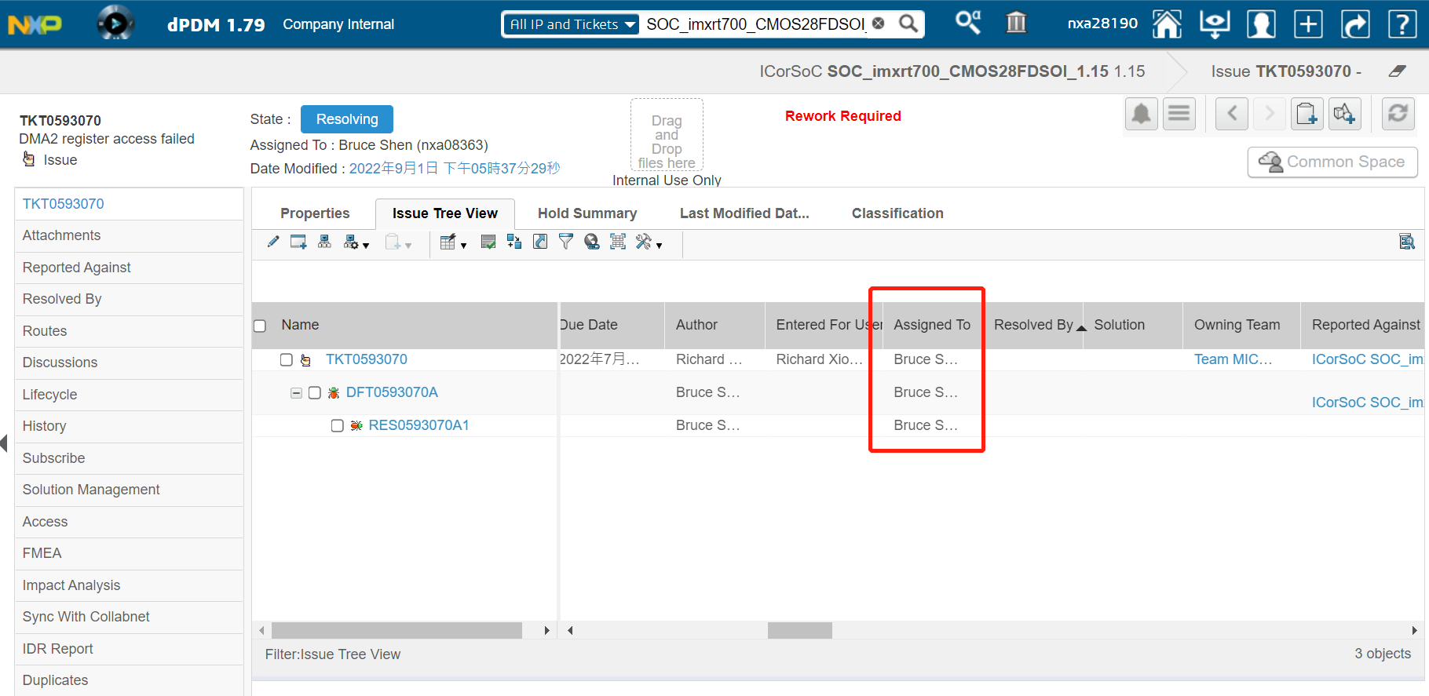

Reassign the soc owner

If you assign the ticket to un-expected soc designer, below steps shows how to re-assign the ticket to the correct person.

