目录
Introduction 2
Background knowledge 3
编译过程 3
代码段，数据段，BSS段，堆，栈 4
ARM执行程序步骤 4
Make 5
GCC 6
参数详解 7
常用参数 7
预编译 -E 8
编译-S 10
汇编 -C 10
链接 11
arm-none-eabi交叉编译工具 12
help 12
arm-none-eabi-gcc 12
arm-none-eabi-ld 12
arm-none-eabi-objdump 13
arm-none-eabi-objcopy 13
arm-none-eabi-size 13
RT700用到的gcc command 13
Boot 13
Linkfile 解析 14
C编译运行 14
Crt0.S 14
_Start.c 15
Pre_main 、 post_main 15
void pre_main() 15
void post_main() 16
Main() 16
CM33 NS boot 17
生成linkfile 17
编译 20
链接 23
启动流程分析 25
CM33_M boot 31
CM33_M_NS boot 32
HIFI4 boot 32
HIFI1 Boot 33
Zenv Boot 34
Dual core boot 35

Introduction
本文介绍RT700 testbench boot流程，包含如下内容：
- 嵌入式C程序如何被执行，编译/链接/反汇编知识阐述
- Testbench用到的makefile, 汇编、链接、反汇编commands
- 启动汇编crt0.s的讲解，从汇编跳转后的第一个C程序
- Testbench从上电到test case执行的详细flow

- Testbench

Background knowledge

编译过程
CPU执行程序的本质，是从存储器里面获取机器码。可执行程序从代码到机器码的过程如下：
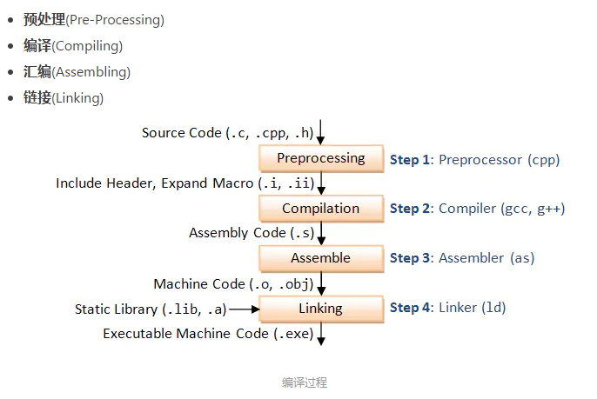
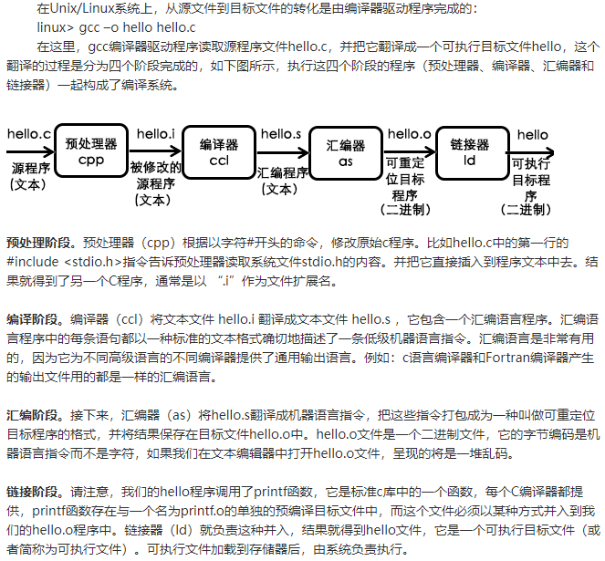

代码段，数据段，BSS段，堆，栈
程序，变量的存储会分成五个段，详解如下。我们写的code在进行链接的时候，需要手动配置代码，变量各个段的地址。
https://www.cnblogs.com/zl1991/p/15039949.html

ARM执行程序步骤
以CM33为例，ARM上电后会从0地址取SP，0x4取PC。从PC指向的地址获取第一条command.
RT700, RTL做了配置，上电后vector table配置到ROM 0地址，也就是0x13000000
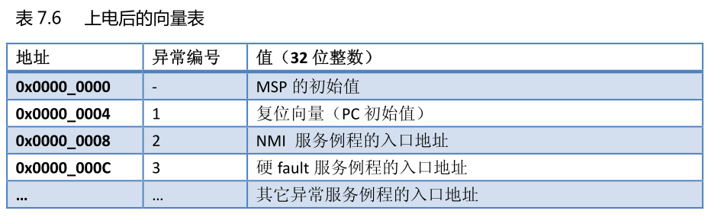
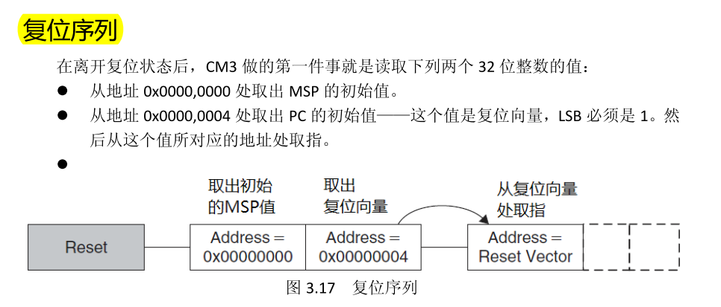

Make
Makefile的本质是为了让整个工程能够按照设定的规则取进行编译操作。
RT700 make过程中产生的make文件，bin，hex，反汇编，map文件都会存放到如下的目录中
testbench/blocks/soc_tb/tool_data/verilog.
RT700用到的几个makefile如下：
run_make_stim.sh
Make -f testbench/blocks/soc_tb/testbench/makefile.stimulus -I testbench/blocks/soc_tb/testbench
-C testbench/blocks/soc_tb/vectors/dma/stimulus
SRAY mem map generation

testbench/common_blocks/v_ip_makefile/tool_data/compiler/makefile.compile
显示build elf需要的文件依赖
Log：Build Directory

testbench/common_blocks/v_ip_makefile/tool_data/compiler/makefile.compile.gxx
C编译命令

testbench/blocks/soc_tb/testbench/makefile.opts
定义C编译参数

Testbench/blocks/soc_tb/tool_data/compiler/cm33/cm33_s/makefile.pre_compile
定义code、data section，默认stimulus等，生成linkfile

GCC
Gcc是常用的C 编译器，如下列出常用的一些command。
https://www.jianshu.com/p/1bab86143f1c

参数详解

常用参数
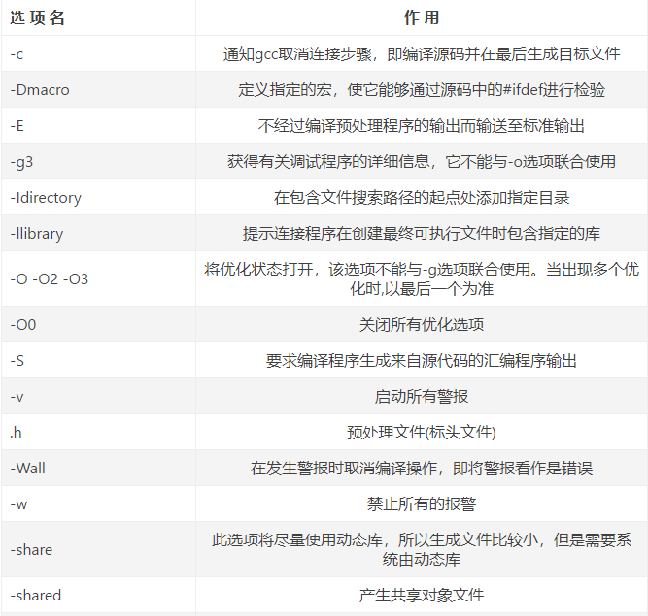
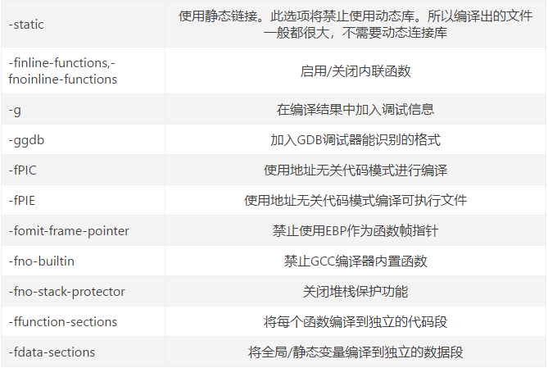

预编译 -E

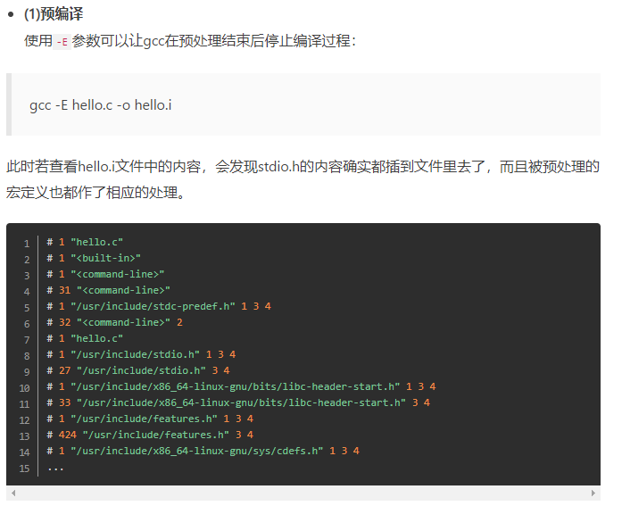

编译-S
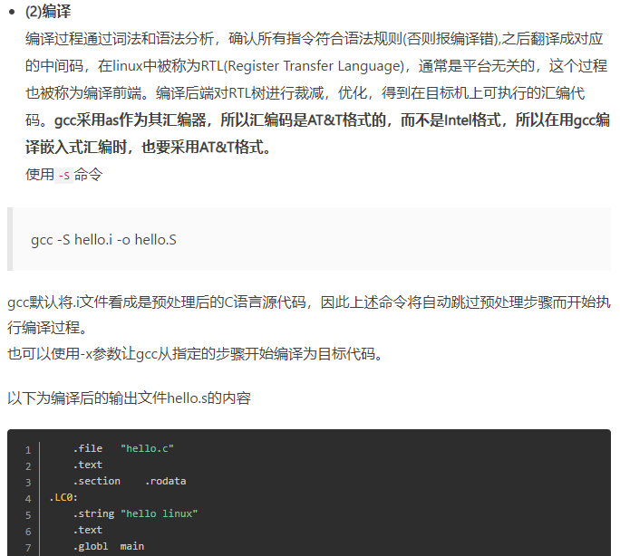

汇编 -C
汇编得到的结果没有链接，不可执行
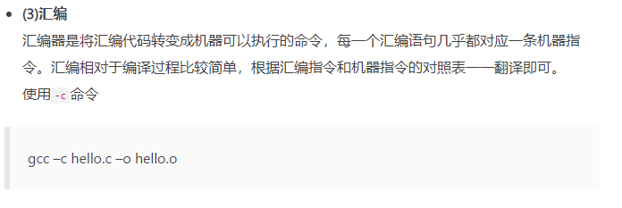

链接
也可以使用ld命令将汇编得到的.o连接成可执行文件
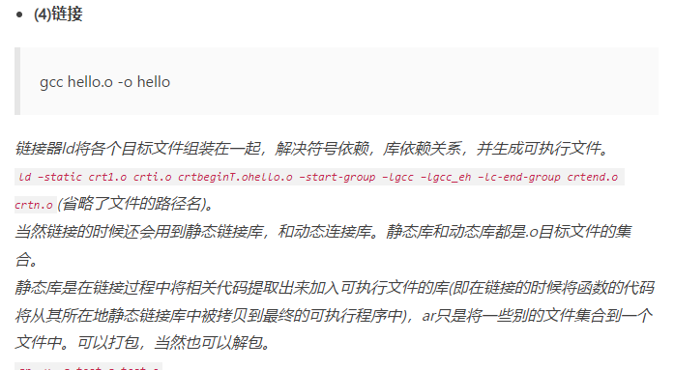

arm-none-eabi交叉编译工具

help
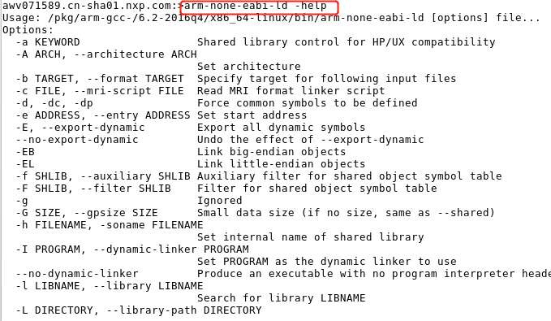

arm-none-eabi-gcc
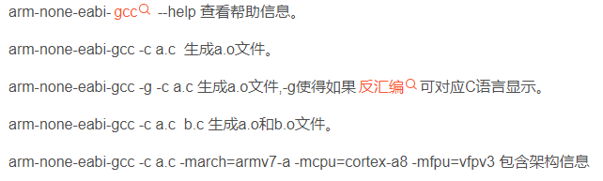

arm-none-eabi-as
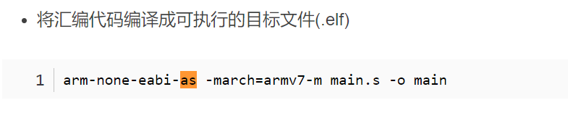

arm-none-eabi-ld
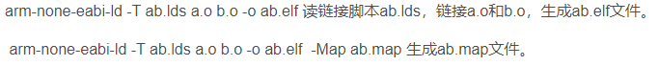

arm-none-eabi-objdump
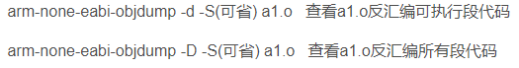

arm-none-eabi-objcopy

arm-none-eabi-size
计算文件大小

RT700用到的gcc command
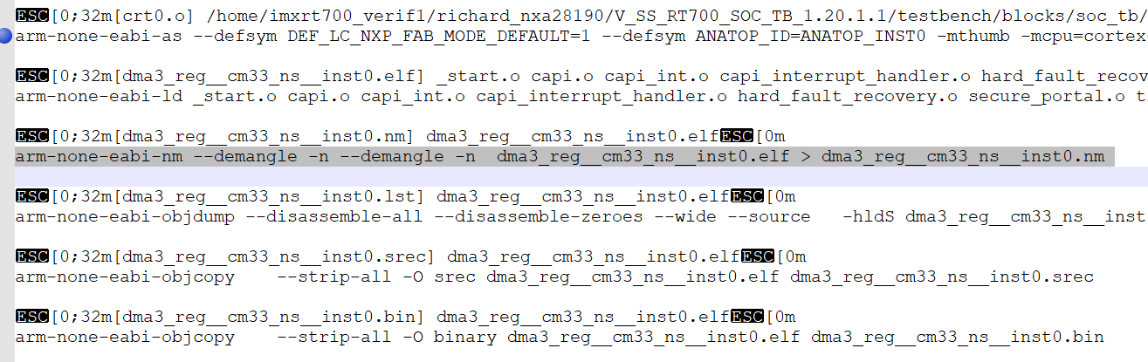

Boot

Linkfile 解析
https://blog.csdn.net/ymj321/article/details/116937630
V_SS_RT700_SOC_TB_1.10/testbench/blocks/soc_tb/tool_data/compiler/cm33/cm33_s/ldscripts/cm33_s.lnk

C编译运行
testbench/blocks/soc_tb/tool_data/compiler/cm33/cm33_s/ cm33_s.lnk

/* Set the initial value for the stack pointer */
/* Leave 8 bytes at the top for the CAPI */
__SP_INIT = ADDR(stack) + SIZEOF(stack) - 8;

/* GDB needs to be told where the entry-point is */
__START_ADDR = ADDR(.startup);
ENTRY(__START_ADDR);

Linkfile指定了入口地址，从.startup段中获取第一条指令。。。
对应的crt0.S中会指定startup段。

Crt0.S
V_SS_RT700_SOC_TB_1.9/testbench/blocks/soc_tb/tool_data/compiler/cm33/src/_start.c

ROM offset 0开始存放0x400个中断数据，0x400处为__startup:
CPU上电后，第一个运行的命令就是从这里获取。Link文件中指定了startup段为CPU获取的第一个指令

.section .vectors,"ax"
.globl __vectors
__vectors:
.word __SP_INIT @ 0 000: reset stack pointer val
.word __startup+1 @ 1 004: reset start address
@ The +1 is to indicate Thumb mode

.ifdef MEMORY_ate
.else
.rept 254
.word _capi_interrupt_handler+1 @ 2-255 The remaining 254 vectors //伪指令rept重复执行254次。对应二进制binary word2-256都是一样的数值，为_capi_interrupt_handler+1
.endr @ The +1 is to indicate Thumb mode
.endif @ MEMORY_ate
.global vector_table_end
vector_table_end:

.section .text.startup,"ax" //linkfile 这段的数据被配置到了ROM中
.globl __startup
__startup:
MOV r0,#0 @ Initialize the GPRs
MOV r1,#0
MOV r2,#0
MOV r3,#0
MOV r4,#0
MOV r5,#0
MOV r6,#0
MOV r7,#0

CPSIE i @ Unmask interrupts
BL _start @ call the C code

_Start.c
V_SS_RT700_SOC_TB_1.9/testbench/blocks/soc_tb/tool_data/compiler/cm33/src/_start.c
C入口函数为_start

第一个C函数：
void _start()
{ int main_status;

pre_main();

main_status = main();

post_main();

CAPI_END_SIM(main_status);
}

Pre_main 、 post_main
V_SS_RT700_SOC_TB_1.10/testbench/blocks/soc_tb/tool_data/compiler/cm33/cm33_s/include/ pre_post_main.h

Pre_main()的作用是在正式进入main跑test case之前，对clock，power，secure，syscon等关键模块做相关配置，目的是为了test case能够跑起来
Post_main的作用是test case完成后做一些退出的配置动作。
Main（）跑完后一定要return 0， CAPI_END_SIM(main_status) 会根据main的返回值来判定test是否pass

void pre_main()
{
//SHOW32("pre_main", "SHOW32= ", 0x32323232);
INFO("pre_main","In pre main of cm33_s.");
WR32(capi_error_counter, 0x0);//berk will remove it when we have GPR to replace

INFO("pre_main","release_all_peripheral_rst.");
release_all_peripheral_rst();

INFO("pre_main","initialize clock....");
clkctl_initial_config();

INFO("pre_main","config sense cm33 vector....");

/*to do design will change register from sense to common syscon
#ifdef CM33_M_RESET_VECTOR
W32(REG32(0x40042098), CM33_M_RESET_VECTOR>>7);//system_svtor_i
W32(REG32(0x4004209C), CM33_M_RESET_VECTOR>>7);//system_nsvtor_i
#else
W32(REG32(0x40042098), S_SSRAM_P22_BASE>>7);//system_svtor_i
W32(REG32(0x4004209C), NS_SSRAM_P22_BASE>>7);//system_nsvtor_i
#endif */

TRIGGER_SET(CM33_TBCOMM_BASE);
TRIGGER_SET(CM33_TBCOMM_BASE+1);

#ifdef CM33_NS_RESOURCES_SWITCH
INFO(__FILE__, "secure state switching configuration");
enable_idau();
configure_sau();

if (!tt_get_addr_secure_attr((address_t)(&enable_idau)))
ERROR("pre_main", "Function address is Non-secure");

init_nonsec_stack( __SP_INIT__SYMBOL__ ); // initialize NS stack pointer
WR32(NSEC(SYSCTRL_VTOR), __vectors__SYMBOL__ ); // initialize NS vector table base

MB_PUT32(SEC2NS_NSC_VNR_ADDR_MBOX, (address_t)&nsc_func_veneer);
MB_PUT32(SEC2NS_NSC_ADDR_MBOX, (address_t)&nsc_func);

MB_PUT32(NS2SEC_POST_MAIN_HDSK_MBOX, 0xdeaddead);

//sec2ns_switch_blxns(0x0fffe400 );
#endif
INFO("pre_main","out pre main of cm33_s.");
return;

}

void post_main()
{
INFO("post_main","In post main of cm33_s ");

#ifdef CM33_NS_RESOURCES_SWITCH
uint32_t rdata;
MB_GET32(NS2SEC_POST_MAIN_HDSK_MBOX, rdata);
SHOW32("CM33_POST_MAIN","rdata = ",rdata);
FLAG_WAIT(9,1);
INFO("post_main","End post main ");
//if (rdata>0xbabeface)
// ERROR("post_main", "NS code did not finish executing");
#endif
SHOW32("post_main", "capi_error_counter= ", capi_error_counter);

}

Main()
Test case中的main函数
V_SS_RT700_SOC_TB_1.9/testbench/blocks/soc_tb/vectors/dma/stimulus/dma3_interrupt.c

CM33 NS boot
Testbench V1.20.1.1为例
分两步，
- testbench preload CM33 secure的code 到ROM跟secure SRAM中。 Preload non-secure demo 到NS ram中.
- Secure demo pre_main, 配置non-secure的vector，配置SAU,IDAU对non-secure空间进行配置
执行sanity_cm_init.c中的main函数，call Non-secure的C code。 _start.c

Code 分布：
CM33 secure demo： 汇编-》ROM, code、data -》SRAM16, nsc-》sram0 末尾
CM33 NS demo： code，data-》SRAM4 NS , vector -》SRAM1 NS

生成linkfile

Non-secure demo linkfile
cat /home/imxrt700_verif1/richard_nxa28190/V_SS_RT700_SOC_TB_1.20.1.1/testbench/blocks/soc_tb/tool_data/compiler/cm33/cm33_ns/ldscripts/cm33_ns.lnk | m4 -I/home/imxrt700_verif1/richard_nxa28190/V_SS_RT700_SOC_TB_1.20.1.1/testbench/blocks/soc_tb/tool_data/compiler/include -P | cpp -P -Dcm33_ns -DCM33_NS_RESOURCES -DCM33_NS -DVMEM=sram_1 -DXMEM=sram_4 -DUMEM=sram_4 -DSMEM=sram_4 -DDMEM=sram_4 -DSTRAMEM=sram_4 -I/home/imxrt700_verif1/richard_nxa28190/V_SS_RT700_SOC_TB_1.20.1.1/testbench/blocks/soc_tb/tool_data/compiler/include > /home/imxrt700_verif1/richard_nxa28190/V_SS_RT700_SOC_TB_1.20.1.1/testbench/blocks/soc_tb/tool_data/verilog/verilog_FILENAMES_apc7092.cn-sha01.nxp.com_24999/dma/cm33/cm33_ns/CM33_ns_local.lnk

cm33_ns.lnk
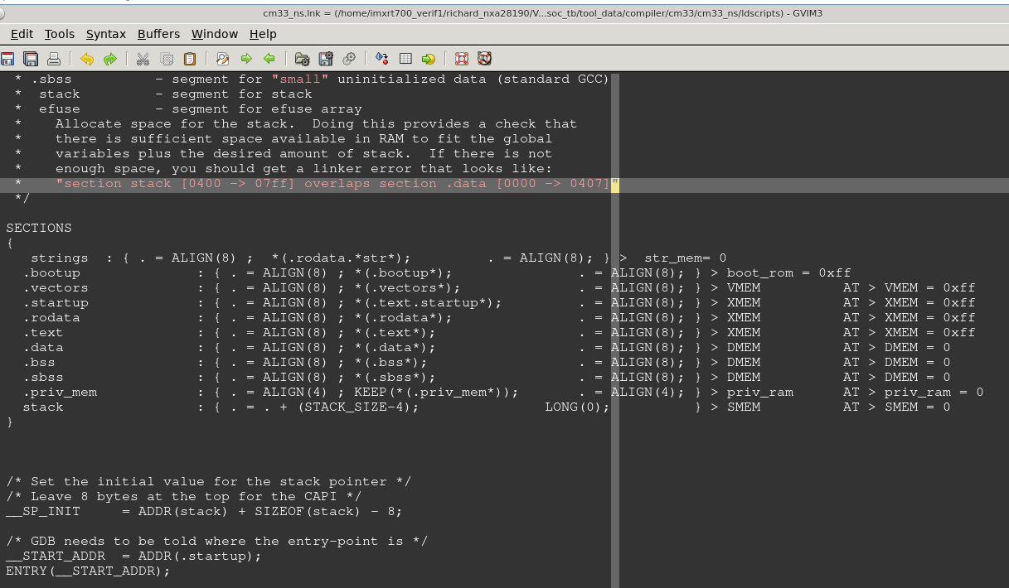
生成的linkfile， CM33_ns_local.lnk 。。 SRAM1放vector，sram4放code
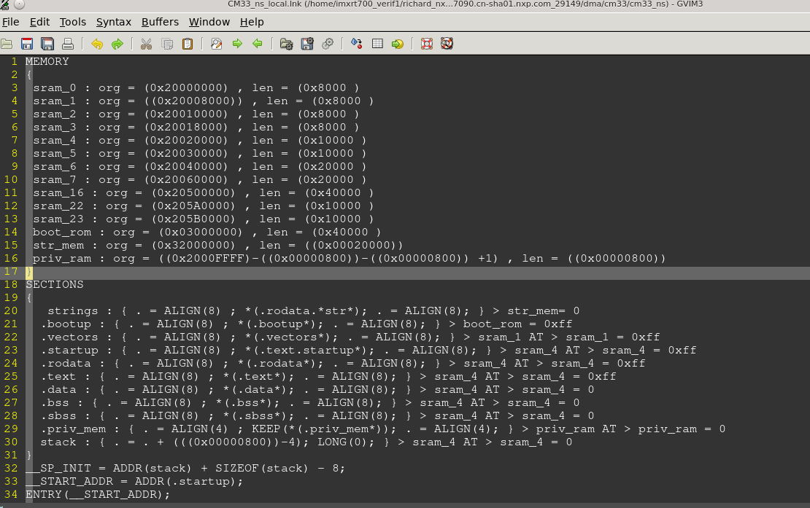

Secure demo linkfile
### C-Stimulus : /home/imxrt700_verif1/richard_nxa28190/V_SS_RT700_SOC_TB_1.20.1.1/testbench/blocks/soc_tb/tool_data/compiler/include/sanity_cm33_init.c
### C-RunTime : /home/imxrt700_verif1/richard_nxa28190/V_SS_RT700_SOC_TB_1.20.1.1/testbench/blocks/soc_tb/tool_data/compiler/cm33/cm33_s/src/crt0.s

cat /home/imxrt700_verif1/richard_nxa28190/V_SS_RT700_SOC_TB_1.20.1.1/testbench/blocks/soc_tb/tool_data/compiler/cm33/cm33_s/ldscripts/cm33_s.lnk | m4 -I/home/imxrt700_verif1/richard_nxa28190/V_SS_RT700_SOC_TB_1.20.1.1/testbench/blocks/soc_tb/tool_data/compiler/include -P | cpp -P -Dcm33 -DCM33_RESOURCES -DCM33 -DVMEM=boot_rom -DSTRMEM=str_mem -DXMEM=sram_16 -DUMEM=sram_16 -DSMEM=sram_16 -DDMEM=sram_16 -DSTRAMEM=sram_16 -I/home/imxrt700_verif1/richard_nxa28190/V_SS_RT700_SOC_TB_1.20.1.1/testbench/blocks/soc_tb/tool_data/compiler/include> /home/imxrt700_verif1/richard_nxa28190/V_SS_RT700_SOC_TB_1.20.1.1/testbench/blocks/soc_tb/tool_data/verilog/verilog_FILENAMES_apc7092.cn-sha01.nxp.com_24999/dma/cm33/cm33_s/CM33_local.lnk

SRAM16放code，data。 汇编启动代码放置在ROM中

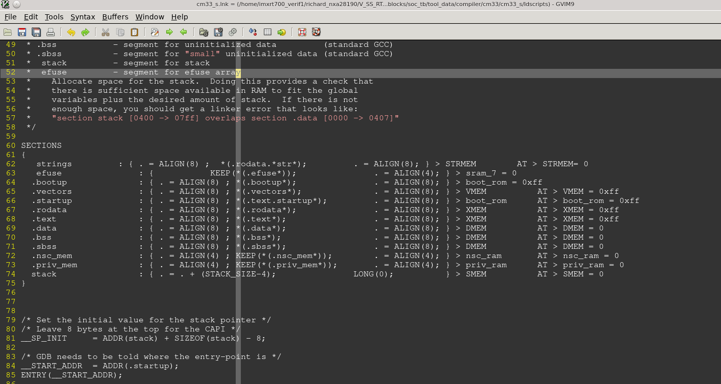

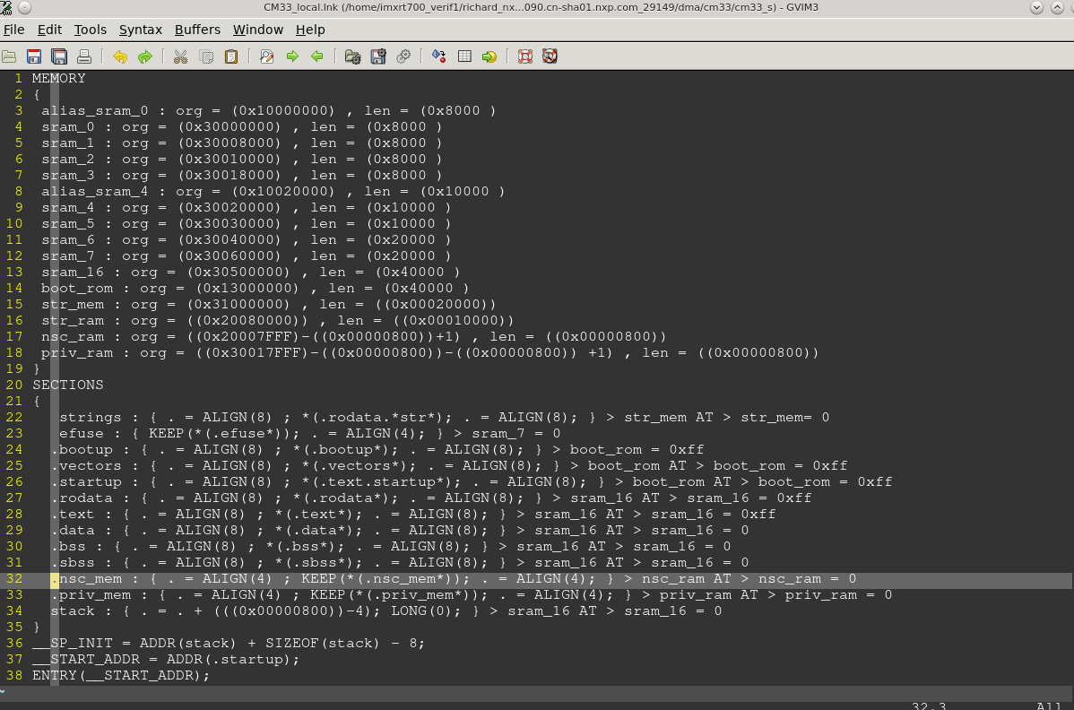
ENTRY(__START_ADDR) //告诉链接器程序的启动地址，

编译

Non-secure demo
编译.c
arm-none-eabi-g++ -D DEF_LC_NXP_FAB_MODE_DEFAULT=1 -D ANATOP_ID=ANATOP_INST0 -D SRC=S_SSRAM_P10_BASE -D DST=S_SSRAM_P10_BASE -D SRC_NS=NS_SSRAM_P10_BASE -D DST_NS=NS_SSRAM_P10_BASE -D LEN=0x80000 -D ADDR_START=0 -DCM33_NS_RESOURCES=1 -Dcm33_ns -DCM33_NS_RESOURCES -DCM33_NS -DVMEM=sram_1 -DXMEM=sram_4 -DUMEM=sram_4 -DSMEM=sram_4 -DDMEM=sram_4 -DSTRAMEM=sram_4 -I /home/imxrt700_verif1/richard_nxa28190/V_SS_RT700_SOC_TB_1.20.1.1/testbench/blocks/soc_tb/tool_data/compiler/include/ -DCM33 -DCM33_NS_RESOURCES=1 -DCPRINT_REGS_BASE=0x2001FFE0 -DCPRINT_CMD_OFFSET=0x00 -DCPRINT_ARG_OFFSET=0x8 -DCPRINT_RSP_OFFSET=0x4 -Dcm33_ns -DCM33_NS_RESOURCES -DCM33_NS -DVMEM=sram_1 -DXMEM=sram_4 -DUMEM=sram_4 -DSMEM=sram_4 -DDMEM=sram_4 -DSTRAMEM=sram_4 -DDMA_ID=INST0 -D CAPI_INCLUDE_C=0 -D CAPI_INCLUDE_STARTUP=0 -D STARTUP_STIM=pre_main -D SHUTDOWN_STIM=post_main -D CORE_NUM=0 -D PH_BASE=0x37FFFFF0 -D CPRINT_REGS_BASE=0x37FFFFF0 -D TARGET_MEM_START=0x34000000 -D TARGET_MEM_SIZE=0x00070000 -D TARGET_MEM_WIDTH=64 - -MD -c /home/imxrt700_verif1/richard_nxa28190/V_SS_RT700_SOC_TB_1.20.1.1/testbench/blocks/soc_tb/tool_data/compiler/cm33/src/_start.c -o _start.o

编译.s
arm-none-eabi-as --defsym DEF_LC_NXP_FAB_MODE_DEFAULT=1 --defsym ANATOP_ID=ANATOP_INST0 --defsym SRC=S_SSRAM_P10_BASE --defsym DST=S_SSRAM_P10_BASE --defsym SRC_NS=NS_SSRAM_P10_BASE --defsym DST_NS=NS_SSRAM_P10_BASE --defsym LEN=0x80000 --defsym ADDR_START=0 -mthumb -mcpu=cortex-m33 --defsym CM33_NS_RESOURCES=1 --defsym cm33_ns=1 --defsym CM33_NS_RESOURCES=1 --defsym CM33_NS=1 --defsym cm33_ns=1 --defsym CM33_NS=1 --defsym VMEM=sram_1 --defsym XMEM=sram_4 --defsym UMEM=sram_4 --defsym SMEM=sram_4 --defsym DMEM=sram_4 --defsym STRAMEM=sram_4 --defsym DMA_ID=INST0 --defsym CAPI_INCLUDE_C=0 --defsym CAPI_INCLUDE_STARTUP=0 --defsym STARTUP_STIM=pre_main --defsym SHUTDOWN_STIM=post_main --defsym CORE_NUM=0 --defsym PH_BASE=0x37FFFFF0 --defsym CPRINT_REGS_BASE=0x37FFFFF0 --defsym TARGET_MEM_START=0x34000000 --defsym TARGET_MEM_SIZE=0x00070000 --defsym TARGET_MEM_WIDTH=64 /home/imxrt700_verif1/richard_nxa28190/V_SS_RT700_SOC_TB_1.20.1.1/testbench/blocks/soc_tb/tool_data/compiler/cm33/cm33_ns/src/crt0.s -o crt0.o

Secure demo
编译.c
arm-none-eabi-g++ -D DEF_LC_NXP_FAB_MODE_DEFAULT=1 -D ANATOP_ID=ANATOP_INST0 -D SRC=S_SSRAM_P10_BASE -D DST=S_SSRAM_P10_BASE -D SRC_NS=NS_SSRAM_P10_BASE -D DST_NS=NS_SSRAM_P10_BASE -D LEN=0x80000 -D ADDR_START=0 -DCM33_RESOURCES=1 -DNONE -DNONE -DNONE -Dcm33_s -DCM33_RESOURCES -DCM33 -DVMEM=boot_rom -DXMEM=sram_16 -DSTRMEM=str_mem -DUMEM=sram_16 -DSMEM=sram_16 -DDMEM=sram_16 -DSTRAMEM=sram_16 -D CM33_NS_RESOURCES_SWITCH=1 -I /home/imxrt700_verif1/richard_nxa28190/V_SS_RT700_SOC_TB_1.20.1.1/testbench/blocks/soc_tb/tool_data/compiler/include/ -I DTEST_NAME=dma3_slave_access_sram__cm33_ns__inst0 -DVECTOR_SET=dma -DMAIN_TEST=main -DDEF_LC_NXP_FAB_MODE_DEFAULT=1 -DANATOP_ID=ANATOP_INST0 -DSRC=S_SSRAM_P10_BASE -DDST=S_SSRAM_P10_BASE -DSRC_NS=NS_SSRAM_P10_BASE -DDST_NS=NS_SSRAM_P10_BASE -DLEN=0x80000 -DADDR_START=0 -fdata-sections -fno-exceptions -std=c99 -Wall -Werror=declaration-after-statement -Wno-unused-function -ffunction-sections -falign-functions=4 -fno-zero-initialized-in-bss -O1 -I/home/imxrt700_verif1/richard_nxa28190/V_SS_RT700_SOC_TB_1.20.1.1/testbench/blocks/soc_tb/vectors/dma/stimulus -DACTIVE_CORES=0x3 -DACTIVE_CBFMS=0x0 -Wfatal-errors -Werror=implicit-function-declaration -Wmain -Werror=main -D ASM=__asm__ -fno-zero-initialized-in-bss -mthumb -mcpu=cortex-m33 -nostdlib -ffunction-sections -g -mthumb -march=armv8-m.main -mfpu=fpv5-sp-d16 -mfloat-abi=hard -fpermissive -Wno-narrowing -DCM33_RESOURCES=1 -DCPRINT_REGS_BASE=0x3001FFE0 -DCPRINT_CMD_OFFSET=0x00 -DCPRINT_ARG_OFFSET=0x8 -DCPRINT_RSP_OFFSET=0x4 -DADDR_START__SYMBOL__=0x00000000 -DANATOP_ID__SYMBOL__=0x00000000 -DCAPI_INCLUDE_C__SYMBOL__=0x00000000 -DCAPI_INCLUDE_STARTUP__SYMBOL__=0x00000000 -DCORE_NUM__SYMBOL__=0x00000000 -DDMA_ID__SYMBOL__=0x00000000 -DDMEM__SYMBOL__=0x00000000 -DDST__SYMBOL__=0x00000000 -DDST_NS__SYMBOL__=0x00000000 -DSHUTDOWN_STIM__SYMBOL__=0x00000000 -DSMEM__SYMBOL__=0x00000000 -DSRC__SYMBOL__=0x00000000 -DSRC_NS__SYMBOL__=0x00000000 -DSTARTUP_STIM__SYMBOL__=0x00000000 -DSTRAMEM__SYMBOL__=0x00000000 -DUMEM__SYMBOL__=0x00000000 -DVMEM__SYMBOL__=0x00000000 -DXMEM__SYMBOL__=0x00000000 -DCM33_NS__SYMBOL__=0x00000001 -DCM33_NS__SYMBOL__=0x00000001 -DCM33_NS_RESOURCES__SYMBOL__=0x00000001 -DCM33_NS_RESOURCES__SYMBOL__=0x00000001 -DDEF_LC_NXP_FAB_MODE_DEFAULT__SYMBOL__=0x00000001 -Dcm33_ns__SYMBOL__=0x00000001 -Dcm33_ns__SYMBOL__=0x00000001 -DTARGET_MEM_MSB__SYMBOL__=0x0000003f -DTARGET_MEM_WIDTH__SYMBOL__=0x00000040 -DTARGET_MEM_WIDTH__SYMBOL__=0x00000040 -DTARGET_MEM_STACK_SIZE__SYMBOL__=0x00000800 -DTARGET_MEM_SIZE__SYMBOL__=0x00070000 -DTARGET_MEM_SIZE__SYMBOL__=0x00070000 -DLEN__SYMBOL__=0x00080000 -D__vectors__SYMBOL__=0x20008000 -Dvector_table_end__SYMBOL__=0x20008400 -D__START_ADDR__SYMBOL__=0x20020000 -D__startup__SYMBOL__=0x20020000 -D__end__SYMBOL__=0x20020016 -D_start__SYMBOL__=0x20020020 -DCAPI_END_SIM__SYMBOL__=0x20020038 -DUNIMPLEMENTED_ISR__SYMBOL__=0x20020058 -DPROCESS_INTERRUPT__SYMBOL__=0x20020098 -Dcore_enable_irq__SYMBOL__=0x200200c0 -D_capi_interrupt_handler__SYMBOL__=0x200200f0 -D_hard_fault_recovery__SYMBOL__=0x2002013c -D_chk_prec_data_err__SYMBOL__=0x20020146 -D_chk_instr_type__SYMBOL__=0x2002014c -D_rtn_addr__SYMBOL__=0x2002016a -D_chk_instr_err__SYMBOL__=0x2002016e -D_end_isr__SYMBOL__=0x20020194 -Dset_interrupt_secure_state__SYMBOL__=0x200201b4 -Djump_to_nsc__SYMBOL__=0x200201cc -D__NS_RETURN_ADDR__SYMBOL__=0x200201ea -Ddma3_int_isr__SYMBOL__=0x200201fc -Ddma3_err_int_isr__SYMBOL__=0x20020320 -Ddma_populate_request__SYMBOL__=0x200203b4 -Dipc_dma0_assign__SYMBOL__=0x200203c4 -Dipc_dma0_release__SYMBOL__=0x2002040c -Dipc_dma1_assign__SYMBOL__=0x20020454 -Dipc_dma1_release__SYMBOL__=0x2002049c -Dipc_dma2_assign__SYMBOL__=0x200204e4 -Dipc_dma2_release__SYMBOL__=0x2002052c -Dipc_dma3_assign__SYMBOL__=0x20020574 -Ddma3_pcc_assign__SYMBOL__=0x200205bc -Dipc_dma3_release__SYMBOL__=0x20020614 -Ddma3_pcc_release__SYMBOL__=0x2002065c -Dipc_dma0_rstb_set__SYMBOL__=0x200206b4 -Dipc_dma0_rstb_clr__SYMBOL__=0x200206fc -Dipc_dma1_rstb_set__SYMBOL__=0x20020744 -Dipc_dma1_rstb_clr__SYMBOL__=0x2002078c -Dipc_dma2_rstb_set__SYMBOL__=0x200207d4 -Dipc_dma2_rstb_clr__SYMBOL__=0x2002081c -Dipc_dma3_rstb_set__SYMBOL__=0x20020864 -Ddma3_reset_negate__SYMBOL__=0x200208ac -Dipc_dma3_rstb_clr__SYMBOL__=0x20020904 -Ddma3_reset_assert__SYMBOL__=0x2002094c -Ddma3_setup_int__SYMBOL__=0x200209a4 -Ddma3_check_int__SYMBOL__=0x200209e4 -Ddma3_setup_err_int__SYMBOL__=0x20020a38 -Ddma3_check_err_int__SYMBOL__=0x20020a78 -Ddma3_enable_err_int__SYMBOL__=0x20020ad0 -Ddma3_validate_channel__SYMBOL__=0x20020b1c -Ddma3_setup_complex__SYMBOL__=0x20020b68 -Ddma3_setup_hw__SYMBOL__=0x200212b4 -Ddma3_start_sw__SYMBOL__=0x20021304 -Ddma3_prepare_source_data__SYMBOL__=0x20021350 -Ddma3_check_destination_data__SYMBOL__=0x20021368 -Dsoc_new_request__SYMBOL__=0x20021bbc -Dsoc_allocate_ip__SYMBOL__=0x20021c28 -Dpre_main__SYMBOL__=0x20021c8c -Dpost_main__SYMBOL__=0x20021d18 -Dmain__SYMBOL__=0x20021d68 -Dns_return_addr__SYMBOL__=0x20022270 -Dinit_ip_request__SYMBOL__=0x20022274 -DtrSize__SYMBOL__=0x2002238c -DINTERRUPT_CONTEXT_TABLE__SYMBOL__=0x200223a0 -DINTERRUPT_JUMP_TABLE__SYMBOL__=0x200227a0 -Dns2sec_comm_isr_msg__SYMBOL__=0x20022ba0 -Dnsc_addr__SYMBOL__=0x20022ba4 -Dnsc_veneer_addr__SYMBOL__=0x20022ba8 -D__SP_INIT__SYMBOL__=0x20023470 -DTARGET_MEM_START__SYMBOL__=0x34000000 -DTARGET_MEM_START__SYMBOL__=0x34000000 -DTARGET_MEM_END__SYMBOL__=0x3406ffff -DCPRINT_REGS_BASE__SYMBOL__=0x37fffff0 -DPH_BASE__SYMBOL__=0x37fffff0 -DNONE -DNONE -DNONE -Dcm33_s -DCM33_RESOURCES -DCM33 -DVMEM=boot_rom -DXMEM=sram_16 -DSTRMEM=str_mem -DUMEM=sram_16 -DSMEM=sram_16 -DDMEM=sram_16 -DSTRAMEM=sram_16 -DCM33_NS_RESOURCES_SWITCH=1 -D CAPI_INCLUDE_C=0 -D CAPI_INCLUDE_STARTUP=0 -D STARTUP_STIM=pre_main -D SHUTDOWN_STIM=post_main -D CORE_NUM=1 -D PH_BASE=0x3001FFE0 -D CPRINT_REGS_BASE=0x3001FFE0 -D TARGET_MEM_START=0x34070000 -D TARGET_MEM_SIZE=0x00070000 -D TARGET_MEM_WIDTH=64 -I/home/imxrt700_verif1/richard_nxa28190/V_SS_RT700_SOC_TB_1.20.1.1/testbench/blocks/soc_tb/tool_data/compiler/cm33/cm33_s/include - -MD -c /home/imxrt700_verif1/richard_nxa28190/V_SS_RT700_SOC_TB_1.20.1.1/testbench/blocks/soc_tb/tool_data/compiler/include/sanity_cm33_init.c -o sanity_cm33_init.o

编译.S

arm-none-eabi-as --defsym DEF_LC_NXP_FAB_MODE_DEFAULT=1 --defsym ANATOP_ID=ANATOP_INST0 --defsym SRC=S_SSRAM_P10_BASE --defsym DST=S_SSRAM_P10_BASE --defsym SRC_NS=NS_SSRAM_P10_BASE --defsym DST_NS=NS_SSRAM_P10_BASE --defsym LEN=0x80000 --defsym ADDR_START=0 -mthumb -mcpu=cortex-m33 --defsym CM33=1 --defsym CM33_RESOURCES=1 --defsym cm33_s=1 --defsym CM33_RESOURCES=1 --defsym CM33=1 --defsym cm33_s=1 --defsym CM33=1 --defsym VMEM=boot_rom --defsym XMEM=sram_16 --defsym STRMEM=str_mem --defsym UMEM=sram_16 --defsym SMEM=sram_16 --defsym DMEM=sram_16 --defsym STRAMEM=sram_16 --defsym CM33_NS_RESOURCES_SWITCH=1 --defsym CAPI_INCLUDE_C=0 --defsym CAPI_INCLUDE_STARTUP=0 --defsym STARTUP_STIM=pre_main --defsym SHUTDOWN_STIM=post_main --defsym CORE_NUM=1 --defsym PH_BASE=0x3001FFE0 --defsym CPRINT_REGS_BASE=0x3001FFE0 --defsym TARGET_MEM_START=0x34070000 --defsym TARGET_MEM_SIZE=0x00070000 --defsym TARGET_MEM_WIDTH=64 /home/imxrt700_verif1/richard_nxa28190/V_SS_RT700_SOC_TB_1.20.1.1/testbench/blocks/soc_tb/tool_data/compiler/cm33/cm33_s/src/crt0.s -o crt0.o

链接
将.o文件按照link文件的要求整合起来，生成map跟elf文件

Non-secure demo
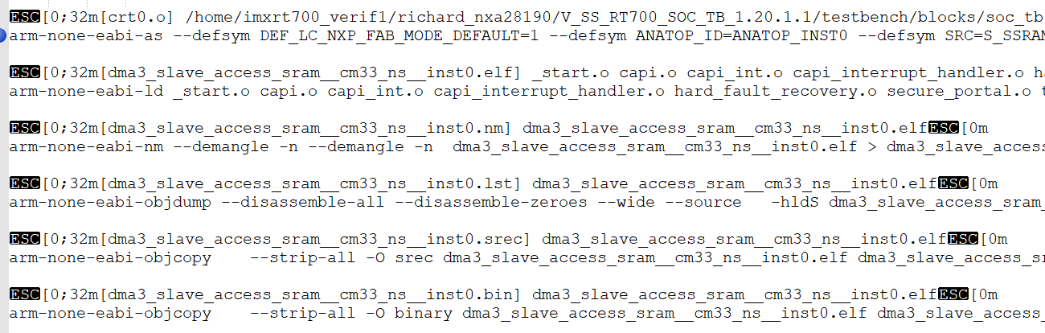
arm-none-eabi-ld _start.o capi.o capi_int.o capi_interrupt_handler.o hard_fault_recovery.o secure_portal.o trustzone_api.o dma3_slave_access.o crt0.o -L/home/imxrt700_verif1/richard_nxa28190/V_SS_RT700_SOC_TB_1.20.1.1/testbench/blocks/soc_tb/tool_data/compiler/cm33/cm33_ns/lib -L/home/imxrt700_verif1/richard_nxa28190/V_SS_RT700_SOC_TB_1.20.1.1/testbench/blocks/soc_tb/tool_data/compiler/cm33/lib --whole-archive --no-whole-archive -nostdlib -gc-sections --gc-sections -nostdlib --entry=__vectors --defsym TARGET_MEM_WIDTH=64 --defsym TARGET_MEM_START=0x34000000 --defsym TARGET_MEM_STACK_SIZE=0x800 --defsym TARGET_MEM_END=0x3406ffff --defsym TARGET_MEM_MSB=63 --defsym TARGET_MEM_SIZE=0x00070000 -T./CM33_ns_local.lnk -Map dma3_slave_access_sram__cm33_ns__inst0.map -o dma3_slave_access_sram__cm33_ns__inst0.elf

Secure demo
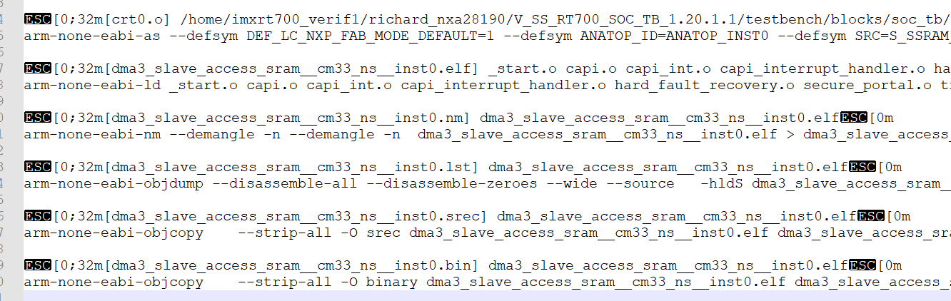

arm-none-eabi-ld _start.o capi.o capi_int.o capi_interrupt_handler.o hard_fault_recovery.o secure_portal.o trustzone_api.o sanity_cm33_init.o crt0.o -L/home/imxrt700_verif1/richard_nxa28190/V_SS_RT700_SOC_TB_1.20.1.1/testbench/blocks/soc_tb/tool_data/compiler/cm33/cm33_s/lib -L/home/imxrt700_verif1/richard_nxa28190/V_SS_RT700_SOC_TB_1.20.1.1/testbench/blocks/soc_tb/tool_data/compiler/cm33/lib --whole-archive --no-whole-archive -nostdlib -gc-sections --gc-sections -nostdlib --entry=__vectors --defsym TARGET_MEM_WIDTH=64 --defsym TARGET_MEM_START=0x34070000 --defsym TARGET_MEM_STACK_SIZE=0x800 --defsym TARGET_MEM_END=0x340dffff --defsym TARGET_MEM_MSB=63 --defsym TARGET_MEM_SIZE=0x00070000 -T./CM33_local.lnk -Map dma3_slave_access_sram__cm33_ns__inst0.map -o dma3_slave_access_sram__cm33_ns__inst0.elf

启动流程分析

Loadfile
Secure demo Load into ROM, sram16

UVM_INFO @ 1085131.913200 ns --: [testbench.load_memory_cm33] load_memory_string: ==== File : /home/imxrt700_verif1/richard_nxa28190/V_SS_RT700_SOC_TB_1.20.1.1/testbench/blocks/soc_tb/tool_data/verilog/verilog_FILENAMES_apc7092.cn-sha01.nxp.com_24999/CM33_dma3_slave_access_sram__cm33_ns__inst0.rom.hex

Non-secure demo, load into SRAM1,SRAM4
UVM_INFO @ 1085131.913200 ns --: [testbench.load_memory_cm33_ns] load_memory_string: ==== File : /home/imxrt700_verif1/richard_nxa28190/V_SS_RT700_SOC_TB_1.20.1.1/testbench/blocks/soc_tb/tool_data/verilog/verilog_FILENAMES_apc7092.cn-sha01.nxp.com_24999/CM33_NS_dma3_slave_access_sram__cm33_ns__inst0.rom.hex

Boot into non-secure demo
Secure demo从CM33 BOOT 起来后，执行pre_main函数，跳转之前trustzone会对ram进行non-secure的配置

Non-secure 配置
- 配置non-secure vctor， vector__SYMBOL. Secure demo在编译的时候定义了这个变量，为non-secure demo的vector address
- Config SAU,idau配置NON-SECURE address, NON-SECURE ram
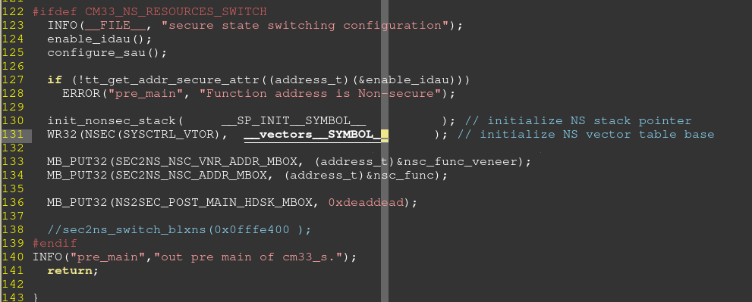

Boot into non-secure demo
- 执行Sanity_cm33_init.c中的main函数。
CM33_NS_RESOURCES_SWITCH#ns_source_switch 存在，跳转到non-secure demo中，跳转地址#start_symbol (NON-SECURE code 的_start.c)

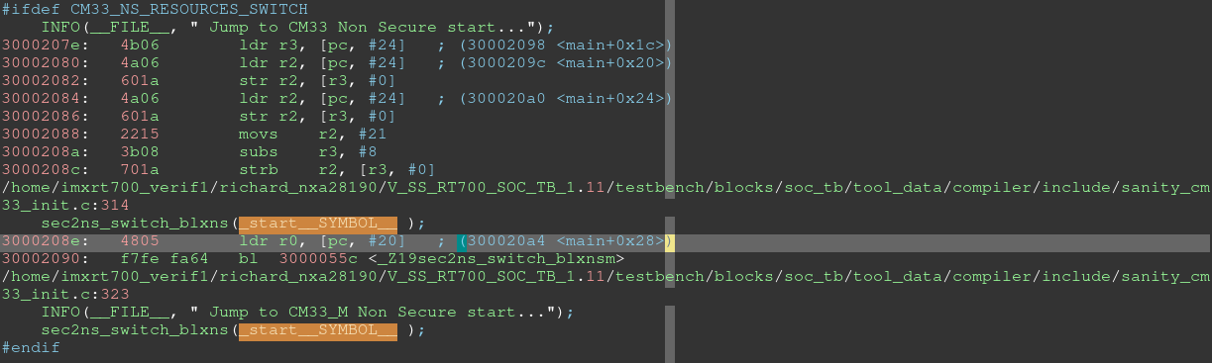

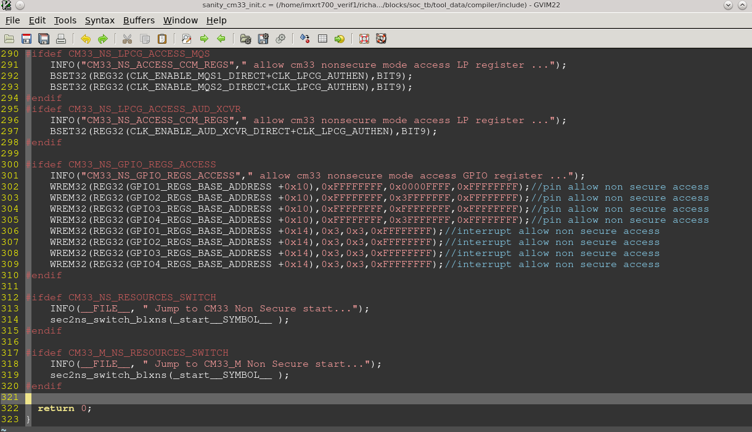

CM33_ns_local.lnk

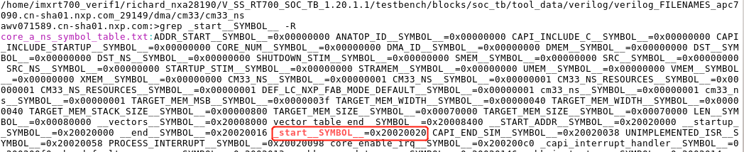
CM33 ns demo反汇编lst文件
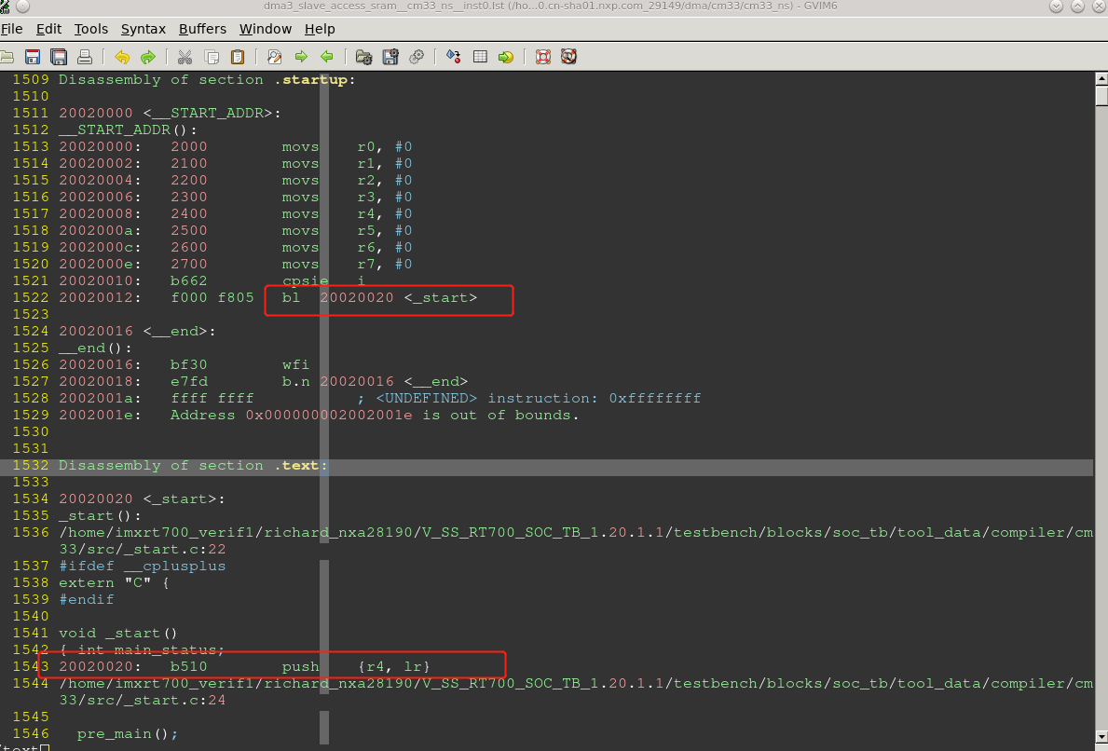

信号分析

Vector重定向
芯片上电后，secure vector会默认从0，重定向到0x13000000.
然后从0x13000400处取指令执行
Secure vctor如下所示
testbench.top.compute_vdd2.cm33_main.INITSVTOR[31:7] = 0x26000
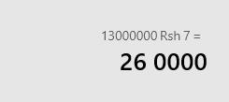
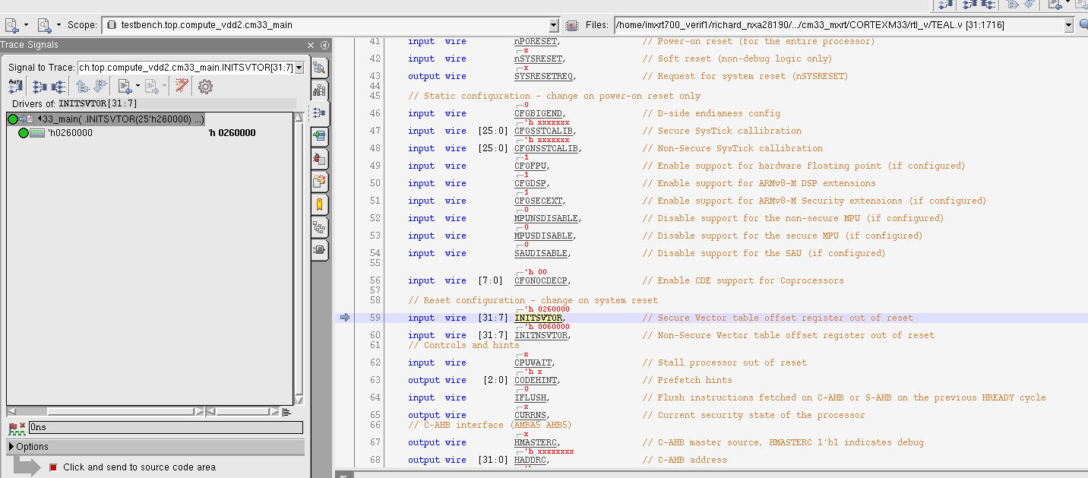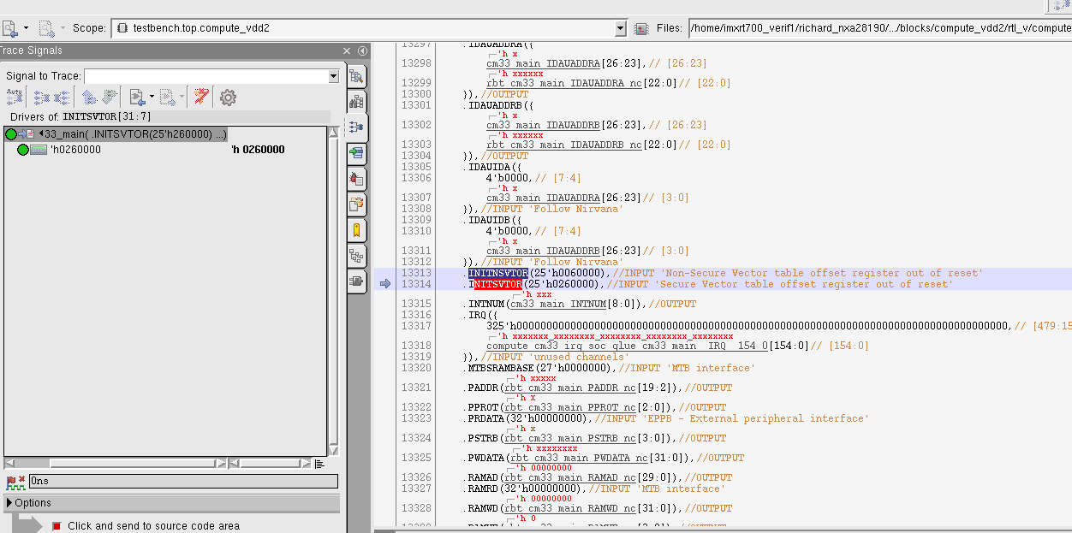

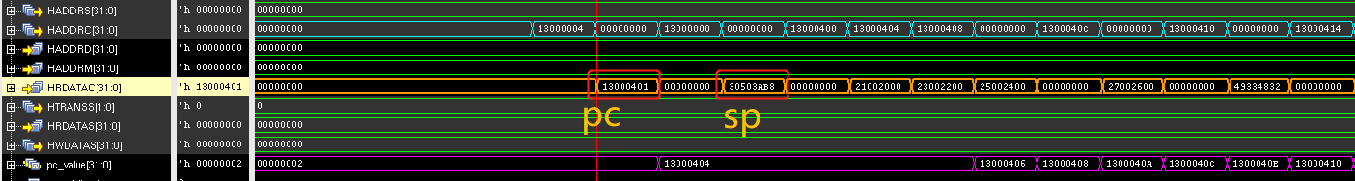

跳转到c
Crt0.s
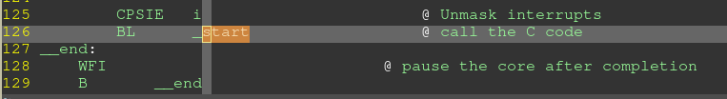
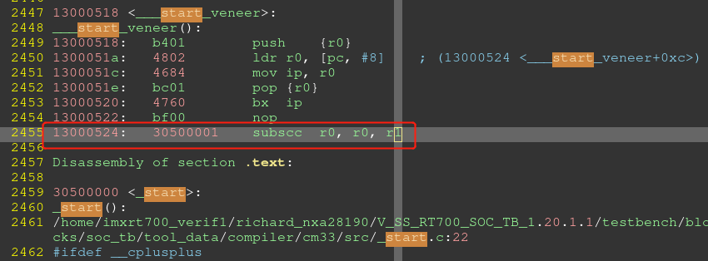
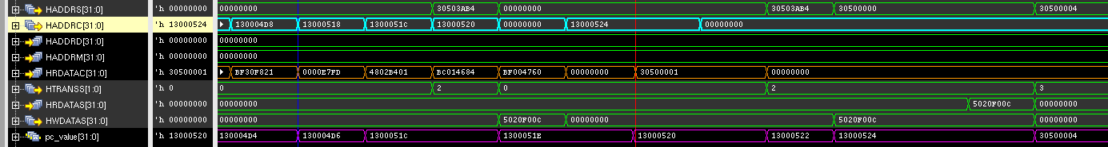

跳转到NON-SECURE DEMO
跳转到non-secure demo的_start.c
Boot into non-secure demo

Secure demo cdoe:
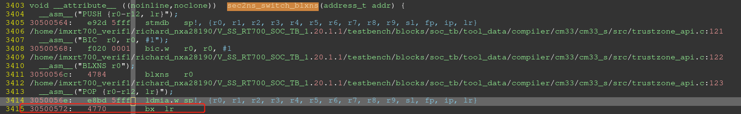
Non-secure demo code
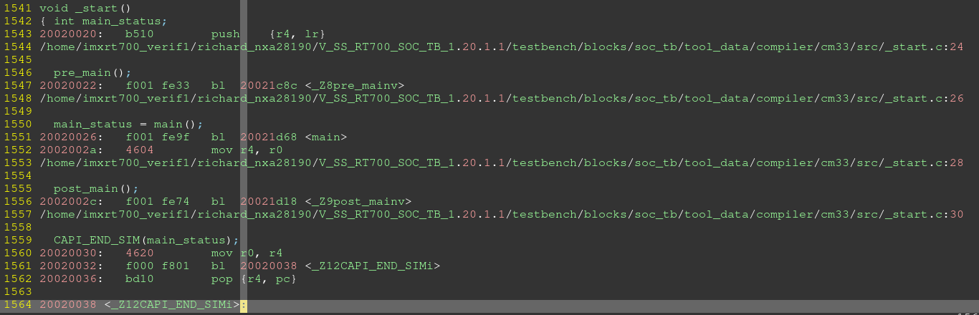

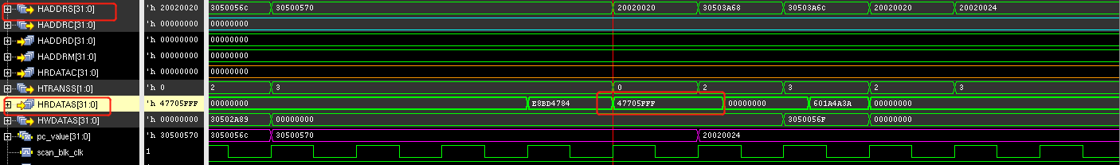

CM33_M boot
CM33_S : sanity_cm33_m_init.c, cm33_s/src/crt0.s
CM33_M_S: dma3_reg.c, cm33_m_s/src/crt0.s

- CM33_S demo: vector/crt0.s-》ROM， code/data-》sram16
Pre_main中配置CM33_M的vector
#ifdef CM33_M_BOOT_ENABLE
INFO("pre_main","config sense cm33 vector....");
#ifdef CM33_M_RESET_VECTOR
W32(REG32(SYSCTL_SHA_VDD1_BASE + 0x98), CM33_M_RESET_VECTOR>>7);//system_svtor_i
W32(REG32(SYSCTL_SHA_VDD1_BASE + 0x9C), CM33_M_RESET_VECTOR>>7);//system_nsvtor_i
#else
W32(REG32(SYSCTL_SHA_VDD1_BASE + 0x98), S_SSRAM_P28_BASE>>7);//system_svtor_i
W32(REG32(SYSCTL_SHA_VDD1_BASE + 0x9C), S_SSRAM_P28_BASE>>7);//system_nsvtor_i
#endif CM33_M_BOOT_ENABLE

INFO("pre_main","release sense cm33 reset....");//CM33_M demo loading
BCLR32(REG32(RSTCTL_SHA_VDD1_BASE + 0x0010), BIT31);

INFO("pre_main","release sense cm33 CPUWAIT....");
BCLR32(REG32(SYSCTL_SHA_VDD1_BASE + 0xA0), BIT0);
#endif //CM33_M_BOOT_ENABLE
- Release CM33_M reset， testbench load CM33_M demo, 运行CM33_M demo
CM33_M demo, vector/code/data->SRAM28

CM33_M_NS boot
CM33_M_NS: dma3_interrupt.c , cm33_m_ns/src/crt0.s, cm33/src/_start.c
CM33_S: sanity_cm33_m_init.c, cm33/cm33_s/src/crt0.s, cm33/src/_start.c
CM33_M_S: sanity_cm33_init.c, cm33_m_s/src/crt0.s, cm33/src/_start.c

- CM33 vector/crt0.s-> ROM, code/data->SRAM16
程序跑起来后，识别到CM33_M_BOOT_ENABLE， 配置CM33_M的vector， 然后release CM33_M reset
- CM33_M vector/code/data -> SRAM28, CM33_M_NS -> SRAM1/SRAM4
CM33_M demo识别到CM33_M_NS_RESOURCES_SWITCH， 配置SAU/IDAU non-secure空间，
然后main函数中跳转到CM33_M_NS demo。
跳转地址_start__SYMBOL__， 为CM33_M_NS demo的C入口地址

HIFI4 boot
HIFI使用的编译器是xt-clang
HIFI4: dma3_reg.c, hifi4/src/vectors.S, /hifi4/src/_start.c
CM33_S: cm33_s/src/crt0.s , compiler/include/sanity_hifi4_init.c, cm33/src/_start.c

- CM33_S vector/crt0.s -> ROM, C code/data->SRAM16
Cm33_s/include/pre_post_main.h 检测到 HIFI4_BOOT_ENABLE。Release HIFI4 reset.
一旦release HIFI4 reset， testbench 将HIFI4 DEMO load到HIFI4的ITCM,DTCM中。 Demo开始运行

#ifdef HIFI4_BOOT_ENABLE
INFO("pre_main","release hifi4 reset....");//
//W32(REG32(RSTCTL_COM_VDD2_BASE + 0x0024), 0x0000000);
BCLR32(REG32(RSTCTL_COM_VDD2_BASE + 0x0024), BIT0);
#endif //HIFI4_BOOT_ENABLE

MEMORY
{
sram0_seg : org = 0x20040004, len = 0x3FFFC
dram0_0_seg : org = 0x24000000, len = 0x10000
iram0_0_seg : org = 0x24020000, len = 0x2E0
iram0_1_seg : org = 0x240202E0, len = 0x120
iram0_2_seg : org = 0x24020400, len = 0x178
iram0_4_seg : org = 0x2402057C, len = 0x1C
iram0_5_seg : org = 0x24020598, len = 0x4
iram0_6_seg : org = 0x2402059C, len = 0x1C
iram0_7_seg : org = 0x240205B8, len = 0x4
iram0_8_seg : org = 0x240205BC, len = 0x1C
iram0_10_seg : org = 0x240205DC, len = 0x1C
iram0_12_seg : org = 0x240205FC, len = 0x1C
iram0_13_seg : org = 0x24020618, len = 0x4
iram0_14_seg : org = 0x2402061C, len = 0x1C
iram0_16_seg : org = 0x2402063C, len = 0x1C
iram0_17_seg : org = 0x24020658, len = 0xF9A8
string_0_seg : org = 0x36000000, len = 0x20000
}

UVM_INFO @ 1559524.603122 ns --: [testbench.load_memory_hifi4] Loading DTCM ......
UVM_INFO @ 1559524.603122 ns --: [testbench.memory_map_load_gnu_hex] platform:HIFI4 Loading into mem from address 24000000 to 2400ffff
UVM_INFO @ 1559524.603122 ns --: [testbench.memory_map_load_gnu_hex] platform: HIFI4 address=9008000 over range
UVM_INFO @ 1559524.603122 ns --: [testbench.memory_map_load_gnu_hex] platform: HIFI4 address >= 24000f94 Load default value into mem...
UVM_INFO @ 1559524.603122 ns --: [testbench.load_memory_hifi4] Loading ITCM ......
UVM_INFO @ 1559524.603122 ns --: [testbench.memory_map_load_gnu_hex] platform:HIFI4 Loading into mem from address 24020000 to 2402ffff
UVM_INFO @ 1559524.603122 ns --: [testbench.memory_map_load_gnu_hex] platform: HIFI4 address=d800000 over range
UVM_INFO @ 1559524.603122 ns --: [testbench.memory_map_load_gnu_hex] platform: HIFI4 address >= 24020628 Load default value into mem...
UVM_INFO @ 1559524.603122 ns --: [testbench.load_memory_hifi4] Loading Shared SRAM6 ......
UVM_INFO @ 1559524.603122 ns --: [testbench.memory_map_load_gnu_hex] platform:HIFI4 Loading into mem from address 20040000 to 2005ffff
UVM_INFO @ 1559524.603122 ns --: [testbench.memory_map_load_gnu_hex] platform: HIFI4 address=9000000 over range
UVM_INFO @ 1559524.603122 ns --: [testbench.memory_map_load_gnu_hex] platform: HIFI4 address >= 20043f1c Load default value into mem...
UVM_INFO @ 1559524.603122 ns --: [testbench.load_memory_hifi4] Loading Shared SRAM7 ......
UVM_INFO @ 1559524.603122 ns --: [testbench.memory_map_load_gnu_hex] platform:HIFI4 Loading into mem from address 20060000 to 2007ffff
UVM_INFO @ 1559524.603122 ns --: [testbench.memory_map_load_gnu_hex] platform: HIFI4 address=9000000 over range
UVM_INFO @ 1559524.603122 ns --: [testbench.memory_map_load_gnu_hex] platform: HIFI4 address >= 0xxxxxxxxX Load default value into mem...
UVM_INFO @ 1559524.603122 ns --: [testbench.load_memory_hifi4] Loading string ......
UVM_INFO @ 1559524.603122 ns --: [testbench.memory_map_load_gnu_hex] platform:HIFI4 Loading into mem from address 36000000 to 3607ffff
UVM_INFO @ 1559524.603122 ns --: [testbench.memory_map_load_gnu_hex] platform: HIFI4 address >= 36010634 Load default value into mem...

HIFI1 Boot
HIFI1的vector table是RTL设置好的，为HIFI1 ITCM的start address

HIFI1: hifi/hifi1/src/vectors.S, dma/stimulus/dma3_soft_trigger.c
CM33: sanity_hifi1_init.c, cm33_s/src/crt0.s
CM33_M: sanity_hifi1_init.c, cm33_m_s/src/crt0.s

- CM33 vector-> ROM, data/code->SRAM16
上电后，ROM启动，执行CM33的code，识别到CM33_M_BOOT_ENABLE，对CM33_M进行vector的配置，然后release CM33_M reset
- Testbench load CM33 demo， code/data -> SRAM28
CM33_M 启动后，CM33_M_S/include/pre_post_main.h识别到HIFI1_BOOT_ENABLE，release HIFI1 reset

#ifdef HIFI1_BOOT_ENABLE
INFO("pre_main","release hifi1 reset....");
W32(REG32(RSTCTL_SEN_VDD1_BASE + 0x0010), 0x00000000);
W32(REG32(SYSCTL_SEN_VDD1_BASE + 0x0300), 0x00000000);
#endif //HIFI1_BOOT_ENABLE
- Testbench load HIFI1 demo，code->HIFI1 ITCM ,data->SRAM23
运行HIFI1 demo

Zenv Boot
ZENV使用的编译器riscv32-unknown-elf-g++

Zenv: dma3_reg.c zenv/src/zv0335_crt0.s
CM33: cm33_s/src/crt0.s sanity_zenv_init.c

- CM33 VECTOR->ROM, code/data->SRAM16,
程序识别到ZENV_BOOT_ENABLE， 配置zenv的vector，release zenv的reset
#ifdef ZENV_BOOT_ENABLE
INFO("pre_main","config EZH vector....");
#ifdef ZENV_RESET_VECTOR
INFO("pre_main","config EZH reset vector to ZENV_RESET_VECTOR");
W32(REG32(SYSCTL_MED_VDD2_BASE + 0xD4), ZENV_RESET_VECTOR); // MTVEC
W32(REG32(SYSCTL_MED_VDD2_BASE + 0xD8), ZENV_RESET_VECTOR+0x400); // STVEC
W32(REG32(SYSCTL_MED_VDD2_BASE + 0xD0), (ZENV_RESET_VECTOR+0x800)>>2); // RSTBASE
#else
W32(REG32(SYSCTL_MED_VDD2_BASE + 0xD4), 0x24100000); // MTVEC
W32(REG32(SYSCTL_MED_VDD2_BASE + 0xD8), 0x24100400); // STVEC
W32(REG32(SYSCTL_MED_VDD2_BASE + 0xD0), 0x24100800>>2); // RSTBASE
#endif
INFO("pre_main","release ezhv reset....");
BCLR32(REG32(RSTCTL_MED_VDD2_BASE + 0x0010), BIT5);
#endif //ZENV_BOOT_ENABLE
- Testbench load ZENV demo,运行zenv demo
Vector、code -> ZENV_ITCM , data->SRAM17

Dual core boot
以CM33&CM33_M为例：
- VPLAN中填入CM33&CM33_M，生成的arg文件中就会指定两者的stimulus为相同的main
- CM33跑的最快，可以在CM33_M 的main跑起来之前，通过CM33做一些配置，实现CM33_M对相关功能的访问
如果两个core需要互相控制code执行，可以通过trigge_get/trigger_set的方式进行

