Contents
Revision 2
Introduction 3
Rules 3
Rules for ticket content 3
Title 3
Description 3
Ticket operation 4
Create a ticket 4
Edit a ticket 8
Set ticket status 9
Filter ticket 9

Revision
Revision | Date & Author | ChangeLog
V1.0 | 2024/12/10, Richard | Initial version

Introduction
ACE_China_SoC_verification_Support(ACSVS) is a jira project used to record/tracking all the tickets raised for Soc verification team. This document brief introduced how to raise a ticket to verification team.

Rules
To unify manage all the tickets, reporter should follow below rule. You can contact the project administrator to add rules if below rules doesn’t meet your requirement.
Admin: Angela Liang/Damon Gong/Michael Xu/Bill Cui/Richard Xiong
- Labels is used to indicate different verification teams
Labels: SUZHOU, SHANGHAI,TEDA
- Component/s is used to identify reporter form different teams
Component : ROM/SE/VALIDATION/DIP/MSIP/SOC/EMULATION/SW
- Affects version is used to classify different products
Affects version : i.mxRT1180, i.mxRT700, MCXA10, MCXA18, MCXA20, MCXA20-256, MCXA2TX, i.mx95, i.mx952, i.mx93, i.mx943

Rules for ticket content

Title
Ticket title should be easy to get what the issue is, the example title content:
[Platform]Module: <Bug Summary> possibility
1) Platform: MX6DQ_SD, MX6DL_SD, etc
2) Module: DMA, UART, etc
3) Bug Summary: The info should be simple and describe the bug as clearly as we can;
4) Possibility: The frequency of the issue occurs.
Eg: [imx.RT700]DMA2 tcd_mem wlpd is not connect, will cause access TCD register failed. 100%

Description
- BUG DETAIL DESCRIPTION:
Describe this bug clearly, and you can also add partial log.
- REPRODUCE STEPS:
1.
2.
...
Describe the steps to reproduce this bug.
Please include all necessary conditions, such as test environment, testbench version
- EXPECTED RESULTS:
Normal test results or expected case results
- POSSIBILITY: %

Ticket operation

Create a ticket
https://jira.sw.nxp.com/projects/ACSVS
- Login Jira, Click Create
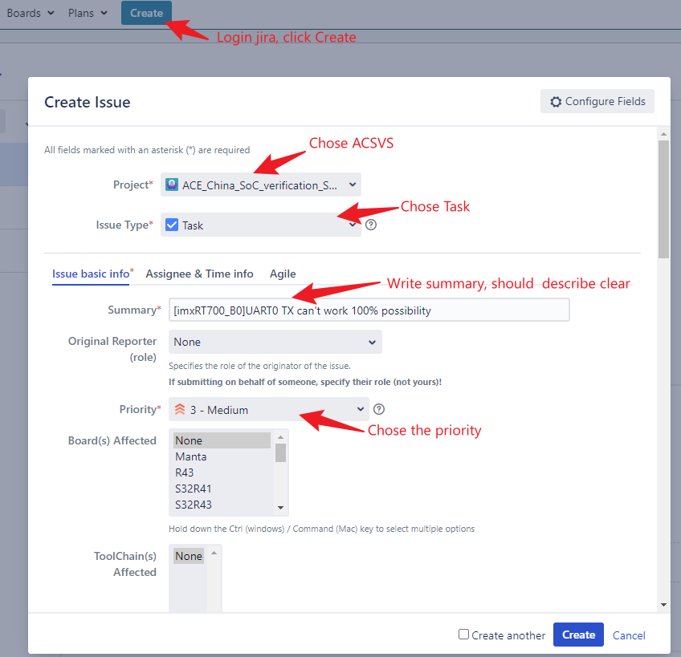
- Reporter should chose the correct team in Component and correct product in Affects Version
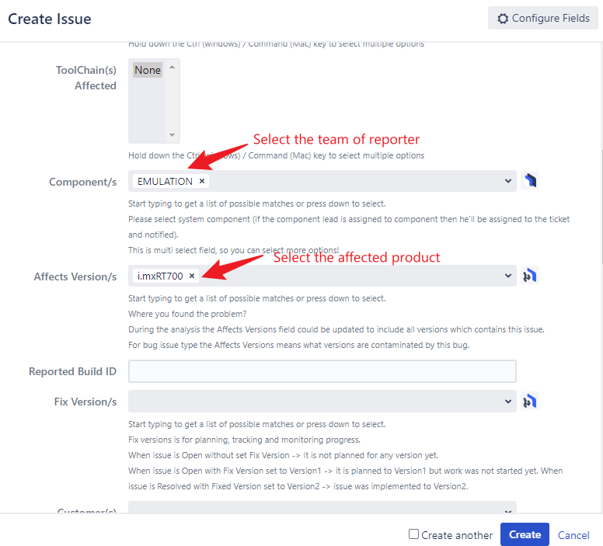
- Reporter should assign to the correct verification team, describe the issues in detail.
You can refer to the rule of description
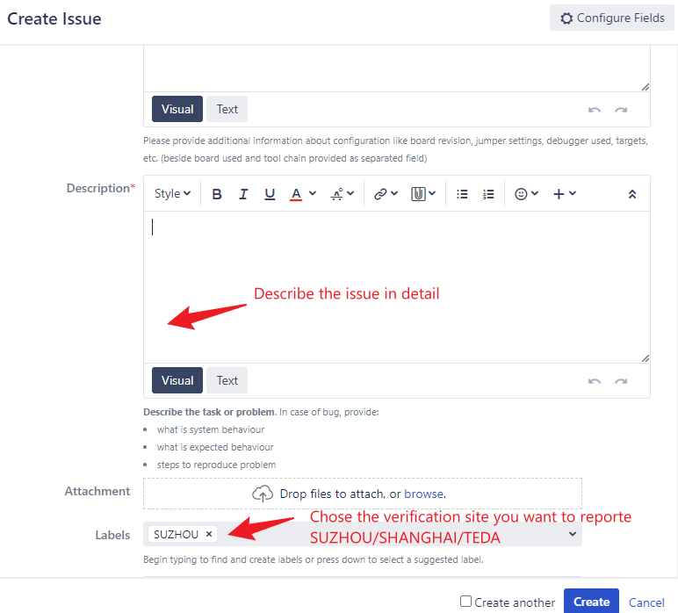
- Assign ticket to verification owner and add reviewer
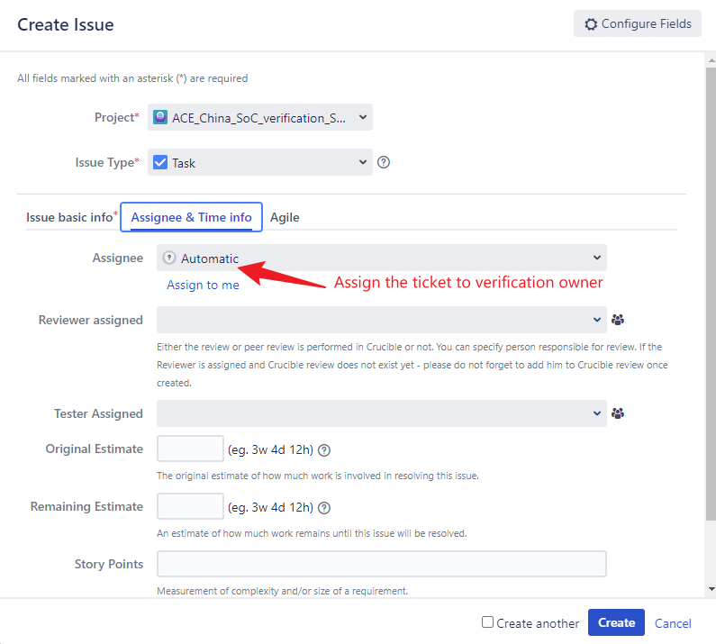
- Create ticket
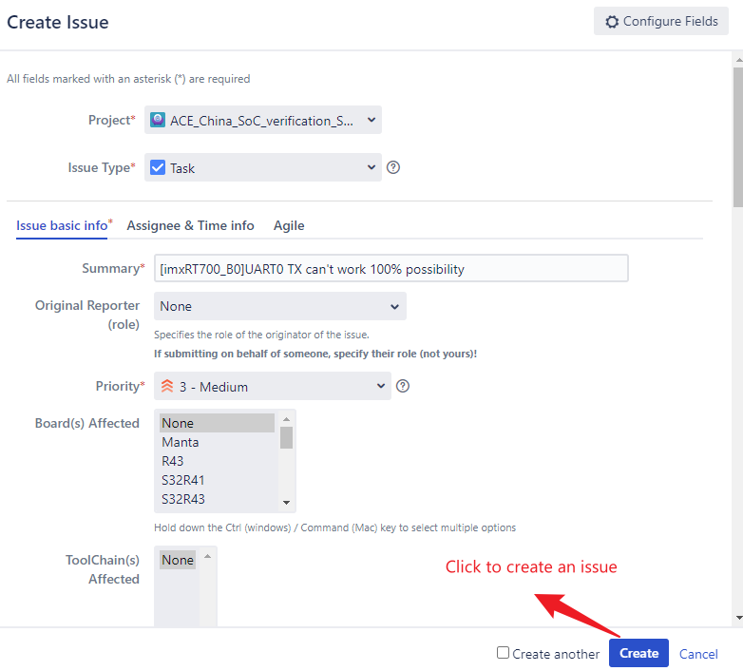

Edit a ticket
You can edit the ticket if something is wrong for a ticket
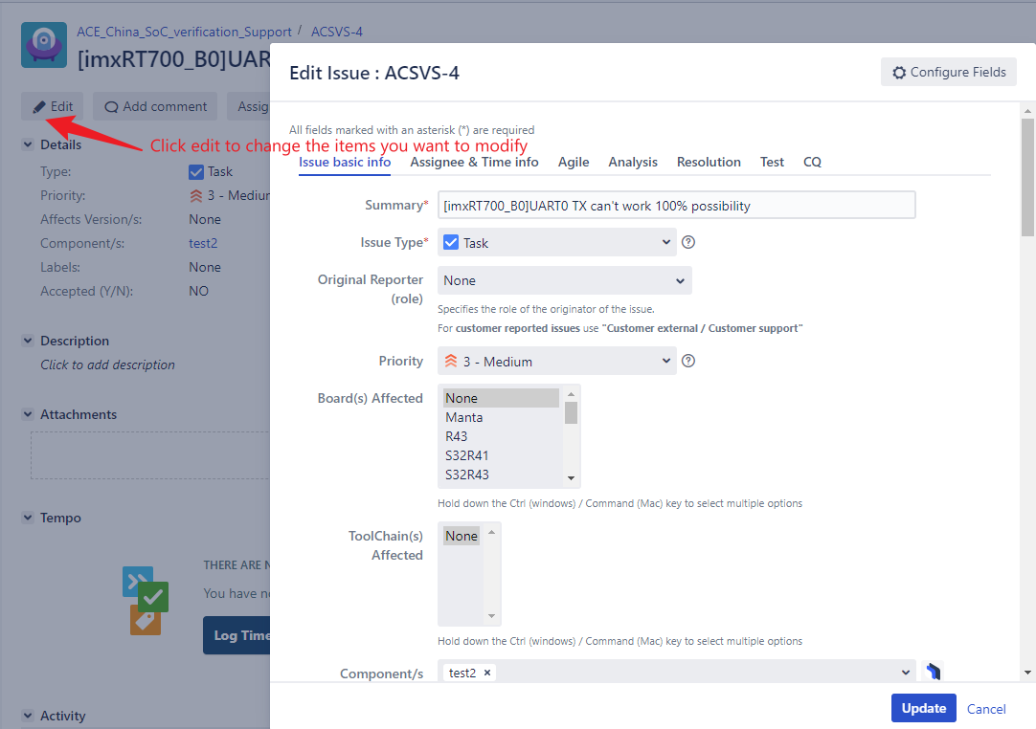

Set ticket status
You can set the ticket status as review/blocked/closed etc for different period
Don’t forget to close the ticket when it was sloved
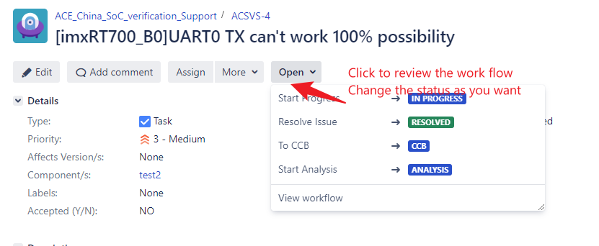

Filter ticket
You can filter all the tickets for SUZHOU/SHANGHAI/TEDA
Also can filter all the tickets for specific product.
