# RT1050配置nor

./blhost.exe -p com8 -- fill-memory 0x2000 4 0xe0233009

./blhost.exe -p com8 -- configure-memory 9 0x2000

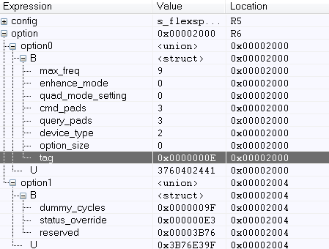

第一个参数0xe，告诉flash loader我要进行nor的配置

if (option->option0.B.tag == kSerialNorCfgOption_Tag)

{

status = flexspi_nor_get_config(FLEXSPI_NOR_INSTANCE, &s_flexspiNorConfigBlock, option);

if (status != kStatus_Success)

{

break;

}

isNorConfigOption = true;

}

对应的枚举变量如下

enum

{

kSerialNorCfgOption_Tag = 0x0E,

kSerialNorCfgOption_DeviceType_ReadSFDP_SDR = 0,

kSerialNorCfgOption_DeviceType_ReadSFDP_DDR = 1,

kSerialNorCfgOption_DeviceType_HyperFLASH1V8 = 2,

kSerialNorCfgOption_DeviceType_HyperFLASH3V0 = 3,

kSerialNorCfgOption_DeviceType_MacronixOctalDDR = 4,

kSerialNorCfgOption_DeviceType_MacronixOctalSDR = 5,

kSerialNorCfgOption_DeviceType_MicronOctalDDR = 6,

kSerialNorCfgOption_DeviceType_AdestoOctalDDR = 8,

};