PERSONAL INFORMATION | Radoslav Stanev
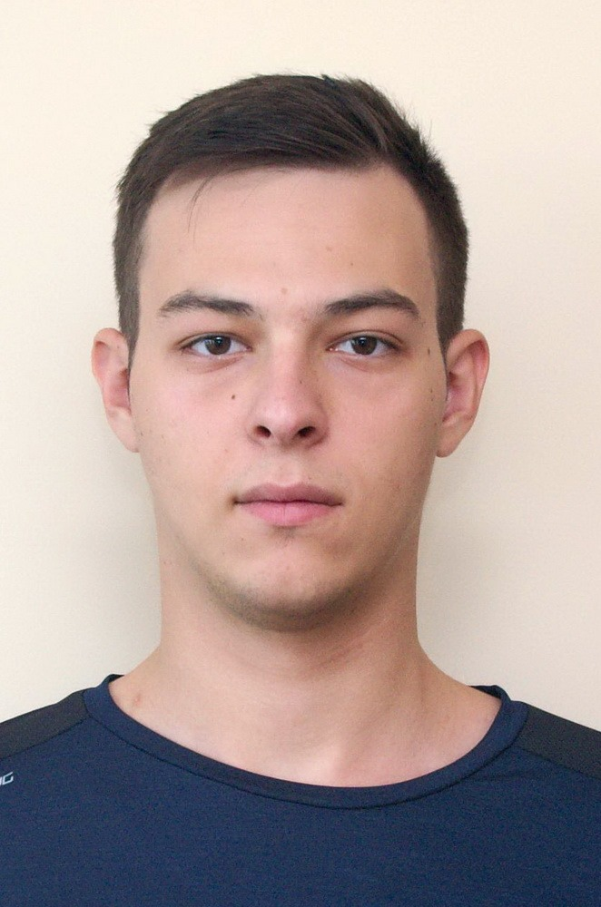 |   Nikola Vaptsarov Street No. 57, Blagoevgrad, Bulgaria
 |  +359879079197

rs01287@surrey.ac.uk
 | Sex Male | Date of birth 01/12/2000 | Nationality Bulgarian

JOB APPLIED FOR  POSITION  PREFERRED JOB  STUDIES APPLIED FOR | Front-End Developer Internship at Accenture Bulgaria

WORK EXPERIENCE

Replace with dates (from - to) | No previous work experiences.

EDUCATION AND TRAINING

Replace with dates (from - to) | From September 2019 to now  University of Surrey, Computer Science (currently year 2)  Subjects Covered:  Year 1:  - Programming Fundamentals (Java)  - Foundations of Computing (Mathematics)  - Computer Logic (Assembly and Arduino Programming)  - Web and Database Systems (HTML, CSS and MySql)  - Software Engineering (Java)  - Operating Systems (Raspberry Pi Programmimg)  - Foundations of Computing II (Advanced Mathematics)  - Data Structures and Algorithms  Year 2:  - Further Programming Paradigms  - Advanced Algorithms  - Information Retrieval  - Web Applications Development  - Parallel Computing  - Artificial Intelligence  - Software Engineering Project  - Computer Networking  Graduated from Natural Science and Mathematics High School “Acad. Sergey Korolyov”, Blagoevgrad, Bulgaria in 2019.

PERSONAL SKILLS

Mother tongue(s) | Bulgarian
Other language(s) | UNDERSTANDING |  | SPEAKING |  | WRITING
Other language(s) | Listening | Reading | Spoken interaction | Spoken production
English | C1 | C1 | C1 | C1 | C1
 | B2 certificate from American University in Bulgaria, Blagoevgrad and 7.5 on IELTS

Communication skills | - Good communication skills from multiple group projects in university.

Job-related skills | Good knowledge in Java, Ruby on Rails, JavaScript, NodeJS, React, Linux, Databases, HTML and CSS, Git.

Computer skills | - good command of Microsoft Office™ tools

