Saral Test Application
User Features, Functionality & Screenshot Guide

Document Type | User-facing feature and functionality guide
Application Scope | Log Book, Shift Dashboard, Operator Management, Model Master, Login/Dashboard, Role/Page/Category Management, User Management
Source Analyzed | Pasted text(139).txt - Node-RED flow JSON
Flow Size | 233 nodes, 7 tabs, 44 HTTP endpoints, 63 function nodes
Database Target Found | MySQL database named master on 127.0.0.1:3306
API Port Found | global api_port is set to 1881
How to use this document
Replace each screenshot placeholder with the actual UI screenshot after opening the matching route in the browser. Keep the feature tables as user-facing explanations for training, handover, or client review.

1. Application Overview
The uploaded flow represents a Node-RED based web application that serves multiple HTML screens and REST APIs over HTTP. It uses MySQL as the backend database and provides operational dashboards, master data management, role/menu configuration, and user administration.

1.1 Main Modules Identified
Module | Primary UI Route | Main Users | Core Purpose
Login & Dashboard | /login, /dashboard_user, /admin_login, /dashboard_admin | All users / admins | Authenticate users and load role-based dashboard menus.
Log Book Dashboard | /log_books | Production / Quality team | View detailed test logs with search, filters, pagination, PASS/FAIL badges, and Excel export.
Shift Analytics Dashboard | /analise | Production supervisors | Show total tested, pass/fail count, running model, model mix, hourly production, and rejection charts.
Operator Management | /operator | Admin / supervisor | Create, edit, search, filter, and delete operator records.
Model Master | /modelmasterdata | Engineering / quality admin | Maintain model-wise test limits, speed parameters, RPM limits, and optional test blocks.
User Management | /userData | Admin | Create, edit, delete, search, and filter application users and assign roles.
Page/Role/Category Manager | /page-manager, /role-manager | Admin | Manage dashboard pages, categories, roles, and role-wise page access.

1.2 Overall User Flow
- User opens the login page and enters username and password.
- System validates the user and reads the role-wise menu/page access.
- Dashboard loads the allowed pages in a left/top navigation layout.
- Users open operational screens such as Log Book, Shift Dashboard, Operator Management, Model Master, or User Management based on role access.
- Admin users manage pages, roles, categories, and user access to control what each role can see.

2. Screenshot Attachment Guide
Use this section while replacing the screenshot placeholders in later pages. The document is prepared with dedicated screenshot boxes for every important UI screen.

2.1 Recommended Screenshot Rules
- Open the UI route in the browser using the same host as Node-RED and the configured API port, for example: http://localhost:1881/login.
- Use Windows + Shift + S or the Snipping Tool to capture the visible browser area.
- For dashboards, capture the header, filters, charts/cards, and at least the first few rows of data.
- For create/edit forms, capture the modal or form after opening it, not only the empty list page.
- Paste the screenshot inside the matching placeholder box. Right-click the image in Word and use Wrap Text -> In Line with Text for clean layout.
- Keep screenshots readable. Do not compress too much, and avoid cutting off important buttons, table headers, filters, or chart legends.

2.2 Screenshot Checklist
ID | Screen | Route / Source | Capture focus
SS-01 | User Login | /login | Login card with username/password fields.
SS-02 | User Dashboard | /dashboard_user | Dashboard menu after successful login.
SS-03 | Super Admin Login | /admin_login | Admin login screen.
SS-04 | Super Admin Dashboard | /dashboard_admin | Admin dashboard landing page.
SS-05 | Log Book Dashboard | /log_books | Search/filter row, sticky table header, PASS/FAIL statuses.
SS-06 | Log Book Export | Downloaded .xls file | Excel export opened with styled header and status colors.
SS-07 | Shift Analytics Dashboard | /analise | Summary cards and charts.
SS-08 | Operator Management List | /operator | Operator table/cards with filters.
SS-09 | Add/Edit Operator Modal | /operator | Operator modal with fields.
SS-10 | Model Master List | /modelmasterdata | Existing model table and search.
SS-11 | Model Master Form | /modelmasterdata | Add/edit model form with speed/test parameters.
SS-12 | User Management | /userData | User table, role filter, and action buttons.
SS-13 | Page Manager | /page-manager | Page list and add/edit modal.
SS-14 | Role Manager | /role-manager | Role configuration with page/category mapping.

3. Login, Session & Dashboard
UI Route(s) | - /login, /dashboard_user,  - /admin_login, /dashboard_admin
Purpose | Provides entry point to the application and displays dashboard navigation according to the user role.

Key Features
Feature | What it does | User value
User login | Username and password based login form posts to the login API. | Prevents direct access and personalizes the session.
Role-wise menu | Dashboard calls the role menu API and shows only mapped pages. | Users see only the modules assigned to their role.
Session storage | User, menu, token, login time, and last activity are stored in browser session storage. | Maintains session state during dashboard usage.
Idle timeout logic | The login page includes a five-minute session and idle timeout concept. | Improves session control for shared systems.
Dashboard iframe/content area | Selected module pages load inside a dashboard frame/container. | Keeps navigation consistent while switching modules.

How to Use
- Open /login for normal user login or /admin_login for super admin login.
- Enter credentials and submit.
- After success, dashboard opens with allowed menu items.
- Click any menu item to open that module inside the dashboard frame.

Screenshot Placeholder
Screenshot SS-01 - User Login
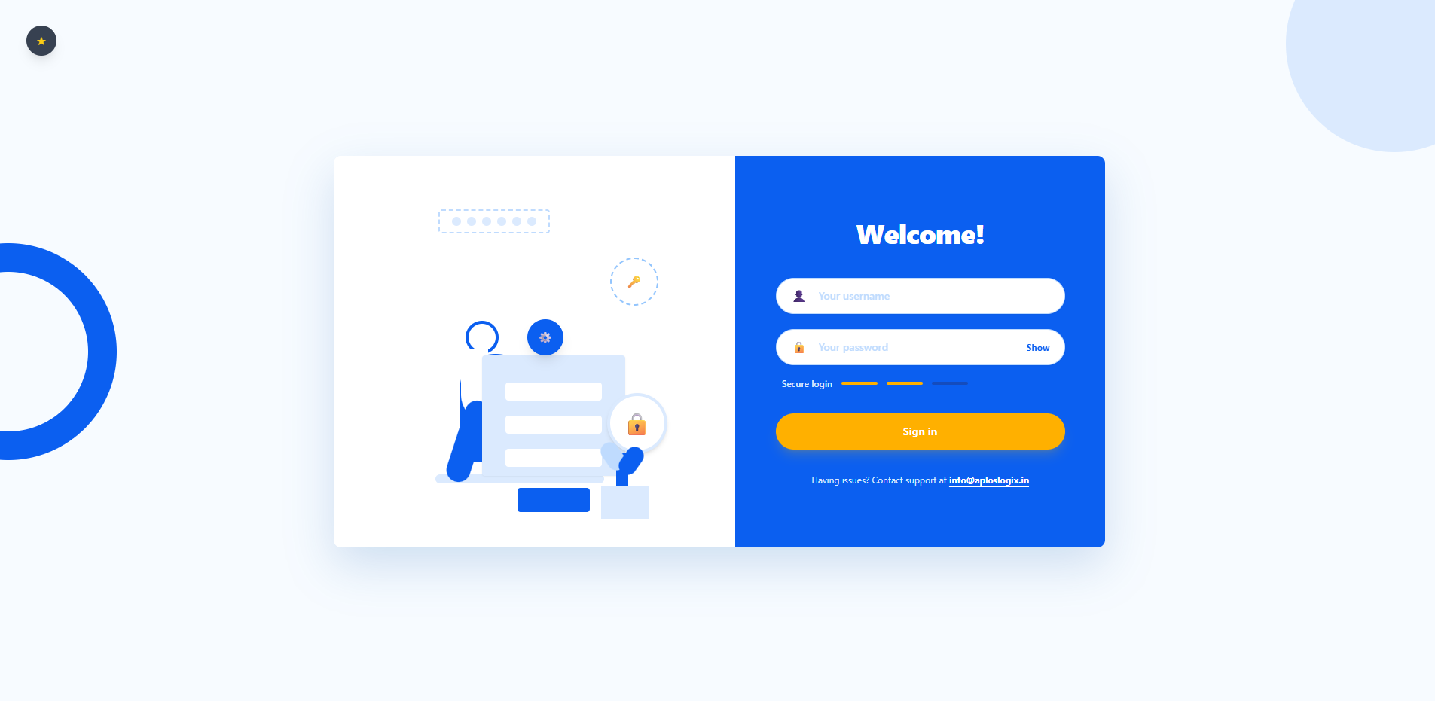

Screenshot SS-02 - User Dashboard Menu
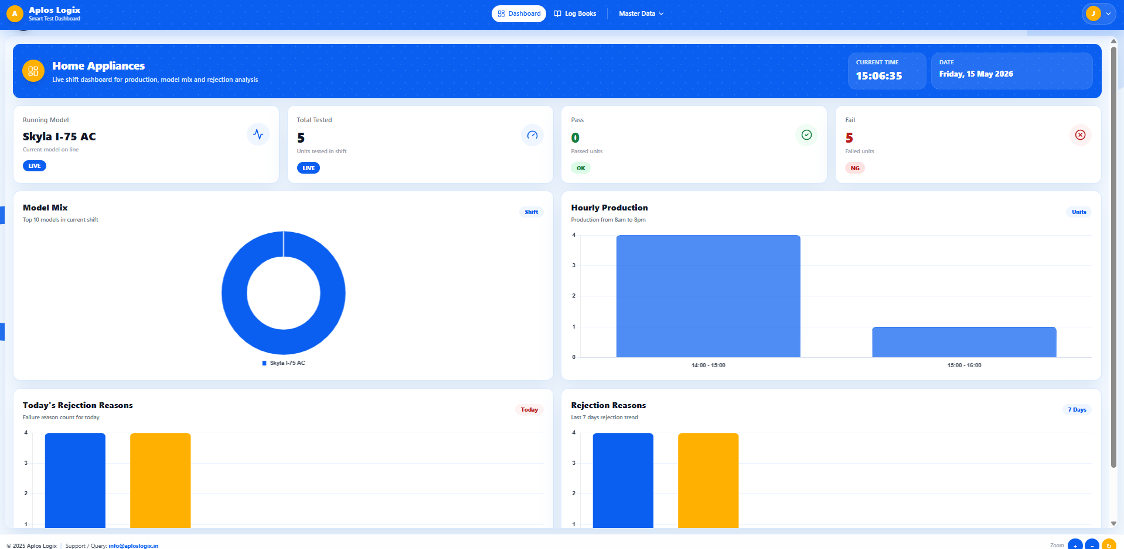

Screenshot SS-03/SS-04 - Admin Login and Admin Dashboard
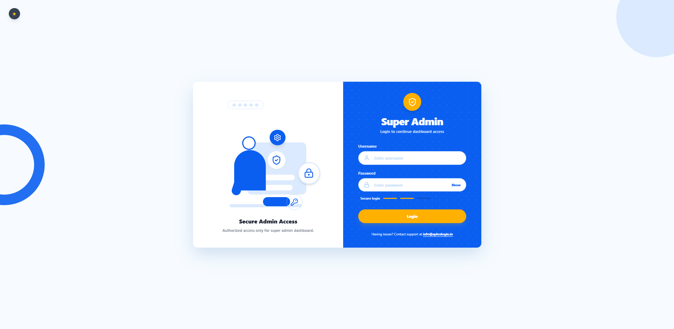

4. Log Book Dashboard
UI Route(s) | /log_books
Purpose | Shows detailed production/test log records from the log_book table with filtering, pagination, sticky columns, and Excel export.

Key Features
Feature | What it does | User value
Search | Searches operator, product code, model, serial number, statuses, and final result. | Quickly find a specific unit, model, operator, or failed condition.
Date filtering | From and To date inputs filter records by timestamp. | Helps review a specific shift, day, or period.
Pagination and row count | Rows can be shown as 20, 50, 100, 200, or all. | Improves performance and readability for large log data.
Sticky table headers and columns | Timestamp, operator, product code, model, and serial number remain visible while scrolling. | Users do not lose context in wide tables.
PASS/FAIL badges | PASS and FAIL values are displayed with green/red visual badges. | Quality status becomes easy to scan.
Fail row highlight | Rows with final FAIL are highlighted. | Failed units are immediately visible.
Excel export | Downloads filtered records in a styled .xls file. | Supports offline reporting, sharing, and audit records.
Auto refresh | The screen refreshes the current page every 60 seconds. | Keeps live production status updated.

How to Use
- Open /log_books.
- Use Search to filter by serial number, model, status, or operator.
- Select From/To dates and click Apply Filter.
- Change Rows count when more records are needed.
- Click Export Excel to download the current filtered report.

Screenshot Placeholder
Screenshot SS-05 - Log Book Dashboard
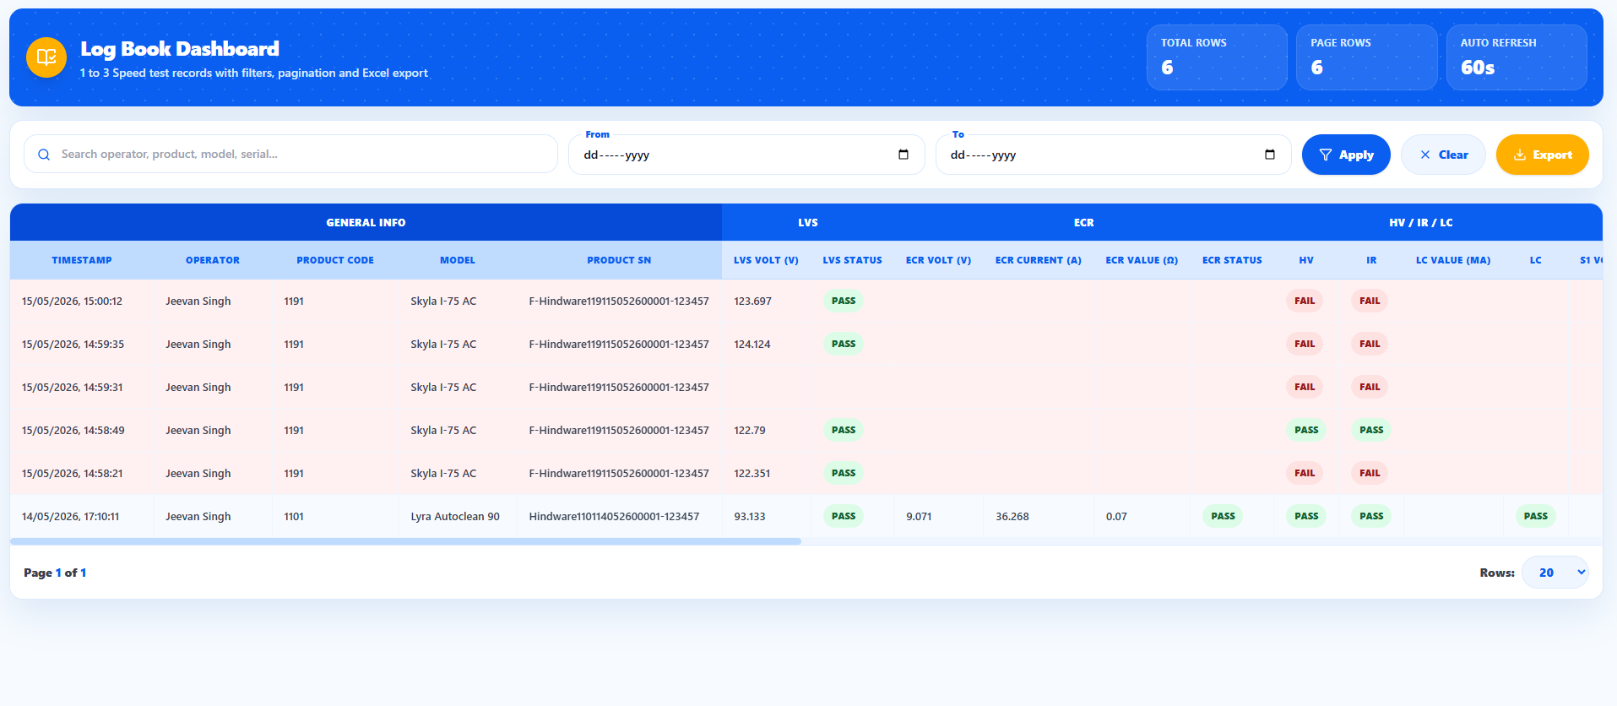

Screenshot SS-06 - Exported Excel Output
General Info |  |  |  |  | LVS |  | ECR |  |  |  | HV / IR / LC |  |  |  | Stage 1 |  |  | Stage 2 |  |  | Stage 3 |  |  | Swing |  |  | Final | RPM
Timestamp | Operator | Product Code | Model | Product SN | LVS Volt (V) | LVS Status | ECR Volt (V) | ECR Current (A) | ECR Value (Ω) | ECR Status | HV | IR | LC Value (mA) | LC | S1 Volt (V) | S1 Wattage (W) | S1 Status | S2 Volt (V) | S2 Wattage (W) | S2 Status | S3 Volt (V) | S3 Wattage (W) | S3 Status | Swing Volt (V) | Swing Wattage (W) | Swing Status | Final Result | RPM S1 | Status S1 | RPM S2 | Status S2 | RPM S3 | Status S3
15/05/2026, 15:00:12 | Jeevan Singh | 1191 | Skyla I-75 AC | ​F-Hindware119115052600001-123457 | 123.697 | PASS |  |  |  |  | FAIL | FAIL |  |  |  |  |  |  |  |  |  |  |  |  |  |  | FAIL
15/05/2026, 14:59:35 | Jeevan Singh | 1191 | Skyla I-75 AC | ​F-Hindware119115052600001-123457 | 124.124 | PASS |  |  |  |  | FAIL | FAIL |  |  |  |  |  |  |  |  |  |  |  |  |  |  | FAIL
15/05/2026, 14:59:31 | Jeevan Singh | 1191 | Skyla I-75 AC | ​F-Hindware119115052600001-123457 |  |  |  |  |  |  | FAIL | FAIL |  |  |  |  |  |  |  |  |  |  |  |  |  |  | FAIL
15/05/2026, 14:58:49 | Jeevan Singh | 1191 | Skyla I-75 AC | ​F-Hindware119115052600001-123457 | 122.79 | PASS |  |  |  |  | PASS | PASS |  |  |  |  |  |  |  |  |  |  |  |  |  |  | FAIL
15/05/2026, 14:58:21 | Jeevan Singh | 1191 | Skyla I-75 AC | ​F-Hindware119115052600001-123457 | 122.351 | PASS |  |  |  |  | FAIL | FAIL |  |  |  |  |  |  |  |  |  |  |  |  |  |  | FAIL
14/05/2026, 17:10:11 | Jeevan Singh | 1101 | Lyra Autoclean 90 | ​Hindware110114052600001-123457 | 93.133 | PASS | 9.071 | 36.268 | 0.07 | PASS | PASS | PASS |  | PASS

5. Shift Analytics / Addon Dashboard
UI Route(s) | /analise
Purpose | Provides a shift-level production analytics view with summary metrics and charts based on log_book data.

Key Features
Feature | What it does | User value
Total tested count | Displays total tested units for the current shift/day logic. | Gives immediate production volume visibility.
Pass and fail counters | Shows pass count and fail count separately. | Makes quality outcome visible at a glance.
Running model | Shows the latest/running model from production data. | Helps supervisors identify current production context.
Model mix chart | Shows model-wise distribution of produced/tested units. | Useful for understanding production mix.
Hourly production chart | Shows production volume by hour. | Helps identify slow hours and bottlenecks.
Today rejection chart | Breaks down today rejection by test/status type. | Helps quickly locate the highest rejection source.
Seven-day rejection trend | Shows rejection trend across the last seven days. | Helps track recurring quality issues.

How to Use
- Open /analise.
- Check the summary cards first: total tested, pass, fail, and running model.
- Review charts for model mix, hourly production, today rejection, and seven-day rejection trend.
- Use the screenshot to show the complete dashboard view with both cards and charts.

Screenshot Placeholder
Screenshot SS-07 - Shift Analytics Dashboard
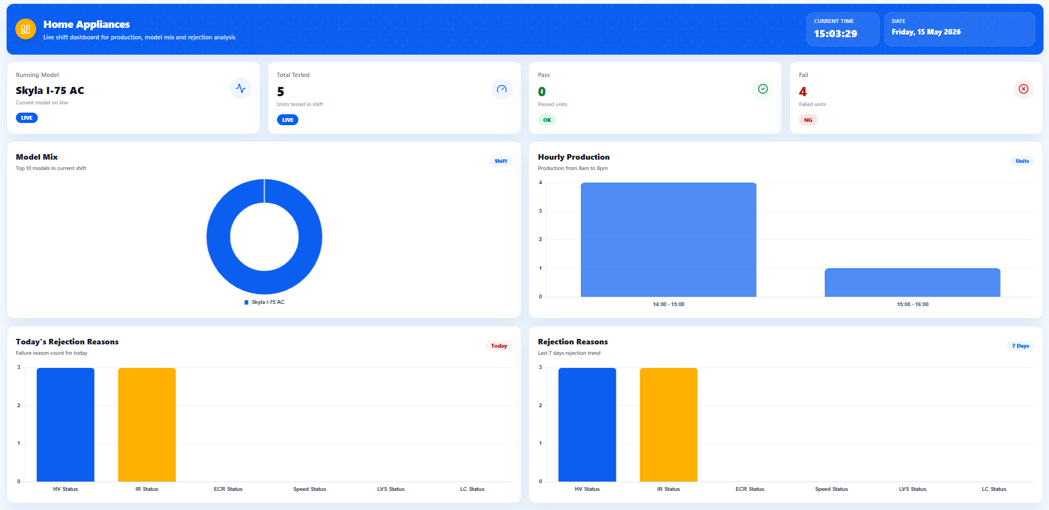

6. Operator Management
UI Route(s) | /operator
Purpose | Allows admins/supervisors to manage operator master data through a UI and CRUD APIs.

Key Features
Feature | What it does | User value
Operator listing | Shows operator records with ID, operator ID, name, role, shift, and created date. | Central place to maintain operator master data.
Search | Search by ID, name, or operator ID. | Finds operators quickly.
Role filter | Filter operators by Operator, Technician, or Supervisor. | Useful for role-wise review.
Shift filter | Filter by Shift A or Shift B. | Useful for shift-wise team management.
Add operator | Add Operator button opens a modal/form. | Simplifies new operator creation.
Edit operator | Edit action loads the selected record into the form. | Supports corrections and role/shift updates.
Delete operator | Delete action removes unwanted records. | Keeps operator master clean.
Refresh and clear filters | Manual refresh and clear filter buttons are available. | Keeps the list current and easy to reset.

How to Use
- Open /operator.
- Use Search, Role filter, or Shift filter to locate records.
- Click Add Operator to create a new operator.
- Use Edit to update operator details.
- Use Delete only after confirming the record is not required.

Screenshot Placeholder
Screenshot SS-08 - Operator Management List
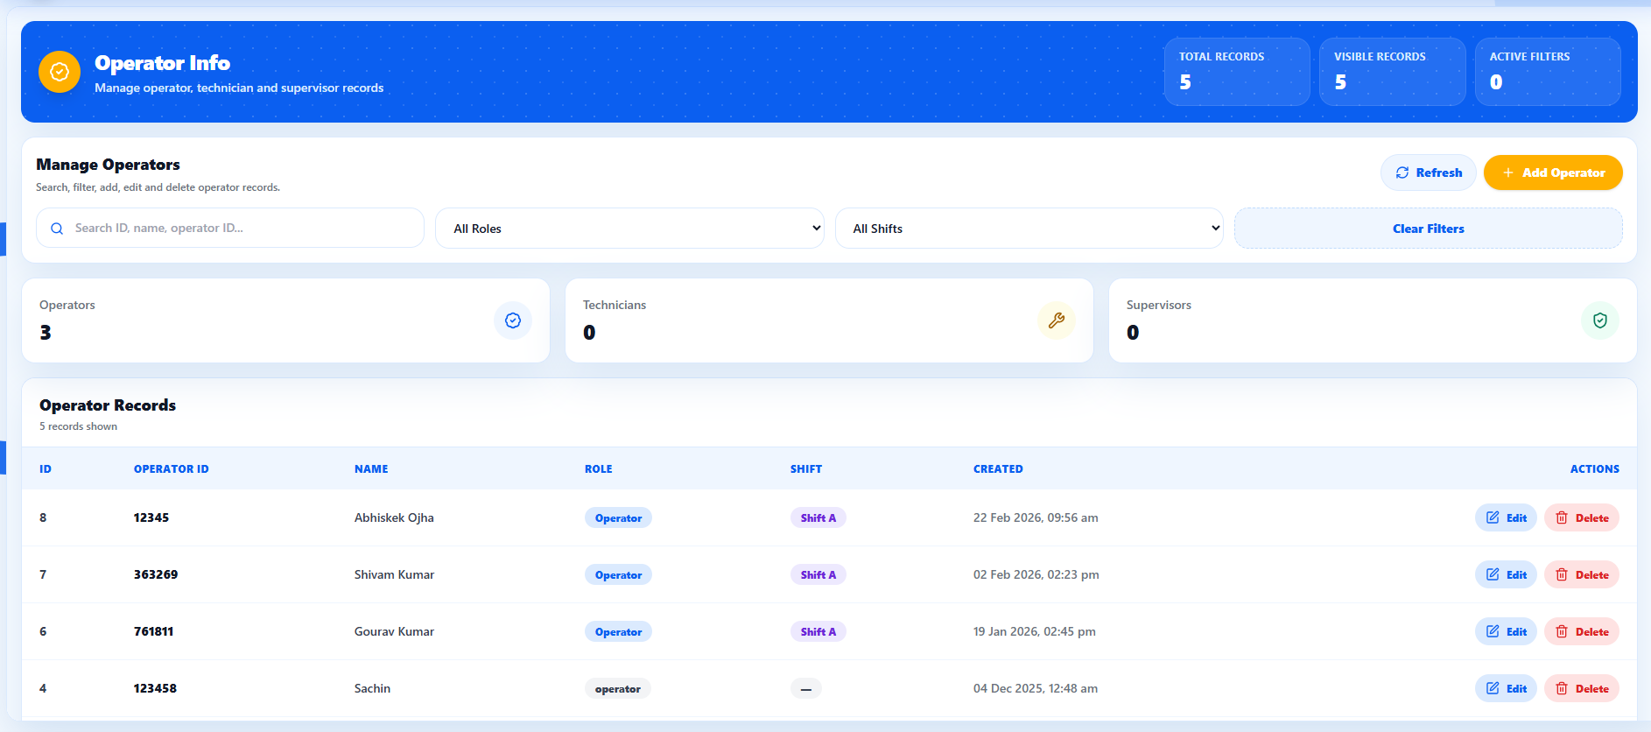

Screenshot SS-09 - Add/Edit Operator Modal
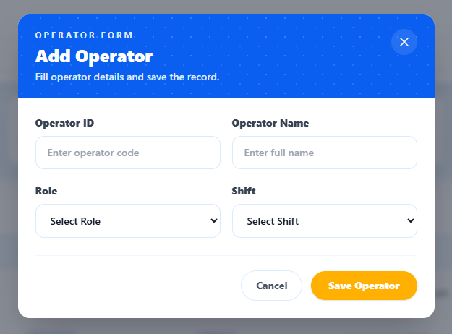

7. Model Master Management
UI Route(s) | /modelmasterdata
Purpose | Maintains model-specific testing parameters and limits used in production testing.

Key Features
Feature | What it does | User value
Existing models list | Displays model master records ordered by latest ID. | Allows quick review of configured models.
Search model | Search input filters model records in the UI. | Finds a model quickly.
Add new model | Form supports brand, model, motor, voltage, status, speed numbers, and limit fields. | Creates new production test configuration.
Speed parameters | Supports current and power lower/upper limits for multiple speeds. | Controls model-specific speed test acceptance limits.
RPM limits | Supports lower/upper RPM limits for multiple speeds. | Defines RPM quality validation limits.
Optional test blocks | Includes test blocks such as ECR, HV/LC, total power, HE power, LED, and related limits. | Allows flexible model configuration based on test requirements.
Edit and delete | Existing records can be updated or removed. | Keeps model master aligned with current product definitions.

How to Use
- Open /modelmasterdata.
- Review Existing Models or search by model details.
- Click Add New Model to open the form.
- Fill basic details and speed/test parameters.
- Save the record, then verify it appears in the list.

Screenshot Placeholder
Screenshot SS-10 - Model Master List
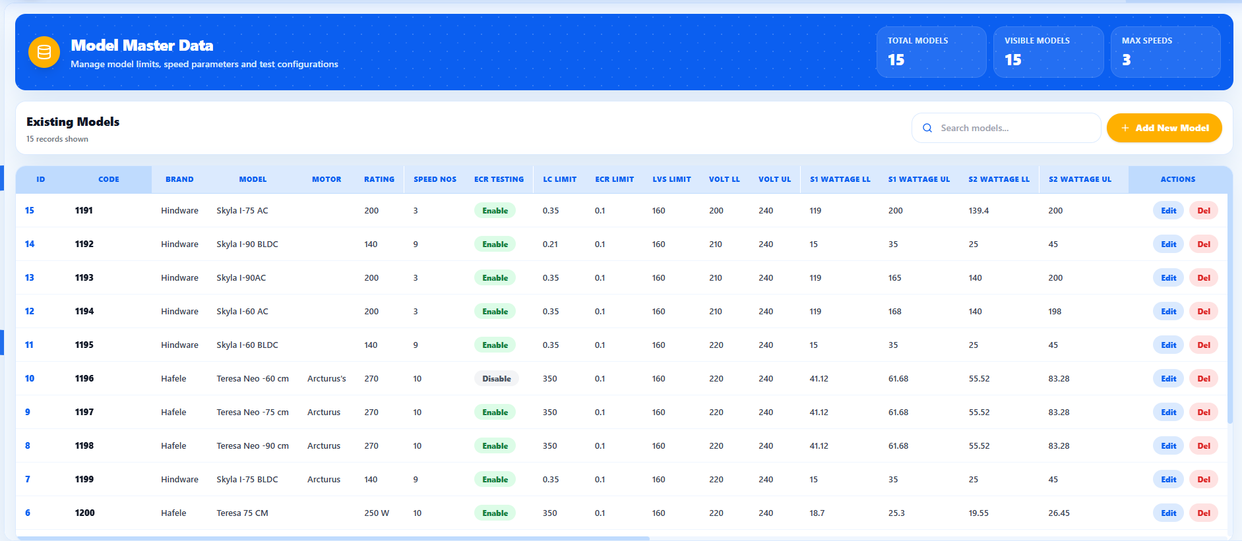

Screenshot SS-11 - Model Master Add/Edit Form
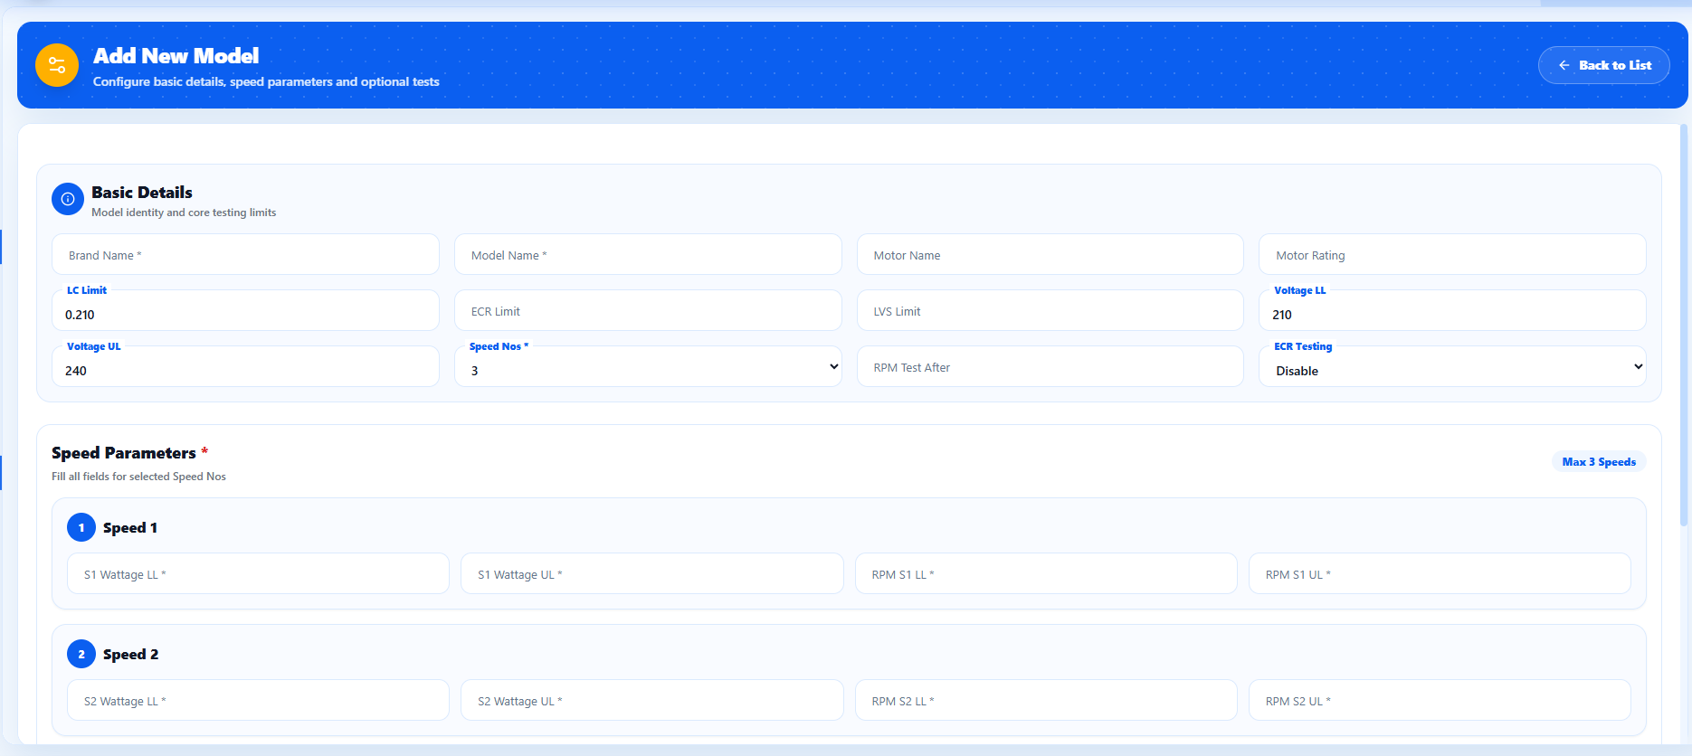

8. User Management
UI Route(s) | /userData
Purpose | Allows admin users to maintain application users and assign roles.

Key Features
Feature | What it does | User value
User listing | Shows username, name, email, phone, role, created date, and actions. | Provides a complete user master view.
Search users | Search box filters users by visible data. | Finds a user quickly.
Role filter | Filter users by assigned role. | Helps check role-wise user access.
Role distribution | Dashboard shows role/user counts in summary cards. | Quickly summarizes user access spread.
Add user | Add User button opens a modal/form. | Creates new application users.
Edit user | Edit action pre-fills user details. | Updates user details and role mapping.
Delete user | Delete action removes users after confirmation. | Removes obsolete users.
Password visibility in UI | UI includes a password reveal action for listed users. | Useful for admin checking, but should be reviewed before production use.

How to Use
- Open /userData.
- Use search or role filter to locate a user.
- Click Add User to create a new account.
- Select the correct role so the user receives the correct dashboard menu.
- Use Edit/Delete carefully because it impacts access.

Screenshot Placeholder
Screenshot SS-12 - User Management
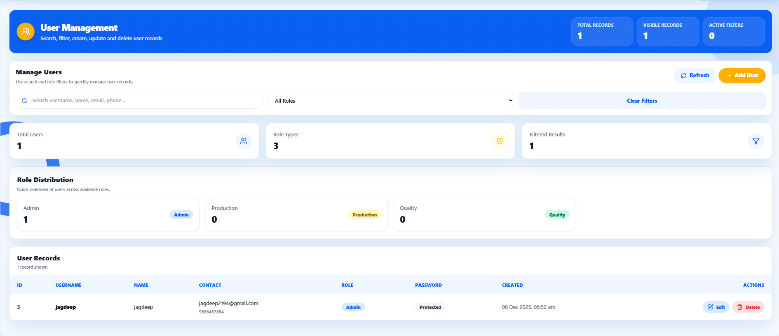

9. Page, Role & Category Management
UI Route(s) | /page-manager, /role-manager
Purpose | Controls dashboard navigation, page access, categories, and role-wise page mappings.

Key Features
Feature | What it does | User value
Page Manager | Add, edit, and delete dashboard pages with page name and URL. | Defines which screens can appear in the dashboard menu.
Role Manager | Add and update roles. | Creates user groups for access control.
Role-page mapping | Map pages to roles with ordering. | Controls what each role can access and how menu items appear.
Category Manager | Create and update menu categories. | Groups pages into readable dashboard sections.
Role-wise menu API | Dashboard fetches menu using role ID. | Enforces role-based navigation at runtime.

How to Use
- Open /page-manager to create or edit menu pages.
- Open /role-manager to create roles and assign pages.
- Create categories before grouping pages if required.
- After changes, login with a user of that role and verify the dashboard menu.

Screenshot Placeholder
Screenshot SS-13 - Page Manager
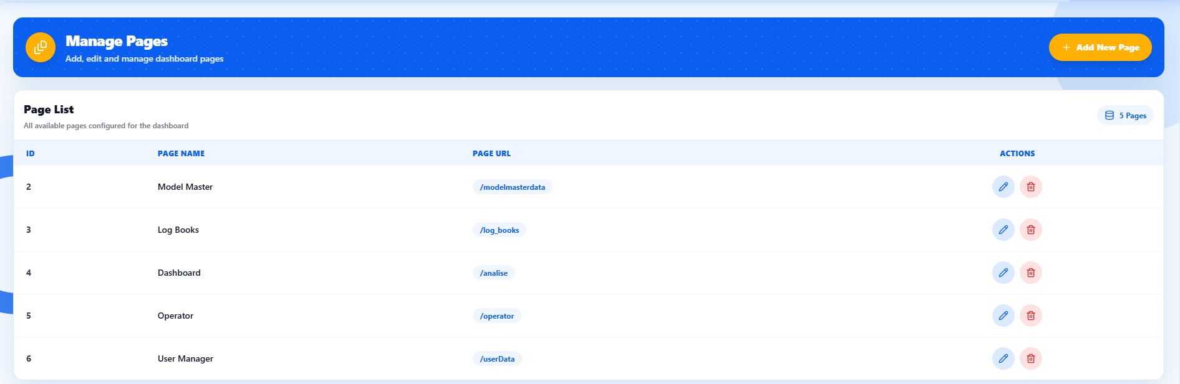

Screenshot SS-14 - Role Manager
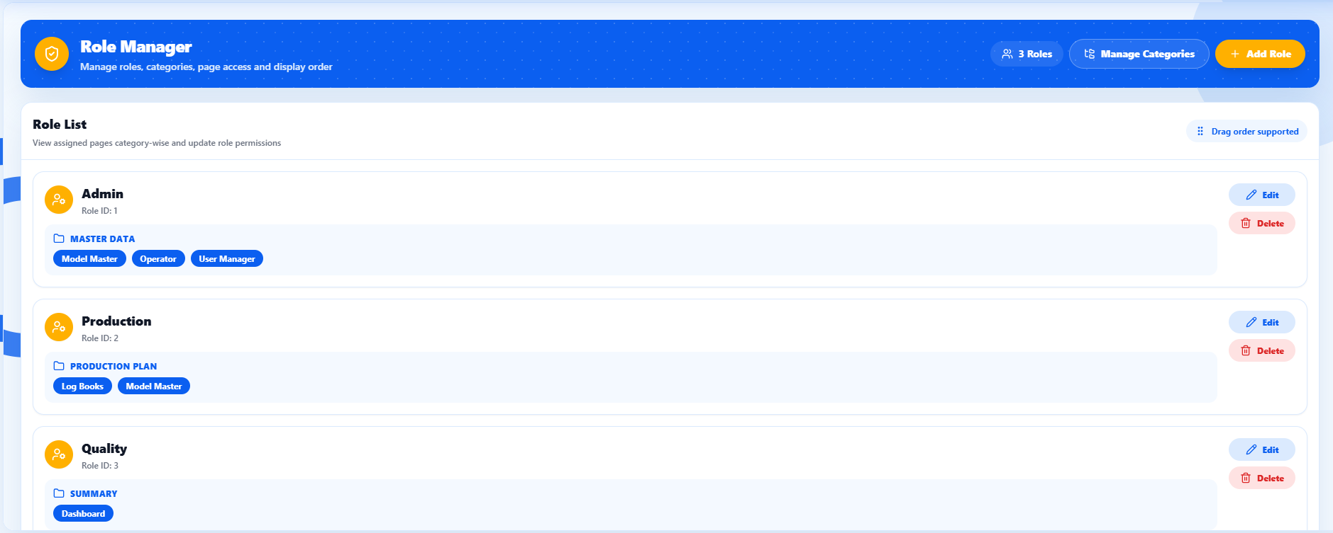

10. API Reference Summary
The table below summarizes the HTTP endpoints found in the uploaded Node-RED flow. These routes support the UI screens and CRUD operations described above.
Module | Method | Route | Purpose
Addon Screen | GET | /analise | Loads shift analysis dashboard UI.
Addon Screen | GET | /logbook/shift/hourlyproduction | Returns hour-wise production trend.
Addon Screen | GET | /logbook/shift/modelmix | Returns model-wise production mix.
Addon Screen | GET | /logbook/shift/rejection/7days | Returns seven-day rejection trend.
Addon Screen | GET | /logbook/shift/rejection/today | Returns today rejection breakdown.
Addon Screen | GET | /logbook/shift/summary | Returns tested/pass/fail/running model summary.
Dashboard Screen Auth + Pages + Roles Clean | GET | /admin_login | Loads login screen.
Dashboard Screen Auth + Pages + Roles Clean | GET | /api/categories | Read categories.
Dashboard Screen Auth + Pages + Roles Clean | POST | /api/categories | Create category.
Dashboard Screen Auth + Pages + Roles Clean | DELETE | /api/categories/:id | Delete category.
Dashboard Screen Auth + Pages + Roles Clean | PUT | /api/categories/:id | Update category.
Dashboard Screen Auth + Pages + Roles Clean | POST | /api/login | Authenticates user and returns role menu.
Dashboard Screen Auth + Pages + Roles Clean | GET | /api/menu/:roleId | Returns role-wise dashboard menu.
Dashboard Screen Auth + Pages + Roles Clean | GET | /api/pages | Read pages.
Dashboard Screen Auth + Pages + Roles Clean | POST | /api/pages | Add page.
Dashboard Screen Auth + Pages + Roles Clean | DELETE | /api/pages/:id | Delete page.
Dashboard Screen Auth + Pages + Roles Clean | PUT | /api/pages/:id | Update page.
Dashboard Screen Auth + Pages + Roles Clean | GET | /api/roles | Read roles and mapped pages.
Dashboard Screen Auth + Pages + Roles Clean | POST | /api/roles | Create role and page mappings.
Dashboard Screen Auth + Pages + Roles Clean | PUT | /api/roles/:id | Update role and page mappings.
Dashboard Screen Auth + Pages + Roles Clean | GET | /dashboard_admin | Loads dashboard container.
Dashboard Screen Auth + Pages + Roles Clean | GET | /dashboard_user | Loads dashboard container.
Dashboard Screen Auth + Pages + Roles Clean | GET | /login | Loads login screen.
Dashboard Screen Auth + Pages + Roles Clean | GET | /page-manager | Loads Page Manager UI.
Dashboard Screen Auth + Pages + Roles Clean | GET | /role-manager | Loads Role Manager UI.
Log Book | GET | /log_books | Loads Log Book dashboard UI.
Log Book | GET | /testdata | Returns paginated and filtered log_book data.
Log Book | GET | /testdata/export | Returns filtered data for Excel export.
Model Master Dashboard | DELETE | /api/modelmasterdata | Delete model master record.
Model Master Dashboard | GET | /api/modelmasterdata | List model master records.
Model Master Dashboard | POST | /api/modelmasterdata | Create model master record.
Model Master Dashboard | PUT | /api/modelmasterdata | Update model master record.
Model Master Dashboard | GET | /modelmasterdata | Loads Model Master UI.
Operator | GET | /operator | Loads Operator Management UI.
Operator | GET | /operatorinfo | Read operator records.
Operator | POST | /operatorinfo | Create operator record.
Operator | DELETE | /operatorinfo/:id | Delete operator record.
Operator | GET | /operatorinfo/:id | Read operator records.
Operator | PUT | /operatorinfo/:id | Update operator record.
Users Data Clean | GET | /userData | Loads User Management UI.
Users Data Clean | GET | /users | Read users.
Users Data Clean | POST | /users | Create user.
Users Data Clean | DELETE | /users/:id | Delete user.
Users Data Clean | PUT | /users/:id | Update user.

11. Data Sources and Technical Notes

11.1 Database Tables Found in SQL
Table | Used By | Purpose
log_book | Log Book + Shift Analytics | Stores test log records, timestamps, model/product details, statuses, and final result.
operatorInfo | Operator Management | Stores operator ID, operator name, role, shift, and creation timestamp.
modelmasterdata | Model Master | Stores model-wise production/test limits and configuration parameters.
users | Login + User Management | Stores login/user profile data and role assignment.
roles | Role Manager | Stores role names.
role_pages | Role Manager + Dashboard Menu | Maps roles to pages and page order.
pages | Page Manager | Stores page names and URLs for dashboard navigation.
categories | Role/Menu Manager | Stores menu categories used to group pages.

11.2 Functional Highlights from Code
Feature | What it does | User value
Parameterized APIs | Several APIs use ? placeholders and msg.payload arrays for safer MySQL queries. | Better protection for paginated log data and user CRUD.
Dynamic API base URL | UI pages build API base URL using current protocol, host, and configured api_port. | Same UI can run on different machines without hard-coded host.
Styled Excel export | Export builds an Excel-compatible HTML file with headers, freeze panes, and PASS/FAIL colors. | Improves readability of reports.
Client-side UI enhancements | Tailwind CSS, modals, loaders, toast messages, filters, cards, and responsive layouts are used. | Makes the UI easier for operators/admins to use.
Role-based menu | Menu is generated from roles, pages, categories, and role_pages mapping. | Supports access-based navigation.

11.3 Production Improvement Notes
Important security notes
The uploaded code includes places where SQL is built using string interpolation, especially in some Operator and Model Master operations. It also shows plain-text password storage/display patterns in User Management. Before production release, move all SQL writes to parameterized queries, hash passwords, remove password display from UI, add server-side authorization checks, and validate all input fields.

Testing notes
This document is based on static analysis of the uploaded Node-RED flow. The flow was not executed against a live database here. Validate route behavior, login behavior, SQL schema compatibility, and screenshots in the deployed environment before sharing this as a final operational manual.

12. UI Template Inventory
The following HTML templates were found in the flow. Some modules contain more than one template version; keep only the latest/required version in the final deployed flow to avoid confusion.
Module | Template Node | HTML Title | Approx. Size
Log Book | Log Book HTML | Log Book Dashboard - 1 to 3 Speed | 21540 chars
Log Book | Log Book HTML | Log Book Dashboard | 28347 chars
Addon Screen | Addon Screen HTML | Logbook Shift Dashboard | 9647 chars
Addon Screen | Addon Screen HTML | Logbook Shift Dashboard | 9609 chars
Operator | Operator Admin HTML | Operator Info – Admin | 26907 chars
Operator | Operator Admin HTML | Operator Info – Admin | 9116 chars
Model Master Dashboard | 3rdh speed with TP power | Model Master Data | 27378 chars
Model Master Dashboard | 10th speed with TP power | Model Master Data | 26924 chars
Model Master Dashboard | 3rdh speed with TP power | Model Master Data | 26067 chars
Dashboard Screen Auth + Pages + Roles Clean | User Login | User Login | 4262 chars
Dashboard Screen Auth + Pages + Roles Clean | Dashboard Page | Saral Test Dashboard | 10015 chars
Dashboard Screen Auth + Pages + Roles Clean | Page Manager | Manage Pages – Modal UI | 8011 chars
Dashboard Screen Auth + Pages + Roles Clean | Role Manager | Manage Roles | 21846 chars
Dashboard Screen Auth + Pages + Roles Clean | Login HTML | Login - Super Admin | 2294 chars
Dashboard Screen Auth + Pages + Roles Clean | Dashboard HTML | Super Admin Dashboard | 3887 chars
Users Data Clean | Users UI HTML | User Management – Admin | 31189 chars
Users Data Clean | Users UI HTML | User Management | 8345 chars

13. Final Handover Checklist
- All UI screenshots added in the matching placeholder boxes.
- All routes tested from the deployed host and configured API port.
- Login tested with at least one normal user and one admin user.
- Role-wise menu verified after changing role/page/category mapping.
- Log Book filter, pagination, and Excel export tested with real data.
- Operator, Model Master, and User CRUD tested end-to-end.
- Security notes reviewed before production release.

