1. Open<http://35.153.30.160/#/>

a. If site looks like below, go to step 3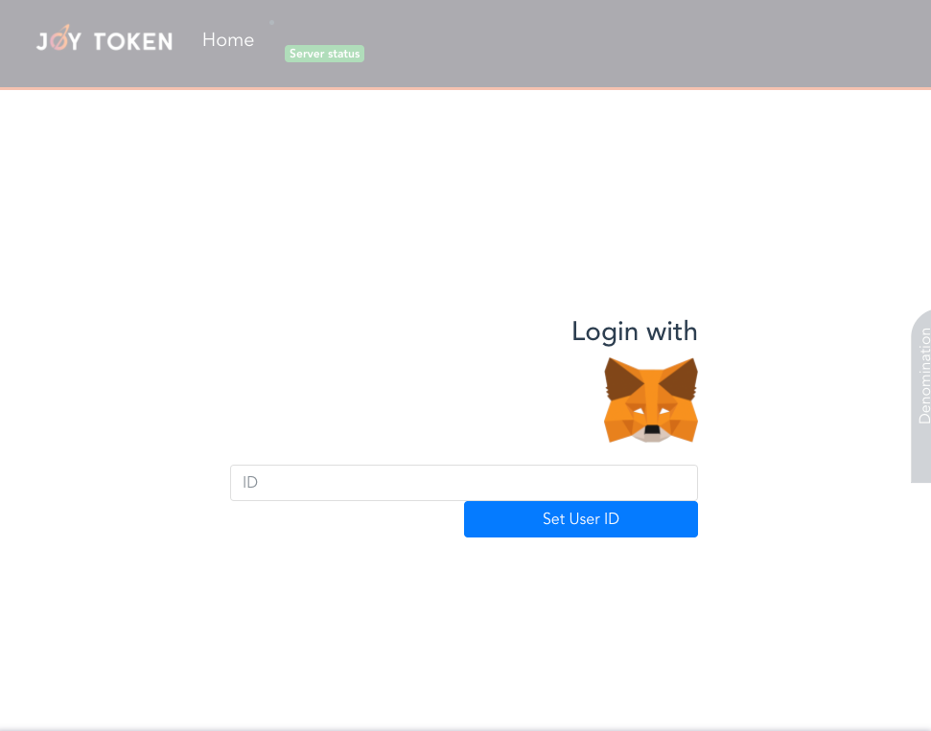

b. If the site is blank, please add manually MetaMask extension to your browser in step 2

2. Go to website <https://metamask.io/> and add correct extension for your browse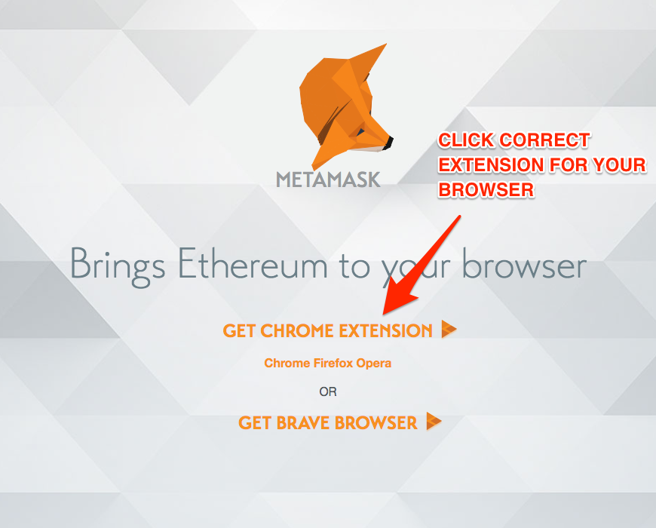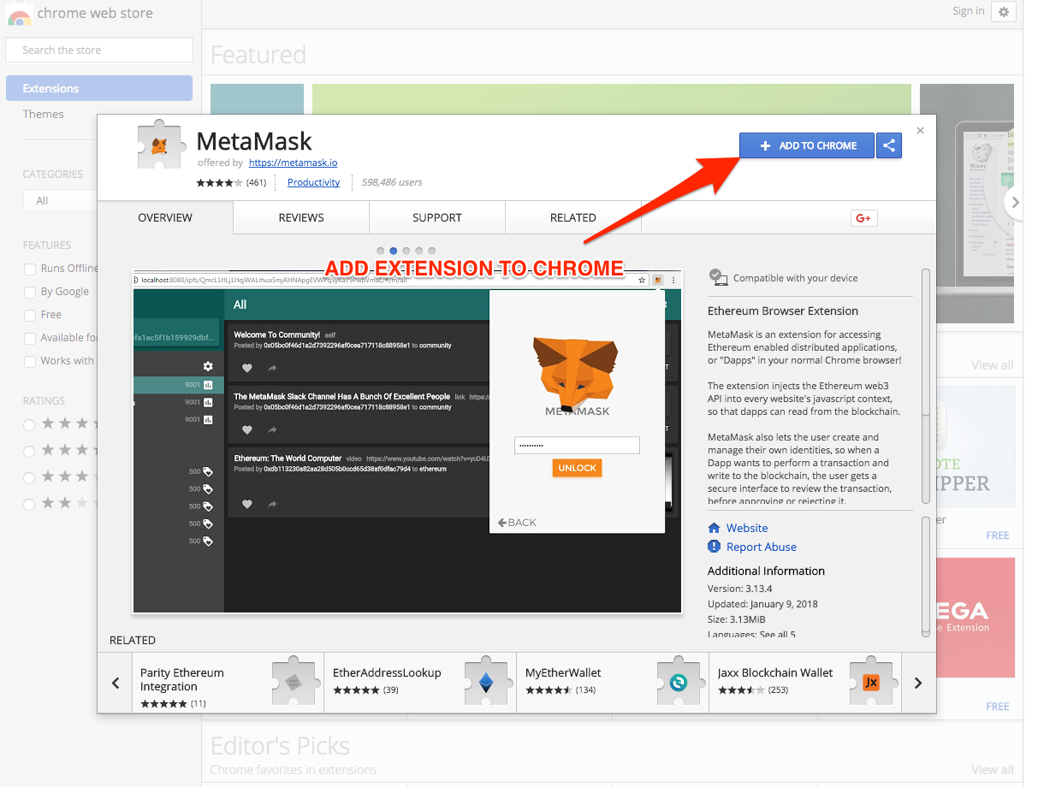r

**EXAMPLE IN CHROME:**

a)Click blue button “ADD TO CHROME”

b) accept permissions by click “Add extension”

c) after successful add of extension, back to site: **<http://35.153.30.160/#/>**

If site is blank,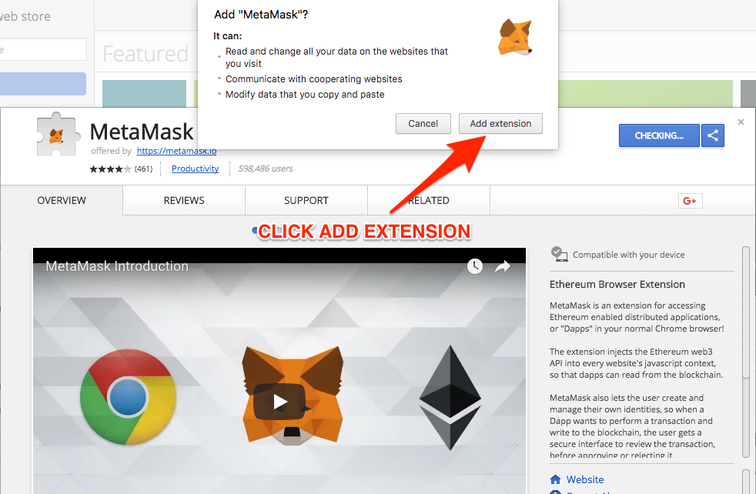 refresh site by click **CMD + R** (on Mac) or **F5** on Windows

3.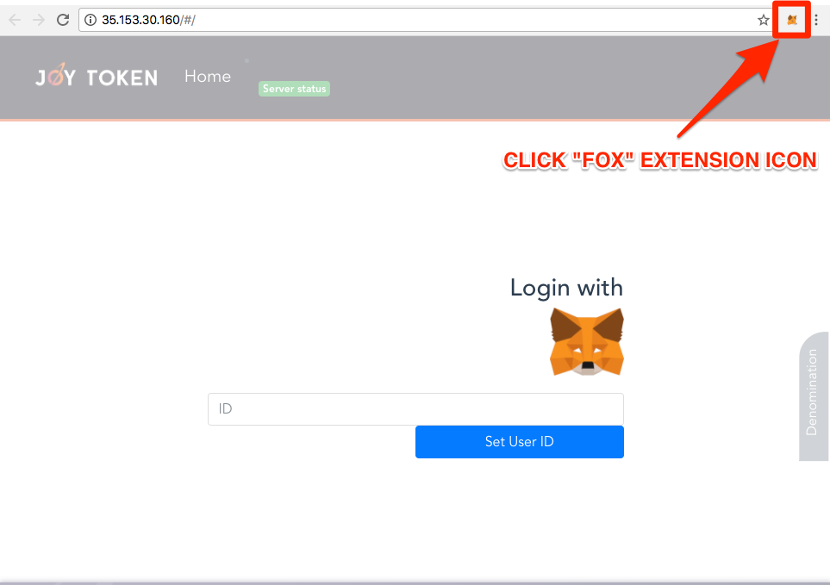 Click MetaMask icon extension (example still in Chrome)

4. Accept MetaMask “Privacy notice”

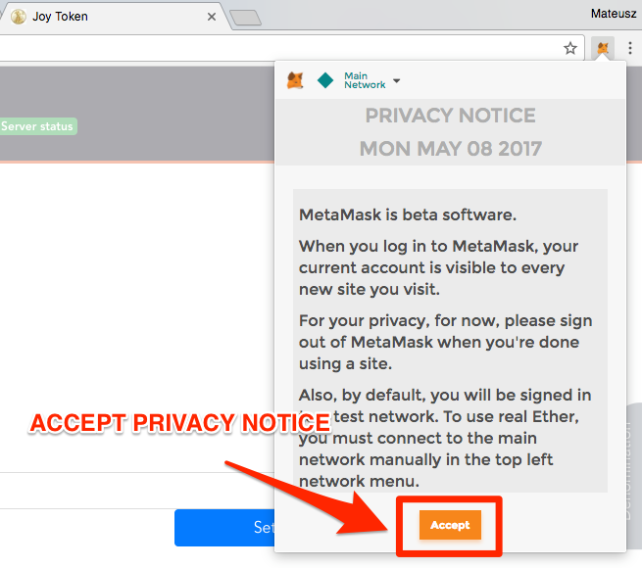

5. Scroll to bottom of “Terms of use” and after button “Accept” colour change from grey to orange, click them (button “Accept”) to accept “Terms of use”.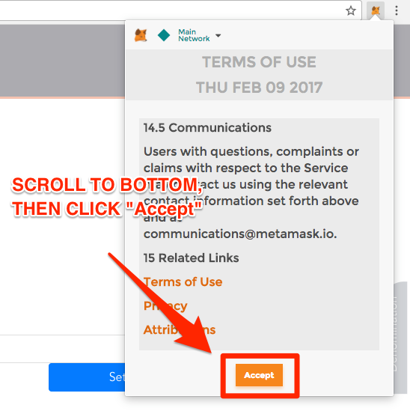

6. Click “Main Network” to change network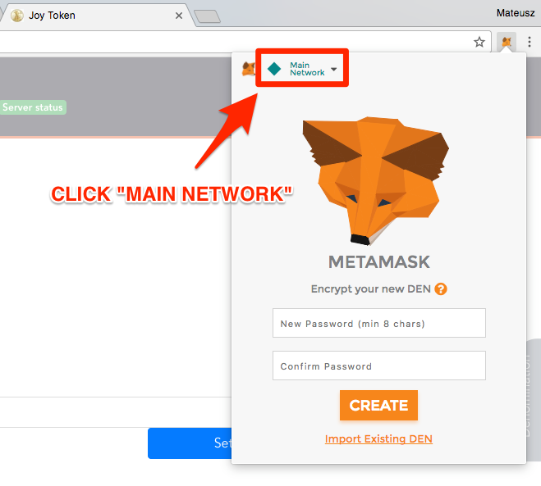

7.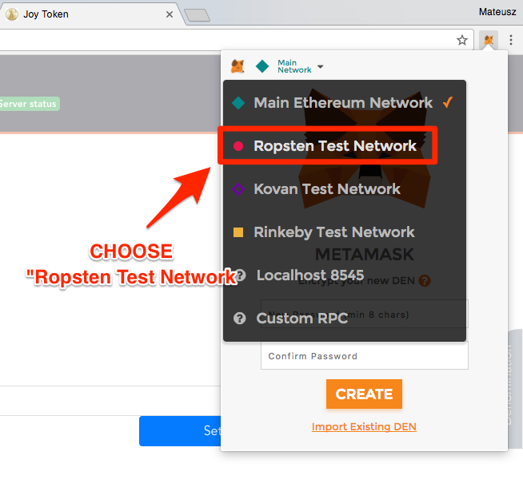 Choose “Ropsten Test Network” from the list

8. Now in top-left corner of dialog should be “Ropsten Test Net”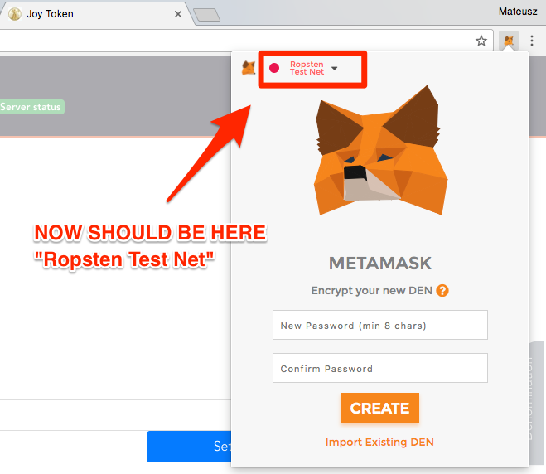

9. Input your password two times and click button “CREATE”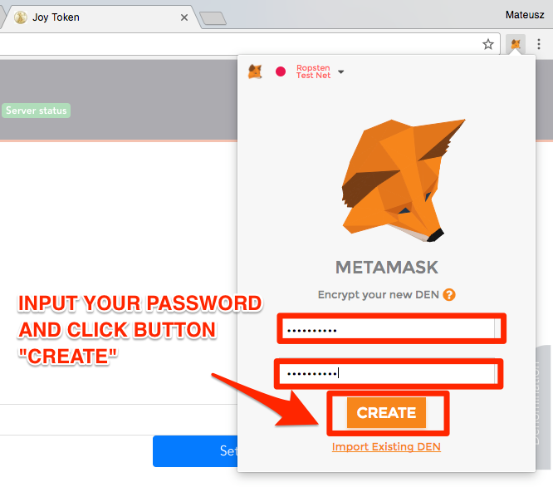

**10. VERY IMPORTANT !!!** Please copy this 12 words to safety place or save it in a file. This will let you to log in from another computer. Without this code, you will be not able to log in from another computer.

You can save it by check all text and click **CMD + C** (on Mac) or **CTRL + C** (on Windows) and save it in file somewhere on a disk. Or you can click button “SAVE SEED WORDS AS FILE” to download “csv” file.

After save this key words, click button “I’VE COPIED IT SOMEWHERE SAFE”.

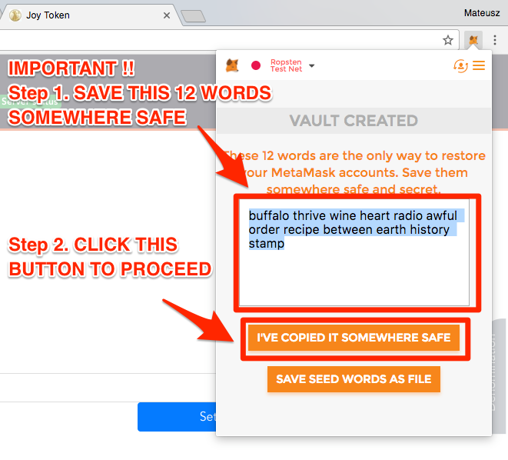

11. Your “ETH” balance is now 0. You need buy some “ETH”. Click button “BUY”

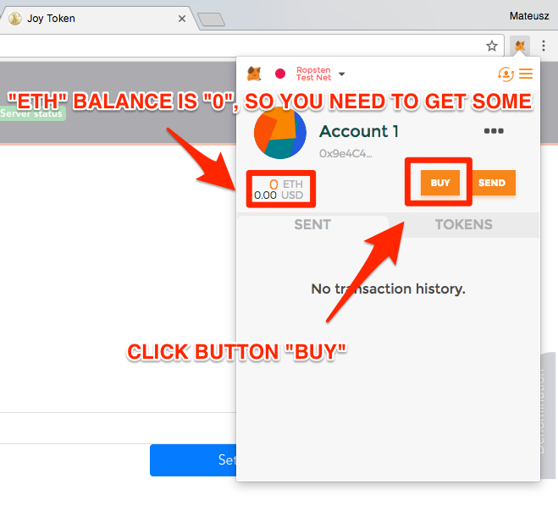

12. Click button “ROPSTEN TEST FAUCET”

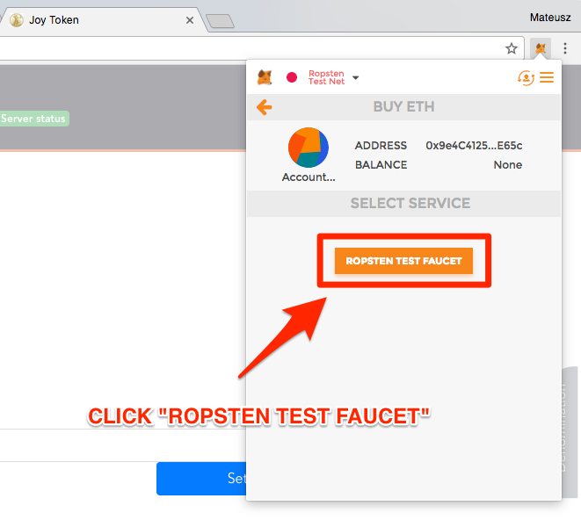

13. Click green button “request 1 ether from faucet”

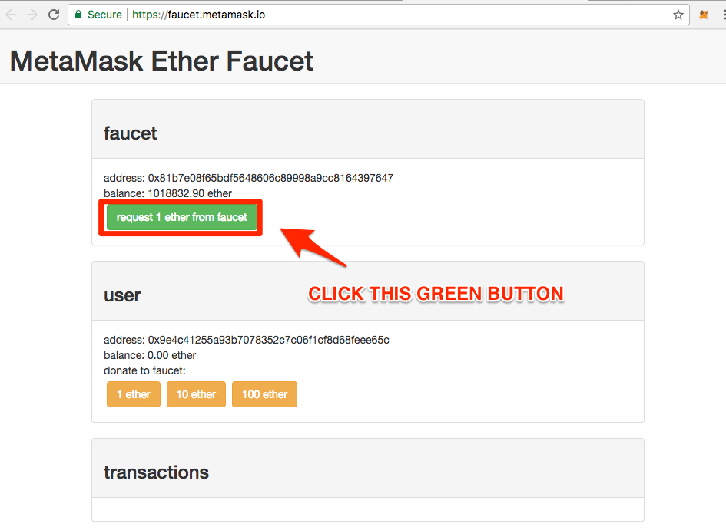

14. In the “Transaction” on the bottom should appear link to transaction pending status. If link will not appear, please try click a few times again green button “request 1 ether from faucet” in a few seconds break time between clicks. If it still will not help, pleas try go to back to **<http://35.153.30.160/#/>** and make action from step 17.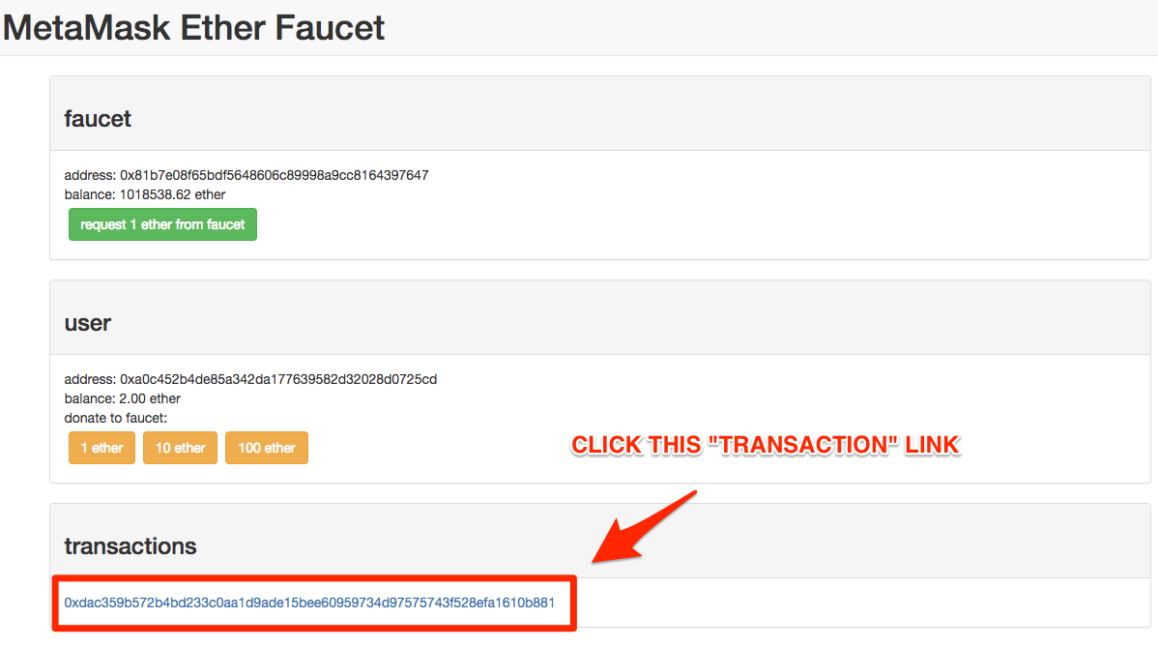

15. Wait for change status from “Pending” to “Success”. If after 1 minute status will not changed, please try refresh site by click **CMD + R** or **F5.**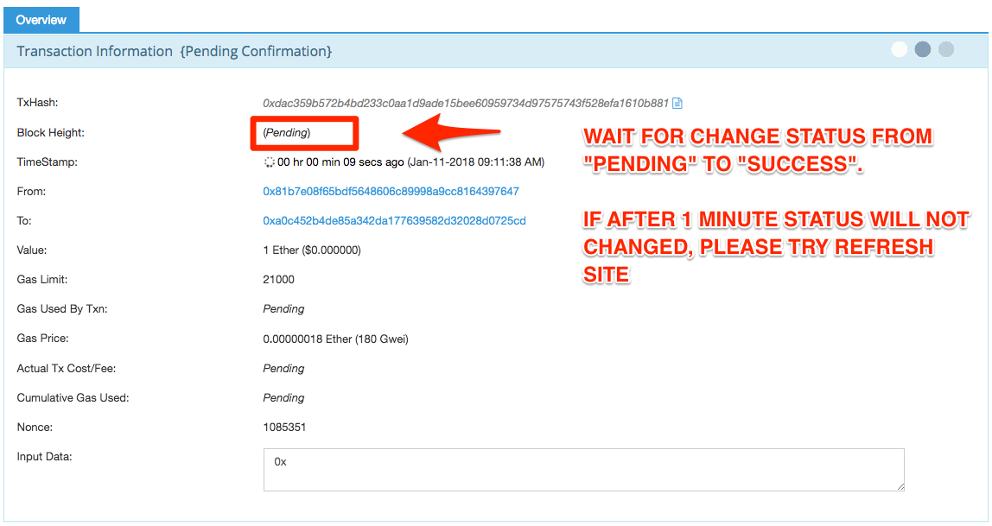

16. Aftes status changed to “success” please back to 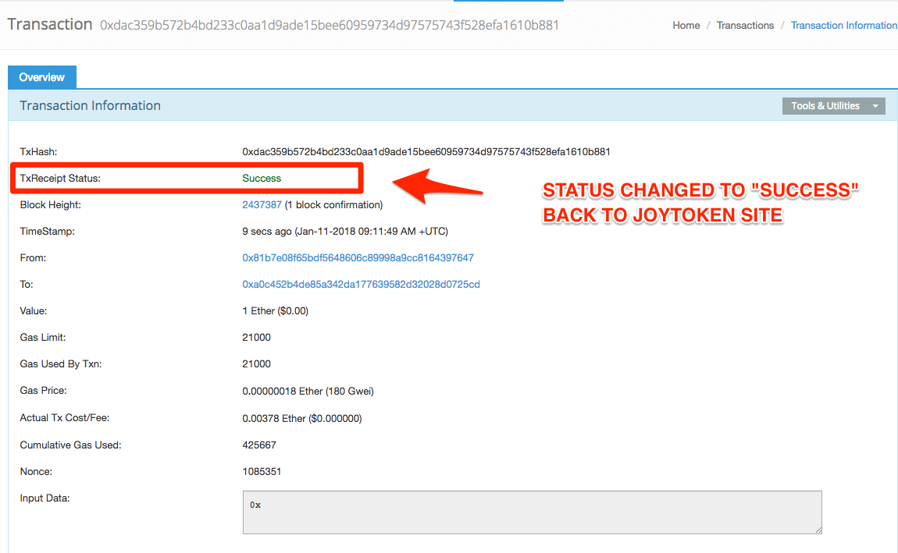 **<http://35.153.30.160/#/>**

17. After back to the site **<http://35.153.30.160/#/>** for have sure, please refresh site by click

**CMD + R** or **F5.**

Then click again “MetaMask” extension on your toolbar of browser and on the account dialog your balance of “ETH” should be changed. So close the dialog and go to next step.

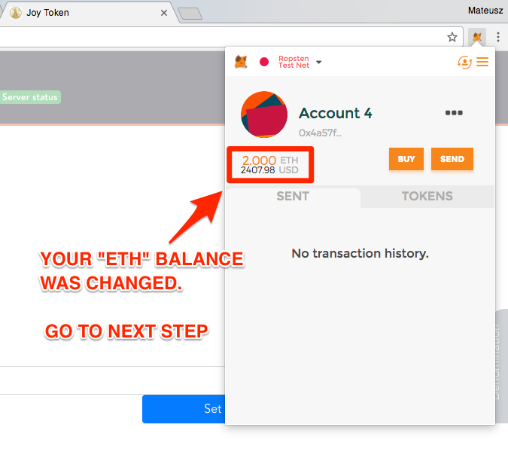

18. Click the MetaMask icon to log in

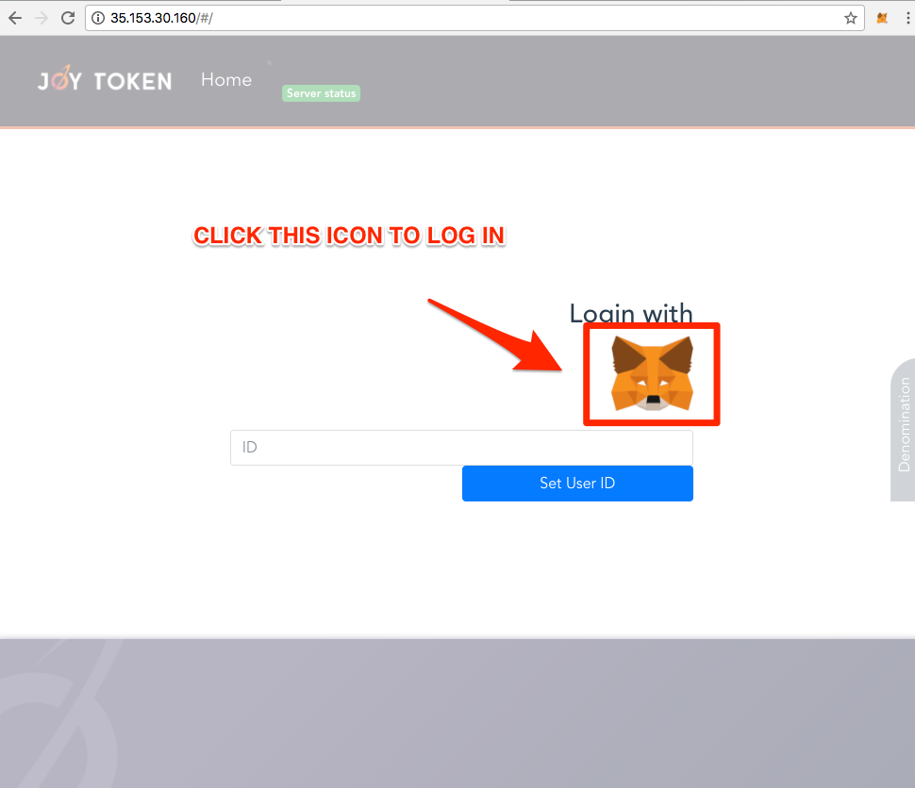

**19. LAST STEP:**

After successful log in, your JoyToken balance is now 0.

You have to contact with us to add JoyTokens to your account.

**ADDITIONAL: LOG IN FROM ANOTHER COMPUTER**

20. To log in from another computer on the same account after correct add “MetaMask” extension to your browser, please click “Import Existing DEN”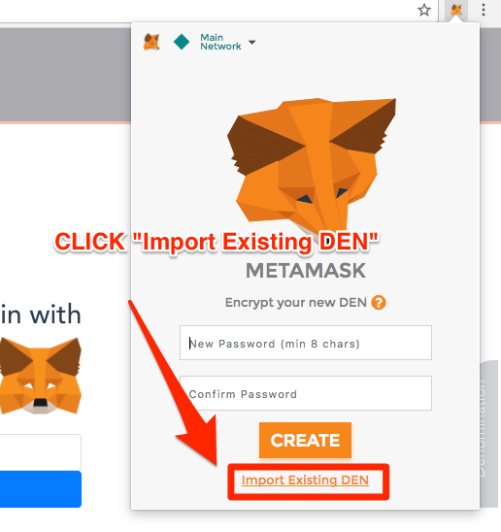

21. In “Wallet Seed” field pleas paste 12 words which you saved in Step 10 during your first time log in. Next input your password. Then click button “OK”

