su

Password

Visudo

Access given

1. sudo apt update

2. sudo apt install ns2

(select y)

3. man ns2(type q)

4. cd Desktop

5. sudo dpkg -i filename

6. Create new folder in Desktop and copy those 4 files and paste it in the new folder we just now created on desktop

7.cd CN

8.ns tcp.tcl

9.ns udp.tcl

10.ns linkstat.tcl

11.ns linkfail.tcl

**1)ipconfig** - Displays all current TCP/IP network configuration values and refreshes DHCP and DNS settings. Used to view and manage the IP configuration of network interfaces.

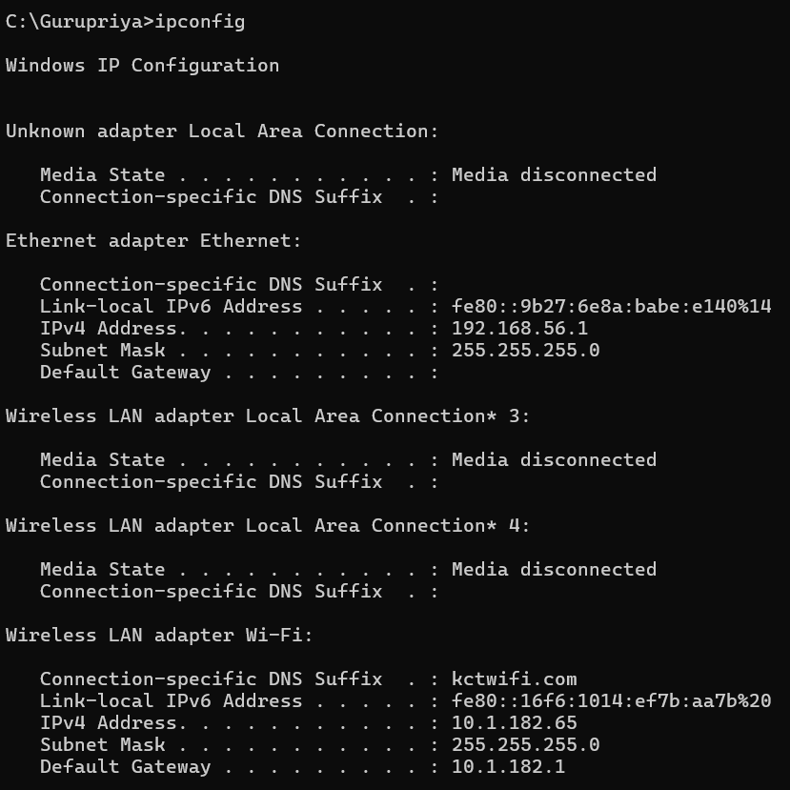

* **Ipconfig /release -** Releases the current DHCP lease, dropping the assigned IP address from the network adapter. Useful for troubleshooting and re-acquiring an IP address from the DHCP server.

* **Ipconfig /all -** Displays detailed IP configuration information, including DNS servers, DHCP lease information, and MAC addresses. Useful for comprehensive network diagnostics.

* **Ipconfig /renew-** Renews the DHCP lease, requesting a new IP address from the DHCP server. Useful for refreshing network settings and resolving IP address conflicts.

* **Ipconfig /flushdns -** Clears the DNS resolver cache, forcing the system to re-query DNS servers for domain name resolutions. Useful for resolving DNS resolution issues and ensuring up-to-date DNS information.

* **Ipconfig /displaydns-** Displays the contents of the DNS resolver cache. Useful for viewing cached DNS entries and troubleshooting DNS issues.

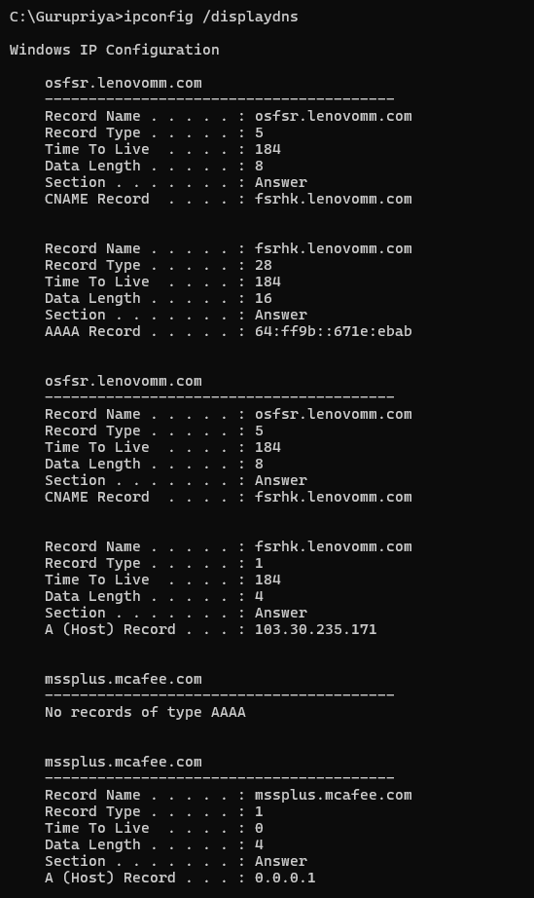

1. Write the use of *ping* command and show the any 5 variants of the command.

*Sol:*

**2)ping** - Sends ICMP Echo Request messages to network hosts to test reachability and measure round-trip time. Useful for checking connectivity to a network device.

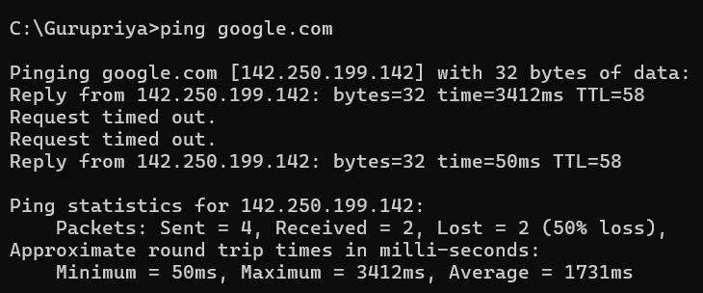

* **ping -n -** Ping with a Specific Number of Echo Requests. Use the -n option to specify the number

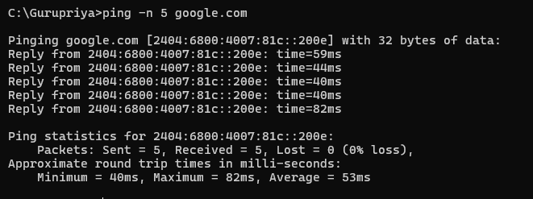

* **ping -1** Ping with a Specific Packet Size. Use the -1 option to specify the size of the ICMP Echo Request message in bytes.

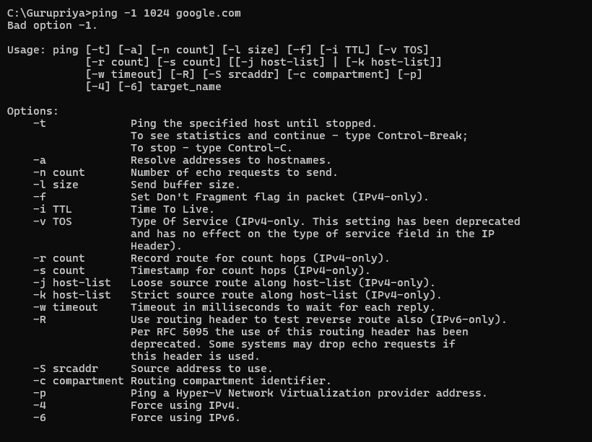

* **ping -t -** Ping Continuously Until Stopped. Use the -t option to send ping requests continuously until interrupted with Ctrl+C.

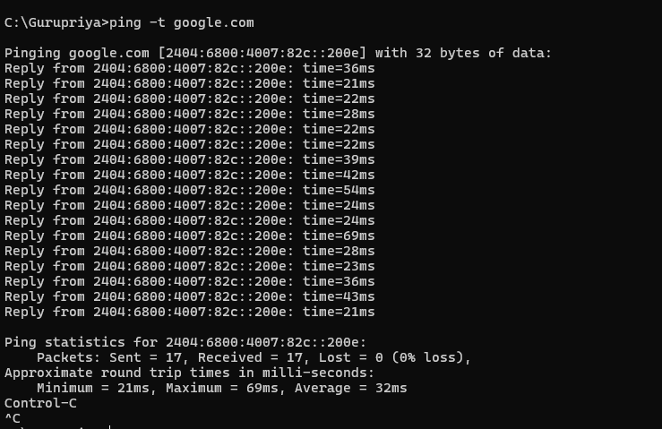

* **ping -w –** Ping with a Specific Timeout.Use the -w option to specify a timeout in milliseconds for each reply.

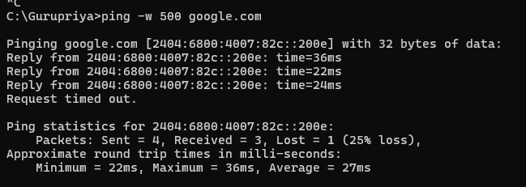

* **ping ip_address -** Ping a Specific IP Address. Instead of a domain name, you can ping a specific IP address directly.

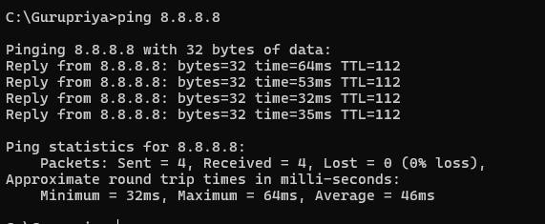

3. Write the use of *tcpdump(windump)* command execute the following commands.

a. windump -i 1

b. windump -i 1 port 80

c. windump -i 1 -w C:\net\fcap.pcap

Sol:

a.windump -I 1

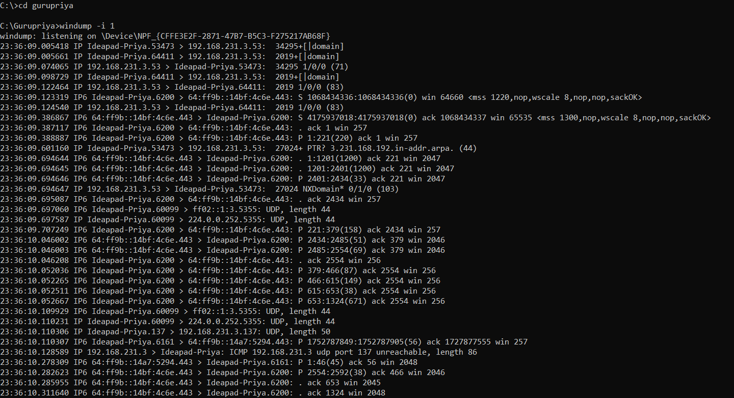

b**.** windump -i 1 port 80

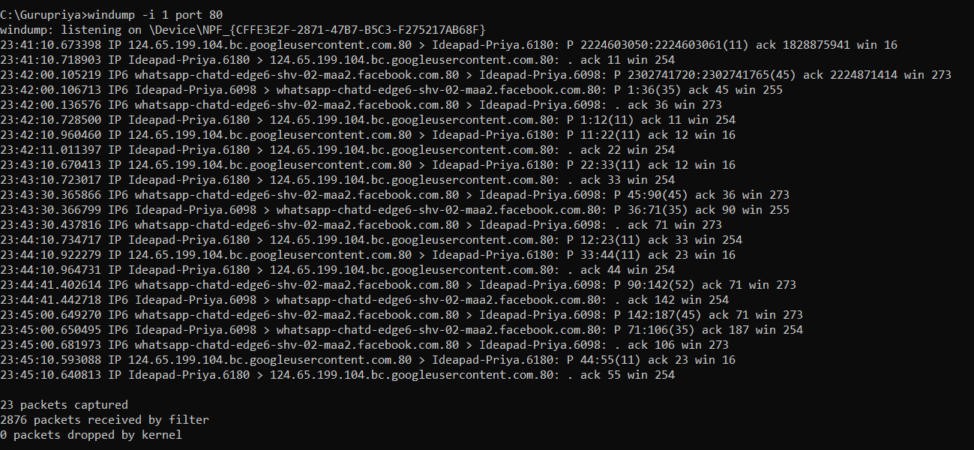

1. windump -i 1 -w C:\net\fcap.pcap

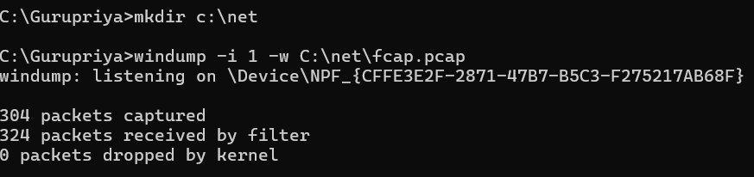

4. Write the use of *traceroute* command and show the any 5 variants of the command.

Sol:

**tracert-** Useful for checking connectivity to a network device. Helps identify routing paths and potential points of failure or delay.

* **tracert -h -** Specify Maximum Hops. Use the -h option to specify the maximum number of hops to search for the target.

* **tracert -w -** Sets the timeout period in milliseconds for each response.

* **tracert -d** - Disables DNS resolution of IP addresses to hostnames, which can speed up the trace.

* **tracert (use IPv4) -** Forces the use of IPv6 instead of the default IPv4.

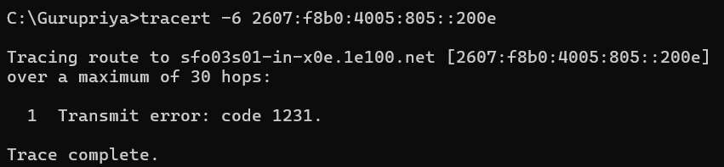

5. Write the use of *netstat* command and show the any 5 variants of the command.

Sol:

**netstat -a** - Shows all active connections and the TCP and UDP ports on which the computer is listening. This is useful for getting a comprehensive overview of all network activity on the system.

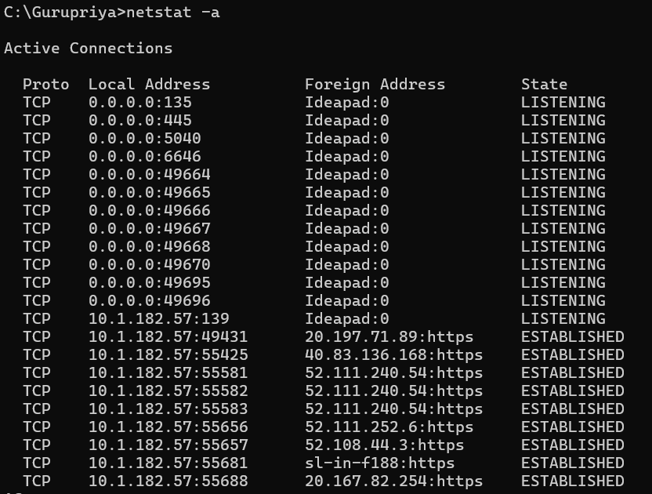

* **netstat -e** - Shows detailed statistics on network interfaces, including the total number of bytes and packets sent and received, errors, and discards. This command is useful for monitoring the performance and health of network interfaces.

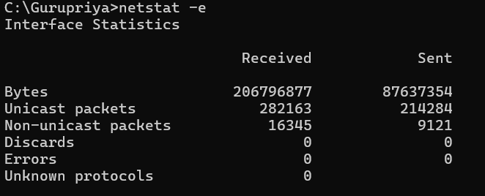

* **netstat -r -**Displays the routing table, showing how network packets are routed through your network. This helps in understanding the network's routing infrastructure and troubleshooting routing problems.

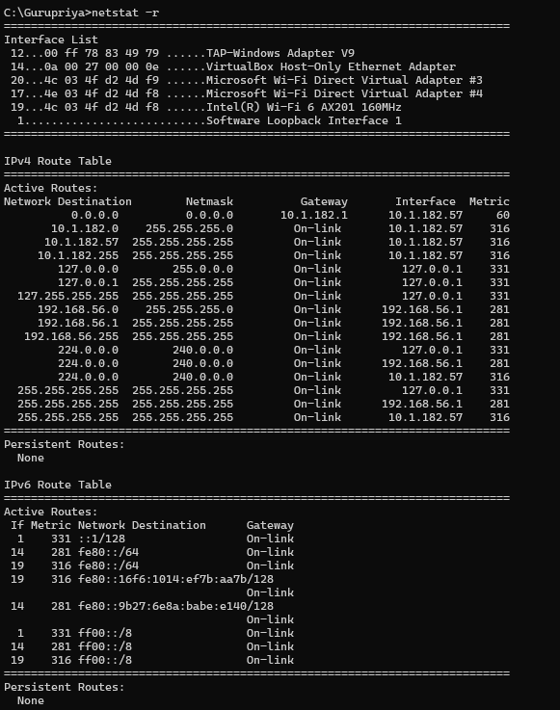

* **netstat -s**  - Provides statistics for all network protocols, including TCP, UDP, ICMP, and IP. This command is useful for diagnosing protocol-specific network issues and analyzing overall network performance.

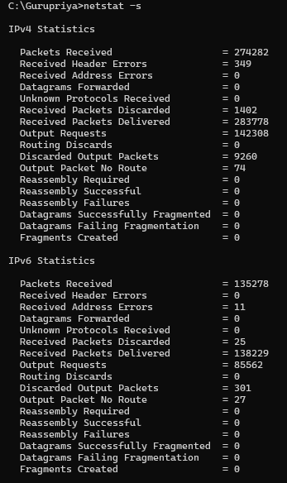

* **netstat -b -** Lists all network connections along with the process ID (PID) and the executable name of the application that owns each connection. This command is particularly useful for identifying applications that are generating network traffic.

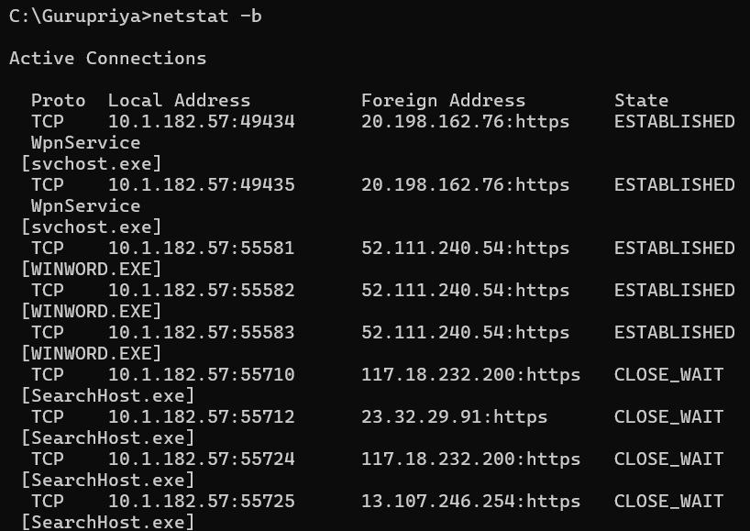

**Other commands:**

**6)nslookup-** Queries the DNS to obtain domain name or IP address mappings. Handy for troubleshooting DNS-related problems.

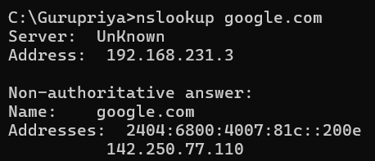

**7)hostname-** Shows or sets the system's hostname. Important for identifying devices on a network and managing system identification.



**8)route-** Displays or modifies the IP routing table. Essential for managing and troubleshooting network routing and paths.

**9)arp-** Displays and modifies the ARP (Address Resolution Protocol) cache, which maps IP addresses to MAC addresses.Useful for diagnosing network issues related to ARP and for network security.

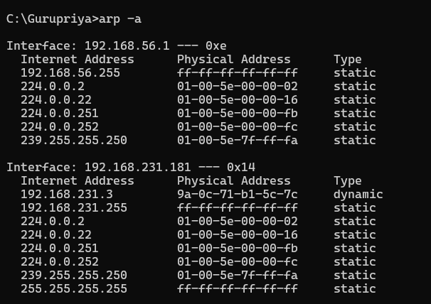

**10)route-** Displays and modifies the IP routing table. Essential for managing network routing and paths.

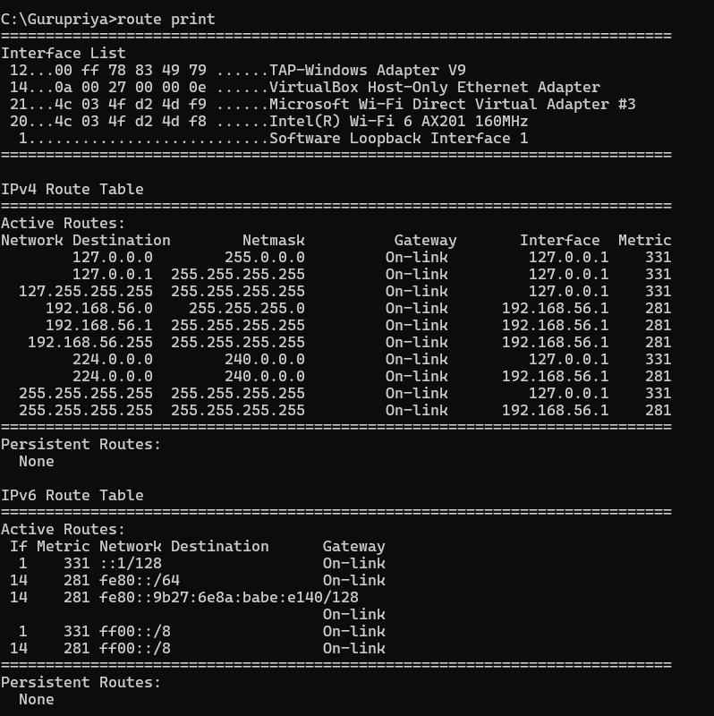

**11)** **netsh-** A command-line scripting utility that allows you to display or modify the network configuration of a computer. Used for various network-related configurations and also diagnostics.

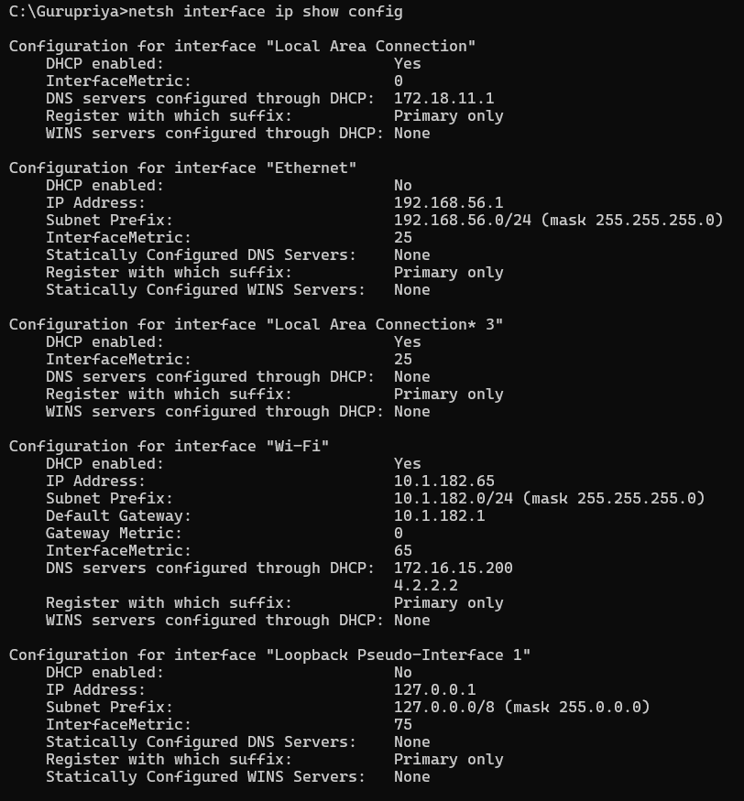

**12) nbtstat-** Displays protocol statistics and current TCP/IP connections using NetBIOS over TCP/IP.Useful for troubleshooting NetBIOS name resolution issues.

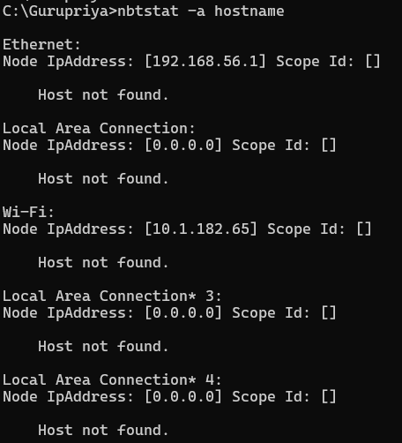

**14) tasklist / taskkill-** tasklist displays a list of running processes. taskkill terminates tasks by process ID or image name. Useful for managing processes that may affect network performance.

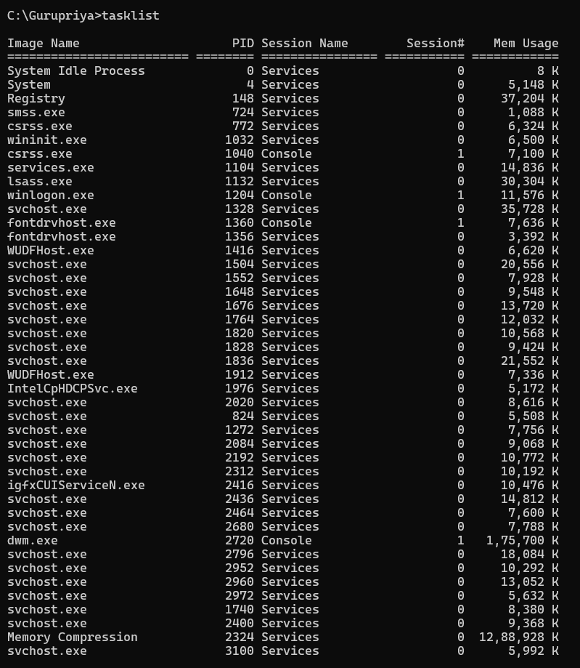

**15)systeminfo-** Displays detailed configuration information about a computer and its operating system. Useful for gathering information about the system’s network configuration and history.

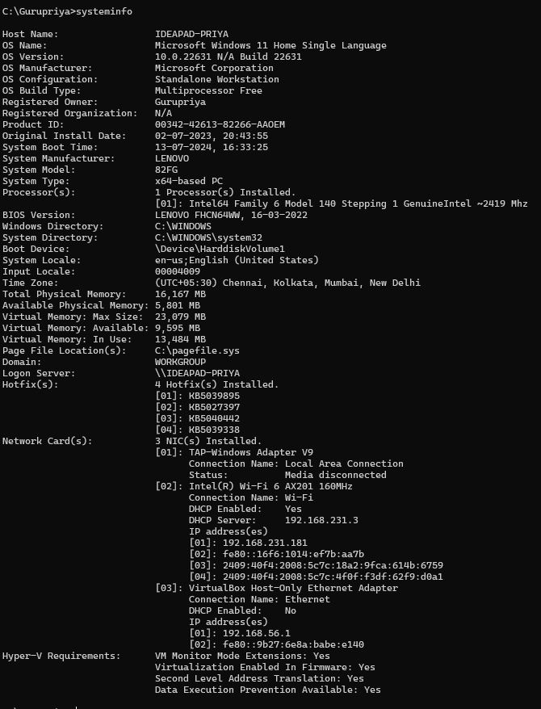

**16)pathping-** Combines the functionality of ping and tracert to provide detailed information about network paths. Useful for diagnosing intermittent network issues.

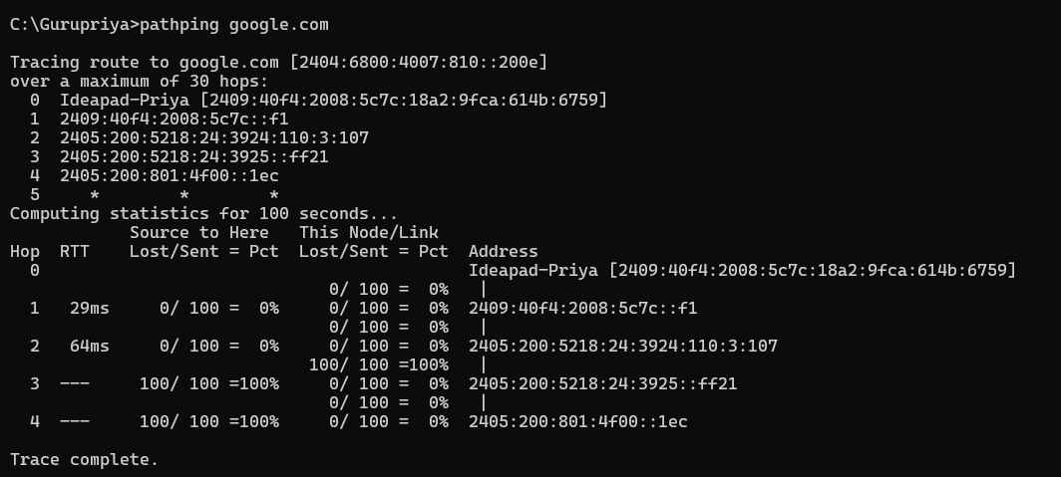

**17)net user-** Displays and manages user accounts. Useful for network administrators managing user access.

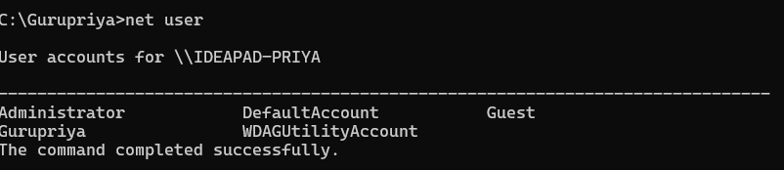

**18) netsh wlan show profiles-** Displays the list of wireless network profiles stored on the computer. Useful for managing and troubleshooting wireless connections.

**19)get-netadapter-** A PowerShell command that retrieves information about network adapters. Useful for viewing and managing network adapter configurations.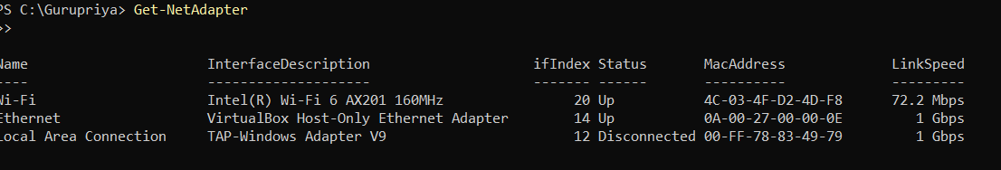

**20)curl-** Transfers data from or to a server using various protocols (HTTP, FTP, etc.).Versatile tool for testing and interacting with web services and APIs.

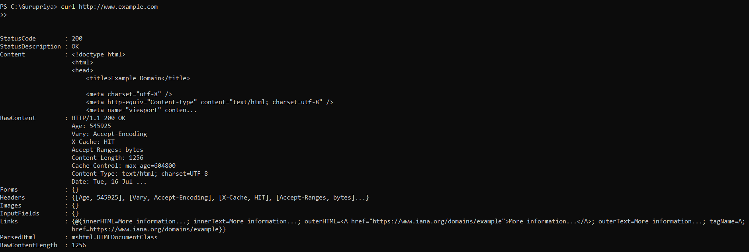

Post Lab:

**Result:**