**Diagnostic Rev. 586220 Harness - Cassette Port Rev. 1**

**Module Description**

This PCB is a part of the harness for the Diagnostic Rev. 586220 test software for the Commodore C64.

The cassette port PCB connects to the cassette port of the C64 and provides the signal on a 2x3 pin header, which is connected to the central component of the Diagnostic Rev. 586220 harness, the user port PCB.

J3 provides the WRITE signals, which serves for switching off the analog switches on the extended Keyboard Dongle (Project No. 143).

This version of the Cassette Port Dongle can be used with version 0 of the user port dongle and the previous keyboard dongle (Project No. 116) or the extended keyboard dongle. The WRITE signal only connects to the latter.

There are two LEDs on this PCB. One showing the status of the Motor Signal and the other showing the status of the SENSE signal. To keep the load low on the sense signal, a transistor amplifies the SENSE to provide enough current for the latter LED.

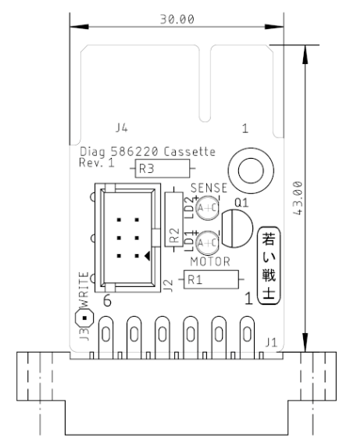

Figure : The CASSETTE Port PCB

The male Cassette Port edge connector was added to make this a real break out board, which fits between the C64 and the Datasette.

# Pin outs

## Cassette Port

J1 – 2 x 6p edge connector (pitch 3.96mm)

|  |  |  |  |
| --- | --- | --- | --- |
| **Pin** | **Signal** | **Pin** | **Signal** |
| 1 | GND | A | GND |
| 2 | +5V | B | +5V |
| 3 | MOTOR | C | MOTOR |
| 4 | READ | D | READ |
| 5 | WRITE | E | WRITE |
| 6 | SENSE | F | SENSE |

## Harness Connector

J2 – 2x3p Pin Header (pitch 2.54mm)

|  |  |  |  |
| --- | --- | --- | --- |
| **Pin** | **Signal** | **Pin** | **Signal** |
| 1 | GND | 2 | +5V |
| 3 | MOTOR | 4 | READ |
| 5 | WRITE | 6 | SENSE |

## WRITE Pin

J3 – 1x1p Pin Header

|  |  |
| --- | --- |
| **Pin** | **Signal** |
| 1 | WRITE |

# Test

The test was passed successfully. It is described in the document of the User Port Dongle.

# Revision History

## Rev. 0 → Rev. 1

* J3 is new. It provides the WRITE Signal for the Extended Keyboard Dongle.
* The Sense LED was added.
* The male edge connector was added to make this PCB a cassette breakout board