**Diagnostic Rev. 586220 Harness - User Port Rev. 1**

**Module Description**

The User Port module is the central part of the Diagnostic Rev. 586220 harness. It provides the required feedback connections for testing the C64’s CIA U2, which is connected to the user port. It also holds the analog switches, which are required to test the Control Ports and the feedback connections for testing the cassette port.

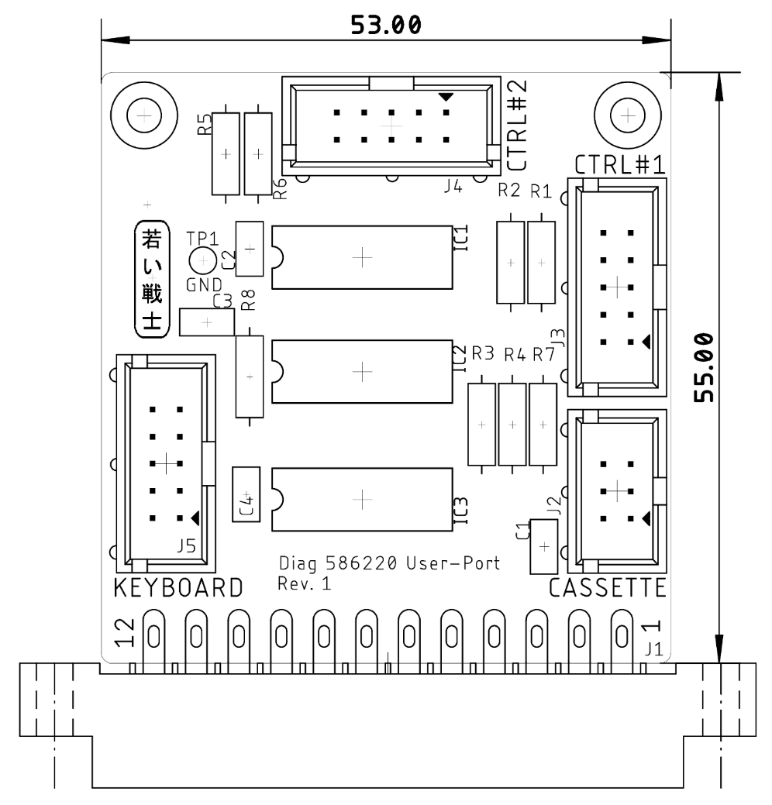

Figure : User Port PCB

The MOTOR output signal of the cassette port has approximately a 6V level. To use it as a control signal for operating logic devices, a voltage divider consisting out of a 150Ω resistor and a 320Ω (316Ω works here, 330Ω should work as well) resistor is required, which has a ratio of about 0.7.

This way, the MOTOR signal is fed back to the WRITE pin and is also used for switching the analog switches between the joystick signals of both control ports.

New on Rev. 1 are the analog switches for the keyboard feedbacks. This feature requires a ribbon cable to the keyboard PCB (Rev. 1). It does not connect to the Keyboard PCB Rev. 0.

The reason for this modification:

The feedbacks on keyboard dongle are identical to the feedback provided by the analog switches for the control port feedback. Since the feedbacks on the keyboard dongle are permanent, the analog switches are not effective and the control ports are not fully tested. This can lead to a false “OK”.

The new version can open the keyboard feedbacks with additional analog switches, so it is not required to remove the keyboard dongle for proper testing anymore.

# Pin Outs

## User Port

J1- Edge Connector (2x12, 3.96mm pitch)

|  |  |  |  |
| --- | --- | --- | --- |
| **Pin** | **Signal** | **Pin** | **Signal** |
| 1 | GND | A | GND |
| 2 | +5V | B | /FLAG2 |
| 3 | /RESET | C | PB0 |
| 4 | CNT1 | D | PB1 |
| 5 | SP1 | E | PB2 |
| 6 | CNT2 | F | PB3 |
| 7 | SP2 | H | PB4 |
| 8 | /PC2 | J | PB5 |
| 9 | ATN | K | PB6 |
| 10 | 9VAC(1) | L | PB7 |
| 11 | 9VAC(2) | M | PA2 |
| 12 | GND | N | GND |

## Cassette Port

J2 – 2x3 pin header for a ribbon cable connected to the cassette port PCB (project number 114).

|  |  |  |  |
| --- | --- | --- | --- |
| **Pin** | **Signal** | **Pin** | **Signal** |
| 1 | GND | 2 | n.c. |
| 3 | MOTOR | 4 | READ |
| 5 | WRITE | 6 | SENSE |

## Control Port #1

J3 – 2x5 pin header for a ribbon cable which connects via a D-SUB 9 (female) to the control port.

|  |  |  |  |  |  |
| --- | --- | --- | --- | --- | --- |
| **Pin** | D-SUB | **Signal** | **Pin** | D-SUB | **Signal** |
| 1 | 1 | JOYA0 (up) | 2 | 6 | FIREA |
| 3 | 2 | JOYA1 (down) | 4 | 7 | +5VCTR1 |
| 5 | 3 | JOYA2 (left) | 6 | 8 | n.c. (GND) |
| 7 | 4 | JOYA3 (right) | 8 | 9 | POTXA |
| 9 | 5 | POTYA | 10 | - | n.c. |

## Control Port #2

J4 – 2x5 pin header for a ribbon cable which connects via a D-SUB 9 (female) to the control port.

|  |  |  |  |  |  |
| --- | --- | --- | --- | --- | --- |
| **Pin** | D-SUB | **Signal** | **Pin** | D-SUB | **Signal** |
| 1 | 1 | JOYB0 (up) | 2 | 6 | FIREB |
| 3 | 2 | JOYB1 (down) | 4 | 7 | +5VCTR2 |
| 5 | 3 | JOYB2 (left) | 6 | 8 | n.c. (GND) |
| 7 | 4 | JOYB3 (right) | 8 | 9 | POTXB |
| 9 | 5 | POTYB | 10 | - | n.c. |

## Keyboard

J5 – 2x5 pin header for a ribbon cable which connects to the keyboard PCB.

|  |  |  |  |
| --- | --- | --- | --- |
| **Pin** | **Signal** | **Pin** | **Signal** |
| 1 | Keyboard PB0 | 2 | Keyboard PA0 |
| 3 | Keyboard PB4 | 4 | Keyboard PA4 |
| 5 | Keyboard PB3 | 6 | Keyboard PA3 |
| 7 | Keyboard PB2 | 8 | Keyboard PA2 |
| 9 | Keyboard PB1 | 10 | Keyboard PA1 |

# Interconnects

## User Port

|  |  |  |  |  |
| --- | --- | --- | --- | --- |
| **Pin** | **Signal** |  | **Signal** | **Pin** |
| 4 | CNT1 | ↔ | CNT2 | 6 |
| 5 | SP1 | ↔ | SP2 | 7 |
| 8 | /PC2 | ↔ | /FLAG2 | B |
| 9 | ATN | ↔ | PA2 | M |
| C | PB0 | ↔ | PB4 | H |
| D | PB1 | ↔ | PB5 | J |
| E | PB2 | ↔ | PB6 | K |
| F | PB3 | ↔ | PB7 | L |

## Cassette Port

|  |  |  |  |  |
| --- | --- | --- | --- | --- |
| **Pin** | **Signal** |  | **Signal** | **Pin** |
| 3 | MOTOR | Volt.div. | WRITE | 5 |
| 4 | READ | ↔ | SENSE | 6 |

## Control Ports

|  |  |  |
| --- | --- | --- |
| **Signal** |  | **Signal** |
| FIREA | switched by MOTOR | FIREB |
| JOYA0 | switched by MOTOR | JOYB0 |
| JOYA1 | switched by MOTOR | JOYB1 |
| JOYA2 | switched by MOTOR | JOYB2 |
| JOYA3 | switched by MOTOR | JOYB3 |
| POTXA | via 110kΩ (R1) | +5V (CTR 1) |
| POTYA | via 110kΩ (R2) | +5V (CTR 1) |
| POTXB | via 110kΩ (R5) | +5V (CTR 2) |
| POTYB | via 110kΩ (R6) | +5V (CTR 2) |

The digital signals of the control ports are connected by an analog switch. A HIGH level of the MOTOR signal will switch on.

The POT (paddle) signals are tested with a fix resistor of 110k, that is connected to the +5V provided by the respective control port.

# Cables

## User Port/Cassette Port Cable

One cable as shown in Doc.-No. 113-3-01-01 is required. It connects to J2.

## User Port/Control Cables

Two cables as shown in Doc.-Nr. 113-3-02-01 are required. They connect to J3 and J4.

## User Port/Keyboard PCB Cable

One cable as shown in Doc.-No. 113-3-04-01 is required. It connects to J5

## The IEC-Dongle

The IEC-Dongle is not attached to the PCB, it is an extra built.

6p. DIN plug, connect according to Doc.-No. 113-3-03-01

|  |  |  |  |  |
| --- | --- | --- | --- | --- |
| **Pin** | **Signal** |  | **Signal** | **Pin** |
| 1 | SRQ | ↔ | DATA | 5 |
| 3 | ATN | ↔ | CLK | 4 |

# Revision History

## BOM v0.1 → v0.2

* Pos. 6: value 120k →110k
* Pos. 8: value 320R →316R

## Rev. 0 → Rev. 1

* This is a PCB revision
* Analog switches added (IC3)
* Pin header added (J5)
* New Ribbon Cable
* 3D printed case (Rev. 1) is required