**Diagnostic Rev. 586220 Harness - User Port Rev. 3**

**Testing**

This document describes the testing procedure of the complete Rev. 1 diagnostic harness. A Rev. 0/1/2/3 Harness was connected to a known working C64 (ASSY250469). The dongles were introduced one by one.

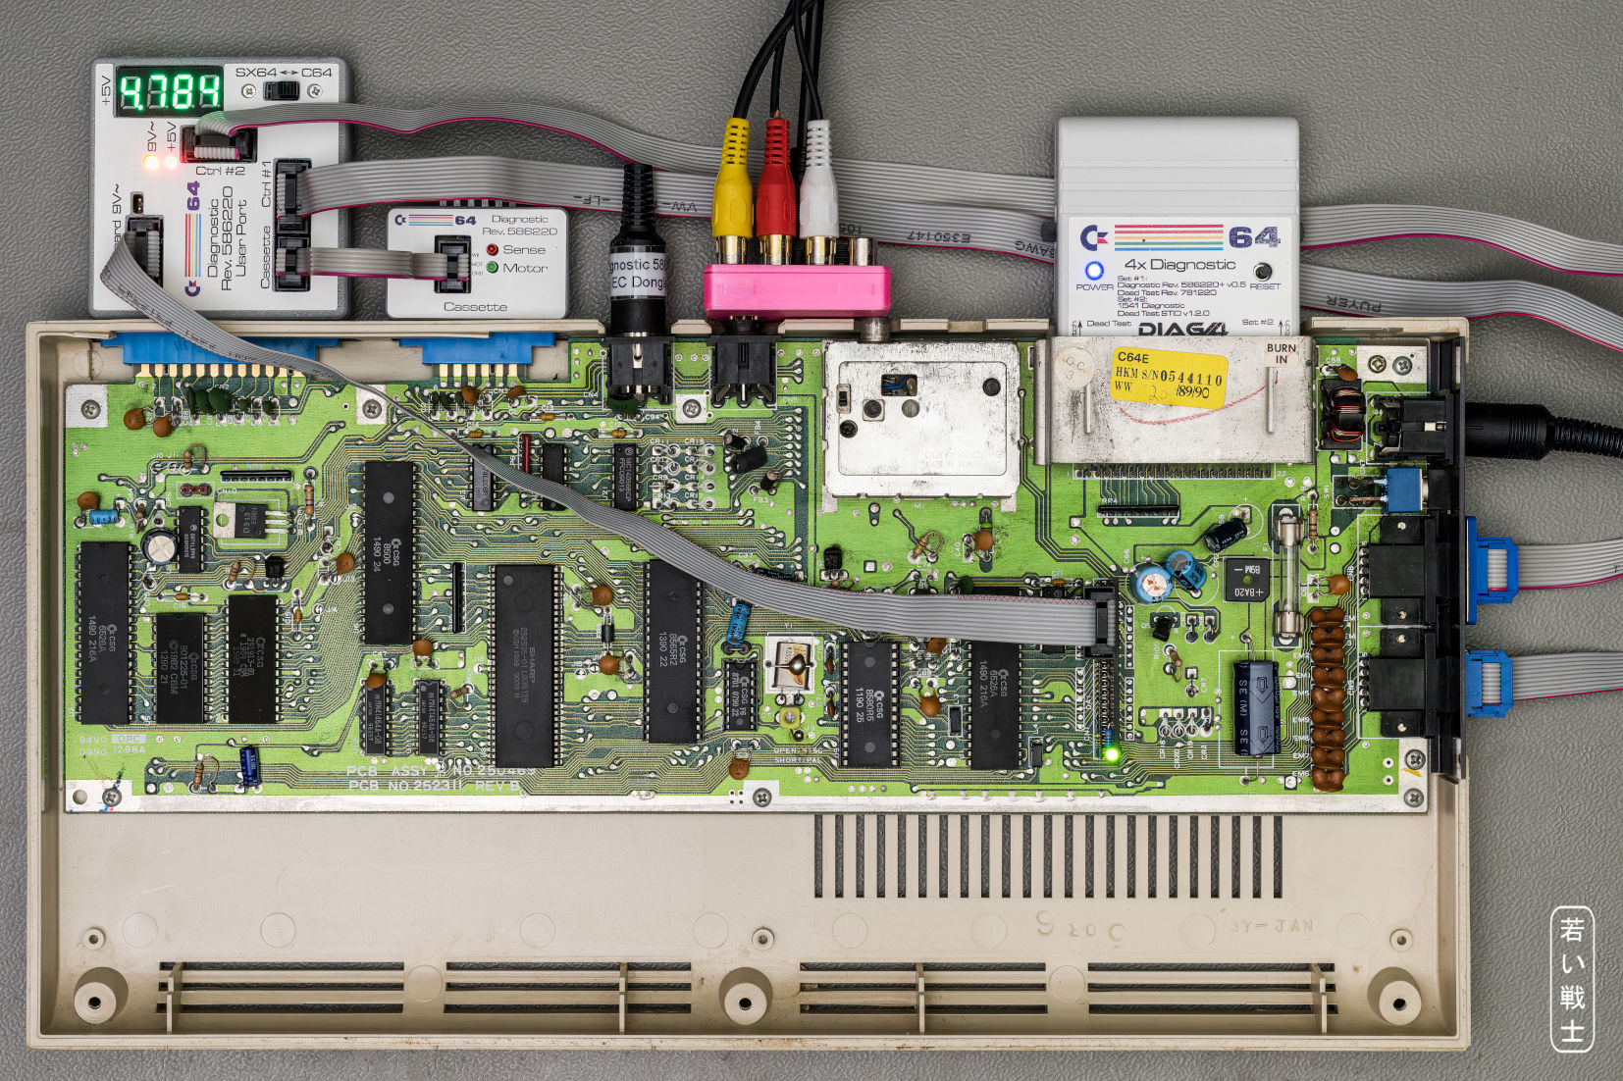

Figure 1: Harness Rev. 1 while being tested

First, the keyboard dongle Rev. 1 was connected, J2 was bridged with jumpers (the feedback connections were made permanent this way).

The Diagnostic Rev. 586220 cartridge was installed and the diagnostic test was run. It was completed successfully, all components were reported “OK”.

Next was the Cassette Dongle Rev. 1 being connected for the test. The diagnostic test was passed, all components were reported “OK”. The SENSE LED changed the status several times while the test, the MOTOR LED was off and only switched on for the cassette port test and the control port test.

The User Port Dongle Rev. 1 was then connected and a ribbon cable between J5 and the keyboard dongle Rev. 1. The diagnostic test was passed, all components were reported “OK”.

To simulate a failing control port connection, IC1 was extracted from the socket. The diagnostic test reported the control ports “BAD”. IC1 was installed again.

To simulate a failing keyboard connection, the ribbon cable to the keyboard dongle was removed. The diagnostic test reported the keyboard “BAD”.

The keyboard dongle was removed from the setup completely. The diagnostic test reported the keyboard “OPEN”.

The test harness was completely removed, except the Cassette Dongle. The Diagnostic Cartridge was disconnected from the C64. A Datassette with a tape was connected to the Cassette Dongle. The purpose of this test is to prove the breakout board properties of the Cassette Dongle.

The software on the tape could be loaded successfully.

A short program was written to (another) tape. It could be verified successfully.

Conclusion:

* The Diagnostic Harness Rev. 1 is fully functional.
* Rev. 2 is fully functional
* Rev. 3 is tested and working.