**Versa64Cart v1.4**

**Module Description**

Content

1. Introduction 2

2. Configuration 2

2.1. Explanation 2

2.2. Jumper & DIP-Switch Settings 3

2.3. Bank Switching 3

2.4. Solder Bridges 4

3. Assembly of the Versa64Cart 4

4. Retrieving the binary and the settings from a CRT file 5

4.1. VICE cartconv 5

4.2. Example I 5

4.3. Example II 6

4.4. Example III 7

4.5. Example IV 7

5. EPROMs 8

6. Startup and Trouble shooting 8

7. Revision History 9

7.1. Rev. 1.1 ⇒ Rev. 1.2 9

7.2. Rev. 1.2 ⇒ Rev. 1.3 9

7.3. Rev. 1.3 ⇒ Rev. 1.4 9

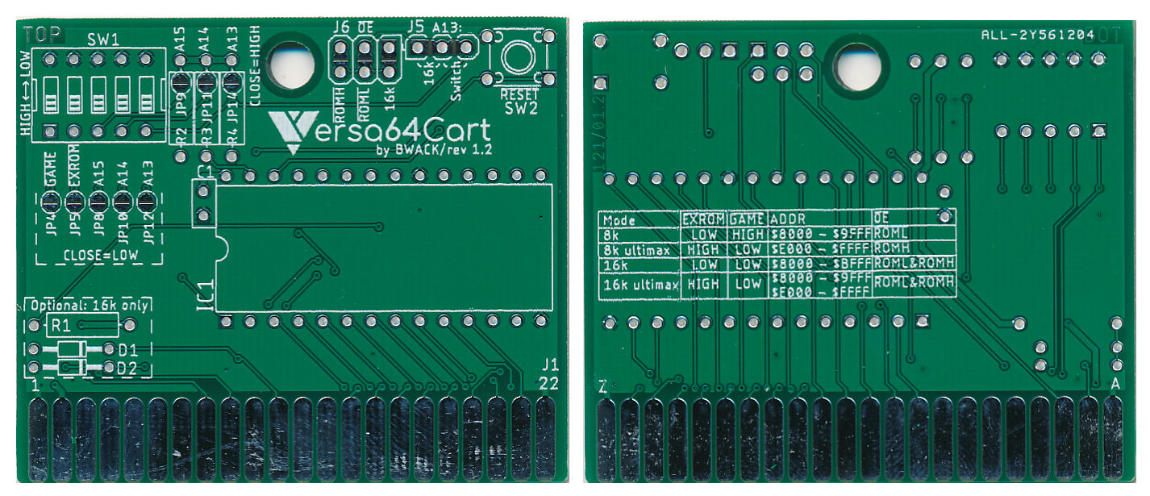

Figure 1: Both sides of the Versa64Cart Rev. 1.2

# Introduction

The Versa64Cart is a generic EPROM cartridge for the Commodore C64 and C128. It can be configured as 8k, 16k, 8k ultimax or 16k ultimax cartridge. Further on, the most sufficient address bits of the EPROM can be set by a DIP-switch which offers a manual bank switching for multi game/multi ROM cart option.

The Versa64Cart is not suitable to run a Kernal or software, which require bank switching by that software (e.g. games > 16k).

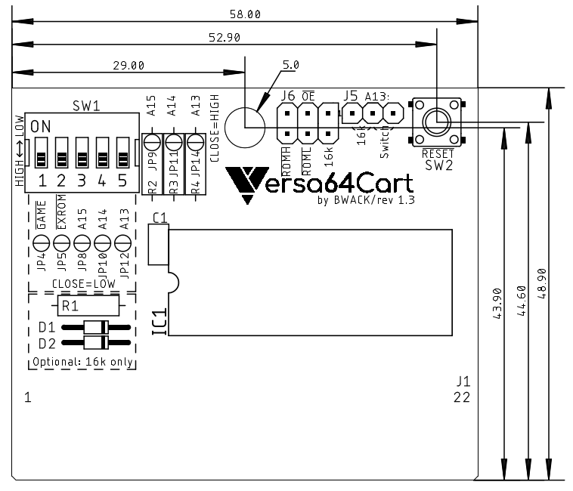

Figure 2: Versa64Cart - placement and dimensions

# Configuration

## Explanation

The extension cartridges signalize their configuration with two flags. Those are and . For addressing the EPROM, the C64 offers two chip-select signals for an 8kB address space, which are and . The chip-select signals are required to locate the EPROM content within the address space of the C64. It is possible to use either , or combining both to get a 16kB address space in total.

| Mode |  |  |  | Address space |
| --- | --- | --- | --- | --- |
| 8k | LOW | HIGH |  | 0x8000 – 0x9FFF |
| 8k ultimax | HIGH | LOW |  | 0xE000 – 0xFFFF |
| 16k | LOW | LOW | & = “16k” | 0x8000 – 0xBFFF |
| 16k ultimax | HIGH | LOW | & = “16k” | 0x8000 – 0x9FFF + 0xE000 – 0xFFFF |

Table 1: Cartridge configuration

In the “ultimax” modes, the Kernal ROM (0xE000 – 0xFFFF) is replaced by the content of the EPROM of the Versa64Cart. The Reset vector is located at 0xFFFC and 0xFFFD. This is a guidepost for the microprocessor, which shows where to start the execution after the processor was powered up (or received a RESET pulse). This way, the software in the EPROM will completely take control.

In EXROM mode, the C64 Kernal (the one on the mainboard) will check the memory locations 0x8004-0x8008 for the “cartridge signature” CBM80 (PETSCII 0xC3, 0xC2, 0xCD, 0x38, 0x30). If this sequence is found, the execution will follow the cartridge cold start vector located at the first two memory addresses of the EPROM (0x8000 and 0x8001 in the C64’s address space).

## Jumper & DIP-Switch Settings

The DIP-Switch SW1 configures the cartridge mode and the three most sufficient address bit of the EPROM (the “bank switching”). Annotation: ON position connects the signal to ground (=LOW).

The jumper J6 () sets the chip select signal for the EPROM. It can be , or “16k”(this is a diode logic AND of and ).

The jumper J5 (A13) can be set to “Switch” or “16k”. “Switch” means, that A13 is set by the DIP-Switch, “16k” means, that A13 is controlled by the signal.

A 16k cartridge requires both jumpers (J5 and J6) set to “16k”.

For the required settings refer to Table 1.

## Bank Switching

The EPROM offers more memory (27C512 = 64kB), than it is required for a generic 8k or 16k cartridge. On account of this an EPROM can keep the content of several cartridges. The DIP-Switch SW1 (3, 4, 5 = A15, A14 and A13) selects, which of these cartridges is selected. In 16k mode, the setting of A13 is ignored.

|  |  |  |  |  |  |  |
| --- | --- | --- | --- | --- | --- | --- |
| DIP-Switch | | | Address Bits | | | EPROM Address  (Offset) |
| **3** | **4** | **5** | **A15** | **A14** | **A13** |
| ON | ON | ON | L | L | L | 0x0000 – 0x1FFF |
| ON | ON | OFF | L | L | H | 0x2000 – 0x3FFF |
| ON | OFF | ON | L | H | L | 0x4000 – 0x5FFF |
| ON | OFF | OFF | L | H | H | 0x6000 – 0x7FFF |
| OFF | ON | ON | H | L | L | 0x8000 – 0x9FFF |
| OFF | ON | OFF | H | L | H | 0xA000 – 0xBFFF |
| OFF | OFF | ON | H | H | L | 0xC000 – 0xDFFF |
| OFF | OFF | OFF | H | H | H | 0xE000 – 0xFFFF |

Table 2: 8k cartridges memory banks

|  |  |  |  |  |  |  |
| --- | --- | --- | --- | --- | --- | --- |
| DIP-Switch | | | Address Bits | | | EPROM Address  (Offset) |
| **3** | **4** | **5** | **A15** | **A14** | **A13** |
| ON | ON | X | L | L | X | 0x0000 – 0x3FFF |
| ON | OFF | X | L | H | X | 0x4000 – 0x7FFF |
| OFF | ON | X | H | L | X | 0x8000 – 0xBFFF |
| OFF | OFF | X | H | H | X | 0xC000 – 0xFFFF |

Table 3: 16k cartridges memory banks

The C64 address must not be confused with the EPROM Address offset.

## Solder Bridges

Instead of setting jumpers and the DIP-Switch, solder bridges can be utilized to configure the Versa64Cart. This is an option, in case the configuration of the Versa64Cart is not prone to be changed. Solder bridges are used to “hard wire” the configuration.

|  |  |  |
| --- | --- | --- |
| Signal | HIGH | LOW |
|  | JP4 = open | JP4 = closed |
|  | JP5 = open | JP5 = closed |
| A15 | JP8 = open, (JP9 = closed) | JP8 = closed, (JP9 = open) |
| A14 | JP10 = open, (JP11 = closed) | JP10 = closed, (JP11 = open) |
| A13 | JP12 = open, (JP14 = closed) | JP12 = closed, (JP14 = open) |

Table 4: Configuration with solder bridges

The jumpers in ( ) are only required, in case the pull-up resistors R2, R3 and R4 are not populated. **Never (!!!!) close both jumpers of one address signal. It cannot be LOW and HIGH at the same time, this will produce a SHORT CIRCUIT!!!!**

The footprints of the jumpers J5 and J6 are designed to be solder bridged, when not populated.

# Assembly of the Versa64Cart

The Versa64Cart can work with a minimum of components when being configured with solder bridges. Just the EPROM and a 100nF capacitor is required.

* The reset switch is nice to have, but it is just an option.
* The DIP-switch can be replaced by configuring the solder bridges JP4, 5, 8, 10 and 12.
* The pull-up resistors (R2-4) can be omitted and JP9, 11, 14 can be utilized to set a HIGH level on A15 … A13 **(BE CAREFUL, see warning above!). If you are not sure, keep the pull up resistors.**
* J5 and J6 can be hard wired with solder bridges.
* R1, D1 and D2 are only required in 16k modes.
* The EPROM can be soldered, a socket is not necessary

Soldering the EPROM can be required if a shallow cartridge case is used. A socket might add too much height. In this case, it is advised to test the EPROM with a Versa64Cart with a socket before.

# Retrieving the binary and the settings from a CRT file

## VICE cartconv

The CRT file format is created to emulate cartridges with VICE or devices like the Ultimate II+ etc. It should not be programmed into an EPROM; this will not work.

Instead, the binary has to be retrieved from the CRT file. The binary is a file that can be used for programming EPROMs. Also, it is possible to find out the required settings for and .

The utility that is used here is CARTCONV, which is a command line too that comes with VICE (C64 emulator). For the examples, CARTCONV and the cartridge files are copied to the same directory. To start, enter *cmd* into the search box on the task bar of Windows 10.

First the CRT information is required. Enter the following command

*cartconv -f mycartridge.crt*

mycartridge.crt stands for the crt file, that you want to convert.

The second step is to generate a *.bin file from the *.crt. The *.bin file can be used to program EPROMs.

cartconv -i mycartridge.crt -o mycartridge.bin

## Example I

|  |
| --- |
| *C:\cartconv>cartconv -f deadtest.CRT* |
| *CRT Version: 1.0* |
| *Name: C64DEADTESTREV718220* |
| *Hardware ID: 0 (Generic Cartridge)* |
| *Mode: exrom: 1 game: 0 (ultimax)* |
|  |
| *offset sig type bank start size chunklen* |
| *$000040 CHIP ROM #000 $e000 $2000 $2010* |
|  |
| *total banks: 1 size: $002000* |

The important information is colored red in the above example.

First of all, **it has to be a generic cartridge** (Hardware ID 0). Many (game or special) cartridges have additional hardware build it, that is required for proper operation. That might be one of manifold automatic bank switching circuits, a freezer circuit like in the Final Cartridge etc.

Next, has to be 1 (HIGH) and has to be 0 (LOW) ⇒ DIP Switch 1=ON, 2=OFF. The ultimax mode is mentioned here, too. The start address is $e000 (0xE000). Referring to Table 1, J6 has to be set to . The size is $2000 (which is hexadecimal for 8k). Hence jumper J5 is set to “switch”. It is assumed, that the binary is programmed to the first 8k of the EPROM, so the address lines A15, A14 and A13 are L, L, L ⇒ the switches 3-5 are ON.

|  |  |  |
| --- | --- | --- |
| Item | cartconv | Setting |
|  | 0 (= LOW) | SW1-1 = ON |
|  | 1 (= HIGH) | SW1-2 = OFF |
| size | $2000 (=8k cartridge) | A13 (J5) = “Switch” |
| start | $E000 | (J6) = |
| EPROM offset | $2000 | A15…13 = LLL ⇒  SW1-3 = ON  SW1-4 = ON SW1-5 = ON |

Now the deadtest.bin file can be generated:

|  |
| --- |
| *C:\cartconv>cartconv -i deadtest.CRT -o deadtest.bin* |
| *Input file : deadtest.CRT* |
| *Output file : deadtest.bin* |
| *Conversion from Generic Cartridge .crt to binary format successful.* |

## Example II

|  |
| --- |
| *C:\cartconv>cartconv -f diag04.crt* |
| *CRT Version: 1.0* |
| *Name: 586220PLUS_0.4* |
| *Hardware ID: 0 (Generic Cartridge)* |
| *Mode: exrom: 0 game: 1 (8k Game)* |
| *offset sig type bank start size chunklen* |
| *$000040 CHIP ROM #000 $8000 $2000 $2010* |
| *total banks: 1 size: $002000* |

Here, the Hardware ID is 0 (Generic Cartridge) again. The Versa64Cart is suitable for running the software. Now, it is assumed, that the first 8k are already in use and the binary should be programmed to the second 8k slot of the EPROM.

|  |  |  |
| --- | --- | --- |
| Item | cartconv | Setting |
|  | 1 (= HIGH) | SW1-1 = OFF |
|  | 0 (= LOW) | SW1-2 = ON |
| size | $2000 (=8k cartridge) | A13 (J5) = “Switch” |
| start | $8000 | (J6) = |
| EPROM offset | $2000 | A15…13 = LLH ⇒  SW1-3 = ON  SW1-4 = ON SW1-5 = OFF |

The binary conversion is exactly the same like in Example I.

## Example III

|  |
| --- |
| *C:\cartconv>cartconv -f neutron.crt* |
| *CRT Version: 1.0* |
| *Name: NEUTRON* |
| *Hardware ID: 0 (Generic Cartridge)* |
| *Mode: exrom: 0 game: 0 (16k Game)* |
| *offset sig type bank start size chunklen* |
| *$000040 CHIP ROM #000 $8000 $4000 $4010* |
| *total banks: 1 size: $004000* |

Again, it is assumed, the binaries should be programmed to the first 16k of the EPROM.

|  |  |  |
| --- | --- | --- |
| Item | cartconv | Setting |
|  | 0 (= LOK) | SW1-1 = OFF |
|  | 0 (= LOW) | SW1-2 = ON |
| size | $4000 (=16k cartridge) | A13 (J5) = “16k” (J6) = “16k” |
| start | $8000 | Not relevant in 16k mode |
| EPROM offset | $0000 | A15…13 = LLL ⇒  SW1-3 = ON  SW1-4 = ON SW1-5 = ON |

The binary conversion is exactly the same like in Example I.

## Example IV

|  |
| --- |
| *C:\cartconv>cartconv -f batman.crt* |
| *CRT Version: 1.0* |
| *Name: batman* |
| *Hardware ID: 5 (Ocean)* |
| *Mode: exrom: 0 game: 1 (8k Game)* |
| *Warning: game in crt image set incorrectly.* |
| *offset sig type bank start size chunklen* |
| *$000040 CHIP ROM #000 $8000 $2000 $2010* |
| *$002050 CHIP ROM #001 $8000 $2000 $2010* |
| *[…]* |
| *$01e130 CHIP ROM #015 $8000 $2000 $2010* |
| *total banks: 16 size: $020000* |

Here, the hardware ID is ***not*** 0 (generic). The Versa64Cart is ***not*** suitable for this software. The size is $20000, which is 128kB, more than what fits into the memory space of the C64. This kind of software requires a cartridge with a certain automatic bank switching circuit, in this case the Ocean cartridge type and a 27C010 (128kx8bit) EPROM is required.

# EPROMs

Four different types/sizes of EPROMs can be used with the Versa64Cart, not all settings make sense with them. Their pin out is shown in Table 5.

The effect of the settings and the recommended configurations are shown in Table 6.

|  |  |  |  |  |  |  |  |  |  |  |  |
| --- | --- | --- | --- | --- | --- | --- | --- | --- | --- | --- | --- |
| 27C64 | | | | | | | | | | | |
|  | 27C128 | | | | | | | | | |  |
|  | 27C256 | | | | | | | |  |
|  | 27C512 | | | | | |  |
|  | SOCKET | | | |  |
| Vpp | Vpp | Vpp | A15 | 1 | A15 | VCC | 28 | VCC | VCC | VCC | VCC |
| A12 | A12 | A12 | A12 | 2 | A12 | A14 | 27 | A14 | A14 | /PGM | /PGM |
| A7 | A7 | A7 | A7 | 3 | A7 | A13 | 26 | A13 | A13 | A13 | n.c. |
| A6 | A6 | A6 | A6 | 4 | A6 | A8 | 25 | A8 | A8 | A8 | A8 |
| A5 | A5 | A5 | A5 | 5 | A5 | A9 | 24 | A9 | A9 | A9 | A9 |
| A4 | A4 | A4 | A4 | 6 | A4 | A11 | 23 | A11 | A11 | A11 | A11 |
| A3 | A3 | A3 | A3 | 7 | A3 | /OE | 22 | /G/Vpp | /G | /G | /G |
| A2 | A2 | A2 | A2 | 8 | A2 | A10 | 21 | A10 | A10 | A10 | A10 |
| A1 | A1 | A1 | A1 | 9 | A1 | GND | 20 | /E | /E | /E | /E |
| A0 | A0 | A0 | A0 | 10 | A0 | D7 | 19 | D7 | D7 | D7 | D7 |
| D0 | D0 | D0 | D0 | 11 | D0 | D6 | 18 | D6 | D6 | D6 | D6 |
| D1 | D1 | D1 | D1 | 12 | D1 | D5 | 17 | D5 | D5 | D5 | D5 |
| D2 | D2 | D2 | D2 | 13 | D2 | D4 | 16 | D4 | D4 | D4 | D4 |
| GND | GND | GND | GND | 14 | GND | D3 | 15 | D3 | D3 | D3 | D3 |

Table 5: EPROM pin compatibility

|  |  |  |  |  |  |
| --- | --- | --- | --- | --- | --- |
| EPROM | Size | A15 | A14 | A13 | 16k |
| 27C512 | 64kx8 | yes | yes | yes | yes |
| 27C256 | 32kx8 | HIGH | yes | yes | yes |
| 27C128 | 16kx8 | HIGH | HIGH | yes | yes |
| 27C64 | 8kx8 | HIGH | HIGH | HIGH | no |

Table 6: Settings per EPROM type

In case Vpp is located at a dedicated pin (pin 1), A15 has no effect anymore. A HIGH level is recommended (switch is off) . The /PGM Pin should be set HIGH. The n.c. (not connected) pin should be HIGH (with pull-up) or open. For an 8k EPROM, the 16k setting makes no sense.

# Startup and Trouble shooting

Before you insert the Versa64Cart into the expansion port of the C64, you should make sure, that there are no fatal failures on it. In the worst case, it will produce a short circuit.

* Check the solder joints on the solder side
* Check the orientation of the socket. The notch is at the side, where the capacitor is
* In case you have used the solder bridges to configure the address, check according to the warning in chapter 2.4 or measure the resistance between pin 1 and 2 (that is GND and +5V) of the edge connector (without an EPROM inserted). It must not be less than about 3kΩ.
* After inserting the EPROM, check if the notch is at the same side like the notch of the socket. Check all pins are properly seated in the socket and not bent inwards or outwards.

After all these points are correct, nothing really bad can happen to your C64 anymore. If you get a black screen or a normal startup display with less than 38911 Basic Bytes free, you might have a configuration problem.

* Did you program the EPROM with a proper *.bin and not with the *.crt file? CRT files are not suitable to program an EPROM. Refer to chapter 4.
* Did you set the configuration bits correctly? ON means LOW
* Did you select the required (J6)?
* Did you jumper A13 (J5) as required?
* In case it is a 16k cartridge: Are R1, D1 and D2 placed?

# Revision History

## Rev. 1.1 ⇒ Rev. 1.2

* Schematic and layout were redrawn in Eagle (v 9.2)
* All solder bridges (jumpers) are located on the component side now (the footprint of the jumpers includes the solder bridge option)
* A13…A15 can be configured by solder bridges now
* No test points for A13…A15 anymore
* The jumpers are moved to the outer edge for easier access
* J5 for the configuration of A13 is a 3-pin jumper now
* A reset switch is added
* A configuration table is added on the solder side

## Rev. 1.2 ⇒ Rev. 1.3

Some issues with cartridge cases were fixed.

* The diodes D1 & D2 and R1 were moved north by 4.93mm
* D1&D2 moved east by 4.6mm, R1 by 2.54mm
* IC1&C1 moved west by 1.59mm

## Rev. 1.3 ⇒ Rev. 1.4

* The width of the contact pads of the expansion port was reduced to 1.5mm and the whole area is free of solder stop mask.