Variation in Ventilation Abstract ATS 2024

Nick Ingraham

2024-11-01

Table of contents

# 1. Setup

## 1.1 Run r script to get functions and libraries

## 1.2 In Main Script… Run all above IMPORT

## 1.3 Table 1

## 1.4 getting variables for abstract

# 2. Abstract Sex/Height LTVV

[Google Doc](https://docs.google.com/document/d/1T1-nFrZV6F-FomMsiBHxZldc3dtiIenXkcg9V4koNSA/edit?usp=sharing)

## 2.1 Sex_category / LTVV graph

## 2.2 Sex_category point estimates

## 2.3 Sex_category / Height Models

## 2.4 Abstract Writing

**Sex and Height-Based Variation in Ventilator Tidal Volume Settings** Nicholas E. Ingraham, Casey Eddington, Benjamin Schmid, Alex Ortiz, Gary Weissman, William Parker, Kaveri Chhikara

**Introduction**  
Low tidal volume ventilation (LTVV) reduces mortality in mechanically ventilated patients with severe hypoxic respiratory failure.(1) LTVV also benefits populations not originally included in the landmark trail. (2) Despite this, adherence to delivering LTVV varies in clinical practice. (3) In this study we sought to explore potential mechanisms underlying LTVV adherence, specifically patient sex and their height.

**Methods**  
The Common Longitudinal Intensive Care Unit (CLIF) consortium is comprised of **5** US academic health systems that use a standardized data format to facilitate federated studies of critical illness. We identified all adult patients admitted to the ICU and required at least 24 hours of mechanical ventilation from **January 1st, 2018** to **December 31st, 2024** , excluding patients with tracheostomy within 72 hours of admission.

**Results**  
Of the **31798** critically ill adults, the mean age was **62.4** years (standard deviation **3.4** years), and there were **224433** (**42.4%**) females, **9294** (**29.2%**) Black patients, and **1452** (**4.6%**) Hispanic patients across **5** healthcare systems and **26** hospitals. **Figure 1** shows the distribution of LTVV statified by patient sex. The mean rate of LTVV in females across all patients was **23.8% (23.6 - 24)** while the rate for males was **6.3% (6.2 - 6.3)**. When adjusting for height

**Conclusion** XYZ

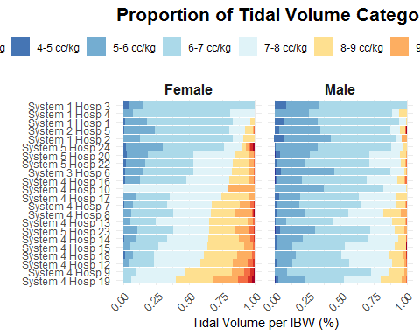

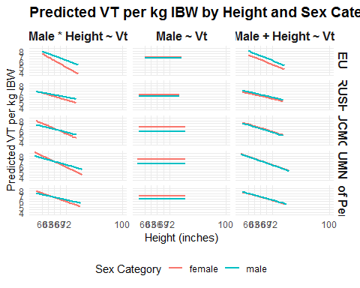

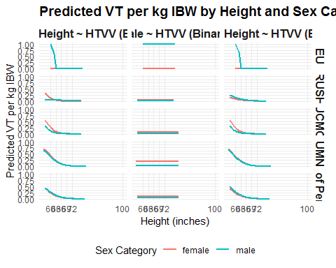

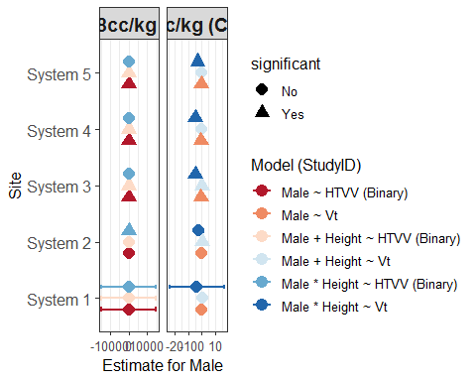

# 3. Abstract Mode Variation

## 3.1 Mode Graph

## 3.2 LTVV graph

## 3.3 Abstract Writing

**Critical Care Respiratory Support Data Wrangling and Mode Variation**

[Google Doc](https://docs.google.com/document/d/1kyPNfOT2v0zwF-xFmcmWp_nzY2vyxgGyFlGVR90R0iU/edit?usp=sharing)

**Introduction**  
Healthcare outcomes vary across institutions in critically ill patients. Practice variation is difficult to capture on a large scale without utilizing the electronic healthcare records. A specific obstacle includes dealing with raw ventilator data. We sought to develop systemic methodology to accurately capture the time course of mechanical ventilation for a patient. Furthermore, we aimed to make this process generalizable across healthcare systems by using the Common Longitudinal ICU Format (CLIF). In addition to developing syntax that outputs an hourly-patient-level dataframe with pertinent ventilator data, we used variation in mode ventilation as a use-case to explore differences in mode selection across U.S. health systems.

**Methods**  
The Common Longitudinal Intensive Care Unit (CLIF) consortium is comprised of **5** US academic health systems that use a standardized data format to facilitate federated studies of critical illness. We identified all adult patients admitted to the ICU and required at least 24 hours of mechanical ventilation from **January 1st, 2018** to **December 31st, 2024** , excluding patients with tracheostomy within 72 hours of admission.

**Results**  
Of the **31798** critically ill adults, the mean age was **62.4** years (standard deviation **3.4** years), and there were **224433** (**42.4%**) females, **9294** (**29.2%**) Black patients, and **1452** (**4.6%**) Hispanic patients across **5** healthcare systems and **26** hospitals. Using device and mode flosheet names from the EHR that were linked to the CLIF common data elements, we executed the “CLIF Respiratory Support Waterfall” across all our sites. The algorithm leverages the most specific data from the EHR (oxygen devices) to identify transitions in the patients respiratory status. It then takes a stepwise approach by looking within the prior hierarchy to find other transitions (e.g. modes). This approach leads to a final respiratory support ID which is used to fill in missing data. The final dataframe includes an hourly level of patient information. The most common modes used across all health systems included volume control (**59.4**), pressure control (**6.6**), and pressure-regulated volume control (**3.4**). Hospitals varied on the use of different mode settings with the highest hospital rate of volume control was **94** and the lowest was **1.5**. Less common forms of ventilation, such as SIMV, varied from **0.1** to **15.2**.

**Conclusion**  
Granular data from critically ill patients can be complex and rittled with missingness and erroneous data. By leveraging the CLIF platform, we developed a cross-institutional mechanism to extract and formulate hourly patient data that is critical to ICU research. The usefulness is demonstrated through our exploration of mode variation across **26** hospitals.

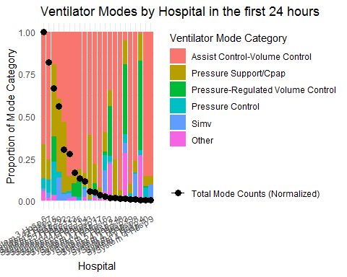

# 4. Abstract Prediction Methodology

## 4.1 Daily Mortality Models

**htvv_daily_percent** = $\left(set volume hours>8cc/ibw\right)/\left(ventilator hours that day\right)$

Testing: laps2, pf_ratio, sf_ratio, oxygenation_index (if available)

**Oxygenation Index** = $\left(mean airway pressure*Fio_{2} set\right)/Po_{2} arterial)$

* fio2 and pa02 and mean_airway_pressure need to be within 1 hour of each other

"mortality_enc ~ VAR_first_24hr + daily_VAR + age_at_admission + sex_category + day + htvv_daily_percent + hospital_id" "VFDs ~ VAR_first_24hr + daily_**VAR** + age_at_admission + sex_category + day + htvv_daily_percent + hospital_id"

## 4.2 Daily Vent Free Days

## 4.3 Effect of High Tidal Volume Ventilation

**htvv_daily_percent** = hours with set volume > 8cc/ibw / ventilator hours that day

"mortality_enc ~ pf_ratio_first_24hr + daily_pf_ratio + age_at_admission + sex_category + day + htvv_daily_percent + hospital_id" "VFDs ~ pf_ratio_first_24hr + daily_pf_ratio + age_at_admission + sex_category + day + htvv_daily_percent + hospital_id"

## 4.4 Abstract Writing

**Introduction** Patient outcomes are determined by many factors other than their critical illness.

These include processes of care and institutional factors. (4, 5)

Hospital variation in critical care outcomes (6–8) and processes of care (9) exist, but the extent to which this variation may affect research is less well known. We sought to explore the underlying variation in severity of illness scores and their association with outcomes in mechanically ventilated patients with acute respiratory failure.

**Methods**  
Methods: The Common Longitudinal Intensive Care Unit (CLIF) consortium is comprised of **5** US academic health systems that use a standardized data format to facilitate federated studies of critical illness. We identified all adult patients admitted to the ICU and required at least 24 hours of mechanical ventilation from **January 1st, 2018** to **December 31st, 2024** , excluding patients with trachestomy within 72 hours of admission.

**Results**  
Of the **31798** critically ill adults, the mean age was **62.4** years (standard deviation **3.4** years), and there were **224433** (**42.4%**) females, **9294** (**29.2%**) Black patients, and **1452** (**4.6%**) Hispanic patients across **5** healthcare systems and **26** hospitals.

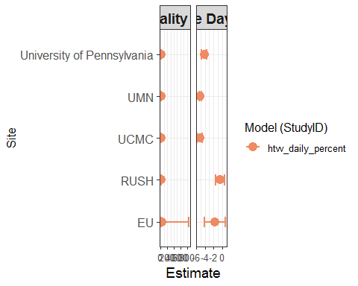

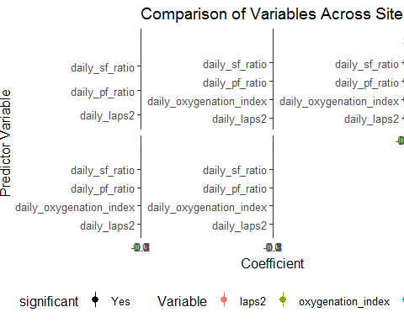

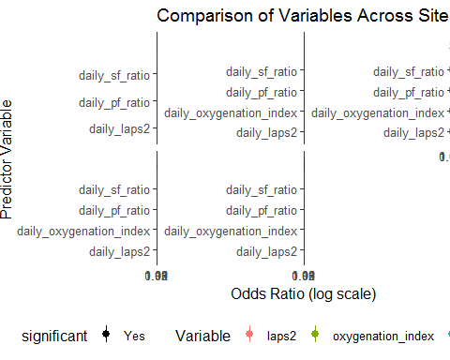

1. Network ARDS. Brower RG, matthay MA, morris a, schoenfeld d, thompson BT, wheeler a. Ventilation with lower tidal volumes as compared with traditional tidal volumes for acute lung injury and the acute respiratory distress syndrome. *N engl J med* 2000;342:1301–8.

2. Serpa Neto A, Cardoso SO, Manetta JA, Pereira VGM, Espósito DC, Pasqualucci M de OP, *et al.* [Association between use of lung-protective ventilation with lower tidal volumes and clinical outcomes among patients without acute respiratory distress syndrome: A meta-analysis](https://doi.org/10.1001/jama.2012.13730). *JAMA* 2012;308:1651–1659.

3. Gao CA, Howard FM, Siner JM, Candido TD, Ferrante LE. [Lung-protective ventilation over 6 years at a large academic medical center: An evaluation of trends, adherence, and perceptions of benefit](https://doi.org/10.1097/CCE.0000000000000325). *Critical care explorations* 2021;3:e0325.

4. Kerlin MP, Epstein A, Kahn JM, Iwashyna TJ, Asch DA, Harhay MO, *et al.* [Physician-Level Variation in Outcomes of Mechanically Ventilated Patients](https://doi.org/10.1513/AnnalsATS.201711-867OC). *Annals of the American Thoracic Society* 2018;15:371–379.

5. Gaieski DF, Edwards JM, Kallan MJ, Mikkelsen ME, Goyal M, Carr BG. [The relationship between hospital volume and mortality in severe sepsis](https://doi.org/10.1164/rccm.201402-0289OC). *American journal of respiratory and critical care medicine* 2014;190:665–674.

6. Merchant RM, Berg RA, Yang L, Becker LB, Groeneveld PW, Chan PS. [Hospital variation in survival after in-hospital cardiac arrest](https://doi.org/10.1161/JAHA.113.000400). *Journal of the American Heart Association* 2014;3:e000400.

7. Vigen R, Spertus JA, Maddox TM, Ho PM, Jones PG, Arnold SV, *et al.* [Hospital-Level Variation in Angina and Mortality at 1 Year After Myocardial Infarction](https://doi.org/10.1161/circoutcomes.114.001063). *Circulation: Cardiovascular Quality and Outcomes* 2014;7:851–856.

8. Kahn JM, Goss CH, Heagerty PJ, Kramer AA, O’Brien CR, Rubenfeld GD. [Hospital volume and the outcomes of mechanical ventilation](https://doi.org/10.1056/NEJMsa053993). *The New England journal of medicine* 2006;355:41–50.

9. Vranas KC, Scott JY, Badawi O, Harhay MO, Slatore CG, Sullivan DR, *et al.* The association of ICU acuity with adherence to ICU evidence-based processes of care. *Chest* 2020;at <<https://pubmed.ncbi.nlm.nih.gov/32229228/>>.