***SOCIOCRACY – RNDAO PRESENTATION***

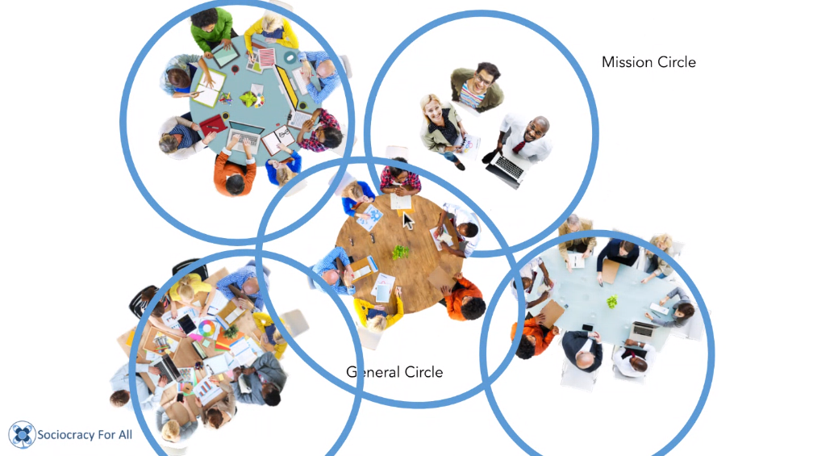

*Governance connect people and the things that we want to do.*

*Having people and project doesn't mean that the thing is going to happen. We need governance for it.*

Sociocracy: concept that has been around since the 80s.

Socio (those who associate together) + Cracy (govern together) = those who work together, decide together

Different from hierarcy: unlinking between decision making and work

There are circles (team) that make decision. They are self-organised as unit.

AIM: purpose of the group (every circle knows what it's for)

DOMAIN: what is the group is allowed to make decisions about

(aim+domain = mandate)

Governance connect people and the things that we want to do.

Having people and project doesn't mean that the thing is going to happen. We need governance for it.

Sociocracy: concept that has been around since the 80s.

Socio (those who associate together) + Cracy (govern together) = those who work together, decide together

Different from hierarcy: unlinking between decision making and work

There are circles (team) that make decision. They are self organised as unit.

AIM: purpose of the group (every circle knows what it's for)

DOMAIN: what is the group is allowed to make decisions about

(aim+domain = mandate)

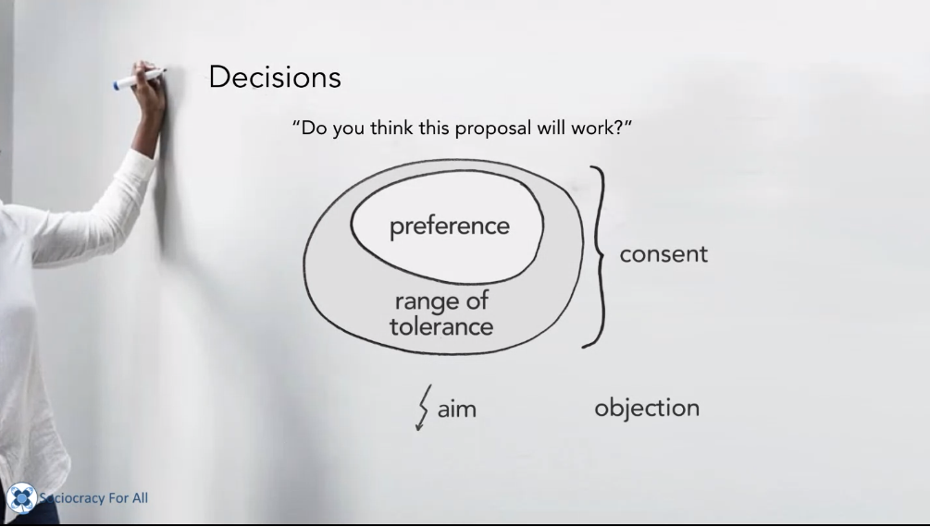

How does that scale beyond one circle?

Ex. gardening. We have 3 teams, all self organised. All groups are doing work in the assigned domain (ex.: one group plants the plants, one group takes care of the infrastructures, one group takes care about people -newletter etc)

You qualify to be a decision maker being part of the team.

General circle: made of representatives from each group

It makes any decision except for the decision of who decides what

How does that scale beyond one circle?

Ex. gardening. We have 3 teams, all self organised. All groups are doing work in the assigned domain (ex.: one group plants the plants, one group takes care of the infrastructures, one group takes care about people -newletter etc)

You qualify to be a decision maker being part of the team.

🡪 **General circle**: made of representatives from each group

It makes any decision except for the decision of who decides what

**Mission circle**: decide about long term vision

No team can overpower another team

Every circle can decide to have a subset of decision makers, passing part of its domain

**Linking roles:**

- Leader

- Delegate

**Other roles:**

- Facilitator

- Secretary (delicate role, because of transparency requirements)

**Operational roles:**

- Whatever is needed (it's possible to cluster certain tasks and give it to a person, a person can hold more than one role)

Each person selects a delegate into a bigger group, but that person has to be accepted by the bigger group as well

What to do with general members of the organization, if they want to participate in decision making? (even if not directly involved in operation)

Decision making (small groups) vs. Feedback (small and big groups)

**How to manage the discussion in a circle?**

- Talk in rounds so everybody can hear everybody (build culture of listeining instead of jumping in right away)

Decision making:

- **CONSENT** (we don't ask do you like it, we ask "do you think it might work?")

We do object if there's a clash (for example if a decision is odd with the aim or the domain)

Objections help to stay on track

All the circle members have to give consent, if a person objects, the discussion continues (100% majority needed)

People from other circles can give feedback but can't oppose a decision

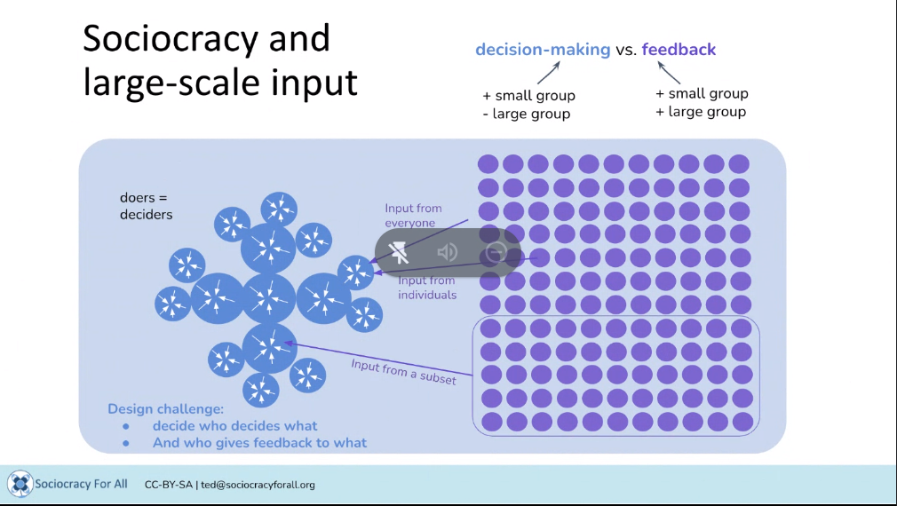

**SELECTION PROCESS:**

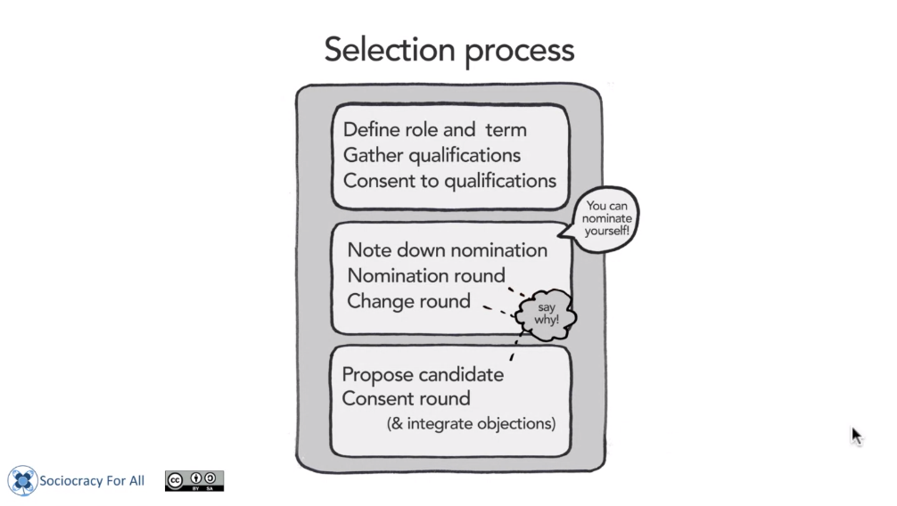

Most successful proposals: the ones written by the team

Policy decisions: governance decisions (General decision) vs. Operations decision: day-to-day operation decision (according to rules that might or might not exist) (one time decision)

Sociocracy is compatible with model that present shared ownership or no owership (commons)

DAOs VS. SOCIOCRACY

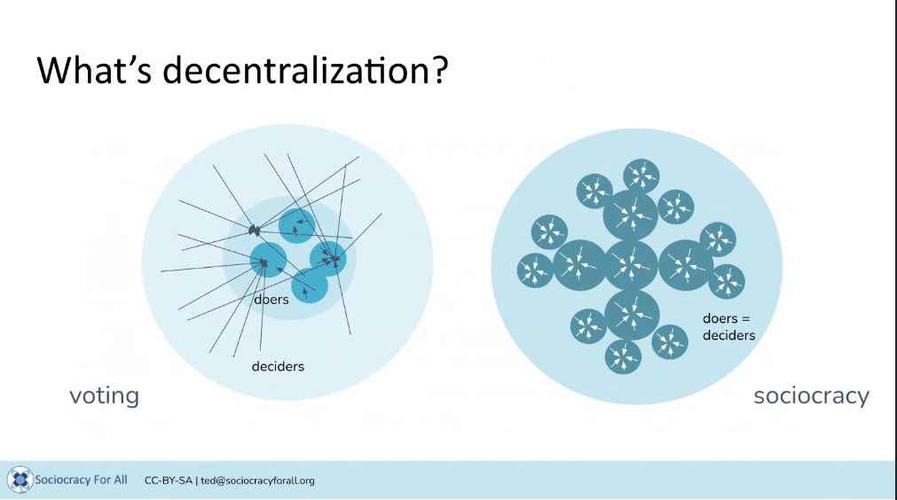

PICTURE OF THE ECOSYSTEM:

