# Orthogonal Frequency Division Multiplexing

# (OFDM) Summary

# OFDM Diagram:

# Carrier Frequency Offset (CFO):

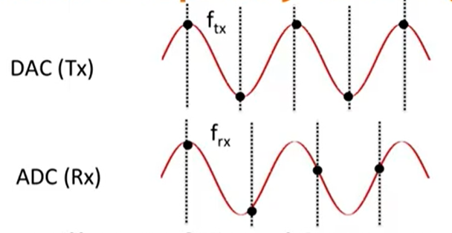

The oscillators of Tx and Rx are not typically tuned to identical frequencies.

To tune them

up-convert baseband signal Sn to passband signal

$$y_{n}=S_{n}*e^{j2πf_{tx}nT_{s}}$$

Down-Convert passband signal Yn back to

$$r_{n}=s_{n}*e^{j2πf_{tx}nT_{s}}*e^{j2πf_{rx}nT_{s}}=S_{n}*e^{j2πf_{Δ}nT_{s}}$$

Error Accumulates

# OFDM Diagram

