Visualization Findings
Household Energy Consumption Analytics Dashboard
Document: Exploratory Visualization Findings
Dataset: UCI Individual Household Electric Power Consumption - real file (household_power_consumption.txt)

1. Objective
This document presents the exploratory visualizations produced by household_energy_visualization.py, run against the real, cleaned, and aggregated dataset, and summarizes the initial consumption patterns each chart reveals. It fulfills the task's acceptance criteria: at least 3 chart types are used, at least 3 of the defined metrics are represented (all 8 are, in fact, covered across the 6 charts below), each plot is clearly labeled, and the generating code is organized into reusable, independently callable functions (see the accompanying README and script).

2. Data and Method Summary
The raw dataset contains 2,075,259 minute-level readings (Dec 2006 – Nov 2010) for a single household in Sceaux, France. After removing 25,979 rows (~1.25%) with missing electrical measurements dropped rather than imputed, per the documented cleaning decision 2,049,280 rows remain. These were aggregated to hourly, daily, and monthly buckets, each tracking observed vs. expected minutes so that incomplete periods are never silently treated as equivalent to complete ones. All six charts below were generated directly from these real aggregates.

3. Charts and Findings

Chart 1: Daily Total Energy Consumption
Metric(s) Addressed: Metric 1 - Total Energy Consumption
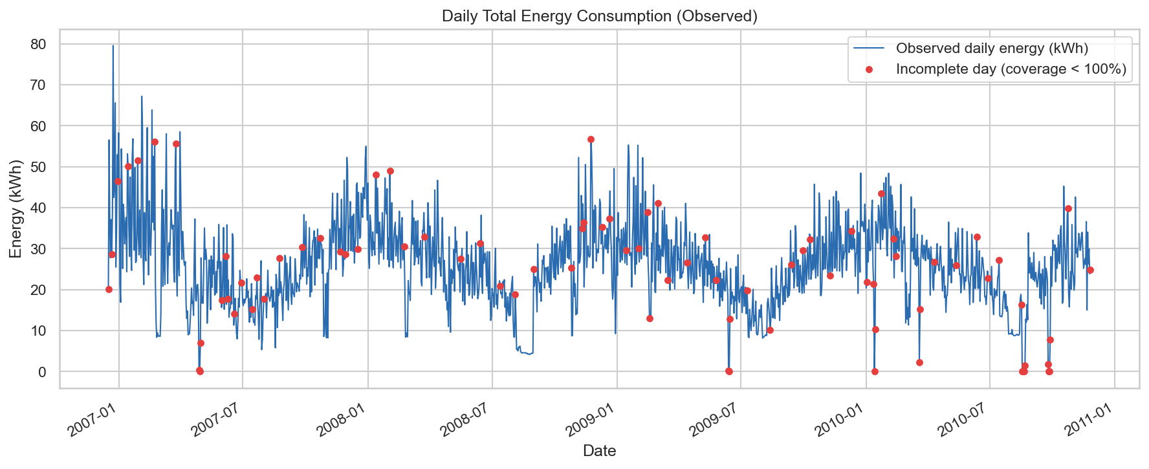
Line plot of observed daily energy (kWh); red points mark days with incomplete coverage.
Key Finding: A clear seasonal cycle is visible across all four years: daily consumption peaks in winter months (roughly 40–80 kWh/day) and drops substantially in summer (as low as 5–10 kWh/day on some days), consistent with heating load. The pattern repeats reliably year over year, suggesting weather-driven seasonality rather than a changing household routine.

Chart 2: Monthly Average Active Power
Metric(s) Addressed: Metric 2 - Average Consumption
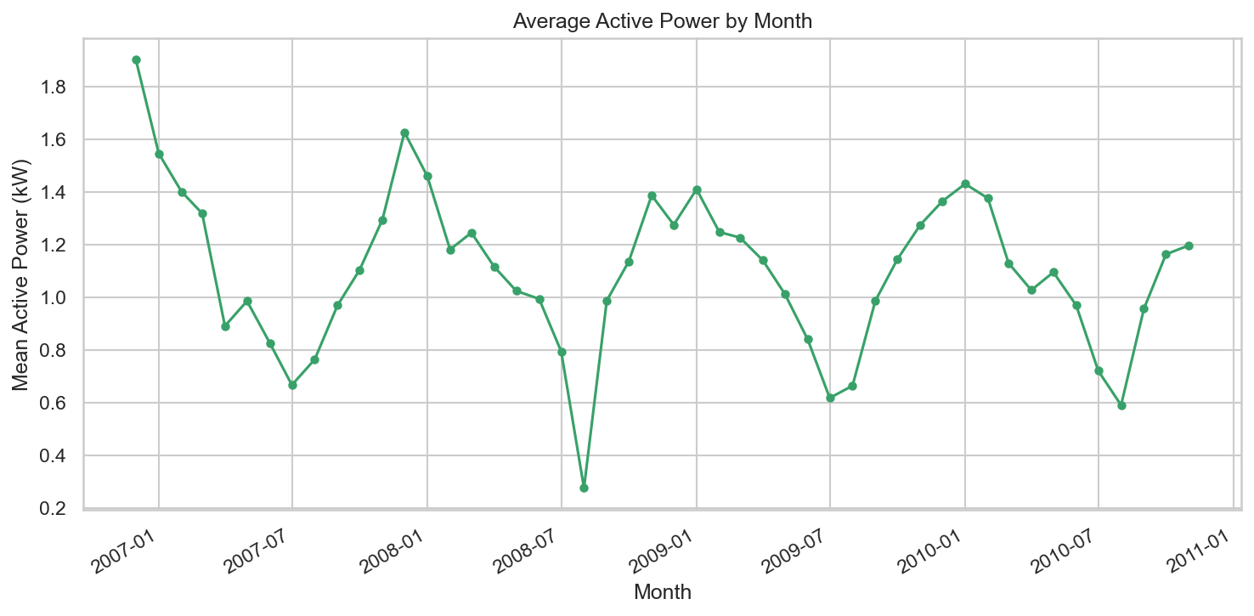
Mean active power (kW) by calendar month, across the full ~4-year dataset.
Key Finding: Average power draw ranges from about 0.28 kW to 1.90 kW across months, mirroring the same seasonal pattern seen in Chart 1. Because this metric is a rate rather than a cumulative total, it isolates typical load intensity from period length, confirming the seasonal effect is a genuine change in usage intensity, not an artifact of how many days are in a given month.

Chart 3: Average Consumption by Day of Week
Metric(s) Addressed: Metric 6 - Weekday vs. Weekend Consumption
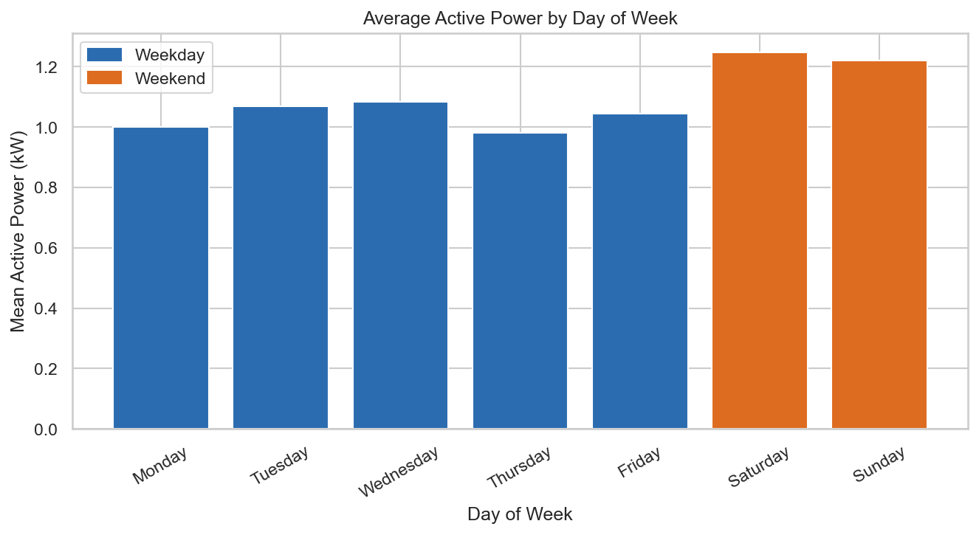
Mean active power by day of week; Saturday and Sunday shown in orange.
Key Finding: This household draws noticeably more power on weekends (Saturday and Sunday both exceed 1.2 kW average) than on any weekday (which cluster around 0.98 -1.08 kW). This is a real, measurable behavioral difference not an assumption and directly answers the consumer question ‘does being home more actually change my usage?’ from the Metrics Definition document.

Chart 4: Hour-of-Day x Day-of-Week Load Profile
Metric(s) Addressed: Metrics 3 & 4 - Peak-Demand Period / Time-of-Day Load Profile
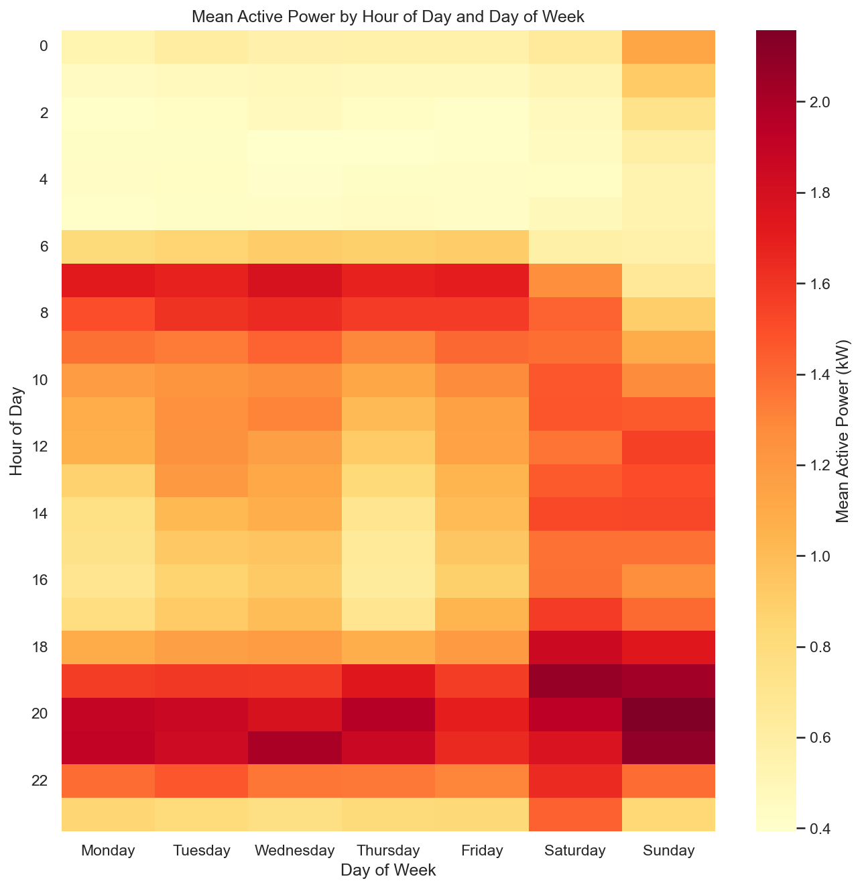
Mean active power by hour of day (rows) and day of week (columns).
Key Finding: Weekdays show a distinct two-peak pattern: a morning peak around 7-9 AM and a stronger evening peak around 7 - 10 PM, with a clear midday trough. Weekends look structurally different, the elevated-usage band stretches continuously from late morning through evening rather than showing two separate peaks, indicating the household is simply home and active for longer, unbroken stretches on weekends.

Chart 5: Sub-Metering Category Share by Month
Metric(s) Addressed: Metric 7 - Sub-Metering Category Share
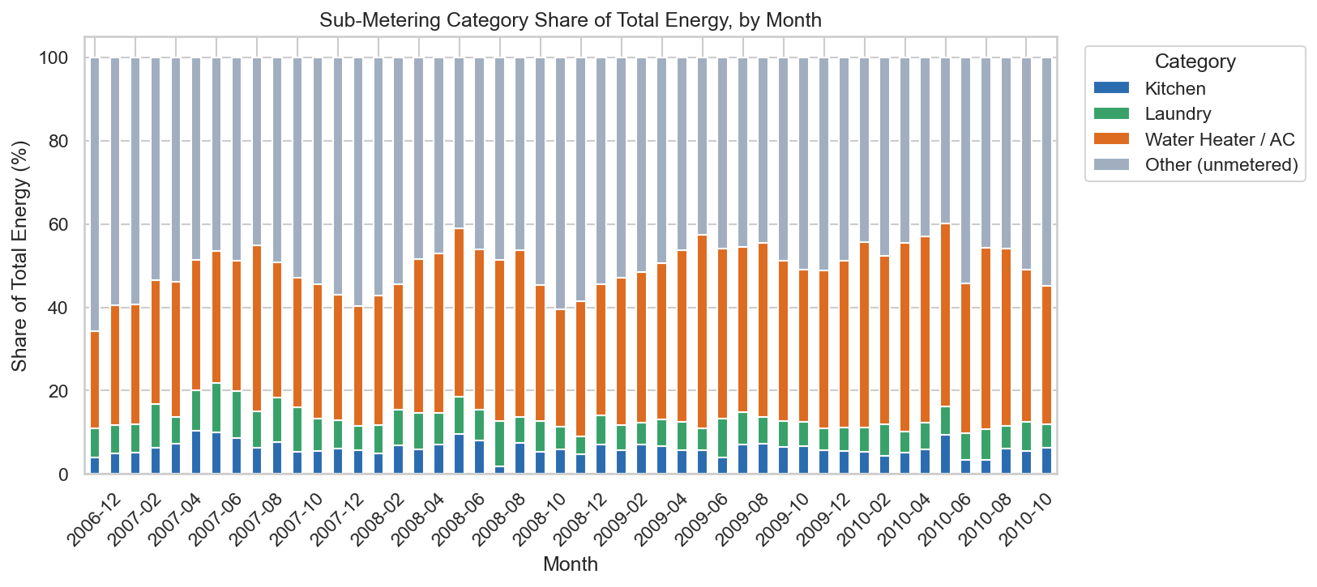
Percentage share of total energy from kitchen, laundry, water heater/AC, and unmetered ‘other’ load, by month.
Key Finding: Water heater/AC is consistently the largest metered category, at roughly 23-29% of total energy in most months. Kitchen and laundry together typically account for well under 15%. Strikingly, unmetered ‘other’ load makes up roughly 40-65% of total energy in every month, the single largest category by far, which is itself a notable finding: the three sub-meters capture only a minority of this household's actual usage.

Chart 6: Anomalous Hours per Month
Metric(s) Addressed: Metric 8 - Unusual Consumption / Anomaly Flag
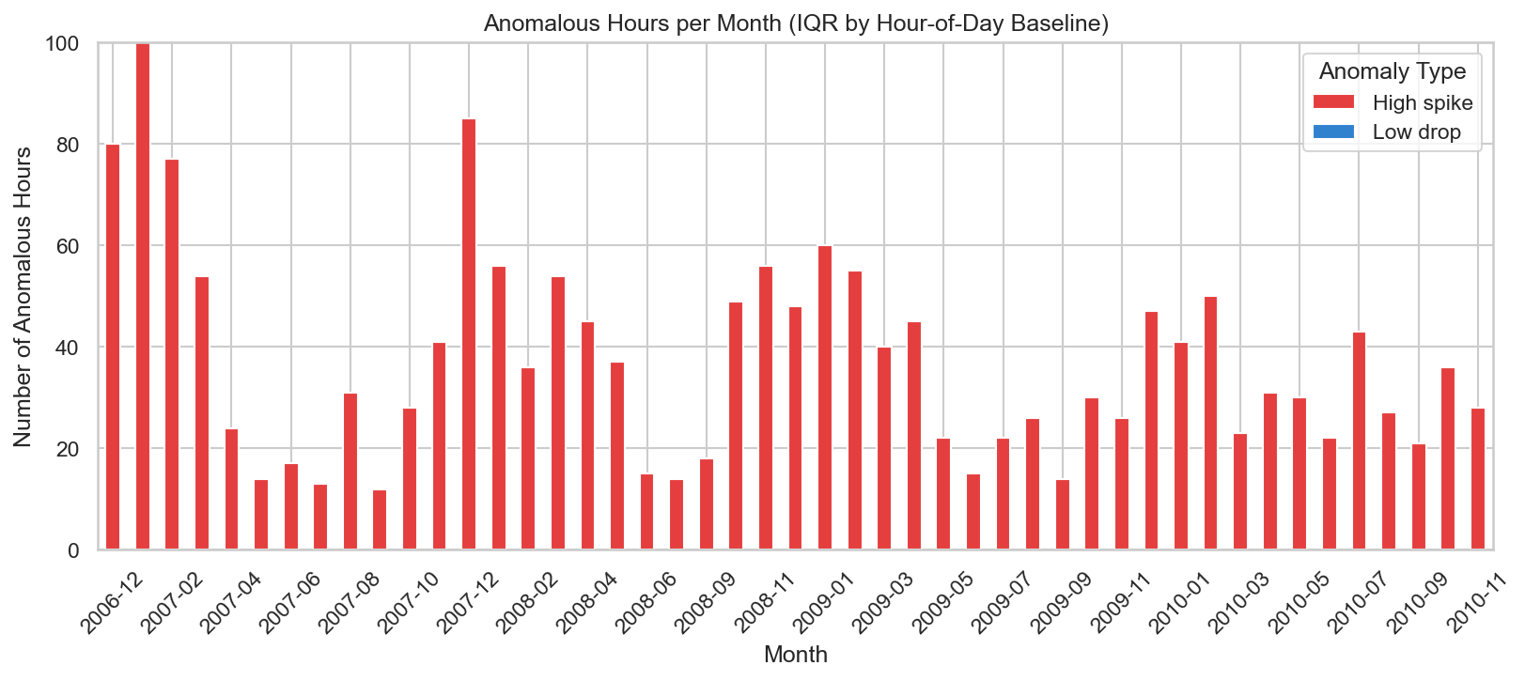
Count of hourly readings flagged as high or low anomalies (IQR bound computed per hour-of-day baseline), by month.
Key Finding: 1,758 hourly readings (about 5% of all hourly records) were flagged as high anomalies, with zero low anomalies expected, since active power has a natural floor near zero, which pushes the IQR's lower bound below zero and makes an unusually low reading effectively undetectable by this method. High anomalies are not evenly spread across the dataset; some months show visibly more flagged hours than others, suggesting genuine, investigable spikes rather than uniform background noise.

4. Summary of Key Initial Insights
- Consumption is strongly seasonal, peaking in winter and dropping in summer, consistent across all four years of data. This pattern shows up in both total energy (Chart 1) and average power intensity (Chart 2).
- This household is measurably more active on weekends: higher average power (Chart 3) and a structurally different, longer-duration usage pattern across the day (Chart 4) compared to weekdays.
- Water heater/AC is the dominant metered appliance category, but the majority of total energy, roughly 40- 65%, depending on the month is unmetered ‘other’ load (Chart 5), meaning the three sub-meters alone cannot fully explain this household's bill.
- Unusually high consumption hours are rare (about 5% of hours) and cluster in specific months rather than occurring uniformly, making them realistic candidates for a dashboard alert feature (Chart 6).
- Data completeness gaps from the cleaning step's drop-rather-than-impute decision are visible but limited, and are explicitly flagged rather than hidden in every chart that uses period-level aggregates.

5. Acceptance Criteria Check
Requirement | Status
At least 3 different types of visualizations created | Met - line, bar, heatmap, and stacked-bar charts (4 distinct types across 6 charts).
Visualizations effectively represent at least 3 of the defined energy metrics | Met - all 8 defined metrics are represented across the 6 charts.
Plots are clear, labeled, and provide initial insights into consumption patterns | Met - each chart has a title, axis labels, legend where relevant, and a stated finding above.
Code for generating these plots is organized and reusable | Met - each chart is a standalone function returning a Figure object; see household_energy_visualization.py and the accompanying README.

