🥦
Community Fridge Project
Technology & Volunteer Platform
Project Proposal for Review

Prepared for  Karen  Community Fridge Project  communityfridgeproject.org | Prepared by  Cathy Kiriakos  Technical Volunteer  March 26, 2026

Purpose: This document outlines the recommended technology stack for the Community Fridge Project volunteer coordination platform. It is designed to be reviewed by Karen without any technical background required. All recommendations prioritize Karen’s independence and ease of use.

📋 Executive Summary
The big picture, in plain English

Right now, coordinating Monday Sack Lunch, shopping runs, fridge cleanings, and Tovala recovery relies on Karen manually texting volunteers one by one. This proposal outlines a simple digital platform that replaces that process with a centralized hub Karen can manage from her phone or laptop.

The platform has three components:

1 | 📧 Email | A professional email address for Karen (karen@communityfridgeproject.org) and an automated system for sending volunteer alerts.
2 | 💻 Admin Dashboard | Karen’s private dashboard (website login) showing which events need volunteers, who’s signed up, and one-click outreach tools. No spreadsheets, no texting chains.
3 | 🌿 Volunteer Portal | A simple public page where volunteers can see upcoming needs and click to claim a spot. No account or password required.

Key Principle: Karen manages everything through a simple website. The technical infrastructure runs invisibly in the background. Cathy sets it up once — then steps back.

🗺️ How Everything Connects
Full system architecture diagram

The diagram below shows how each piece of the technology stack connects. The green elements are what Karen interacts with directly. Everything else runs automatically in the background.

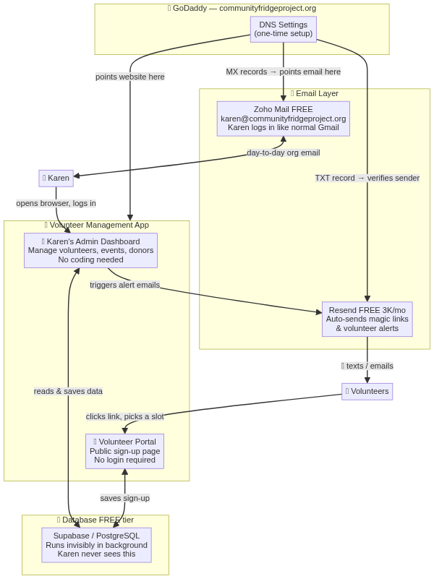

 | GoDaddy domain — already owned, just needs DNS records added |  | Zoho Mail + Resend — email services, set up once |  | Admin Dashboard + Volunteer Portal — Karen’s day-to-day interface

📧 Email Setup
Two services, both free, set up once

3.1 Karen’s Professional Email Address
Recommendation: Zoho Mail (Free tier)

Zoho Mail provides a free, professional email address using your GoDaddy domain. Karen would send and receive email at karen@communityfridgeproject.org through a clean web interface like Gmail — no technical knowledge required.

What Karen gets | How Karen uses it
- Professional email: karen@communityfridgeproject.org  - Web-based inbox (desktop + mobile)  - Free for up to 5 email addresses  - 5 GB storage per account | - Go to mail.zoho.com to check email  - Add to phone like any email app (Gmail app works)  - Manage password in Zoho’s account settings  - If needed later: add a second address for a co-admin

3.2 Automated Volunteer Alerts
Recommendation: Resend (Free — 3,000 emails per month)

When Karen clicks the “Find Gaps” button on her dashboard, the app automatically identifies unfilled volunteer slots and sends email alerts to volunteers with the matching skills. This is handled by a service called Resend, which sends emails on behalf of communityfridgeproject.org.

Important: Karen never logs into Resend. It runs silently in the background. The only time it’s touched is during initial setup by Cathy.

Monthly email volume estimate for this org:
- ~50 outreach emails/week (alerts to volunteers)
- ~30 magic link sign-in emails/week (for volunteer portal)
- Total: ~320/month — well within the 3,000/month free limit

3.3 Push Notifications for Volunteers
Recommendation: OneSignal (Free — up to 10,000 subscribers)

In addition to email alerts, volunteers can opt in to receive instant push notifications directly on their phone or browser — the same type of alert you get from a news app or a text message, but delivered through the volunteer portal website. No app download is required.

How it works for volunteers | How it works for Karen
- Volunteer visits the portal for the first time  - Browser shows a small pop-up: “Allow notifications from communityfridgeproject.org?”  - Volunteer clicks Allow — one-time setup, takes 2 seconds  - From then on, their phone or laptop receives instant alerts even when the browser is closed | - When Karen clicks “Find Gaps & Outreach,” the app fires both an email AND a push notification simultaneously  - Karen can also send a manual broadcast: “We need 2 more helpers Monday!” to all opted-in volunteers at once  - OneSignal’s dashboard shows delivery counts and who tapped the notification  - Reach volunteers who miss emails but always see phone alerts

Why this matters for your volunteer base: Many of Karen’s volunteers are retirees who may not check email frequently. A push notification appears on the phone lock screen just like a text message — immediate and hard to miss — without requiring anyone’s personal phone number.

Notification type | Trigger | Goes to
Gap Alert | Karen clicks Flag on dashboard | Targeted volunteer(s) with matching skill
Broadcast Reminder | Karen sends manually from dashboard | All opted-in volunteers
Day-Before Reminder | Automatically, 24 hrs. before event | Confirmed sign-ups for that event

🗄️ Database Management Options
Where volunteer & event data lives, and how Karen accesses it
This is the most important decision in this proposal. The “database” is simply a structured list of all your volunteers, events, and donors. The key question is: how does Karen view and update that information without needing to know anything technical?

Three options are presented below. The diagram that follows shows the difference visually.

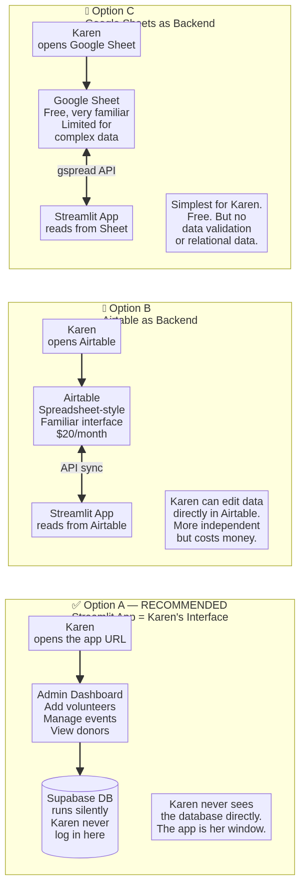

 | Option A ✔ Recommended | Option B | Option C
Name | App as Interface (Supabase hidden) | Airtable Backend | Google Sheets Backend
Karen’s interface | The volunteer app (her website login) | Airtable website (like a spreadsheet) | Google Sheets (already familiar)
Monthly cost | FREE | $20/month (Airtable Pro) | FREE
Karen independence | High — app handles everything | Very High — edit data directly | High — edit like a spreadsheet
Data integrity | Strong — app validates inputs | Medium — easy to make typos | Low — no validation rules
Setup effort | Already built | 1-2 days rebuild | 1-2 days rebuild
Best for | Launch now, grow later | Karen wants full data control | Ultra-simple, no budget

Recommendation: Option A with a “Safety Net”
The volunteer app already built (Karen’s dashboard) covers every action Karen would ever need to take on the database: adding volunteers, updating skills, creating events, managing sign-ups, and viewing donors. She never needs to log into the database directly.

The “safety net” addition: Supabase has a built-in visual table editor — a simple, spreadsheet-like view of all the data. Cathy can configure this as a read-only emergency backup so Karen can view raw data in a worst-case scenario (e.g., the app is temporarily down). This costs nothing extra.

Bottom line: Option A is free, already built, and gives Karen a simple website she can use from her phone. If Karen’s data independence needs grow over time, we can migrate to Airtable later with a day’s work.

📅 Karen’s Weekly Workflow
What Monday morning looks like with the new system

The sequence diagram below walks through a typical Monday morning workflow for Karen, from opening the dashboard through to confirming volunteer slots are filled for Sack Lunch.

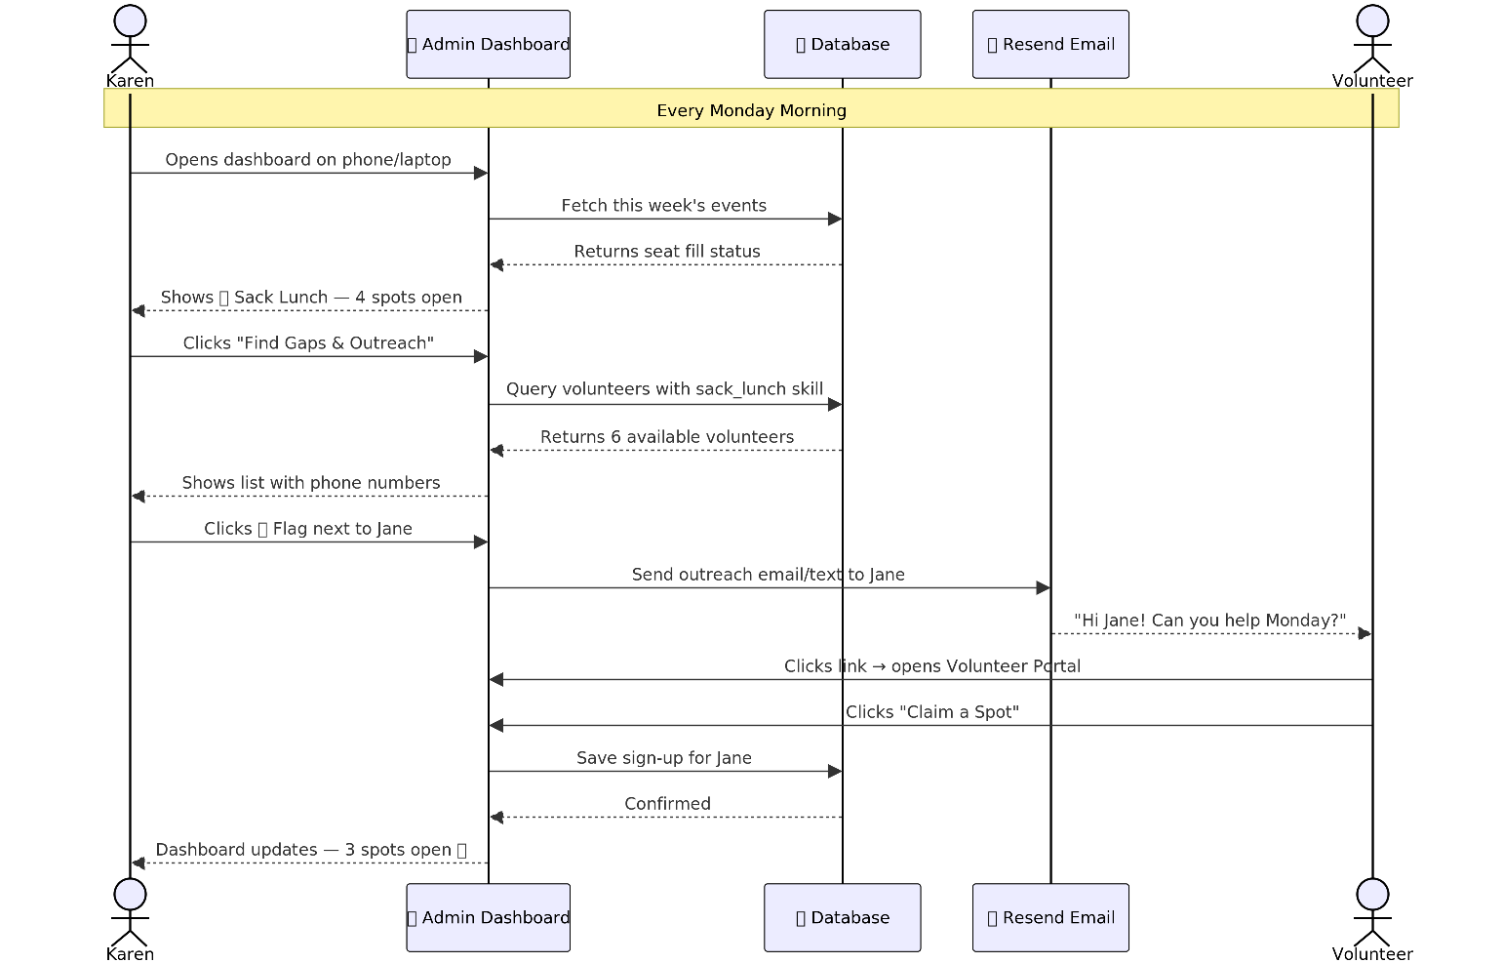

Day-to-Day: What Karen Does vs. What Happens Automatically

Karen does this (manual) | This happens automatically
- Opens the dashboard (phone or laptop)  - Clicks “Generate This Week’s Events” once a week  - Clicks “Find Gaps” to see who’s missing  - Clicks 📱 Flag next to volunteers to prompt outreach  - Adds new volunteers when they join  - Updates donor notes after conversations | - Email alerts sent to volunteers when flagged  - Volunteer portal updates in real-time as slots are claimed  - Dashboard seat counts update immediately on sign-up  - Recurring events auto-populate weekly (Mon Sack Lunch, shopping runs, etc.)  - All data backed up by Supabase (cloud, no data loss)  - Push notifications delivered to opted-in volunteers’ phones instantly  - Day-before reminders sent automatically to confirmed sign-ups  - SSL certificate (secure https://) auto-renews

💰 Cost Breakdown
What this costs to build and run

The recommended stack is designed to run at zero monthly cost indefinitely, using free tiers of well-established services. The only costs are Karen’s existing GoDaddy domain renewal and optional upgrades as the org grows.

Service | Free Tier | If Upgraded | Karen Manages?
GoDaddy Domain | ~$15/year (already owned) | N/A | Yes — annual renewal
Zoho Mail | FREE up to 5 users | $1/user/month | Yes — password only
Resend (email alerts) | FREE 3,000/month | $20/month for 50K | No — runs itself
Supabase (database) | FREE up to 500 MB | $25/month for Pro | No — runs itself
OneSignal (push notifications) | FREE up to 10,000 subscribers | $9/month for advanced | No — runs itself
Volunteer App hosting | FREE (Streamlit Cloud) | $0–$25/month | No — runs itself
TOTAL (launch) | ~$15/year | ~$45/month if fully upgraded | Domain only

Volume reality check: The free tiers are sized for this organization. The Monday Sack Lunch list alone (9–11 volunteers + 5 subs) represents a fraction of Resend’s 3,000/month email limit. Even at full capacity across all 6 fridges, this platform costs nothing to operate.

🗓️ Setup Timeline & Next Steps
What happens, in what order, and who does it

Setup is structured so that Karen’s decisions and one-time actions come first (Steps 1–2), followed by Cathy’s technical configuration (Steps 3–6), followed by Karen taking ownership of the live system (Step 7). Total time: approximately 1 week from green light to live.

# | Owner | Action | When
1 | Karen | Review and approve this proposal. Confirm: (a) Zoho Mail for org email, (b) Option A for database management. | Before anything else
2 | Karen | Create a Zoho Mail account at zoho.com using her personal email, then claim karen@communityfridgeproject.org. Cathy can screen-share to help. | Day 1
3 | Cathy | Add DNS records in GoDaddy: MX records for Zoho Mail, TXT verification record for Resend. (15-minute task — then DNS propagates over 1–24 hours.) | Day 1–2
4 | Cathy | Create Resend account under karen@communityfridgeproject.org email. Add domain verification. Connect Resend to the volunteer app. | Day 2
4b | Cathy | Set up OneSignal account (free). Add the push notification widget to the volunteer portal. Configure gap-alert and day-before reminder automations. | Day 2–3
5 | Cathy | Run schema.sql in Supabase to create all database tables. Load Karen’s existing volunteer list via import. | Day 2–3
6 | Cathy | Deploy the volunteer app to Streamlit Cloud. Configure environment variables. Smoke test all features. | Day 3–5
7 | Karen + Cathy | 30-minute walkthrough session: Karen logs in, adds a test volunteer, generates this week’s events, and confirms outreach works. | Day 5–7
8 | Karen | App is live. Karen is in the driver’s seat. Cathy available for questions but not required for day-to-day operations. | Week 2+

DNS propagation note: Steps 3 and 4 involve adding DNS records in GoDaddy. These take anywhere from 15 minutes to 24 hours to take effect globally. This is normal and nothing to worry about — it just means we schedule steps 4-6 for the day after step 3.

❓ Questions for Karen to Decide
Before Cathy begins setup

The following decisions require Karen’s input before any technical work begins. None of these are technical decisions — they are organizational and personal preference questions.

 | Question | Options / Notes
Q1 | Which email address name do you want? karen@, info@, hello@, coordinator@communityfridgeproject.org? | Recommendation: karen@ is personal and approachable
Q2 | Should volunteers need to log in to claim a spot, or should sign-up be open (no login required)? | Recommendation: no login for simplicity — volunteers just click a link
Q3 | Do you want volunteer outreach to go via email only, or also via SMS text message? (SMS requires an additional free service: Twilio or similar.) | Start with email. Add SMS in Phase 2 if volunteers request it.
Q4 | For push notifications: would you like volunteers to opt in the first time they visit the portal, or would you prefer to introduce it later once the platform is established? | Recommendation: enable from day one. The browser opt-in prompt is familiar and non-intrusive.
Q5 | Should the volunteer app live at the same web address as the main website (communityfridgeproject.org/dashboard) or a separate URL (app.communityfridgeproject.org)? | Subdomain (app.) is simpler to set up. Same domain is cleaner for volunteers.

Questions or feedback on this proposal?
Reach out to Cathy Kiriakos — cathy.a.kiriakos@gmail.com | 312-433-9742
This document is a living draft and can be updated based on Karen’s feedback before any work begins.

