|  |  |  |  |  |
| --- | --- | --- | --- | --- |
| *Athena-A-V1.x-2ET*  *(2 stages counter-rotating)* |  | |  | | --- | | **Athena A**  **Electric VTOL Turbo-Fan**  **Turbine Electrique de Poussée Statique**  **Elektro-Turbo Fan** | | Electric VTOL Turbo-Fans  from  ESP | |
|  |  |  |
| **Technical Specifications – data sheet** |  | Feb. 2020 |

**The Neva Aerospace Athena Series are Electric Ducted Fans (EDF) engineered for efficient static flights, Vertical Take-Off and Landing (VTOL).**

**These devices are known by various names worldwide: *Standschub optimimerter elektroimpeller or Elektro-turbo-fan* in Germany, *“Turbine électrique de poussée statique”* in France and *Electric VTOL Turbo-Fan* (ETF) or static thrust Electric Ducted Fan (EDF) in the UK and USA.**

**Neva Athena Series turbines are the result of several years of R&D and provide high performance and remarkable efficiency. In particular they are designed for static thrust and are optimised for VTOL and STOL operations.**

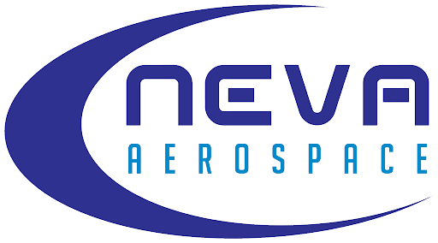

Key Key features:

Safety is intrinsic in the design of all Neva EDFs, as all blades are caged:

* Internal redundancy with 2 separate stages, 2 motors, and 2 ESCs (2ET-version)
* Reduced size
* High thrust density
* Greater efficiency for static flights - high power loading as measured in kg/kW.

Athena A (autonomous) is offered in several variants:

* 2ET: 2 stages counter-rotating (CW or CCW)*

*(*) The residual torque of counter-rotating ETF can be selected as the rotation of the first stage. To be mentioned at purchase. By default we deliver 2 stages (2ET) as residual CW.*

Athena Series turbines are delivered fully assembled with Electronic Speed

Controllers (ESC), motors and propellers.

Applications:

Typical usage for manned or unmanned aircraft:

* Bespoke applications for medium sized UAS / UAV
* Bespoke heavy-payload, high-safety UAV / UAA / AAM /UAM
* Extreme sports (paraglider, base-jump, turbo-ski, etc…)
* Security and Defence applications
* Electric aviation: high -efficiency VTOL and slow speed linear flight
* Airships: high efficiency thrust for VTOL & slow speed linear flight





*Measurements on Athena-A-2ET-V1.6x Feb. 2018.*

*Notes:*

*The residual torque of counter-rotating ETF can be selected as the rotation of the first stage. To be mentioned at purchase. By default we deliver 2 stages (2ET) as first stage CW with residual CW torque.*

*1.5x and 1.6x are in different composite materials and so have different density and weight ratio.*

*1.5x shroud: carbon composite, and other components: plastic composite.*

*1.6x all parts are plastic composite.*

*V1.5x and V1.6x include the ESC weight (ESC integrated within the turbine)*

***Temperatures*** *:*

*Operating temperatures: non-icing conditions only & avoid direct sunlight when not flying*

*from -10 Degree Celsius to +50 Degree Celsius for Carbon shroud (1.5x)*

*from 0 Degree Celsius to +40 Degree Celsius for Plastic Composite shroud(1.6x)*

*Storage Temp: from 5 DegC to +35 DegC – no direct sunlight- dry storage50*

Notes on Technical Specifications:

Contact:

[Sales@Neva-Aero.com](mailto:Sales@Neva-Aero.com)

Neva Aerospace Ltd.  
Sussex Innovation Centre

Brighton BN1 9SB

United Kingdom

**Units used:**

*International System of Units (SI Metric): kg= kilogram, g=gram, kgf=kilogram force means thrust measured in kilograms; g/We (or gf/W) means efficiency in gram-force-thrust per Watt electric consumed.*

**Weight & Control Systems:**

*ESC means Electronic Speed Controller*

*The weight of our turbofans includes shroud, motors, propellers, and motor holder(s) but not the ESCs.*

*ESCs are delivered together with the EDF.*

**Motors:**

*Depending on your applications we mount 2 types of electric motor with different power, please contact us for motor specifications.*

**Accuracies:**

*All figures are given with a +/- 5% accuracy.*

*All thrusts in gf or in kgf and efficiencies (power loadings) in gf/We or kgf/We represent gross values and are given with reference to the International Standard Atmosphere for dry air (ICAO 1964) and as such pertain to measurements at 15 degrees Celsius at 1013.25hPa and zero humidity.*

**Updates:**

*Specifications are subject to be updated without notice.*

*Please contact us to obtain the latest specifications.*

**Warranty Warning:**

*Any modification made to the ESC, motor, propellers, fan or shroud geometry, or over-clocking will void the warranty.*

*Icing condition: De-icing may not be fitted, and our electric turbofans are currently not acceptable for icing conditions.*

*Flight Level: Operational flight level up to 3281 ft (Feet) / 1000 M (Meter)*

*Restrictions: Neva authorize and warrant the use of its electric ducted fans only for civilian applications up to 25kg MTOW aircraft (LT25) and lower than 3 000 ft.*

**Shroud Warranty – outside of wearable parts**:

*Carbon shroud 3 years or 5 000 hrs*

*Plastic composite shroud 1 years or 2 000 hrs*

**Turbine Ingress Protection Code (IP):** *IP 53 .* *Please note that high level of dust or sand in atmosphere may wear blades or motor bearings more rapidly than usual.*

*IP*

**About Certifications & Flight Rules:**

*We make no warranties on the acceptability by the local regulator nor certification under local UAV/UAS regulation or Manned aircraft regulations. It is the full responsibility of the UAS/UAV integrator, aircraft manufacturer, to liaise with its certification body if/when need be.*

**Unmanned:**

*Our turbofans may be used for VLOS & BVLOS up to 25Kg MTOW depending on your region and local laws; and may not be suitable for BLOS according to your local rules. Applications with a MTOW higher than 25kg and/or above 3 000ft are at your own risks. To obtain warranty above MTOW 25Kg and/or 3 000 ft, you need to contact us.*

**Manned:**

Our turbofans have to be certified within your aircraft under ULM or Prototype certification rules with your aircraft and may be suitable for VFR certification. If you embed our electric turbofan in a manned aircraft, you need to contact us to have an extension of warranty.

All information in this specification sheet is proprietary.

All images are non-contractual.

**Patents (EU, USA, and INTL) granted and/or pending**:

EU DM/089417, 2016-5567, US Application No. 35/5000,663

Copyright © 2015, 2016, 2017, 2018, 2019 – Neva Aerospace Ltd.

**External Dimensions:** Athena -A-2ET-V1.6x

Copyright © 2017, 2018, 2019 – Neva Aerospace Ltd.

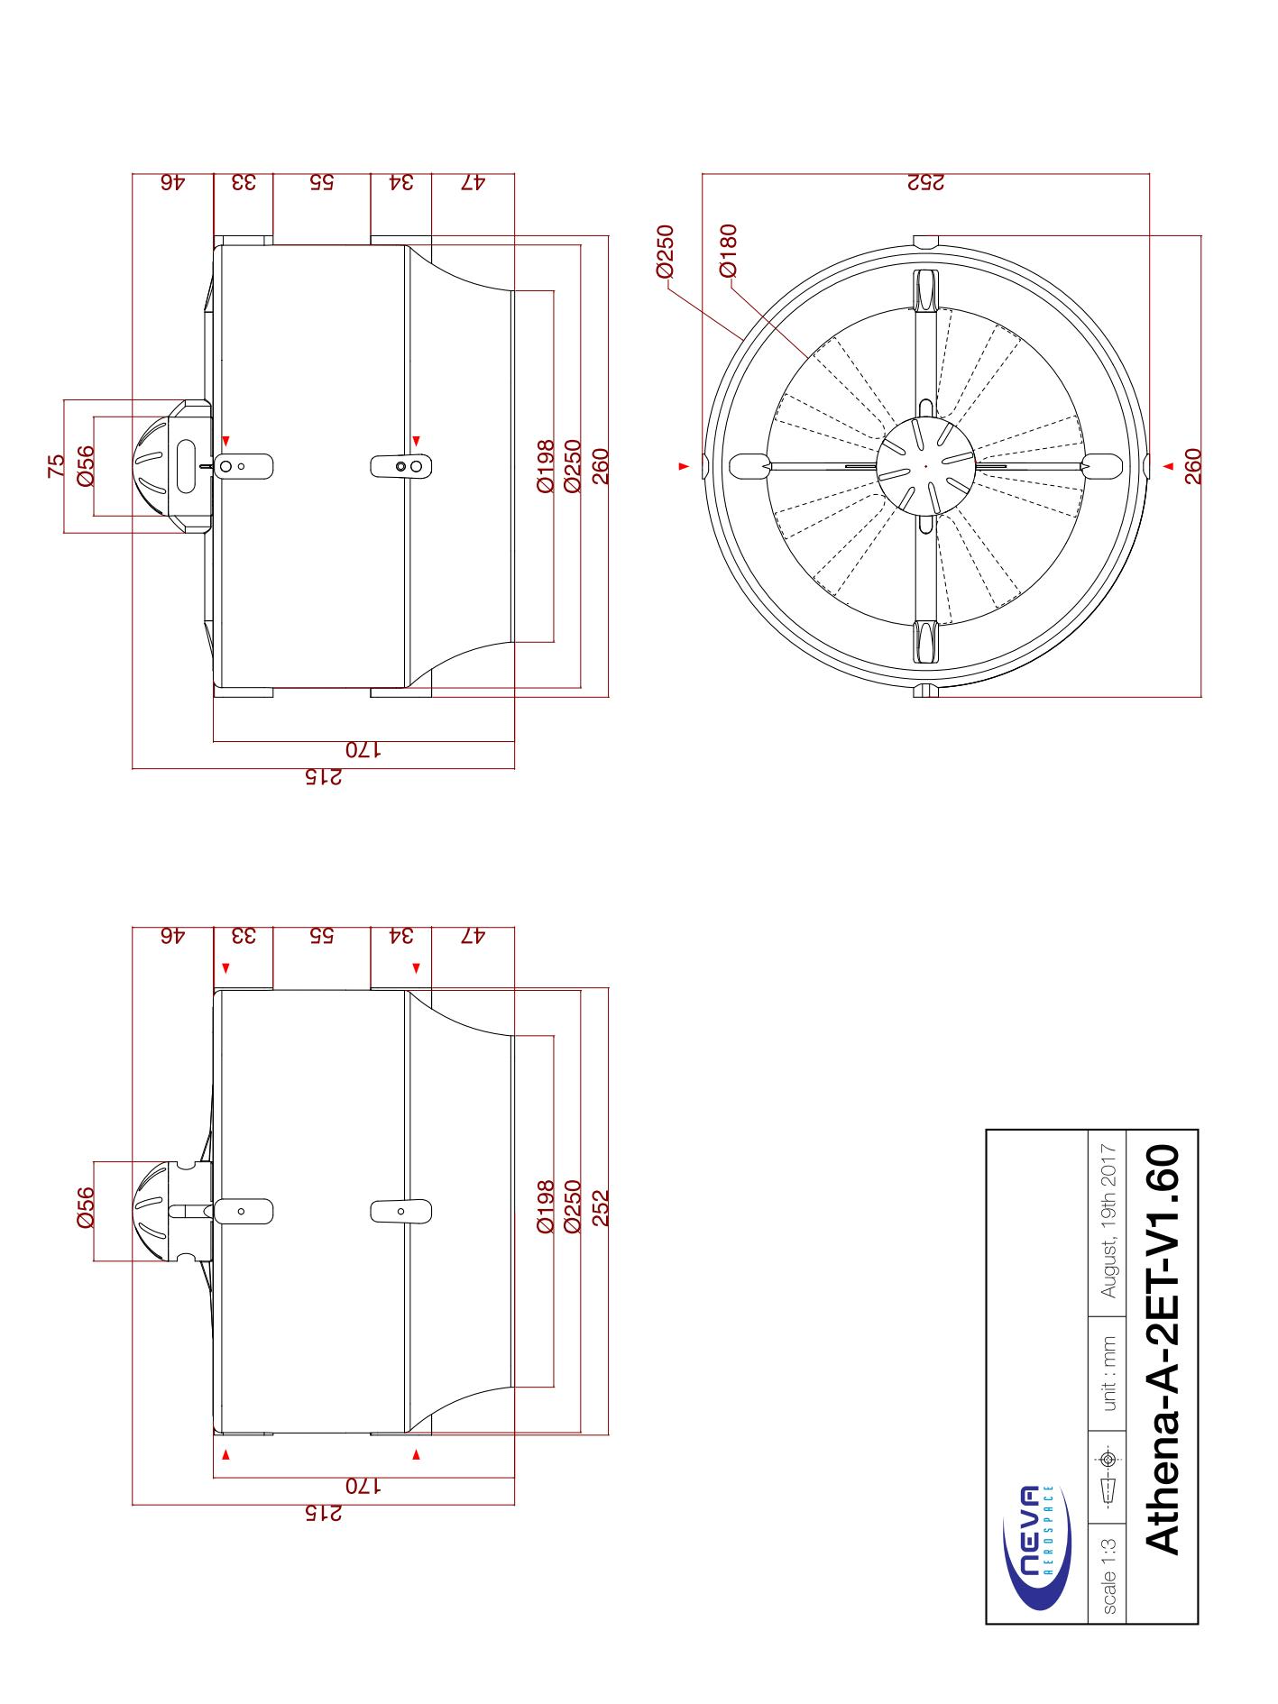

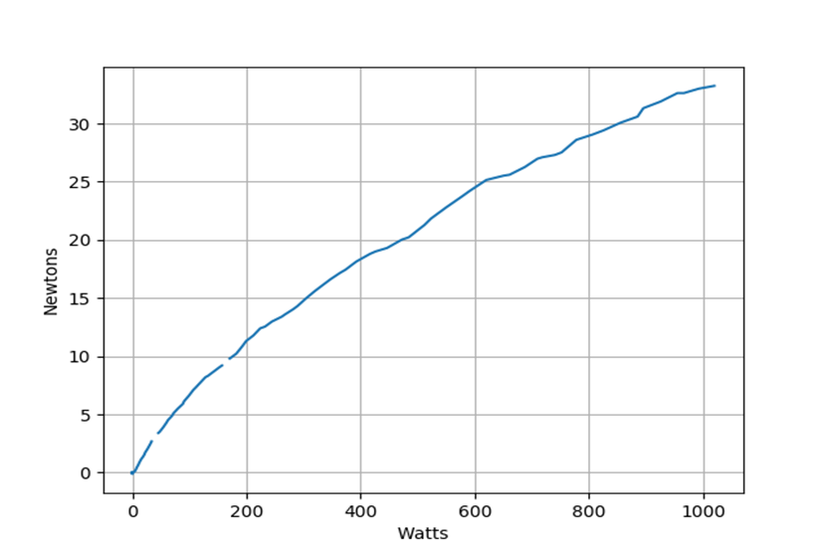

**Efficiency Thrust vs Power – Athena-A-2ET-1.64 (6S)**

**Technical Annex – Athena-A-2ET-V1.6x**

