ATHENA-A-@ET-V1.6x - La Visseries The Screws

Date: 25/01/2019 - issued by : TVL / reviewed by: RFV

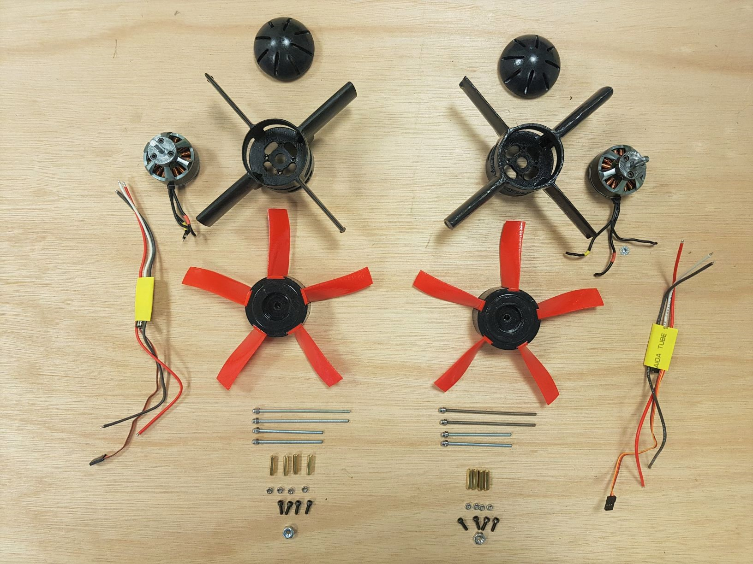

For each turbine:

# Screws / Vis:

4x M3 10mm,

2 x M3 60mm

2 x M3 screws 80mm.

Nuts / Ecrous:

4 x M3 (standard - no nylstop)

1 x M6 (standard - no nylstop)

# 2. Female Thread Hexagonal / Insert Rallonge Hexagonale:

M3 10mm (better)