Computer Organization and Assembly Language Programming
Laboratory Manual

Engr. Leni A. Bulan, MEng
Engr. Liza R. Maderazo, MEng
Engr. Policarpio D. Tena, Meng

Evaluation Copy

Any reproduction of this student manual, use of various graphics or diagrams, content in any manner without the signature of the author and the corresponding number shall be considered as proceeding from illegal source. The author assumes no responsibilities for errors or omissions. Neither is any liability assumed for damages resulting from the use of the program listings or diagram that may be encoded, saved, interfaced or executed in a computer system herein.

2018

PREFACE
This laboratory activity manual for Computer Systems Organization And Assembly Language Programming is designed to make it easier for the students to understand the concepts and inner workings of the computer systems. It is a common misconception that programming using an assembly language is difficult and primitive. In some cases, such observations maybe correct. On the other hand, just like with other programming languages, once a programmer is able to get the idea of putting together the specific program construct for this language, it is actually easy and quite enjoyable. Assembly language programming is not designed for creating screen layouts and outputs similar to higher programming languages. Instead, this language is more on direct control and access of the computer system hardware. But for the purpose of putting the language into the students’ perspective, programming samples and exercises presented in this manual uses screen layouts and displays similar with other languages although more difficult to create.
It is the author’s heartfelt wish that this laboratory manual will be beneficial to many, teachers and students alike.

The authors

TABLE OF CONTENTS
Lesson 1 | The TASM Editor Environment
 | Starting the Assemble Editor . . . . . . . . . . . . . . . . . . . . . . . . . . . . | 1
 | The TASM Environment. . . . . . . . . . . . . . . . . . . . . . . . . . . . . . . . | 3
 | Creating the First Program . . . . . . . . . . . . . . . . . . . . . . . . . . . . . . | 5
 | Saving the Assembly Program . . . . . . . . . . . . . . . . . . . . . . . . . . . | 6
 | Compiling the Program. . . . . . . . . . . . . . . . . . . . . . . . . . . . . . . . . | 7
 | Executing the Program. . . . . . . . . . . . . . . . . . . . . . . . . . . . . . . . . | 9
 | Sample Program. . . . . . . . . . . . . . . . . . . . . . . . . . . . . . . . . . . . . . | 10
Lesson 2 | Introduction to Character Display
 | The Function 02h . . . . . . . . . . . . . . . . . . . . . . . . . . . . . . . . . . . . . | 12
 | Carriage Return and Line Feed . . . . . . . . . . . . . . . . . . . . . . . . . . | 12
 | Character ASCII Code . . . . . . . . . . . . . . . . . . . . . . . . . . . . . . . . . | 13
 | Skills Review . . . . . . . . . . . . . . . . . . . . . . . . . . . . . . . . . . . . . . . . . | 14
Lesson 3 | Program Looping
 | Loop Instruction . . . . . . . . . . . . . . . . . . . . . . . . . . . . . . . . . . . . . . | 17
 | Sample Program . . . . . . . . . . . . . . . . . . . . . . . . . . . . . . . . . . . . . . | 17
 | Skills Review. . . . . . . . . . . . . . . . . . . . . . . . . . . . . . . . . . . . . . . . . | 21
Lesson 4 | Defining Data and the Data Segment
 | The Function 09h. . . . . . . . . . . . . . . . . . . . . . . . . . . . . . . . . . . . . . | 25
 | Sample Program. . . . . . . . . . . . . . . . . . . . . . . . . . . . . . . . . . . . . | 26
 | Skills Review. . . . . . . . . . . . . . . . . . . . . . . . . . . . . . . . . . . . . . . . . | 28
Lesson 5 | Introduction to Screen Processing
 | The Interrupt 10h Function. . . . . . . . . . . . . . . . . . . . . . . . . . . . . . | 31
 | The Screen Lay Out. . . . . . . . . . . . . . . . . . . . . . . . . . . . . . . . . . . | 32
 | Standard Video Colors. . . . . . . . . . . . . . . . . . . . . . . . . . . . . . . . . . | 34
 | Function 06h and 0h. . . . . . . . . . . . . . . . . . . . . . . . . . . . . . . . . . . | 35
 | Function 02h. . . . . . . . . . . . . . . . . . . . . . . . . . . . . . . . . . . . . . . . . | 35
 | Sample Program. . . . . . . . . . . . . . . . . . . . . . . . . . . . . . . . . . . . . . | 36
 | Skills Review. . . . . . . . . . . . . . . . . . . . . . . . . . . . . . . . . . . . . . . . . | 40
Lesson 6 | Introduction to Keyboard Processing
 | The Standard Input Keyboard. . . . . . . . . . . . . . . . . . . . . . . . . . . . | 45
 | Different Keyboard Function Calls. . . . . . . . . . . . . . . . . . . . . . . . . | 46
 | Branching. . . . . . . . . . . . . . . . . . . . . . . . . . . . . . . . . . . . . . . . . . . . | 46
 | Reading Individual Keys. . . . . . . . . . . . . . . . . . . . . . . . . . . . . . . . | 47
 | Sample Programs. . . . . . . . . . . . . . . . . . . . . . . . . . . . . . . . . . . . . | 49
 | Skills Review. . . . . . . . . . . . . . . . . . . . . . . . . . . . . . . . . . . . . . . . . | 57
Lesson 7 | Basic Input/Output Interfacing
 | Parallel Port Interfacing. . . . . . . . . . . . . . . . . . . . . . . . . . . . . . . . . | 59
 | Port Pin Assignment. . . . . . . . . . . . . . . . . . . . . . . . . . . . . . . . . . . | 60
 | Parallel Port Register. . . . . . . . . . . . . . . . . . . . . . . . . . . . . . . . . . . | 61
 | Parallel Port Identification on IBM PC. . . . . . . . . . . . . . . . . . . . . . | 61
 | Accessing Parallel Port Pins in a Program. . . . . . . . . . . . . . . . . . | 61
 | Differentiating Between Memory and I/O Address Space . . . . . . | 62
 | Relationship Between Bits Present and Port Address  and the Voltage Levels on Port Pins. . . . . . . . . . . . . . . . . . . . . . | 62
 | Sample Application. . . . . . . . . . . . . . . . . . . . . . . . . . . . . . . . . . . . | 63
 | IN Port. . . . . . . . . . . . . . . . . . . . . . . . . . . . . . . . . . . . . . . . . . . . . . | 63
 | Introduction to Buffering for Parallel Processing . . . . . . . . . . . . . . | 64
 | Sample Program. . . . . . . . . . . . . . . . . . . . . . . . . . . . . . . . . . . . . . | 65

Lesson 1
The TASM Editor Environment

Objectives:

At the end of this activity, the student should be able to:

- open directly and indirectly of the Turbo Assembler Editor
- go around the Assembly Editor Environment with ease
- Use the different turbo assembler functions
- create and Compile an Assembly File
- debug and/or identify program errors
- Interpret the basic output of the program

The Turbo Assembler (TASM) Environment

- Starting the Assemble editor

- Turbo Assembler (TASM) is a DOS-based type of assembler. To invoke the TASM, the command window will have to be activated. There are several ways to do this. The simplest way is by clicking on the START menu, select RUN, then typed the word command and ENTER or click OK.

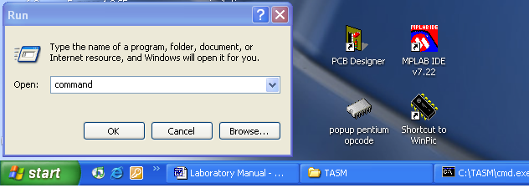

- The command window will be displayed as shown. The display may vary depending on the defined default directory of your computer. If there’s an existing directory in the C:>\ prompt, type the command cd\ then press enter to put the directory to its root C:>\ prompt.

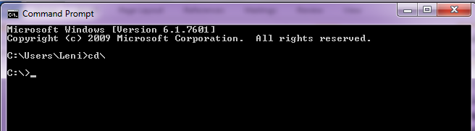

- To open the TASM directory type cd tasm then press ENTER. The prompt will change to TASM sub-directory C:\TASM>

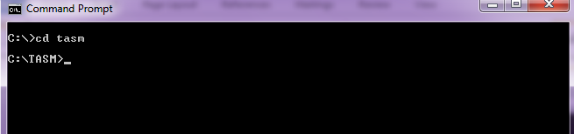

- Type edit at the command prompt then press ENTER. After typing the edit command, the MS-DOS -Assembler Editor will be opened. The editor can be toggled back and forth from its original size to full screen and vice versa simply by pressing ALT + ENTER from the keyboard.

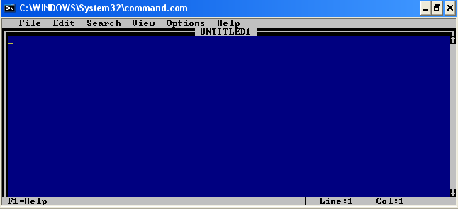

Note: Not all computers support the full screen mode of the editor thus sometimes, the editor window cannot be resized to a full window.

B. The TASM Editor Environment

Each of the area of the editor has a specific purpose in the Turbo Assembler Editor. You can configure these areas in order to customize the Editor.

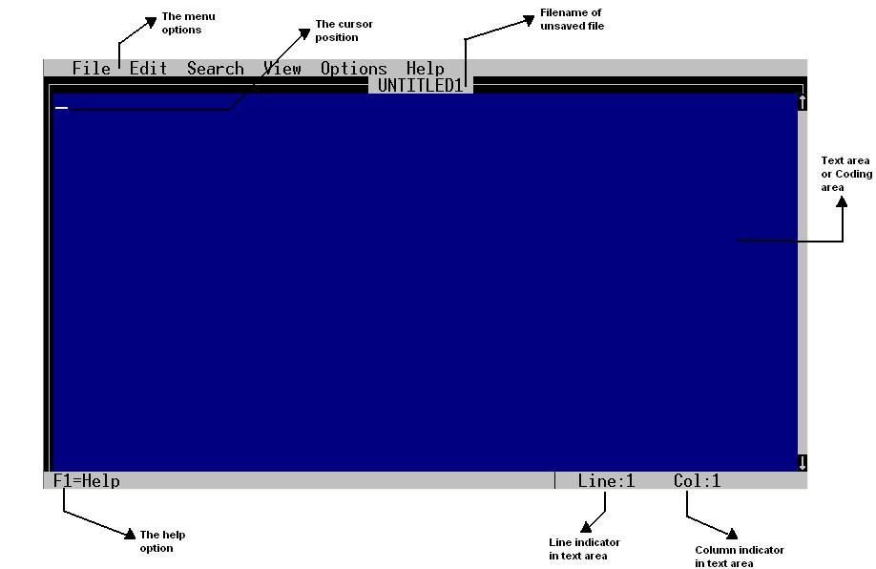

To navigate on the Menu options:
Keyboard Keys | Activates
ALT + F | File Menu
ALT + E | Edit Menu
ALT + S | Search Menu
ALT + V | View Menu
ALT + O | Options Menu
ALT + H | Help Menu

Once a menu option has been activated the UP, DOWN, LEFT and RIGHT arrow keys can be used to navigate on the different menus and sub-menu options that are available. Indicated at the bottom of the editor are help tips that display the information about the highlighted menu.

Tip: A sub- menu option can be activated by simply pressing the ALT key + the capital letter indicating the menu, followed by the highlighted letter on that menu. Example ALT + F + O invokes the Load an Existing File window.

The Menu Bar

The Menu Bar at the top of the Editor provides options to access the different functions available at the editor.
- The File Menu. This menu is basically used for manipulating files. It contains the most standard tools as listed:
- New. This option is used to create new file
- Open. This option is used to open an turbo existing assembler file
- Save. This is used to save new or edited files.
- Save As. Use this option to save an existing file using a different file name.
- Close. This option is used to close an opened file
- Print. This is send and open file to the printer.
- Quit. Use this option to exit from the Turbo Assembler editor.
- The Edit Menu. This menu contains c ommands for editing file. It contains the tools for Copying, Cutting, Pasting and clearing a selected text from the program.
- The Search Menu. This menu is used to conduct searches and replacement of keywords from the program. This is most helpful specially when there are already several program lines in the file and there are particular bugs that needs to be easily found within the program.
- The View Menu. This menu provides the user with options on how to use the editor window. It has options to split the window, resize a window, or close a window. It becomes easier for the programmer to see more part of the program especially if the program is too long to fit on the entire screen and the programmer would like to observe or explore other parts of the program.
- The Options Menu. This menu provides options for setting a preferred printer port to use and editor window color . Tab stop positions can also be set using this menu.
- The Help Menu. This menu provides the programmer with help on some basic keyboard shortcuts that could be easily used. It also shows the version of the editor being used.

The Text Area or Code Area (Editor Area)

The Text Area or Code Area is the space where the programmer writes down, edit or modify an assembly language program. This is also the area where the previously saved program is opened. A programmer may place notations or comments within the program to make it easier for him or any other reader to read and understand the program and it is all done within this area of the editor.

The Cursor Position

The Cursor is the under grade white line blinking inside the text or code area. The cursor position indicates the location where the programmer may start typing his program code. It also indicates the location on an existing program where a programmer may insert or edit texts.

Title of the File

The title indicator of the file is located at the top center of the editor. This area basically shows the name of the file that is opened. It may also be an indicator of whether a file has already been saved or not. A file name indicator that shows “UNTITLED” means that the file is not yet saved on a specific file name required by the programmer.

The Line and Column Indicator

The right hand lower corner of the editor displays the line and column indicator. This area indicates the current line and column location of the cursor. This information is especially important when looking for a bug that has been defined by the assembler after the assembly step.

C. Creating your first Program (All examples of this manual uses the same procedure)

1. To create a new file press ALT + F + N.

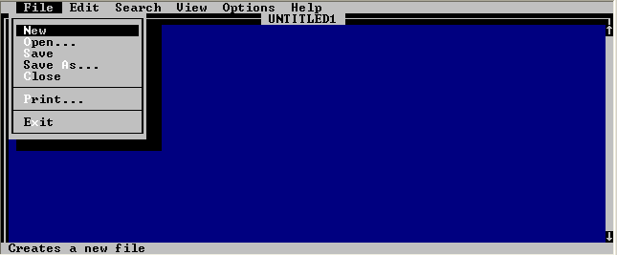

2. Copy the given sample code in the text area.

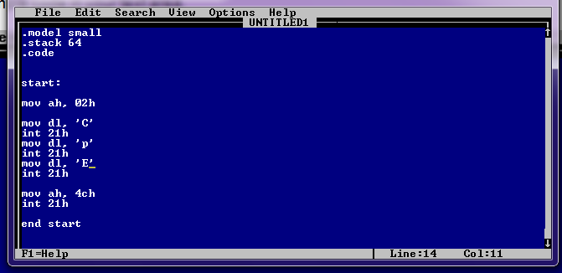

D. Saving the Assembly File (Program)

1. To save the file, press ALT + F + S.

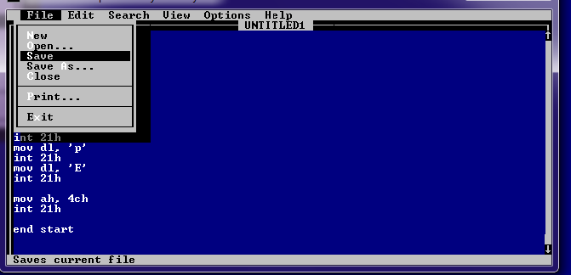

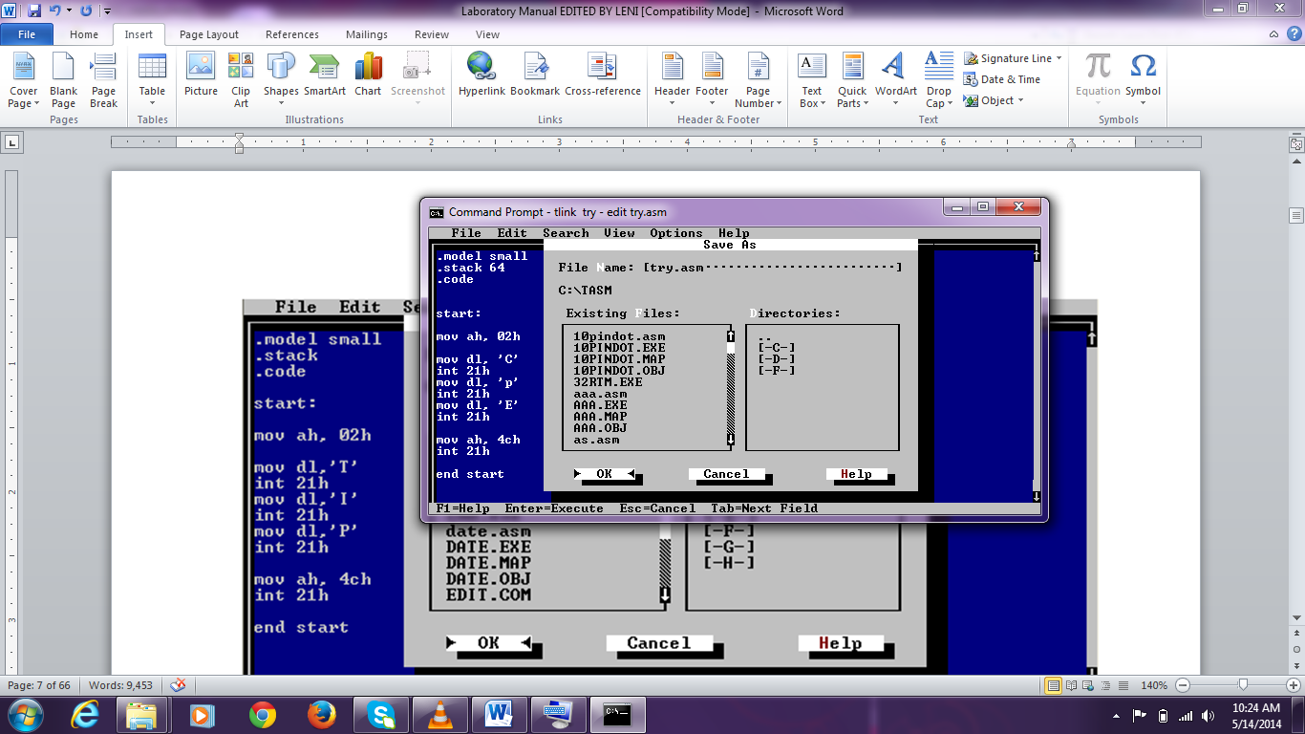
2. The Save As dialog window will be displayed as shown below. Type in the file name ( ‘try.asm’ in this example) along the File Name: line area. Make sure to always use the .asm extension for all assembly language programs. Take note also of the directory where the file will be saved. To choose the directory, simply double click on a directory under the Directories column on the window.
Save file with .asm after the file name

3. After saving the file, the filename indicator on the editor window will be changed into the name that has been used during the saving process.
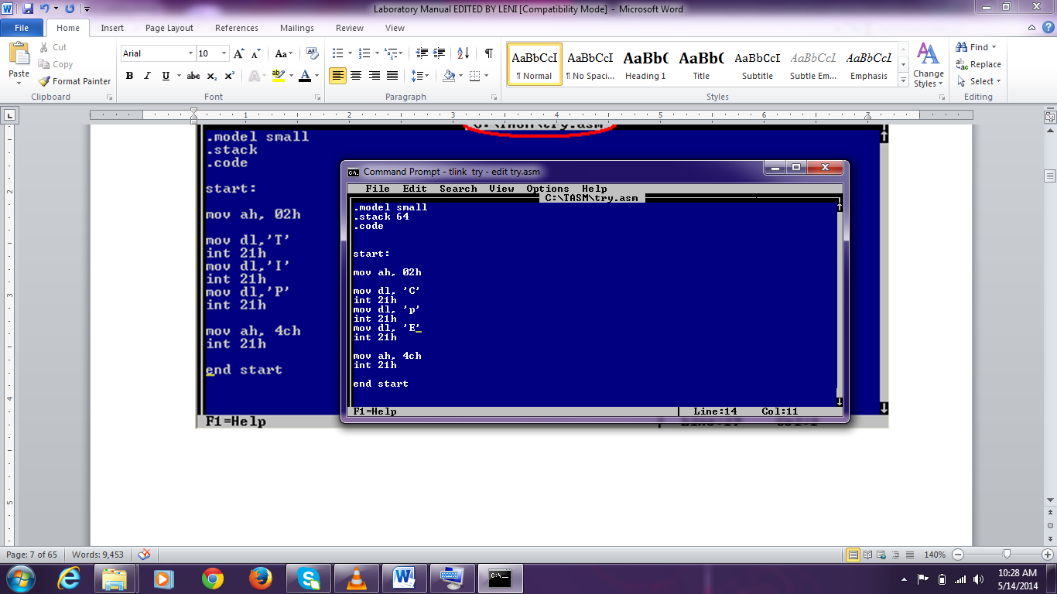
After saving the file, the title indicator will reflect the assigned file name

E. Compiling the Program

1. To compile the program, exit from the editor by pressing ALT + F + X. If the program was not properly saved, a Save File dialog box will prompt the programmer to either save, not save, or cancel the exit process.

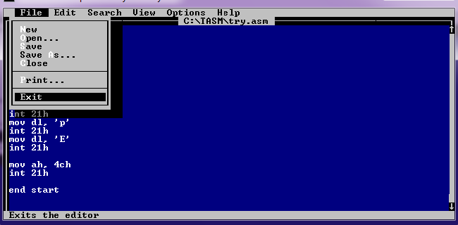

2. After exiting from the Editor, the user will be prompted at the command window with the C:\TASM> prompt.

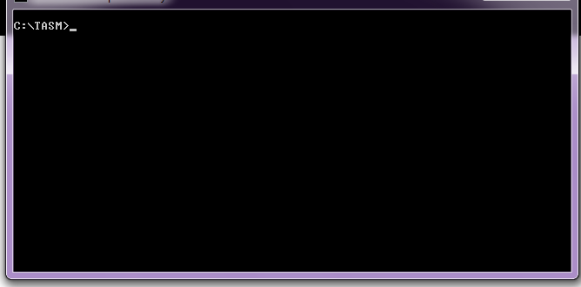

3. To assemble the previously created assembly language file, type the tasm try.asm command on the prompt then press ENTER. If no error or bug has been encountered, a .obj file will be created. This .obj file will be used in the next step which is linking onto the necessary assembly language libraries.

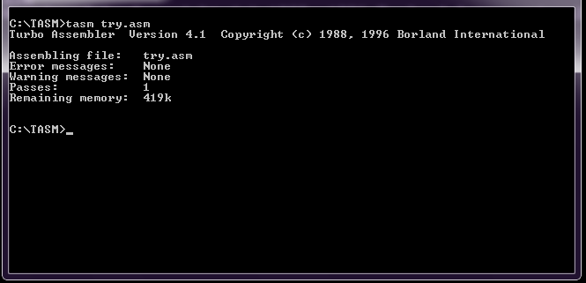

If an error is encountered during the assemblhy step, error messages will be displayed on the screen similar to the one shown in the figure below. If such a case happens, re-open the program at the editor, correct the errors, then save. After saving, repeat the assembly process discussed in the previous step. Do this repeatedly until no more errors occur then proceed to the next step.

There are errors at line numbers 8 and 10 as indicated by the error message

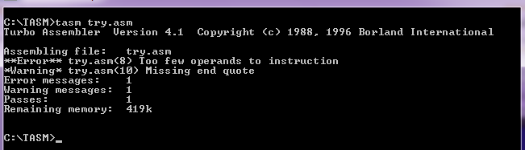

4. To link your .obj file type the command tlink try.obj. The linker will now generate a .exe and .map file. At this stage, no error is expected to be encountered and thus a screen output similar below should be created. Should the system failed to produce similar screen output, there must be something wrong with the .asm file and something must have gone wrong during the assembly step.
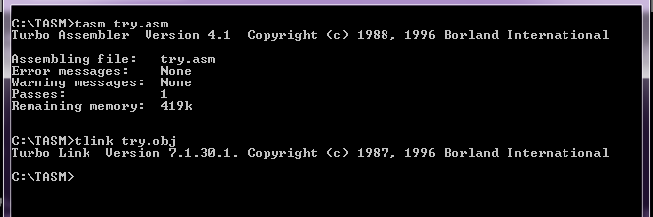

F. Executing the Program

1. After the linker has generated an executable (.exe) file from your object module (.obj), the program can be executed and the output can now be observed. Before the program is executed, it would be helpful to clear the screen by typing the CLS command.

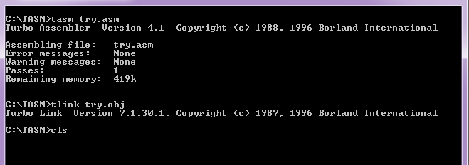

2. To see the output of the program, type its file name at the command prompt then press enter.
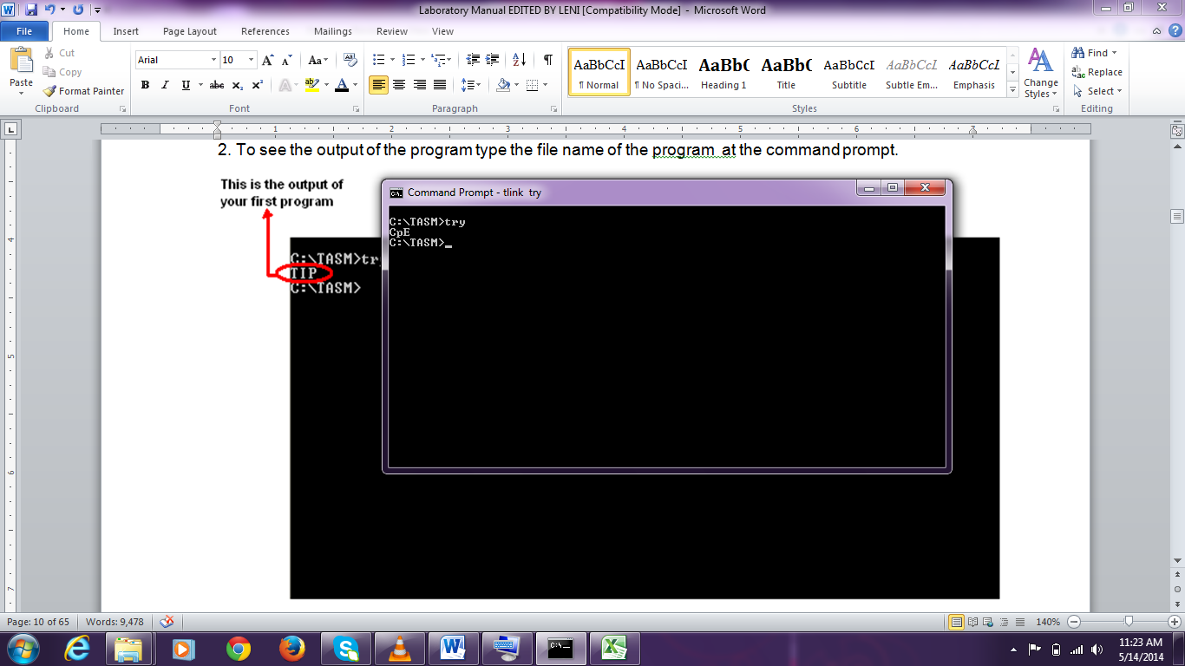
Program filename
Program output

G. Sample Program

Example No. 1:This program will display the text Hello CpE at the computer screen. Code the program using the MS-DOS editor, save using the filename sample1.asm.

Program Output

.model small
.stack
.code

start:

mov ah,02h

mov dl,’H’
int 21h
mov dl,’e’
int 21h
mov dl,’l’
int 21h
mov dl,’l’
int 21h
mov dl,’o’
int 21h
mov dl,’ ’
int 21h
mov dl,’C’
int 21h
mov dl,’p’
int 21h
mov dl,’E’
int 21h

mov ah,4ch
int 21h

end start

Explanation of the Program:
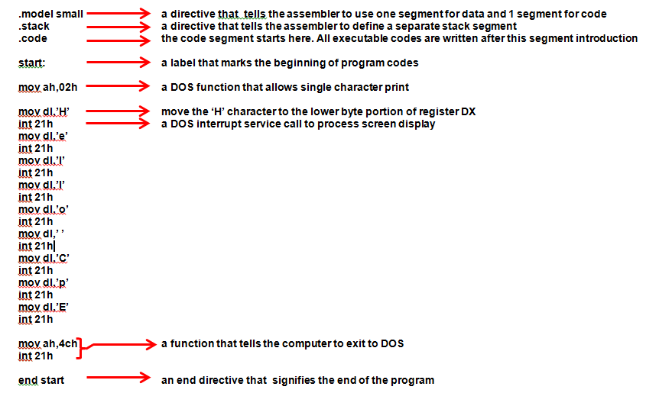

Lesson 2
Introduction to Character Displays

Objectives:

At the end of this activity, the student should be able to:

  - Use the service function 02h and Interrupt 21h in the program.
  - Explain the usage of carriage return and line feed.
  - Identify the errors while compiling the program.
  - Discuss the use of registers.
  - Identify the hexadecimal value of ASCII Codes.
  - Explain the parts of a program and their function.

The Function 02H

Function 02h is a DOS function that allows the display of a character. With the help of interrupt 21 h function call (INT 21h) the data value in dl, the data register, will be printed on the screen. For this function, a character maybe defined directly or a special ASCII code for the character maybe used. See example below that displays a P on the screen.

mov ah,02h ; Function call to display a character
mov dl, ‘P’ ; Specify the character to be displayed
int 21h ; Invoke interrupt 21h to service the requested function

An optional code to display the same using the ASCII code for letter ‘P’ (see the ASCII table at the next page) will be:

mov ah,02h ; Function call to display a character
mov dl, 50h ; 50h is the ASCII code of ‘P’ in hexadecimal form
int 21h ; Invoke interrupt 21h to service the requested function

Carriage Return/Line Feed

Unlike the alphanumeric and special characters found on the keyboard, the assembler does not recognize abbreviations for control characters. Thus insert a control character in an assembly language program, an equivalent ASCII code must be used. For example, to make the cursor advanced to the next line, a carriage return and line feed is sent to the screen as follows:

mov dl,0dh ; Specify carriage return character (0dh)
int 21h ; invoke the equivalent interrupt function call
mov dl,0ah ; Specify the line feed character (0ah)
int 21h ; invoke the equivalent interrupt function call

The effect of executing these codes would be that the cursor would advance to the next line due to the insertion of the carriage return.

(American Standard Code Information Interchange) ASCII Code in hexadecimal value

Upper Case: Lower Case: Number:

A = 41h a = 61h 0 = 30h
B = 42h b = 62h 1 = 31h
C = 43h c = 63h 2 = 32h
D = 44h d = 64h 3 = 33h
E = 45h e = 65h 4 = 34h
F = 46h f = 66h 5 = 35h
G = 47h g = 67h 6 = 36h
H = 48h h = 68h 7 = 37h
I = 49h i = 69h 8 = 38h
J = 4ah j = 6ah 9 = 39h
K = 4bh k = 6bh
L = 4ch l = 6ch Space:
M = 4dh m = 6dh
N = 4eh n = 6eh 20h
O = 4fh o = 6fh
P = 50h p = 70h Dot/Period:
Q = 51h q = 71h
R = 52h r = 72h 2eh
S = 53h s = 73h
T = 54h t = 74h Comma:
U = 55h u = 75h
V = 56h v = 76h 2ch
W = 57h w = 77h
X = 58h x = 78h
Y = 59h y = 59h
Z = 5ah z = 7ah

Skills Review

Exercise No. 1

Name:__________________________ Grade:______________

Course/Section:__________________ Date:_______________

Machine Problem:

Create a program that will display the same output below using the hexadecimal value of its ASCII code and the carriage return and line feed option. Follow the given format with Uppercase and Lower case letters combination. Save your assembly file using Exer1.asm

First Name
Middle Initial
Last Name

Program:

Exercise No. 2

Name:__________________________ Grade:______________

Course/Section:__________________ Date:_______________

Machine Problem:

Create a program that will display your personal information on the computer screen using hexadecimal value of ASCII Codes. Follow the given format below. Save the file using Exer2.asm as the file name.

Name: Juan M. dela Cruz
Birth Date: August 4, 1989
e-mail address: juan_delacruz@mail.com
Address: 2347-B Memory St. Processor Village Calookan Manila
Province: Infanta Quezon
Contact Number: 02-7443567
Guardian’s Name: Sixto C. dela Cruz
Occupation: Government Employee

Program:

Exercise No. 3

Name:__________________________ Grade:______________

Course/Section:__________________ Date:_______________

Machine Problem:

Create a program that will display your first name and surname in the computer screen using hexadecimal value of ASCII Codes. Other character may also be used for the frame. Follow the given format below. Save your program using Exer3.asm as the filename.

@@@@@@@@@@@@@@@@@
@ @
@ @
@ NAME @
@ @
@ SURNAME @
@ @
@ @
@@@@@@@@@@@@@@@@@

Program:

Lesson 3
Program Looping
Objectives:

At the end of this activity, the student should be able to:
- Explain the importance of loops in a program
- Explain the use of the loop instruction
- Discuss the role of a counter in the loop
- Simulate and trace a loop within a program
- Create programs with loops

- Loop Instructions

The Loop instructions using the function 02h allows repetitive execution of a section of the program. The Loop instruction creates a loop that is to be executed a specific number of times.

The LOOP instruction has the following format:

LOOP label

In a loop execution, the count register (CX) stores the number of times that the loop will be executed thus it serves as the repetition counter. For each loop instruction CX is decremented by 1. The content of CX is then checked by the assembler . If CX is not equal to 0, Loop jumps to the specified label and if CX is equal to 0, Loop terminates and no-jump happens then the next instruction will be executed.

Here is an outline of a loop that will execute 10 times. Put a decimal value on CX register (hexadecimal value may also be used thus instead of MOV CX, 10, the line maybe replaced with MOV CX, 0AH):

MOV CX, 10 ; Load the repetition count into CX

BALIK: ; This is a label
; The instructions to be repeated go here

;- - - statements to be executed - - - ; Program to be executed in 10 times

LOOP BALIK ; If CX is not zero, jump to BALIK
;- - - next statement to be executed - - ; If CX is zero, continue here

The counter works as follows: CX is initialized to 10 and then the statements within the loop are executed. The LOOP subtracts 1 from CX and examines the result. Since CX is 9 (which is not equal to 0), LOOP jumps to BALIK. Thus the statements are executed a second time. The loop continues until CX value becomes 0. This will happen after the statements have been executed 10 times and terminate the loop. After terminating the loop when CX becomes 0, the next statement will be executed. See sample programs below:

- Sample Program

a. Simple Loop Program

Example No. 2:The program will display 20 characters of “A”. Save the program using sample2.asm as filename.

Program Output
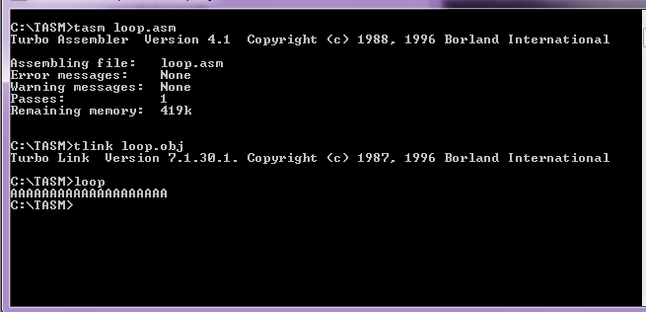

.model small
.stack
.code

start:

mov ah, 02h

mov cx,20
ulit: mov dl,41h
int 21h
loop ulit

mov ah, 4ch
int 21h
end start

b. Loop Program with Carriage Return

Example No. 3:The program will display 20 characters of “A” with carriage return. Save the program using sample3.asm as filename.

Program Output

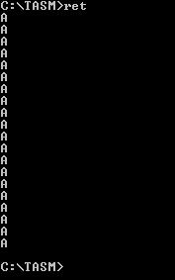
.model small
.stack
.code

start:

mov ah, 02h

mov cx,20
ulit: mov dl,41h
int 21h
mov dl,0dh ;line feed
int 21h
mov dl,0ah ; carriage return
int 21h
loop ulit

mov ah, 4ch
int 21h
end start

c. Loop Program Line Feed diagonal display

Example No. 4:The program will display 20 characters of “A” diagonally with line feed. Save the program using sample4.asm as filename.

Program Output

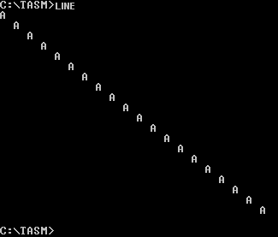
.model small
.stack
.code

start:

mov ah, 02h

mov cx,20
ulit: mov dl,41h ; character A
int 21h
mov dl,20h ; space character
int 21h
mov dl,0ah ;carriage return
int 21h
loop ulit

mov ah, 4ch
int 21h
end start

d. Loop Program with Increment

Example No. 5:The program will display the numbers from 0 to 9. Save the program using sample5.asm as the filename.

Program Output

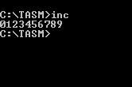
.model small
.stack
.code

start:

mov ah, 02h

mov cx, 10 ; counter set to 10
mov dl, 30h ;ASCII code for number 0
ulit: int 21h
inc dl ; increment count from 0 onwards
loop ulit

mov ah, 4ch
int 21h
end start

e. Loop Program with Decrement

Example No. 6:The program will display the numbers from 9 to 0. Save the program using sample6.asm as the filename.

Program Output
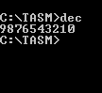
.model small
.stack
.code

start:

mov ah, 02h

mov cx, 10
mov dl, 39h ; ASCII character for number 9
ulit: int 21h
dec dl
loop ulit

mov ah, 4ch
int 21h
end start

f. Loop Program Combinations

Example No. 7:The program will display the numbers from A9 to J0 with carriage return. Save the program using sample7.asm as the filename.

Program Output
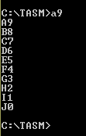
.model small
.stack
.code

start:

mov ah,02h
mov cx,10
mov bl, 39h ; ASCII character for number 9 stored at register bl
mov dl,41h ; display letter A
mov dh,dl ; store letter A to register dh
back: int 21h
mov dl,bl ; display character number 9
int 21h
mov dl,0dh ;line feed
int 21h
mov dl,0ah ;carriage return
int 21h
inc dh ; increment dh from A to J as the loop progresses
dec bl ; decrement from 9 to 0 as the loop progresses
mov dl,dh
loop back

mov ah,4ch
int 21h

end start

SKILLS REVIEW
Exercise No. 1

Name:__________________________ Grade:______________

Course/Section:__________________ Date:_______________

Machine Problem:

Create a program that will display the output format shown below. Save the program using Exer4.asm as the filename.

AaBaCcDdEeFf …………………… Zz

Program:

Exercise No. 2

Name:__________________________ Grade:______________

Course/Section:__________________ Date:_______________

Machine Problem:

Create a program that will display the output format shown below. Save the program using Exer5.asm as the filename.

zAyBxCwDu………………… aZ

Program:

Exercise No. 3

Name:__________________________ Grade:______________

Course/Section:__________________ Date:_______________

Machine Problem:

Create a program that will display the output format shown below. Save the program using Exer6.asm as the filename.

aZ
bY
cX
dW
.
.
.
zA

Program:

Exercise No. 4

Name:__________________________ Grade:______________

Course/Section:__________________ Date:_______________

Machine Problem:

Create a program that will display the output format shown below. Save the program using Exer7.asm as the filename.

Az
By
Cx
Dw
Ev
Fu
.
.
.
Za

Program:

Lesson 4
Defining Data and the Data Segment
Objectives:

At the end of this activity, the student should be able to:

- Use Function 09h in a program
- Develop a program that displays a string of characters
- Differentiate the Function 02h from Function 09h of DOS INT 21h
- Identify the usage of data segment in the segment registers

The Function 09H

Function 09h is a service call for DOS for INT 21h services that allows the display of a string of characters on the computer screen. With the help of type 21 function call (Interrupt 21h) the data string in the data segment register will print the string character on the computer screen. The string of characters defined at the data segment using byte definition is declared enclosed on single quotes and delimited by a dollar ($) sign. For this declaration, the strings of characters can be directly defined even without using their equivalent ASCII codes. The carriage return and line feed codes may often be helpful in displaying the strings of characters defined in the data segment to facilitate for the insertion of new lines and cursors. The general format for string declaration at the data segment is as follows:

variable DB ‘ Great Engineer starts with you ! ! ! ‘,13,10,’$’

You can use the following to display it:

mov ah,09h ; Request for function 09 service to display
mov dx,offset variable ; Specify offset of the string to be displayed from the data segment
int 21h ; Display the string

The decimal value for Carriage Return and Line Feed are the 13 and 10 on the variable declaration respectively which is also equivalent to the hexadecimal value 0dh and 0ah. Variable is a name that could be assigned to hold the defined string of characters. A variable name, just like with other programming languages, should be one word, can be a combination of letters, number s and special characters, and preferably must start with a letter. More so, it is always important that a variable name must be representative of the data it is named with. The dollar sign ($) is the identifier that signifies as the end marker.
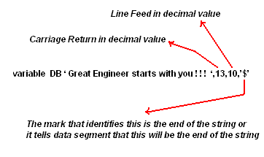

To facilitate the effective implementation of function 09h of DOS INT 21h service, it is needed to initialize the data segment so that the assembler would identify the location of the data that are to be displayed. The instructions to initialize the data segment are

MOV AX, @DATA
MOV DS, AX

These codes maybe inserted either at the beginning of the code segment or anywhere within the program just before invoking the function 09h service routine.

A. Sample Program

Example No. 8: The program will display the string characters shown below. Save the program using sample8.asm as the filename

Proud to be an Engineer
Good teachers can produced
Great Engineers

Program

.model small
.stack
.data

var1 DB ‘Proud to be an Engineer’,13,10,’$’
var2 DB ‘Good teachers can produce’,13,10,’$’
var3 DB ‘Great Engineers’,13,10,’$’
.code

start:

mov ax,@data Output
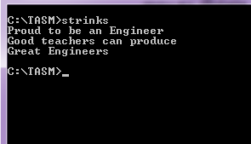
mov ds,ax

mov ah,09h
mov dx,offset var1
int 21h

mov ah,09h
mov dx,offset var2
int 21h

mov ah,09h
mov dx,offset var3
int 21h

mov ah,4ch
int 21h

end start

Example No. 9: Using the same function 09h and DOS INT 21h service routine, string characters showing abstract designs can also be created as shown below. Save the program using sample9.asm as the filename

Program
.model small
.stack
.data

p1 DB'_+88________ROCK_N_ROLL!!!_______ ',13,10,'$'
p2 DB'_+880_____________________________',13,10,'$'
p3 DB'_++88___________BABY!!____________',13,10,'$'
p4 DB'_++88_____________________________',13,10,'$'
p5 DB'__+880_________________________++_',13,10,'$'
p6 DB'__+888________________________+88_',13,10,'$'
p7 DB'__++880______________________+88__',13,10,'$'
p8 DB'__++888_____+++88__________+++8__',13,10,'$'
p9 DB'__++8888__+++8880++88____+++88___',13,10,'$'
p10 DB'__+++8888+++8880++8888__++888____',13,10,'$'
p11 DB'___++888++8888+++888888++888_____',13,10,'$'
p12 DB'___++88++8888++8888888++888______',13,10,'$'
p13 DB'___++++++888888888888888888______',13,10,'$'
p14 DB'____++++++88888888888888888______',13,10,'$'
p15 DB'_______+++++++088888888888_______',13,10,'$'
p16 DB'_______+++++++088888888888_______',13,10,'$'
p17 DB'________+++++++8888888888________',13,10,'$'
p18 DB'________+++++++0088888888________',13,10,'$'
p19 DB'________++++++0088888888_________',13,10,'$'
p20 DB'________+++++0008888888__________',13,10,'$'
p21 DB'________############_____________',13,10,'$'
p22 DB'________############_____________',13,10,'$'
p23 DB'________############_____________',13,10,'$'
.code
Output
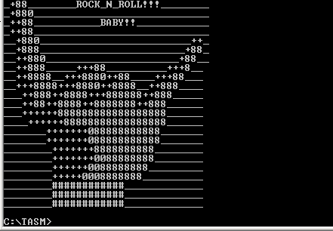
start:

mov ax,@data
mov ds,ax

mov ah,09h
mov dx,offset p1
int 21h
.
.
.
.
.
.
.
.
mov ah,09h
mov dx,offset p23
int 21h

mov ah,4ch
int 21h

end start

Note: Only a maximum of 25 (0-24) lines can be displayed at one time on the screen.

SKILLS REVIEW

Exercise No. 1

Name:__________________________ Grade:______________

Course/Section:__________________ Date:_______________

Machine Problem:

Create a program using Function 09h that will display the string output shown below using the carriage return and line feed option. Save the program using Exer8.asm as the filename.
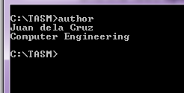

Program:

Exercise No. 2

Name:__________________________ Grade:______________

Course/Section:__________________ Date:_______________

Machine Problem:

Create a personalized calling card that may follow the given format below using Function 09h that will display the string output. You can also choose your own border design and logo according to your design. Save the program using Exer9.asm as the filename.

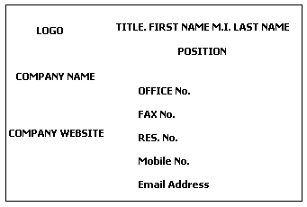

Program:

Exercise No. 3

Name:__________________________ Grade:______________

Course/Section:__________________ Date:_______________

Machine Problem:

Create a program using Function 09h that will display a list of your favorite TV shows in any TV Network local or international. Save the program using Exer10.asm as the filename.

Program:

Lesson 5
Introduction to Screen Processing

Objectives:

At the end of this activity, the student should be able to:

- Use the interrupt 10h Video Display Function in a program
- Identify the different video functions and their usage
- Discuss the video function service call of the BIOS
- Identify the registers to be used in ROWS and COLUMNS declaration for displaying a video
- Use the base register to display a color in any combinations of RGB
- Develop a graphic design that displays any combinations of standard RGB Colors

The Interrupt 10h Video Function

INT 10H is a BIOS interrupt that facilitates handling of the computer’s full screen. To use the operations provided by this BIOS interrupt, it requires that the service code be place at the AH register. These service codes determine the function of the interrupts that needs to be rendered. When this interrupt is called together with the associated service code, it preserves the contents of important registers except for AX.

In this section, different functions using the BIOS interrupt 10H will be used. Interrupt 10h is a function used for video display. This interrupt service routine means that the program basically calls the sequence of codes corresponding to the routine and is invoked through the INT instructions. The routines are built into the computer’s main operating ROM chip. This is often called the Basic I/O System or BIOS. The BIOS stores keyboard characters, displays information on the screen, and transfers data to or from the disk drives, printers, and whatever is attached to your computer.

There are two methods for graphic display;

- BIOS functions using Interrupt 10h
- Direct VRAM access

There are also two types of graphics display;

- Pixels Graphic
- Vector Graphic

Pixel graphic is the more conventional bitmap display in which images are stored as a series of pixels dots. Vector graphics on the other hand, store mathematical vector format for images. Graphically shown below is the screen display difference between pixel based and vector based graphics.

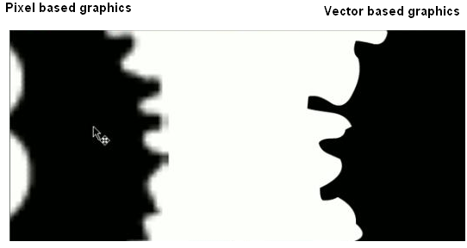

Different Interrupt 10h Video Functions

Function 02h - Position the cursor on the screen

Function 06h - Scroll a window on the current video page upward, replacing scrolled lines with blanks.

Function 07h - Scroll a window on the current video page downward, replacing scrolled lines with blanks.

A. The Screen Layout

The screen layout of the first 8086 computer is 80x24 coordinated as 0-79 columns and , 0-24 rows. The upper left corner has the coordinate 0,0 and the lower right corner has the coordinates 79,24.

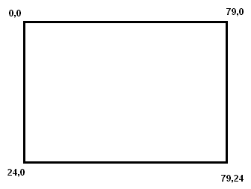

To maximize the utilization of the video graphics display, set the default monitor graphic video mode to 80x24 on the command prompt following the procedure below:

- Right Click on the title bar of your Command Prompt.
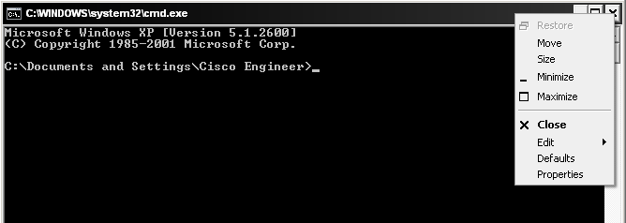

- At the pop-up menu, select Properties, choose the Layout tab folder, then set the Screen Buffer Size and Window Size to 80 in width and 25 in height. Click OK.

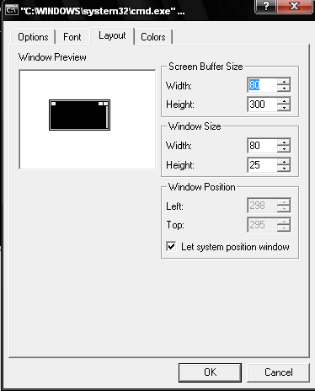

- Choose the radio button Save properties for future windows with same title to automatically set your command prompt in this layout every time you open it.

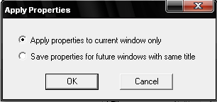

- Standard Video Colors

Standard Color in Binary Value |  |  | COLOR | HEX VALUE
Red | Green | Blue | COLOR | HEX VALUE
0 | 0 | 0 | Black | 00h
0 | 0 | 1 | Blue | 01h
0 | 1 | 0 | Green | 02h
0 | 1 | 1 | Cyan | 03h
1 | 0 | 0 | Red | 04h
1 | 0 | 1 | Magenta | 05h
1 | 1 | 0 | Yellow | 06h
1 | 1 | 1 | White | 07h

Creating Background and Foreground Colors

Background  (Most Significant Nibble) |  |  |  | Foreground  (List Significant Nibble) |  |  |  | Background  Color | Foreground  Color | Hex Value
Blink | R | G | B | Intensity | R | G | B | Background  Color | Foreground  Color | Hex Value
0 | 0 | 0 | 0 | 0 | 0 | 0 | 0 | Black | Low Black | 00
0 | 0 | 0 | 1 | 0 | 0 | 0 | 1 | Blue | Low Blue | 11
0 | 0 | 1 | 0 | 0 | 0 | 1 | 0 | Green | Low Green | 22
0 | 0 | 1 | 1 | 0 | 0 | 1 | 1 | Cyan | Low Cyan | 33
0 | 1 | 0 | 0 | 0 | 1 | 0 | 0 | Red | Low Red | 44
0 | 1 | 0 | 1 | 0 | 1 | 0 | 1 | Magenta | Low Magenta | 55
0 | 1 | 1 | 0 | 0 | 1 | 1 | 0 | Yellow | Low Yellow | 66
0 | 1 | 1 | 1 | 0 | 1 | 1 | 1 | White | Low White | 77
1 | 0 | 0 | 0 | 1 | 0 | 0 | 0 | Blinking Black | High Black | 88
1 | 0 | 0 | 1 | 1 | 0 | 0 | 1 | Blinking Blue | High Blue | 99
1 | 0 | 1 | 0 | 1 | 0 | 1 | 0 | Blinking Green | High Green | AA
1 | 0 | 1 | 1 | 1 | 0 | 1 | 1 | Blinking Cyan | High Cyan | BB
1 | 1 | 0 | 0 | 1 | 1 | 0 | 0 | Blinking Red | High Red | CC
1 | 1 | 0 | 1 | 1 | 1 | 0 | 1 | Blinking Magenta | High Magenta | DD
1 | 1 | 1 | 0 | 1 | 1 | 1 | 0 | Blinking Yellow | High Yellow | EE
1 | 1 | 1 | 1 | 1 | 1 | 1 | 1 | Blinking White | High White | FF

The background and foreground colors can be created through the combination of hex values from 00H up to FFH. The hex value table shown above is the summary of the basic combinations of background/foreground colors. Still you could experiment using other combinations that may not be in the list.

- Functions 06h and 07h

Functions or service 06h and 07h for BIOS interrupt 10h can be differentiated by which the direction of implementation is utilized. Service 06h scrolls up a part or the entire screen depending on the values placed at the CX and DX registers. Service 07 on the other hand scrolls down a part or the entire screen, again, depending on the CX and DX values assigned. The figure below depicts the way at which the screen is scrolled using the two service calls 06 and 07:
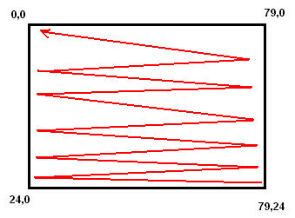
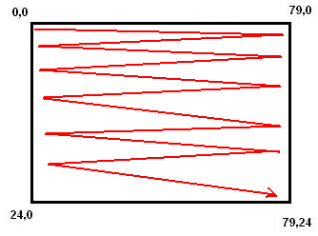

Function 06h Function 07h

To use the functions, place the function number in AH (higher end of the accumulator) to either scroll up or down, set the foreground/background color of the screen by placing the equivalent values at BH, set the coordinates for the row and column position at the CX and DX registers respectively to scroll the screen, then call the BIOS interrupt 10h function.

mov ah, ___ ; use either 06h or 07h to scroll the screen
mov bh, ___ ; specify the color attribute for blank lines. In text mode this corresponds to the attribute byte. In VGA graphics mode the register BASE is assigned with a color number combination to which all the pixels in the blank will be set.
mov ch, ___ ; Start Row, this will set the top left row location of the window to scroll up.
mov cl, ___ ; Start Column, this will set the top left column location of the window to scroll up.
mov dh, ___ ; End Row, this will set the lower right row location of the window to scroll up.
mov dl, ___ ; End Column, this will set the lower right column location of the window to scroll up.
int 10h ; The BIOS function call that satisfies the requested service

- Function 02h

Cursor Positioning/Clearing Screen
The Cursor is the under grade white line that is blinking inside the text area. The cursor position indicates the location on the screen to which a text may be inserted or edited. Positioning the cursor in the screen is important in managing the output on the screen.

Cursor:
mov ah, 02h ;
mov bh, 00h ; Page to position
mov dh, ___ ; Row of Cursor
mov dl, ___ ; Column of Cursor
int 10h ; Interrupt function call

Clear Screen:
mov ah,06h
mov bh,00h
mov ch,0 ; Start Row
mov cl,0 ; Start Column
mov dh,24 ; End Row
mov dl,79 ; End Column
int 10h
- Sample Program

Example No. 10: This program will create big and small rectangles with background and foreground colors. Save the program using sample10.asm as the filename

Setting Coordinates based on the screen layout
0,0
0,79
24,0
24,79
5,5
0,74
17,5
17,74

The coordinates shown on the graphic above are the corresponding Rows and Column settings of your video function display. From the starting origin of 0,0 ( starting x and y coordinates) up to end of 24,79 origins (end x and y coordinates). The bigger rectangle sets the background to BLUE and the small rectangle sets the background color to yellow. Assign the coordinates (0,0 – 24,79) to the big rectangle and the coordinates to (5,5 – 17,74) to the small rectangle in order to display the corresponding screen colors without overlapping.

Program

.model small
.stack
.code
start:

;< ---- Displaying of the big rectangle with BLUE background---- >
mov ah,06h ; Scroll up text Lines
mov bh,10h ; Background setting to Color Blue
mov ch,0 ; starting row of Blue background (starting X coordinate)
mov cl, 0 ; starting column of Blue background (starting Y coordinate)
mov dh, 24 ; end row of Blue background (end X coordinate)
mov dl, 79 ; end column of Blue background (end Y coordinate)
int 10h ; video function call to display the video information

; < ---- Displaying of the small rectangle with YELLOW background--- >

mov ah,06h ; Scroll up text Lines
mov bh, 60h ; Set rectangle color to Yellow
mov ch,5 ; starting row of the Yellow rectangle (starting X coordinate)
mov cl, 5 ; starting column of the Yellow rectangle (starting Y coordinate)
mov dh, 17 ; end row of the Yellow rectangle (end X coordinate)
mov dl, 74 ; end column of the Yellow rectangle (end Y coordinate)
int 10h ; video function call to display the video information

mov ah,4ch
int 21h

end start

Note: It is important to note that the firs rectangle with coordinates 0,0 - 24,79 must be coded before the rectangle with coordinates 5,5 – 17,74 to enable the display of the desired output. Coding the smaller rectangle before the larger one will result to the overlapping of the latter with the former thus when displayed, only the larger rectangle will be seen.

Example No. 11: This program is a combination of Function 09h, Interrupt 10h video function call with scroll down text lines and Cursor Position. It will display the string variables on the coordinates that is specified inside the multiple layer of screen displays. Save the program using sample11.asm as the filename

Setting Coordinates based on the screen layout


24,79
0,0
3,3
7,7
21,76
17,72
8,8

9,8

Program

.model small
.stack
. data
var1 DB ‘PROUD TO BE A ‘, 13,10,’$’
var2 DB ‘FILIPINO ENGINEER ‘ , 13,10,’$’
.code
start:

;< ---- Displaying the 1st Layer Color Background GREEN ---- >
mov ah,07h ; Scroll up text Lines
mov bh,20h ; Background setting to Color Green
mov ch,0 ; starting row of background Green (starting X coordinate)
mov cl, 0 ; starting column of background Green (starting Y coordinate)
mov dh, 24 ; end row of background Green (end X coordinate)
mov dl, 79 ; end column of background Green (end Y coordinate)
int 10h ; video function call to display the video information

;< ---- Displaying the 2nd Layer Color Background RED ---- >
mov ah,07h ; Scroll up text Lines
mov bh,40h ; Background setting to Color Red
mov ch,3 ; starting row of background Red (starting X coordinate)
mov cl, 3 ; starting column of background Red (starting Y coordinate)
mov dh, 21 ; end row of background Red (end X coordinate)
mov dl, 76 ; end column of background Red (end Y coordinate)
int 10h ; video function call to display the video information

; <---- Displaying the 3rd Layer Color Background YELLOW ---

mov ah,07h ; Scroll up text Lines
mov bh, 60h ; Background setting to Color Yellow
mov ch,7 ; starting row of foreground Yellow (starting X coordinate)
mov cl, 7 ; starting column of foreground Yellow (starting Y coordinate)
mov dh, 17 ; end row of foreground Yellow (end X coordinate)
mov dl, 72 ; end column of foreground Yellow (end Y coordinate)
int 10h ; video function call to display the video information

;< ---- Initialize the data segment by placing its address at the DS register--- >
mov ax,@data
mov ds,ax

;< ---- setting cursor position to coordinates 8,8 --- >
mov ah,02h
mov bh,00
mov dh,8 ; Cursors Y coordinate (Column)
mov dl, 8 ; Cursors X coordinate (Row)
int 10h

; <--- Printing of the first set of character string at 8,8 position --- >

mov ah,09h
mov dx,offset var1
int 21h

; <---- setting cursor position to coordinates 9, 8 --- >
mov ah,02h
mov bh,00
mov dh,9 ; Cursors Y coordinate (Column)
mov dl, 8 ; Cursors X coordinate (Row)
int 10h

; <--- Printing of the second set of character string at 9, 8 position ---- >

mov ah,09h
mov dx,offset var2
int 21h

mov ah,4ch
int 21h

end start

SKILLS REVIEW
Exercise No. 1

Name:__________________________ Grade:______________

Course/Section:__________________ Date:_______________

Machine Problem:

Create a program that will display the color coding values of the resistor using Interrupt Function 10h. Use string character printing and cursor positioning to display what ever information needs to be displayed in each Resistor color. Graph the coordinates by drawing the expected output. Save the program using Exer11.asm as the filename.

Output Graph:

Program:

Exercise No. 2

Name:__________________________ Grade:______________

Course/Section:__________________ Date:_______________

Machine Problem:

Create your own LOGO using Interrupt Function 10h that will display variation of colors with coordinates. Use string character printing and cursor positioning to display what ever information you want to be displayed in the LOGO design. Graph the coordinates by drawing the expected output. Save the program using Exer12.asm as the filename.

Expected Output:

Program:

Exercise No. 3

Name:__________________________ Grade:______________

Course/Section:__________________ Date:_______________

Machine Problem:

Create a program using Interrupt Function 10h that will display standard TV color bars following the standard sizes. Use string character printing and cursor positioning to display your favorite International or Local TV Network information in the color bars. Graph the coordinates by drawing the expected output. Save the program using Exer13.asm as the filename.

Expected Output:

Program:

Exercise No. 4

Name:__________________________ Grade:______________

Course/Section:__________________ Date:_______________

Machine Problem:

Create a program using Interrupt Function 10h that will display the mobile phone below with your desired colors and coordinates. Use string character printing and cursor positioning to display what ever information you want to be displayed in the LCD of the mobile phone. Graph the coordinates on the figure below. Save the program using Exer14.asm as the filename.

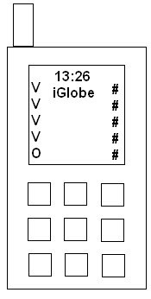

Program:

Exercise No. 5

Name:__________________________ Grade:______________

Course/Section:__________________ Date:_______________

Machine Problem:

Create a program using Interrupt Function 10h that will display a chess board with any combination of two colors that you want. Graph the coordinated on the figure below and shade each square of differing colors. Save the program using Exer15.asm as the filename.



Program:

Lesson 6
Introduction to Keyboard Processing

Objectives:

At the end of this activity, the student should be able to:

- Explain standard input keyboard functions
- Identify the different types of standard input keyboard function
- Discuss the keystroke processing sequence
- Determine the functions of INT 9H and INT 21H in keyboard function
- Use branching or subroutine in programming
- Identify the different types of conditional and unconditional instructions

The Standard Input Keyboard

Keyboard input follows an event path beginning from the keyboard controller chip and ending at the character being placed in a 30-byte array called the keyboard typehead buffer. The keyboard typehead buffer can hold up to 15 keystrokes at any given moment. Each keystroke generates 2 bytes representing the ASCII CODE and the SCAN CODE.

The following events occur when the user presses a key:

- The keyboard controller chip sends an 8-bit numeric SCAN CODE to the input port of the computer.
- The input port is designed to accept signal that triggers an interrupt. The processor will respond by executing the INT 9H service routine.
- The INT 9h service routine retrieves the keyboard SCAN CODE from the input port and checks the ASCII code of the stroked key.
- The combination of the SCAN CODE and ASCII CODE from the INT 9h service routine will then be placed at the TYPEHEAD BUFFER. If the SCAN CODE has no additional ASCII CODE or no keystrokes happened , the ASCCII CODE will be set to zero and will again be placed at the buffer.
- Using the INT 21h function the ASCII CODE retrieves from the buffer. If additional key has been pressed, the INT 21h will request for the second time to retrieve the SCAN CODE.

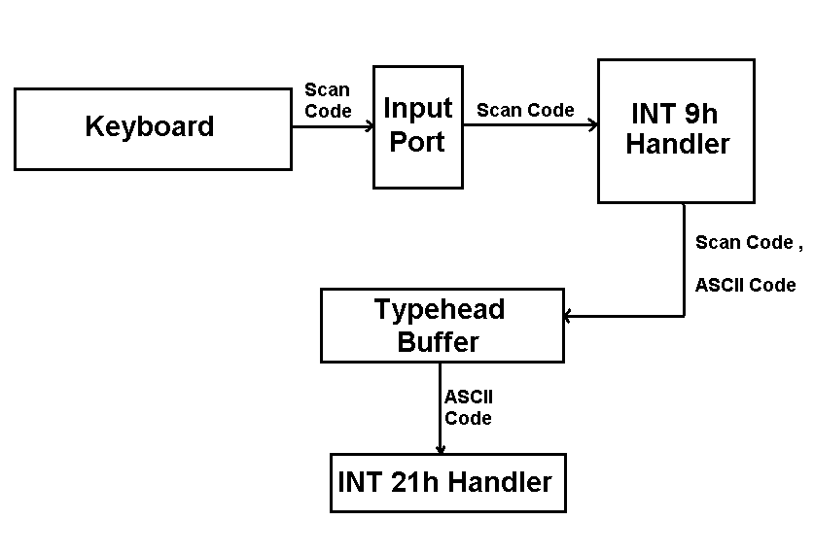
Keystroke Processing Sequence

A. Different Keyboard Function Calls

1. Function 06h and 07h

The function 06h and 07h using interrupt 21h is not same as with the video output display using interrupt 10h. These function in this case are for keyboard inputs. Similar with the interrupt 10h service routines, these functions will also need to use the accumulator as the primary operational register.

Function 06h – is a read keyboard character with no CTRL - Break check (with echo). The results of keystrokes will be placed in AL register if the character is available at the buffer otherwise AL will be set to zero (AL = 0). The input value will then be placed at the DL register but is not displayed on the screen. The zero flag, ZF will be set (ZF=1) if there is no available character and AL will be set to 00h (AL = 00h). The zero flag on the other hand will be reset (ZF = 0) if a character is available and AL will be assigned with the ASCII value of the character (AL = ASCII value of the read character). To clear the buffer, assign DL = 255 and ZF = 0.

Function 07h - is a wait for keyboard character but with no CTRL - Break check (without echo). The results of keystrokes will be directly placed in AL register (AL = character). With function 07h, the input value may be placed in any of the registers.

2. Function 01h

The function 01h is a wait for keyboard character then display it with CTRL – Break check (with echo). The results of keystrokes will be directly placed in AL register (AL = character) then it can be moved to other registers similar to the operation for the function 07h.

3. Function 0Ah

Function 0Ah is an input string from keyboard service routine. More technically, this service is a buffered keyboard input that stores data into the keyboard buffer. With this function, a user will be able to respond to prompts given by the program.

B. Branching

Branching in programming means executing sequence of statements that satisfies a particular condition and skipping program areas that does not satisfy the mentioned conditions. In assembly programming, just like with other programming languages, branching is very important in controlling the program output.

To perform the execution of a subroutine, there are two types of branching that needs to be considered. First is the conditional branching; second is the unconditional branching. Conditional branching requires for a specific condition to be satisfied before a subroutine is executed. Unconditional branching on the other hand does not require any condition to be satisfied for a subroutine to be executed. Listed below are the different types of branching statements/instructions:

Conditional Instructions Unconditional Instructions
je = jump if equal
jne = jump if not equal
jz = jump if zero jmp = jump
jnz = jump if not zero
ja = jump if above call/return = call instruction with return
jna = jump if not above value
jnae = jump if not above or equal
jae = jump if above or equal goto = call instruction with no return
jb = jump if below value
jnbe = jump if not below or equal
jnb = jump if not below
jbe = jump if below or equal

C. Reading Individual Keys using Function 01h, Function 06h, Function 07h and Function 0Ah

Function 01h

Interactive programs often require the user to respond to a prompt or select from a menu by typing a single letter or number. For example, suppose your program displays a message that tells the user to press either a Y or an N (perhaps to continue or to stop). A response of Y makes the program jump to a set of instructions labeled YES. Any other key makes it wait for either Y or N. This sequence does the job.

get_me: mov ah,01h ; Read a key
int 21h ; AL = DL then display
cmp al, ‘Y’ ; Is it Y?
je YES ; If so, jump to YES
jne get_me ; Otherwise, wait for Y or N

Here, only an uppercase Y or N is acceptable. Unfortunately, some users often times overlook the importance of adhering to the condition thus these users simply press the Y key not knowing if it is in upper or lower case. To make the program more flexible, additional codes may be inserted in the program as shown.
get_me: mov ah,01h ; Read a key
int 21h ; AL = DL then display
cmp al, ‘Y’ ; Is it Y?
je YES ; If so, jump to YES
cmp al, ‘y’ ; Is it Y?
je YES ; If so, jump to YES
jne get_me ; Otherwise, wait for Y or N

Checking for Y, N, or any other letter, number, or symbol is easy since the CMP instruction already includes the character at which the comparison is to be made. It becomes more difficult though when a program wants to check for, say the Enter (Return) key. The form CMP AL, ‘Enter’ will not work in this case. The assembler will assume that the instruction simply wants to compare a byte in AL with a five-character string and produces an error message.

Instead of using the strings of characters, the Enter key’s ASCII code must be specified as the second operand. Enter produces a Carriage Return character. Referring to the ASCII code the Carriage Return is represented by the hexadecimal 0D or decimal 13. This will be the number which will be used in the CMP instruction. For example, suppose a program displays some instructions and tells the user to “Press Enter to continue.” To wait for the Enter key, use the sequence.

Ulit_ka: mov ah,01h
int 21h
cmp al,13 ; Is the Enter Key pressed?
je CONTINUE ; If so, jump to CONTINUE
jne Ulit_ka ; If not back to routine Ulit_ka

Function 06h

Now let’s try what is the difference of Function 06h to the Function 01h. For example you want to hold the data input from the keyboard that will print in many times.

mov ah,01h ; Read the key
int 21h ; AL = DL then it will display
(First time display of key)
mov dl,al ; put the AL to the DL
mov ah,06h ; Read the DL to hold
int 21h ; AL = DL then it will display
(Second time display of key)
int 21h ; AL = DL then it will display
(Third time display of key) still the data on hold
mov dl,255 ; this value 255 or 0FFH is for resetting of buffer
DL = 255 and the ZF is cleared
int 21h ; checking if the data is still on hold
if only 3 characters are displayed it
means it was clear

Function 07h

The Function 07h performs a different service although it may look like similar to Function 06h. In function 07h, if there is no character in the keyboard buffer the function waits until a key is pressed on the keyboard. This function may be used when asking for input from the user and a non-press from a keyboard will hold the display until such time that a key is pressed.

mov ah,09h
mov dx,offset pol1 ; Display the first Data
int 21h

mov ah,07h ; Read the key
int 21h ; Press?

mov ah,09h ; If so Display the second Data
mov dx,offset pol2
int 21h
Function 0Ah
So far, the functions discussed accept single character input. To facilitate string of characters input, function 0Ah will be used. With function 0Ah, the user will be able to communicate with the program by responding to the prompts given. For a program that accepts input from the user, there must be a repository for the inputted information. Thus for function 0Ah to function better, a parameter list for the information to be accepted must be declared at the data segment. The sample program sequence below asks the user for some information using the function 0Ah placed at the AH register.

.model small
.stack
.data
wn db 'What is your name:',20h,'$' ; prompt to user to enter name
wnpar label byte ;start of parameter list for name
wnlen db 24 ;maximum number of characters assigned to name
actlen db ? ;actual length of inputted information
wnfld db 24 dup(‘ ‘) ;repository of actual characters entered from
keyboard
.code
start:
mov ax, @data
mov ds, ax

mov ah, 09h
mov dx, offset wn
int 21h

mov ah, 0ah
mov dx, offset wnpar
int 21h

mov ah, 4ch
int 21h

end start

Note: It is interesting to note that function 0Ah may still be used even without the parameter list. The drawback of the non-use of the parameter list would be the difficulty in controlling some output on the screen.

D. Sample Program

Example No. 12: The program will print the key pressed using Function 01h and it will stop after the 10th character input has been pressed. Save the program using sample12.asm as the filename

Program:

.model small
.stack
.data
pol1 DB ‘ 10th CHARACTER HAS BEEN PRESSED..!!! $’
.code

start:

mov ax,@data
mov ds,ax

mov cx,10
mov ah,01h
balik: mov dl,al
int 21h
loop balik

mov ah,09h
mov dx,offset pol1
int 21h

mov ah,4ch
int 21h

end start

Output:

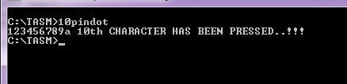

Example No. 13: This program will prompt the user to press uppercase or lowercase letter from the keyboard and responds with a message of what letter has been pressed by the user. The program uses the function 07h to facilitate input without echo. Save the program using sample13.asm as the filename

Program:

.model small
.stack
.data

p0 DB 'Press UPPERCASE or lowercase letter A/a ',13,10,'$'
p1 DB 'You Pressed UPPERCASE letter A ',13,10,'$'
p2 DB 'You Pressed LOWERCASE letter a ',13,10,'$'
p3 DB 'Press any Key to continue [X] to Exit ',13,10,'$'
P4 DB ' ',13,10,'$'
.code

start:

mov ax,@data
mov ds,ax

mov ah,09
mov dx,offset p0
int 21h
mov dx,offset p4
int 21h

mov ah,07h
int 21h

cmp al,41h
je Malaki
cmp al,61h
je Maliit
jne start

Malaki:

mov ah,09h
mov dx,offset p1
int 21h

mov dx,offset p3
int 21h

mov ah,07h
int 21h

mov ah,01h
cmp al,'X'
je EXIT
jne start

Maliit:mov ah,09h
mov dx,offset p2
int 21h

mov dx,offset p3
int 21h

mov ah,07h
int 21h

mov ah,01h
cmp al,'X'
je EXIT
jne start

EXIT: mov ah,4ch
int 21h

end start

Output:

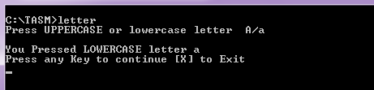

Example No. 14: Simple BOT chat. This program will respond based on what has been pressed from the keyboard using Function 01h, Function 07h, Counter register, and conditional/unconditional instruction. Save the program using sample14.asm as the filename

Program:

.model small
.stack
.data

don1 DB'HELLO ',13,10,'$'
don2 DB'JUAN DELA CRUZ ',13,10,'$'
don3 DB'YES how about you? ',13,10,'$'
don4 DB' PHILIPPINES',13,10,'$'
don5 DB'BSCpE',13,10,'$'
don6 DB'Amazing! ',13,10,'$'
.code

start:
mov cx,2
mov ah,01h
back:mov dl,al
int 21h
loop back

call hi

mov cx,3
mov ah,01h
go:mov dl,al
int 21h
loop go

call huu

mov cx,3
mov ah,01h
lipat:mov dl,al
int 21h
loop lipat

call study

mov cx,3
mov ah,01h
alin:mov dl,al
int 21h
loop alin

call skul

mov cx,3
mov ah,01h
ganda:mov dl,al
int 21h
loop ganda

call course

mov cx,3
mov ah,01h
owss:mov dl,al
int 21h
loop owss

call dscryb

call exit
hi:call agwat
mov ax,@data
mov ds,ax
mov ah,09h
mov dx,offset don1
int 21h
mov ah,07h
int 21h
ret

huu: call agwat
mov ax,@data
mov ds,ax
mov ah,09h
mov dx,offset don2
int 21h
ret

study:call agwat
mov ax,@data
mov ds,ax
mov ah,09h
mov dx,offset don3
int 21h
ret

skul:call agwat
mov ax,@data
mov ds,ax
mov ah,09h
mov dx,offset don4
int 21h
ret

course:call agwat
mov ax,@data
mov ds,ax
mov ah,09h
mov dx,offset don5
int 21h
ret

dscryb:call agwat
mov ax,@data
mov ds,ax
mov ah,09h
mov dx,offset don6
int 21h
ret

agwat: mov ah,0dh
int 21h
mov ah,0ah
int 21h
ret

exit:
mov ah,4ch
int 21h
end start

Output:

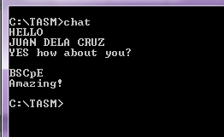

Example No. 15. This program prompts the user to input the required information. To facilitate clean output, functions 06h will be used to clear the screen, 02h to set the screen location to display the prompts, 09h to display, and 0Ah to request input from the user. Save the program using sample15.asm as the filename

.model small
.stack
.data
wn db 'What is your name?',20h,'$'
ag db 'how old are you?',20h,'$'
bd db 'When is your birthday?',20h,'$'
gd db 'What is your gender?',20h,'$'
rpt db 'Repeat? Press N to Exit. ',20h, 20h, '$'
wnpar label byte
wnlen db 20
actwnlen db ?
wnfld db 20 dup(' ')
agpar label byte
aglen db 10
actaglen db ?
agfld db 10 dup(' ')
bdpar label byte
bdlen db 20
actbdlen db ?
bdfld db 20 dup(' ')

.code

start:
mov ax, @data
mov ds, ax

ulit:

;** clear the screen**
mov ah, 06h
mov bh, 07h
mov cx, 0000h
mov dx, 184fh
int 10h

;** first prompt**
mov ah, 02
mov bh, 00
mov dx, 0820h
int 10h

mov ah, 09h
mov dx, offset wn
int 21h

;** response to first prompt**
mov ah, 0ah
mov dx, offset wnpar
int 21h

;** second prompt**
mov ah, 02
mov bh, 00
mov dx, 0920h
int 10h

mov ah, 09h
mov dx, offset ag
int 21h
;** response to second prompt**
mov ah, 0ah
mov dx, offset agpar
int 21h

;** third prompt**
mov ah, 02
mov bh, 00
mov dx, 0A20h
int 10h

mov ah, 09h
mov dx, offset bd
int 21h

;** response to third prompt**
mov ah, 0ah

int 21h

;** fourth prompt**
mov ah, 02
mov bh, 00
mov dx, 0B20h
int 10h

mov ah, 09h
mov dx, offset gd
int 21h

;** response to fourth prompt**
mov ah, 0ah
int 21h

mov ah, 02
mov bh, 00
mov dx, 0e24h
int 10h

mov ah, 09h
mov dx, offset rpt
int 21h

mov ah, 01
mov dx, offset bdpar
int 21h

cmp al, 'N'
jne ulit

mov ah, 4ch
int 21h

end start

OUTPUT
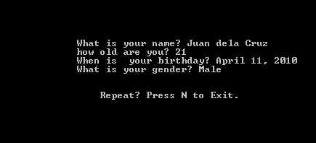

SKLILLS REVIEW

Exercise No. 1. Write a program that will create an output similar below and asks the user to input the necessary information. Use the functions 06h, 02h, 0h, 0Ah, and 07h or 01h. Save the program using Exer16.asm as the filename.
<University/School>
<Address>

Computer Engineering Department
Student Record

Student Name :
Student Number :
Year Level :
Gender :
Birthdate :
Age :

Programmed by: <your name>

Activity No. 6

Program:

Exercise No. 2. Write a program that will paly the Paper, Rocks, Scissors game. To make sure that each player will not see his opponent’s inputted letter, use function 07h to accept the single character input (P, R, or S) of the player. (For the purpose of monitoring the correctness of input character, function 01h maybe used during the program development and testing. Just make sure that the final program will use function 07h instead of 01h). Make the program more flexible by allowing the players to enter either lowercase or uppercase letters. The program must repeat its execution until the players decided to terminate. Use as many functions and designs that have already been discussed before. The sample basic output below maybe used as a guide. Save the program using Exer17.asm as the filename.

PAPER, ROCK, SCISSORS GAME

Player 1: Player 2:

Player 1 wins!
Paper covers Rock!

Program:

Lesson 7
Basic Input/Output Interfacing
Objectives:

At the end of this activity, the student should be able to:

- Discuss the standard communication ports of IBM PC
- Determine the basic and advanced I/O Parallel Port programming
- Identify the functions of each types of Port in Parallel Port
- Perform interfacing and designing of PC Based system
- Perform the AC and DC parallel port interfacing

Parallel Port Interfacing
Parallel port is a simple and inexpensive tool for building computer controlled devices and projects. The simplicity and ease of programming makes parallel port popular in electronics hobbyist world. The parallel port is often used in Computer controlled robots, Atmel/PIC programmers, home automation, and other similar applications. The primary use of a parallel port is to connect printers to computer and is specifically designed for this purpose. Thus it is often called a printer Port or Centronics port (this name came from a popular printer manufacturing company 'Centronics' that devised some standards for parallel port). The parallel port connector is located in the rear panel of the PC. It is a 25 pin female (DB25) connector (to which printer is connected). On almost all the PCs only one parallel port is present, but more parallel ports maybe added by buying and inserting ISA/PCI parallel port cards.
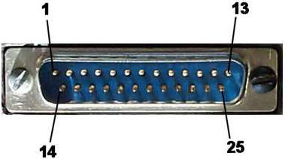
In addition, one input can also be used to create a processor interrupt. This interrupt can be enabled and disabled under program control. Reset from the power-on circuit is also Ored with a program output point, allowing a device to receive a power-on reset when the processor resets. The input/output signals are made available at the back of the adapter through a right-angled, PCB-mounted, 25-pin, D-type female connector. This connector protrudes through the rear panel of the system, where a cable may be attached. When this adapter is used to attach a printer, data or printer commands are loaded into an 8-bit, latched, output port, and the strobe line is activated, writing data to the printer. The program then may read the input ports for printer status indicating when the next character can be written, or it may use the interrupt line to indicate "not busy" to the software. The output ports may also be read at the card's interface for diagnostic loop functions. This allows faults to be isolated between the adapter and the attached device.

A. Pin Assignment
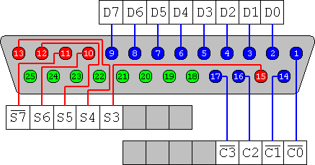
Pin No (DB25) | Signal name | Direction | Register - bit | Inverted
1 | nStrobe | Out | Control-0 | Yes
2 | Data0 | In/Out | Data-0 | No
3 | Data1 | In/Out | Data-1 | No
4 | Data2 | In/Out | Data-2 | No
5 | Data3 | In/Out | Data-3 | No
6 | Data4 | In/Out | Data-4 | No
7 | Data5 | In/Out | Data-5 | No
8 | Data6 | In/Out | Data-6 | No
9 | Data7 | In/Out | Data-7 | No
10 | nAck | In | Status-6 | No
11 | Busy | In | Status-7 | Yes
12 | Paper-Out | In | Status-5 | No
13 | Select | In | Status-4 | No
14 | Linefeed | Out | Control-1 | Yes
15 | nError | In | Status-3 | No
16 | nInitialize | Out | Control-2 | No
17 | nSelect-Printer | Out | Control-3 | Yes
18-25 | Ground | - | - | -

B. Parallel port registers
The Data, Control and status lines are connected to their corresponding registers inside the computer. So by manipulating these registers in a program , one can easily read or write to parallel port with programming languages like 'C' and BASIC.
1. Data register
2 . Status register
3. Control register
Data register is connected to Data lines Pin 2 to Pin 9, Control register is connected to control lines Pin 1, Pin 14, Pin 16 and Pin 17, and Status register is connected to Status lines Pin 10 to Pin 13 and Pin 1. So what ever is written to these registers will appear in corresponding lines as voltages which could be measured using a multimeter. For example , if value '1' is written to the Data register , the line Data0 will be driven to +5v.
C. Parallel port identification on IBM PC

Usually ports are found on the rear of computer and could be any of the following two types;
- Male ports. With pins coming out of port.
2) Female ports. With holes for pins.

Parallel port is generally a 25 pin female connector with which a printer is usually attached.

Data port:
- It includes pin 2 to pin 9 with pin names Data-0 to Data- 9
- It is usually for data output according to old “standard parallel port” standard.

Status Port
Status port is an input only port i.e. Data can’t be output on this port but it can only be read.

Control port
Control port is a read / writes port. For printer purposes it is write only port.

D. How to access parallel port pins in the software.
Parallel port is assigned a unique I/O address which is generally among the following:

- 378h (mostly used in output)
- 278h (normally found when there are more than one parallel ports)
- 379h (for the input)
- 37ah (for the CONTROL PORT outputs)

How to identify the port address on a PC

- Restart the computer then enter the BIOS set up window. Port addresses are enumerated on this window.
- If port addresses are set into auto, there are two things that can be done:
i) Explicitly assign an address in the BIOS.
ii) Check the address in Windows by going to
Control panel >System >Device Manager >
Ports◊Printer port > Properties > Resources >
Input/Output Range.

E. Difference between memory address space and I/O address space

In Intel family of x86 processors the memory addresses and I/O addresses are separate

Memory addresses is dependent on the RAM/ROM present in the PC & Address lines.

I/O address space is dependent on the no. of address lines available for accessing I/O devices.

How to use the two types of address space in Assembly Language

Memory addresses are ,generally, not known to an Assembly language programmer. A programmer basically refers to an address by using pointer notation.

I/O addresses are accessed in Assembly environment by using two commands
i) in
ii) out

F. Relation between bits present at the port address and voltage levels on port pins.

- Each bit present at base address of the port has direct link with the voltage level on corresponding port pin. i.e. a ‘1’ in register at I/O address corresponds to logic high at port pin.

OUTPORT (Data/Control)

A brief overview of logic high and logic Low levels of parallel port.

In parallel port
· Logic high means a voltage of +5V w.r.t ground.
· Logic low means a voltage of 0V w.r.t ground.

Deviation from above ‘bit-logic level’ relation
In case of hardware-inverted pins the above described relation of bit and logic level is reversed

i.e. ‘1’ corresponds to 0V on port pin. Examples are busy and strobe.

Some considerations of control port

Control port can be used both for input or out put. However there are some deviations such as in the case of Open Collector Output. In some hard wares control port pins are open collector. Its equivalent circuit is as follows:

Logic States of Open Collector Pin

i) Logic low (0V). It is actually a short circuit to ground as transistor is conducting.
ii)Logical high ( Open Circuit)

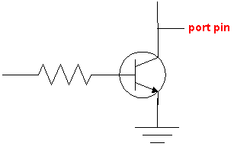

G. SAMPLE APPLICATION

1.) Demonstration of control of light Bulb through parallel port

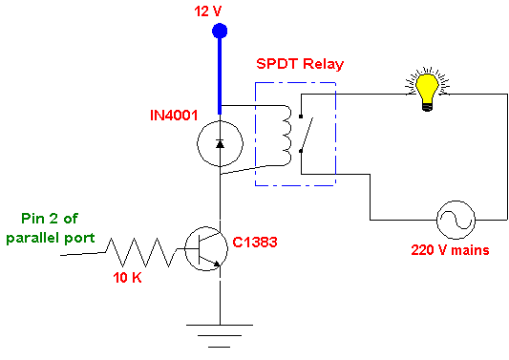

.model small
.stack
.code
start:

mov dx,378h
mov al,1
out dx,al

mov ah,4ch
int 21h
end start

This sample code simply lights the L.E.D. connected in the circuit.

H. IN PORT (Status)

Range of voltage for logic high and logic low

Parallel port is a TTL(transistor transistor logic) compatible in which
-Logic high is a voltage between 0 to 0.8 V
- Logic low is a voltage between 2.0 to 5V
- Any voltage in between the above rage is undefined.
- A voltage higher than the logic high or lower than the logic low can damage your port or any other TTL circuit.

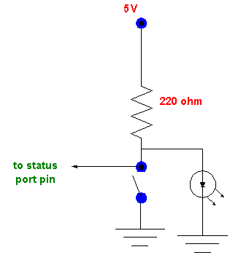

How to set a Logic High Voltage level on Open Collector

  - Connect an external resistor with pin to get a logic high voltage at which the value depends on the supply voltage used in case where parallel port does not use a Vcc greater than +5V.

I. INTRODUCTION TO BUFFERING FOR PARALLEL INTERFACING

  - Buffers are normally used for the purpose of load isolation.
  - For digital interfacing, digital buffers or inverters like
CD4050 (buffer)
CD4049 (inverter)
OR
74 LS245
74 LS244 TTL
are normally used.

Why is there a need for a Buffer?

Introduction to Source & Sink Currents

Source current
On a high output level the port pin or any TTL circuit can provide a certain maximum amount of output current while maintaining logic high level. This current is called source current.
- For parallel port this may be up to a maximum of 1mA among various ratings. Beyond this current, your voltage level decreases. A case that must be avoided.

Sink current

In case of a pin being in logic low state there is a minimum amount of current that the pin can absorb called sink current.
- A current larger than the sink current can result in severe damage to the logic device.
- The amount of the sink current is usually higher than the corresponding source current for the same device.
- The usual range is about 10mA for parallel port.

Advantage of buffers
- Buffers have better ratings of the source and sink currents. They provide protection to your costly circuits in the event a pin is over loaded by excessive source/sink current or an over voltage applied.

It is always a good practice to use buffers for your costly logic devices for both input and output data.

Demonstration of the use of Buffers in Data Output

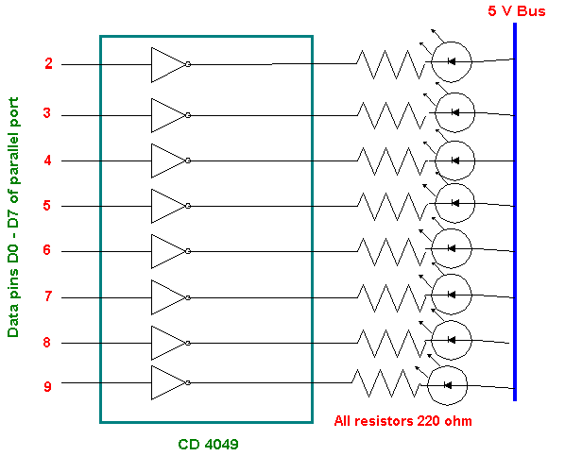

J. Sample Program

Example 16: This program will set all data ports to 1. Save the program using sample16.asm as the filename

Program:

.model small
.stack
.code

start:

mov dx,378h
mov al,255
out dx,al

mov ah,4ch
int 21h

end start

Example 17: This program will control an AC bulb using Parallel Port Relay Module. Save the program using sample17.asm as the filename

Program:
.model small
.stack
.data

poli1 DB' BULB IS ON',13,10,'$'
poli2 DB' BULB IS OFF',13,10,'$'
poli3 DB' BULB IS BLINKING',13,10,'$'
poli4 DB' PLS. ENTER YOUR CHOICE TO CONTROL BULB',13,10,'$'
poli5 DB' [A] ON',13,10,'$'
poli6 DB' [S] OFF',13,10,'$'
poli7 DB' [D] BLINK',13,10,'$'
poli8 DB' [W] EXIT',13,10,'$'
.code

start:

mov ax,@data
mov ds,ax

mov ah,9

mov dx, offset poli4
int 21h

mov dx, offset poli5
int 21h

mov dx, offset poli6
int 21h

mov dx,offset poli7
int 21h

mov dx,offset poli8
int 21h

mov ah,6
int 21h

mov ah,1
mov bl,41h
mov bh,'S'
mov cl,'D'
mov dl,'W'
cmp al,bl
je ON
cmp al,bh
je OFF
cmp al,cl
je BLINK
cmp al,dl
je EXIT
jne start

ON: mov ah,9
mov dx,offset poli1
int 21h
mov dx,378h
mov al,255
out dx,al
jmp start

OFF:mov ah,9
mov dx,offset poli2
int 21h
mov dx,378h
mov al,0
out dx,al
jmp start

EXIT:
mov ah,4ch
int 21h

end start

