# STUDENT VERSION (DevOps-Week-5)

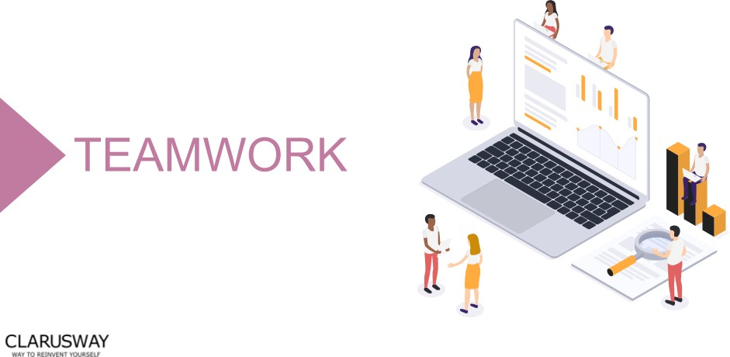

**Meeting Agenda**

▶ Icebreaking

▶ Questions

▶ Interview/Certification Questions

▶ Coding Challenge

▶ Article of the week

▶ Video of the week

▶ Retro meeting

▶ Case study / project

# Teamwork Schedule

## Ice-breaking 5m

Personal Questions (Stay at home & Corona, Study Environment, Kids etc.) Any challenges (Classes, Coding, AWS, studying, etc.)

Ask how they’re studying, give personal advice. Remind that practice makes perfect.

## Team work 10m

Ask what exactly each student does for the team, if they know each other, if they care for each other, if they follow and talk with each other etc.

## Ask Questions 15m

1. **How do we list all the available charts under a Helm Repo? (Helm)**
   1. helm pull repo [namespace]
   2. helm create repo
   3. helm repo add
   4. helm search repo [namespace]
2. **It is a package consists of pre configured Kubernetes Resources? (Helm)**
   1. Release
   2. Repository
   3. Chart
   4. Registery
3. **It is a tool for communicating with a Kubernetes cluster's control plane, using the Kubernetes API. (Kubernetes)**
   1. kubeadm
   2. kubelet
   3. kubectl
   4. minikube
4. **Which command is used to display resource (CPU/memory) usage of pods. (Kubernetes)**
   1. kubectl get pod [NAME]
   2. kubectl describe pod [NAME]
   3. kubectl apply pod [NAME]
   4. kubectl top pod [NAME]
5. **Which command is used to mark a node as unschedulable.(Kubernetes)**
   1. set
   2. cordon
   3. replace
   4. expose

## Interview/Certification Questions 20m

* + 1. **Which of the following is a serverless compute offering from AWS?**
       1. AWS EC2
       2. AWS Lambda
       3. AWS SNS
       4. AWS Config
       5. AWS SQS
    2. **Your company is currently hosting a heavy load application on its On-premise environment. The company has developed this application in-house. Consulting companies then use this application via API calls. You now need to consider moving this application to AWS. Which of the following services would best be suited in the architecture design, which would also help deliver a cost-effective solution? Choose 2 answers from the options given below.**
       1. AWS Lambda
       2. AWS API Gateway
       3. AWS Config
       4. AWS EC2
    3. **An organization runs several EC2 instances inside a VPC using three subnets, one for Development, one for Test and one for Production. The Security team has some concerns about the VPC configuration and requires to restrict the communication across the EC2 instances using Security Groups.**

Which of the following options is true for Security Groups?

* + - 1. You can change a Security Group associated to an instance if the instance state is stopped or running.
      2. You can change a Security Group associated to an instance if the instance state is stopped but not if the

instance state is running.

* + - 1. You can change a Security Group only if there are no instances associated to it.
      2. The only Security Group you can change is the Default Security Group.
      3. The only Security Group you can change is the Default Security Group.
    1. **You are the architect of a custom application running inside your corporate data center. The application runs with some unresolved bugs that produce a lot of data inside custom log files generating time-consuming activities to the operation team who is responsible for analyzing them.**

You want to move the application to AWS using EC2 instances, and at the same time, take the opportunity for improving logging and monitoring capabilities but without touching the application code.

What AWS service should you use to satisfy the requirement?

1. AWS Kinesis Data Streams
2. AWS CloudTrail
3. AWS CloudWatch Logs
4. AWS Application Logs
   * 1. **While reviewing the Auto Scaling events for your application, you notice that your application is scaling up and down multiple times in the same hour.**

What changes would you suggest in order to optimize costs while preserving elasticity? (SELECT TWO)

* + - 1. Modify the Auto Scaling group termination policy to terminate the older instance first.
      2. Modify the Auto Scaling group termination policy to terminate the newest instance first.
      3. Modify the Auto Scaling group cool down timers.
      4. Modify the Auto Scaling group to use Scheduled Scaling actions.
      5. Modify the CloudWatch alarm period that triggers your Auto Scaling scale down policy

## Article of the Week 10m

[Installation of a WordPress Page and a Database with Docker-Compose Using Secrets](https://clarusway.com/installation-of-a-wordpress-page-and-a-database-with-docker-compose-using-secrets/)

## Video of the Week 10m

[What is Helm?](https://www.youtube.com/watch?v=fy8SHvNZGeE)

## Retro Meeting on a personal and team level 10m

Ask the questions below: What went well?

What could be improved?

What will we commit to do better in the next week?

## Coding Challenge 5m

[Watching Free Disk Space](https://github.com/clarusway/clarusway_devops_10_22/blob/main/coding-challanges/cc-005-watching-free-disk-space/README.md)

## Case study/Project 10m

Case study should be explained to the students during the weekly meeting and has to be completed in one week by the students. Students should work in small teams to complete the case study.

[Project-206: Microservice Architecture for Phonebook Web Application (Python Flask) with MySQL using Kubernetes.](https://github.com/clarusway/clarusway_devops_10_22/tree/main/projects/206-Kubernetes-Microservice-Phonebook)

## Closing 5m

-Next week’s plan

-QA Session