|  |  |  |  |  |  |  |  |
| --- | --- | --- | --- | --- | --- | --- | --- |
| System and Integration test case | | | | | | | |
| Test case title: Booking system | | | | | | | |
| **Test Case ID** | **Test Steps** | **Type** | **Test data** | **Test type** | **Expected Result** | **Actual Result** | **Status (Pass/Fail)** |
| 1 | 1 - Open Home page  2 – Click in Booking service | Manual | http://localhost:51511/Home/Index | Top-down Integration Testing | Check the interface is link between the Home page and Booking page | To Be directed to the booking page | Pass |
| 2 | Home page > Booking service >  3 – Set up preferences | Manual | http://localhost:51511/Booking/ServiceDetail | Top-down Integration Testing | Check the Booking interface is saving the customer preferences  (Location: Toronto, Duration: 4 Hours, Shift time: Morning, service day: 12/15/2020 and service ID: 2) into the Order database. | Selected preferences is allowing the customer to set up their preferences and saving in the order database | Pass |
| 3 | Home page > Booking service >  4- Click in continue and choose the cleaner | Manual | http://localhost:51511/Booking/ServiceDetail | Top-down Integration Testing | Check the Service detail interface is saving the cleaner choose by the customer (James) into the order database according to the available cleaners in the cleaner database | The customer can pick the cleaner by their names and can ask to the system to choose randomly | Pass |
| 4 | Home page > Booking service > Service detail >  5- Fill up the customer information and submit | Manual | http://localhost:51511/Booking | Top-down Integration Testing | Check the Booking interface is saving the customer information (Name: Luana, Address: 50 Lombard St, Email: [luana_cesar@hotmail.com](mailto:luana_cesar@hotmail.com), Phone: 647 5629668) into the customer database. | The customer can type their information and be saved on the customer database | Pass |
| 5 | Home page > Booking service > Service detail > Booking > 6 display thank msg | Manual | http://localhost:51511/Booking | Top-down Integration Testing | Check if a thank you msg is loading after the customer fill up all the requirements. | The thank you page is loading on the interface. | Pass |
| 6 | Home page > Booking service > Service detail > Booking > thank msg > Open the SQL server and Check Order database | Manual | Visual studio | - | check if the database saved all the information choose by the customer on the booking system into the Order database. | The Order database is saving all information such as OrderID: 1, CustomerId: 1, CleanerId:20, ServiceID:2, Location:Toronto, Duration 4 hours, Shiftime: morning, ServiceDay: 2020-12-15 and OrderPayment : No payed. | Pass |

**Actual Result:**

**Test ID: 01 -** To Be directed to the booking page

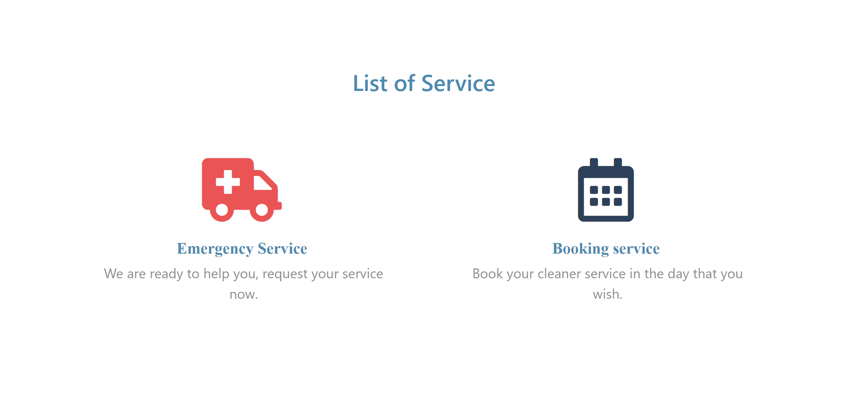

**Test ID: 01 -** To Be directed to the booking page

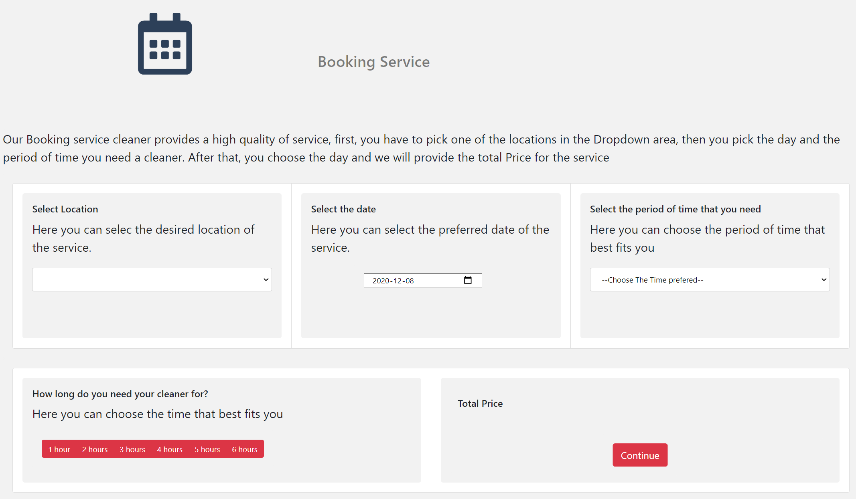

**Test ID: 02 -** Selected preferences is allowing the customer to set up their preferences

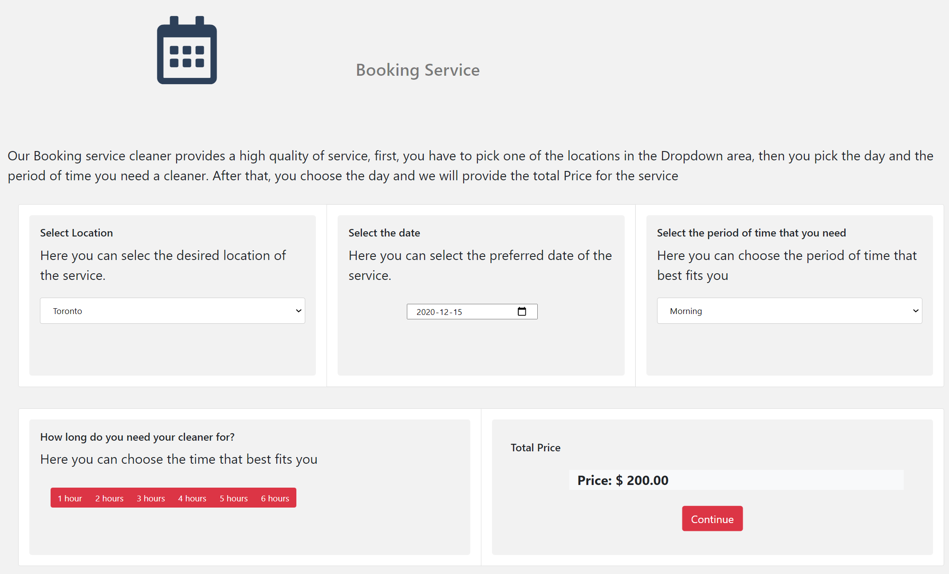

**Test ID: 03 -** The customer can pick the cleaner by their names and can ask to the system to choose randomly

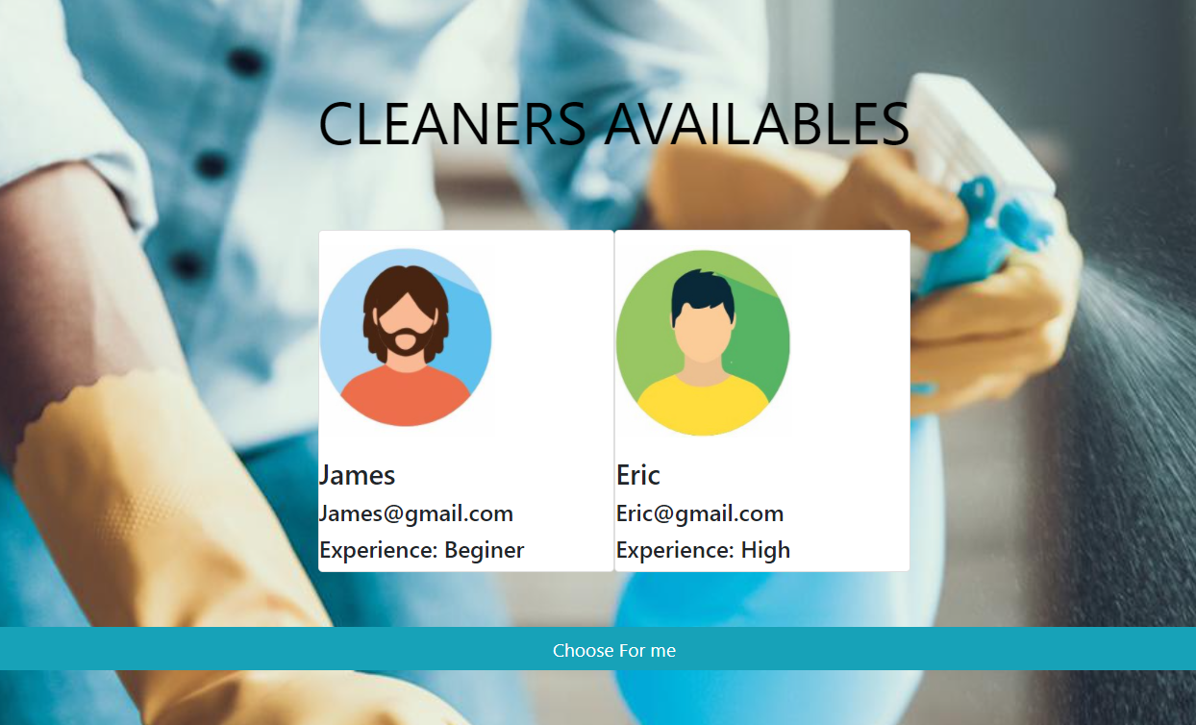

**Test ID: 04 -** The customer can type their information and

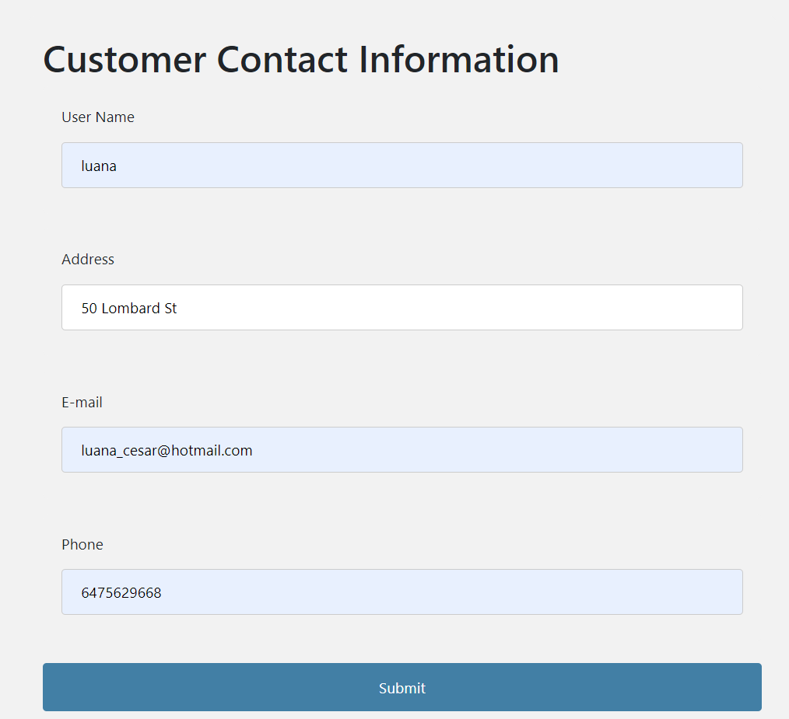

**Test ID: 04 -** be saved on the customer database

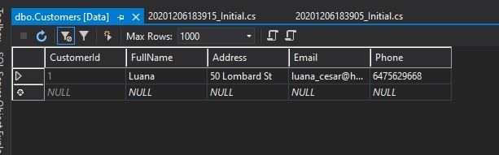

**Test ID: 05 -** The thank you page is loading on the interface.



**Test ID: 06 -** The Order database is saving all information such as OrderID: 1, CustomerId: 1, CleanerId:20, ServiceID:2, Location:Toronto, Duration 4 hours, Shiftime: morning, ServiceDay: 2020-12-15 and OrderPayment : No payed.

