Blood biomarkers of the late-phase asthmatic response are predictive of asthma severity

Mingming Zhang^{1,3}, Young Woong Kim^{1,2,3}, Chen Xi Yang³, Gail M. Gauvreau⁴, J. Mark FitzGerald³, Louis-Philippe Boulet⁵, Paul M. O'Byrne⁴, Scott J. Tebbutt^{2,3}, Amrit Singh^{1,3}

¹Department of Anesthesiology, Pharmacology and Therapeutics, University of British Columbia, Vancouver, BC, Canada;
²PROOF Centre of Excellence, Vancouver BC, Canada;
³UBC Centre for Heart Lung Innovation, Vancouver, BC, Canada;
⁴Department of Medicine, McMaster University, Hamilton, ON, Canada;
⁵Centre de Pneumologie de L’Hopital, Université Laval, Québec City, QC, Canada;

Corresponding author

Amrit Singh, PhD
Department of Anesthesiology, Pharmacology and Therapeutics
UBC Centre for Heart Lung Innovation
Room 166 - 1081 Burrard Street
Vancouver, BC, Canada

Telephone: 604-682-2344 ext. 66107

E-mail: Amrit.Singh@hli.ubc.ca

Authors’ contributions
AS, GMG, and SJT designed the study. GMG, PMO, JMF, LPB and SJT participated in provision of samples. Sample preparation and NanoString nCounter assays were performed by AS, YK and CY. MZ and AS performed the statistical and computational analyses and wrote the manuscript. All authors contributed to the editing of the final manuscript and approved the manuscript for publication.

Sources of support
This research was supported by funding from AllerGen NCE Inc. (Allergy, Genes and Environment Network), PROOF Centre of Excellence, the British Columbia Lung Association and Mitacs (Mitacs‐Accelerate Program).

Running title: Biomarkers of the late phase asthmatic response

Take-Home Message: Blood biomarkers of the late-phase asthmatic response observed in mild asthmatics are predictive of asthma severity.

Word count (3000 word limit):

Abstract (250 words)
Background: The allergen-induced late-phase asthmatic response (LAR) shares many features with chronic persistent asthma such as airway inflammation and airway remodeling. Previously we have shown that baseline gene-expression signatures in the blood can predict whether an asthmatic individual will elicit a LAR upon allergen inhalation. The goal of the present study was to determine whether these signatures are associated with asthma exacerbations and severity.
Methods: 35 mild asthma participants underwent allergen inhalation challenge. All participants underwent a methacholine challenge one prior and after the allergen inhalation challenge. Blood samples were collected prior to allergen inhalation. Lung function was measured at regular intervals from 0-7 hours post-allergen inhalation. Participants were classified as early responders (ER) or dual responders (DR) group based on their drop in forced expiratory volume in 1 second and provocative concentration of methacholine. Blood samples were sent to undergo transcript profiling and returned as Pancancer datast. sPLSDA was conducted with Pancancer dataset for discovering significant biomarker that can discriminate DR from ER. Further our final panel was tested with 7 public datasets. PLSDA models were built to select the most significant biomarkers that can achieve an AUC > 0.7. Enrichment analysis was also done with the final mRNA panel with public databases related to cell-type, transcript factors and path
Results: (I listed many, need to decide which one(s) can be listed here,
Conclusion:

Word count:

Key words: late phase asthmatic response; blood biomarkers, asthma exacerbations, asthma severity, allergen asthma; gene expression

INTRODUCTION
The allergen inhalation challenge model has been used to induce airway responses with associated inflammatory processes in mild allergic asthmatic individuals ^{1,2}. Allergic individuals challenged (via inhalation) with an allergen to which they are sensitized elicit acute bronchoconstriction, which is referred to as the early phase asthmatic response (EAR). The EAR resolves within 1-3 hours. The late phase asthmatic response (LAR) occurs 3-4 hours after allergen inhalation and is characterized by prolonged bronchoconstriction, cellular infiltration of the airways, and airway hyperresponsiveness. Furthermore, the LAR shares many characteristics with chronic asthma such as prolonged airway contraction, persistent airway inflammation, mucus hypersecretion and airway remodeling ^{3,4}.
We have previously shown that gene-expression profiles from blood samples can be used to predict which mild asthmatic individuals will elicit the LAR after allergen inhalation challenge⁵. This suggests that the baseline inflammatory state in the blood can predispose an individual to an LAR. Although this observation is limited to an experimental inhalation challenge model, this inflammatory state may also be present in real-world settings such as in asthma exacerbations or moderate and severe asthma. Therefore, if a molecular link between the LAR and asthma exacerbation/severity can be established than it may be possible to postulate that drugs that abolish the LAR in mild asthmatics may be effective in individuals with more severe asthma.
To address our aim, we identified a gene expression biomarker panel (i.e. set of gene RNA transcripts) using baseline whole blood samples (prior to allergen challenge) was identified that could predict a subject’s response to allergen challenge [isolated early responders (ERs) vs. dual responders (DRs)]. Combining the identified list of gene-transcripts with previously identified mRNA biomarkers of the LAR, resulted in 109 mRNA biomarkers⁵. We assess the ability of these biomarkers to predict asthma exacerbations and severity using six publicly available transcriptomics datasets across blood, airways, bronchoalveolar lavage and induced sputum.

MATERIALS AND METHODS

Subjects
The Institutional Review Boards of the participating institutions, the University of British Columbia (UBC), McMaster University, and Université Laval approved this study (NCT01113697) and subjects provided written informed consent. A total of 35 subjects underwent allergen inhalation challenges and, based on changes in FEV₁ 3-7h post-challenge, were classified as 15 ERs (change in FEV₁ <15% fall from baseline) and 20 DRs (change in FEV₁ ≥15% fall from baseline) (Table 1). Subjects were required to have mild allergic asthma. Subjects were excluded if they smoked, had any other lung or cardiovascular disease, or had a respiratory infection within 6 weeks. All subjects had a baseline FEV₁ ≥ 70% of the predicted value, and methacholine PC₂₀ (provocative concentration of methacholine that causes a 20% drop in FEV₁) < 16 mg/mL. Subjects were not taking maintenance inhaled corticosteroids and β₂-agonist use was infrequent and withheld 8 hours prior to spirometry measurements.

Methacholine and allergen challenge
Methacholine PC₂₀ was determined one-day prior (pre) and one-day after (post) allergen inhalation challenge. The [PC₂₀]_{pre}/[PC₂₀]_{post} was used to determine the allergen induced shift in airway hyperresponsiveness. Skin prick and methacholine challenge testing were used to determine the allergen extract of choice, and the dose of allergen used for the inhalation challenge ⁶. Doubling doses of the target allergen were inhaled during 2 minutes of tidal breathing and inhalations were stopped when a fall in FEV₁ of at least 20% was achieved. Then FEV₁ was measured at regular intervals up to 7h, post-challenge. All subjects demonstrated an FEV₁ drop of 20% between 0-2 hours (early asthmatic response, EAR) after allergen inhalation challenge. Participants that demonstrated a maximum drop in FEV₁ ≥ 15% between 3-7 hours after allergen challenge (late asthmatic response, LAR) were classified as dual responders (DRs). Since the LAR is associated with a 2-fold decrease in methacholine PC20, subjects with an LAR greater than 10% at 7h post-challenge and an allergen induced shift in methacholine PC20 greater than or equal to 2 were assumed to have experienced LAR after the last spirometric measurement at 7h, and classified as DRs. Blood samples were collected immediately prior to (pre) allergen inhalation challenge using standard operating protocols at each participating institution (see online supplement for details).

Blood collection and preparation
Blood samples were collected immediately prior to (pre) allergen inhalation challenge using standard operating protocols at each participating institution. 2.5mL of blood was collected in PAXgene Blood RNA tubes which contain an additive that lyses red blood cells and stabilizes intracellular RNA preventing both degradation and changes in gene expression profiling due to sample handling. These samples were kept at -80°C prior to shipment to the Tebbutt laboratory in Vancouver, Canada. After overnight thawing of PAXgene tubes, total RNA was purified using the RNA extraction kits such as PAXgene Blood RNA kit (PreAnalytiX-Qiagen, Germany) and PAXgene Blood miRNA Kit (PreAnalytiX-Qiagen, Germany) using 5mL of the PAXgene solution (~2.5mL of blood + 6.4 mL of stabilizing reagent). RNA concentrations were determined using NanoDrop 8000 Spectrophotometer (Thermo Scientific, Wilmington, DE, USA). RNA quality was assessed using the Agilent 2100 Bioanalyzer following the RNA 6000 Nano kit protocol (Agilent Technologies, Santa Clara, CA, USA).

Gene-expression biomarker panels of the late-phase asthmatic response
The PanCancer Immune Profiling Panel was used to profile 770 genes related to immune responses t cancer. However, these genes fall into many categories important in the allergic response, such as adaptive, innate and humoral immune response, inflammation, cell specific genes (B-cells, T-Cells) etc. Specifically, these genes consisted of 109 cell surface marker genes for 24 cell-types, 30 genes for cancer antigens, over 500 genes measuring the immune response and 40 house-keeping genes.
100 ng of sample RNA (for each of the 36 samples) was used profile the expression of the 770 panCancer genes using the nCounter® gene expression assay (NanoString Technologies, Seattle). Briefly, 130μL of hybridization buffer was added to the reporter codeset (PanCancer Immune Profiling Panel) to create the master mix. 20μL of the master mix was added to 5μL of the RNA sample in strip tube of 12 tubes (3 sets in total for 36 samples from 35 subjects). 5μL of the capture probeset was added to each tube and then placed at 65°C in a pre-heated thermocycler for 18 hours. Each strip tube was processed with the nCounter Prep-station which purified and immobilized samples onto the nCounter cartridge. The same cartridge was then scanned using the nCounter® Digital Analyzer, which counted the target molecules at 555 fields of view (FOVs).
Quality assessment of the PanCancer NanoString data was performed using RStudio following the data analysis guide by NanoString Technologies (Seattle, USA). All samples had a low binding density [0.41, 1.17] and high Field Of View (FOV) ratio [0.94, 0.99]. Positive controls (External RNA Control Consortium, ERCC) were used to assess the technical performance of the gene expression assay. Eight positive controls (POS_A-POS_F) corresponding to six different concentrations (128fM, 32fM, 8fM, 2fM, 0.5fM, and 0.125fM) demonstrated strong linearity (R² > 0.99) with their corresponding counts. Geometric mean normalization using the positive controls was used to account for assay-to-assay variability. Genes were filtered based on a background threshold level of 45 counts (maximum count based on negative controls). Genes with counts less than 45 counts across all samples were removed. Furthermore, total sum normalization was performed such that total assay counts were the same (equal to the mean of the total sum of all assays) across all assays. Lastly, the normalized counts were log2 transformed prior to downstream data analyses.

Public gene-expression datasets
GSE19301: consisted of time-series gene-expression profiles from asthmatic individuals (7 with mild persistent, 52 with moderate persistent and 59 with severe persistent asthma). Samples were collected during an initial “quiet” period, an “exacerbation” period and a “follow-up” period. Donors with mild persistent were not included in downstream analyses given the limited sample size. From the 52 donors with moderate (severe) persistent asthma, 180 (193) samples were collected during the quiet period, 68 (91) during the exacerbation period and 60 (59) during the follow-up period, respectively. Gene-expression data was derived from isolated peripheral blood mononuclear cells and profiled using Affymetrix Human Genome U133A microarrays.
GSE147878 & GSE147880: was a cross-sectional study examined clinical and transcriptomic data from 73 endobronchial biopsies and 44 induced sputum samples from the European Unbiased Biomarkers for the Prediction of Respiratory Outcomes (U‐BIOPRED) study, and the Australian Priority Research Centre for Healthy Lungs – NOVocastrian Asthma cohort (NOVA)^{7,8,9}. All the subjects were current non-smokers. All the samples underwent transcriptomic profiling using Affymetrix GeneChip® Human Genome U133 Plus 2.0 microarray and Illumina HT-12 version 4 Beadchips. 13 out of 73 endobronchial biopsies were assigned into healthy controls, 18 were classified to moderate asthmatics and the remaining 42 samples into severe asthmatics. The 44 sputum samples were classified into 10 healthy controls, 18 moderate and 16 severe asthmatics.
GSE74986: which contains transcripts from bronchoalveolar lavage (BALF) samples collected from moderate asthmatic patients and healthy subjects as controls in the Study of the Mechanisms of Asthma (MAST; clinicaltrials.gov: NCT00595153)¹⁰ and severe asthmatic patients in the Bronchoscopic Exploratory Research Study of Biomarkers in Corticosteroid- refractory Asthma (BOBCAT) study¹¹. BALF was centrifuged to generate cell pellets from 86 subjects. Total RNA was extracted from the cells with the Qiagen RNeasy Kit. The quantity and quality of the total RNA samples were determined with the Bioanalyzer 2100 (Agilent Technologies). Gene expression was assessed by microarray analysis¹². Among 86 BALF samples, 12 were healthy controls, 28 were moderate and 46 were in severe asthma groups.
GSE69683: This dataset consisted of blood gene-expression profiles from 87 healthy controls, 77 patients with moderate asthma, and 334 patients with severe asthma. Transcriptional profiling of whole blood samples was performed using Affymetrix HT HG-U133+ PM Arrays⁸.
GSE76262: This dataset consisted of blood gene-expression profiles from 21 healthy controls, 25 patients with moderate asthma, and 93 patients with severe asthma. Transcriptional profiling of whole blood samples was performed using Affymetrix U133 Plus 2.0 PM arrays¹³.
GSE161245: This transcriptional profiling data of bronchial epithelial cells was obtained via bronchoscopy from a total of 55 subjects among which 16 healthy controls, 5 moderate and 17 severe asthma subjects¹⁴. The RNA samples underwent sequencing using the Illumina NextSeq 500 platform.
Datasets of the same-type (airways and induced sputum) were combined using the ComBat batch correction algorithm (sva R-package, v3.52.0).

Data analysis
The biomarker panel (set of gene transcripts) of the late phase asthmatic response was identified using sparse Partial Least Squares Discriminant Analysis (sPLS-DA)¹⁵ from the mixOmics R library (version 6.28.0). The classification performance (area under the receiver operating characteristic curve, AUC) was estimated using 5-fold cross-validation repeated 20 times, for a sPLS-DA model retaining two components. The optimal number of variables for each component were chosen based on a grid that tested a range of models retaining 5-30 variables across the two components. These variables were combined with gene biomarkers of the LAR from our previously published study⁵. The final set of biomarkers were evaluated using 20x5-fold cross-validation in seven public gene-expression datasets using partial least squares discriminant analysis (PSLDA) in which the same set of biomarkers are evaluated in this ability to discriminate exacerbation from non-exacerbation samples, healthy controls from moderate asthma and moderate from severe asthma in airway, BALF, induced sputum and blood samples (Figure 1).
Differential gene expression analysis for the time-series dataset: GSE19301, was performed using linear mixed effects models (nlme, version 3.1-128) R-library¹⁶, treating subject as a random-effect and the time period (quiet, exacerbation, follow-up) and sex as fixed-effects. Differential gene expression analysis for all other datasets was performed using the Linear Models for Microarrays and RNA-Seq data (limma R-library version 3.58.1), comparing healthy controls with moderate asthma and moderate with severe asthma adjusting for sex. Multiple testing was accounted for using a Benjamini-Hochberg False Discovery Rate (BH-FDR) of 10% ¹⁷.
Enrichment analyses of the list of biomarker genes was performed using Enrichr ¹⁸, (enrichR, R library version3.2) using a pathways database (WikiPathways 2024 Human), cell-type marker database (CellMarker 2024) and a transcription factors database (Rummagene transcription factors). A BH-FDR of 1% was used for all enrichment analyses.

Figure 1. Compiling the final LAR mRNA panel and application to public gene-expression datasets. Process of selecting the biomarkers for the final LAR mRNA biomarker panel using the panCancer panel identified in the current study and existing LAR panels. The final LAR mRNA panel was used to develop PLSDA models using publicly available asthma exacerbation and severity gene-expression datasets from the airways, BALF, blood and induced sputum. Classification performance between groups (exacerbation vs. quiet or follow-up, healthy control vs. moderate or severe asthma, and moderate vs. severe asthma) using 5-fold cross-validation repeated 20 times. The analyses were repeated after stratification by sex.

RESULTS

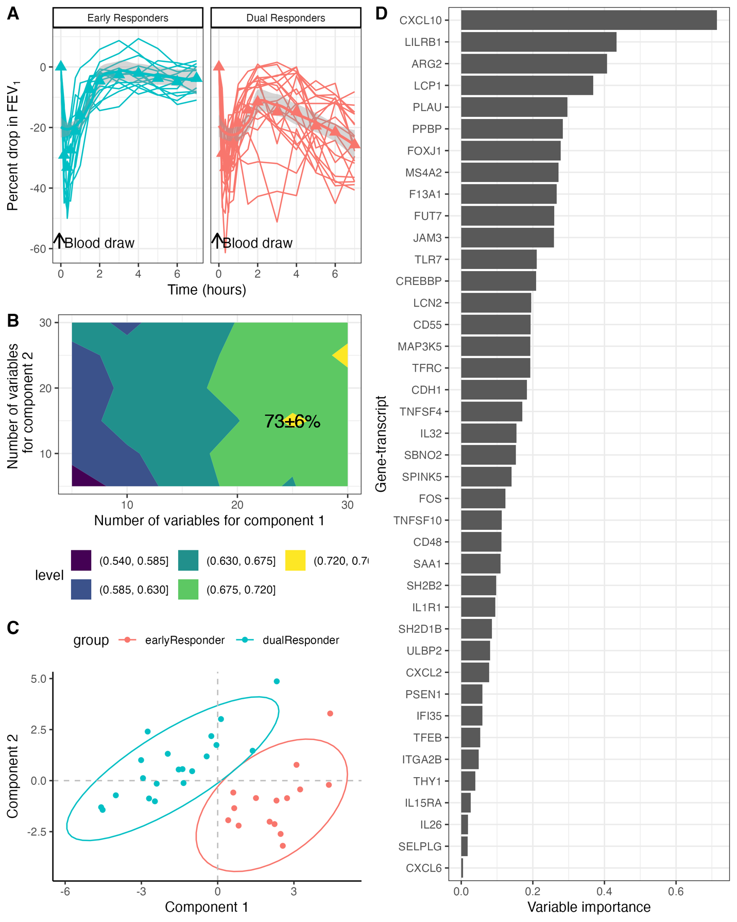
Figure 2. PanCancer gene-expression biomarker panel of the late-phase response. A. Blood was collected prior to the allergen inhalation challenge. The allergen inhalation challenge was performed at 0 hours. FEV₁ was measured using spirometry from 0-7 hours at regular intervals. A 15% drop during the late phase asthmatic response (LAR) was used to characterize subjects into dual responders. B. Parameter tuning of the sPLSDA classification model to select the number of variables for each component that maximized the 20x-5-fold cross-validation AUC. C. Sample clusters of ERs and DRs based on the sPLSDA biomarker panel. D. Variable importance based on the absolute value of the sPLSDA model coefficients for each gene biomarker.

Following allergen inhalation, all subjects developed the early asthmatic response whereas the dual responders (DRs) developed a subsequent decline in lung function during the late asthmatic response (3-7 hours), -30.4±10.6% compared to -6.6±4.1% in isolated early responders (ERs) (p<0.01, Figure 1A). Two DRs has a maximum drop in FEV₁ of -12.6% and -14.9% and thus did not meet the -15% drop criteria, however, since their methacholine PC₂₀ more than doubled (allergen induced shift > 2) on the second methacholine challenge, they were classified as dual responders (Figure S1). On average the allergen induced shift in methacholine PC₂₀ was more than 3 times greater in DRs compared to ERs (Table 1). No demographic variables or complete blood counts with differentials were statistically different between ERs and DRs, however the percentage of neutrophils were marginally greater in ERs compared to DRs, albeit not statistically significant (Table 1).
Six hundred out of the 770 genes were retained after filtering of low abundant transcripts and house-keeping genes. Hyperparameters tuning of the sPLSDA model resulted in a biomarker panel of 35 gene-transcripts (25 variables for component 1 and 15 variables for component 2) which had an average AUC of 73±6% using a 20x5-fold cross-validation (Figure 2B). Figure 2C showed a clear separation between ERs and DRs based on the selected biomarker candidates. Figure 2D depicts the coefficient weights (absolute value) of each gene-biomarker in the sPLSDA model with CXCL10 (C-X-C motif chemokine ligand), LILRB1 (leukocyte immunoglobulin like receptor B1) and ARG2 (arginase 2) as the top 3 gene-transcripts with the highest importance.

Figure 3. Enrichment analysis of all gene-expression biomarkers of the late-phase response of the current and published studies. A. Number of gene-transcripts across the five late-phase biomarkers panels. B. Overlap in gene-biomarkers across the five late-phase biomarker panels. C. Top 10 genesets for three EnrichR databases (cell-type markers, transcription factors and pathways) given an adjusted p-value cut-off of 1% and the number of gene-biomarkers in each geneset. D. Frequently occurring gene-biomarkers in the significant genesets identified in C.

Across five late-phase panels, 156 biomarkers were detected in total. The number of biomarkers range from 14 to 40, with the Trinity panel containing the least number of gene-transcript and the PanCancer panel containing the most (Figure 3A). After removing the duplicated late-phase biomarkers, 109 late-phase biomarkers were obtained for the final mRNA panel. All of these panels were compared to illustrate the overlapping biomarkers (Figure 3B). 37 out of 40 genes from the panCancer panel were independent biomarkers whereas 3 had overlaps with the other panels. 15 independent genes were found in UCSC-isoforms panel, while 12 in Ensembl and 10 in Trinity panels. Nine genes were seen overlapped in both UCSC-isoforms and Ensembl panels. 11 genes were detected overlapped in three panels (UCSC-isoforms, Ensembl and UCSC). Only 2 genes were found in 4 out of 5 panels. Three EnrichR databases were used to explore how the biomarkers found in the 5 panels related to possible cell types (CellMarker_2024 filtered for blood cells only), transcription factors (Rummagene_transcription_factors) and pathways (Wikipathways_2024_Human) using gene set analysis. Geneset analysis identified 32 significant cell-types, 190 transcription factors and 10 pathways at an FDR cut-off of 1%. Figure 3C depicts the top 10 cell-types, transcription factors and pathways. The late-phase biomarkers were most related to CD1C-CD141-dendritic cells followed by monocytes and neutrophils. IRF6 was the top transcription factor. The top biological pathway was the cytokine-cytokine receptor interaction pathway. SARS CoV2 signaling pathway and apoptosis modulation and signaling pathways were also significantly enriched. Amongst the significant gene sets, CD4, CD8, CXCL10, NFKBIA, FOS are the most frequently occurring genes (Figure 3D).

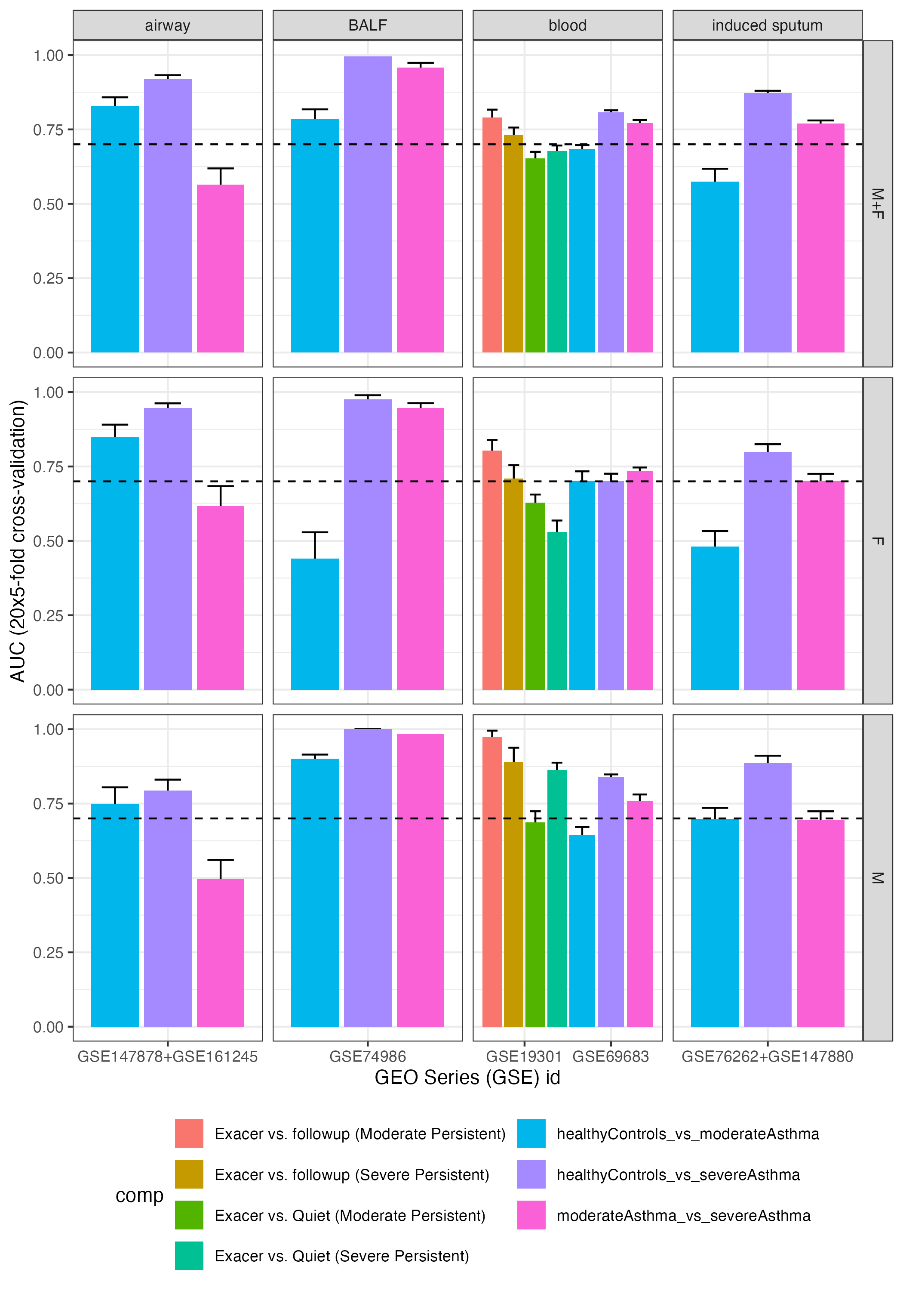
Figure 4: Application of the final mRNA biomarker panel to public real-world asthma datasets. Partial least squares discriminant analysis was used to evaluate the classification of the late phase biomarkers with respect to asthma exacerbation and asthma severity. Model classification was estimated using females (F) and males (M) separately and combined (M+F). Sample of the same-type (airways and induce sputum) were combined after batch correction. The dashed line indicates an AUC = 0.70.

Figure 4 depicts the cross-validated classification performances of PLSDA models consisting of the LAR biomarkers in discriminating asthma exacerbations and severity with and without stratification by sex. With respect to asthma exacerbations, the LAR biomarker panel could differentiate (AUC > 0.70) exacerbation samples from follow-up samples but not compared to samples during the quiet period in patients with both moderate and severe persistent asthma (see GSE19301, M+F, in Figure 4). However, in males only, the LAR panel was able to differentiate exacerbation samples from the quiet period (AUC = 0.86±0.03). With respect to asthma severity, the LAR biomarker panel could differentiate healthy controls from patients with severe asthma, but not as well from patients with moderate asthma. Interestingly, the LAR biomarker panel could differentiate patients with moderate from severe asthma patients in BALF (AUC = 0.96±0.02), blood (AUC = 0.77±0.01) and induced sputum (AUC = 0.77±0.01) samples but not airway samples (AUC = 0.57±0.05).

DISCUSSION
In this present study, we demonstrated that the panCancer biomarker panel could differentiate participants that experienced the late-phase asthmatic response (LAR as compared to those that do not with an AUC > 0.70. Combined with existing gene-expression biomarkers of the LAR⁵, we were able to show its utility in discriminating exacerbation from non-exacerbation in blood samples from asthma patients and moderate from severe asthmatics. This suggests that molecular changes observed during the LAR may play an important role during asthma exacerbations and progression to severe asthma.
The 109 mRNA biomarkers of the late phase asthmatic response consisted of a range of immune cell markers, from dendritic cells, monocytes, neutrophils, platelets, natural killer (NK) cells and γδ T-cells. Each of these cell-types have been shown to play an important role in airway inflammation. For example, dendritic cells have been shown to increase in the bone-marrow, BALF and bronchial tissues upon allergen challenge¹⁹. Similarly monocytes have been shown to accumulate in the airways of patients with fatal asthma²⁰. Neutrophils also play a significant role in severe asthma²¹ and activate pathways related to oxidative stress²². NK cells have been shown to have many roles in asthma including allergic sensitization, virus-induced asthma exacerbations as well as during the resolution of inflammation²³. Similar to NK cells, γδ T-cells have been shown to play an important role in the resolution of airway inflammation and airway remodelling²⁴. These results suggests that the LAR consists of a complex interplay between various immune cells that contribute to promoting and resolving inflammation.
An important finding of this study was the identification of master regulator of interferon regulatory factor 6 (IRF6) as a transcription factor for the majority of the LAR mRNA biomarkers. Interesting IRF6 play an important role in embryonic development, but is not well studied in asthma immunity²⁵. IRF6 has been identified across a range of cancers including colorectal, pancreatic, lung, breast and gliomas²⁵. With respect to epithelial cells, IRF6 has been shown to regulate TLR2-mediated CCL5 expression²⁶. Irf6 has been shown to be expressed in bone marrow-derived neutrophils, macrophages and dendritic cells²⁷, all of which were identified in our study as being markers of LAR biomarkers. Further, IRF6 was shown to regulate NF-κB mediated cytokine production after lipopolysaccharide stimulation²⁷. Future studies are required to delineate the role of IRF6 in the asthmatic response with respect airway inflammation and remodeling.

- Suggests that changes observed in allergic asthma are applicable to real-world asthma which can be due to various factors (e.g. viral).
Further, application of the LAR biomarker panel in asthmatic individuals with moderate and severe persistent asthma

The late phase asthmatic response (LAR) in mild asthma patients shares many symptomatic and pathologic characteristics with chronic asthma such as prolonged airway contraction, persistent airway inflammation, mucus hypersecretion and airway remodeling^{3,4}. As the prolonged pathologic changes, typically over months to years, the patients are more vulnerable to infections, allergens and other etiology that can exacerbate asthmatic symptoms^{28,29}. Therefore, the molecular characterization of the LAR may help in understanding the biological mechanisms of chronic asthma, lead to improved diagnostics and potential new treatments.

The airway contractive changes can be measured by lung function test objectively. A FEV₁ drop can be seen when there is airway contraction due to many reasons including inflammation, mucus hypersecretion and airway remodeling. In our study, the FEV1 of the DR group showed obviously decreasing compared with the ER group (Figure 2A) that indicated there were late-phase asthmatic responses. We tested the gene-transcript panel from Pancancer dataset by sPLS-DA model that achieve an AUC of 73±6% (Figure 2B). A clear separation of ER and DR was shown (Figure 2C). This indicates the 40 biomarkers in the gene-transcript panel selected from PanCancer dataset can discriminate late phase asthmatic responders from the early asthmatic responders among mild subjects. This demonstrates that our late-phase mRNAs from baseline blood samples can be used as biomarkers to discriminate dual responders from early responders. As our mRNA biomarkers discovered with a dataset only has 35 subjects, more validated late-phase mRNA biomarkers were considered to be added to make our final panel more diverse. We chose late-phase mRNA biomarkers from our published asthma-related studies to expand the final mRNA panel up to 109 biomarkers. We tested the overlaps and found the new discovered biomarkers from Pancancer dataset were highly distinct. This indicated that the other late-phase biomarkers can effectively further enhance the diversity and size of the data. By building up PLSDA models between the final mRNA panel and other 7 published dataset with different types of samples, we achieved relatively better performance models among Healthy controls vs Severe asthma groups with airway, BALF and blood samples compared with PBMC samples. This indicates that the inflammation of asthmatic process may be more related to the immune cells in the airway tissues and blood, while PBMC samples only contain limited types of immune cells. According to some studies^{30,31}, asthma development also relied to the integrity of the airway and epithelial cells can play a key role in chronic inflammatory process responsible for airway remodeling. The impairment of the epithelial barrier allows harm substance enter deeper tissues easily that can cause further inflammation and damage to the airway³¹. In addition, gene-expression changes in epithelial cells were found that could contribut to the development of asthma. CDHR3 (encoding cadherin-related family member 3) was found significantly highly expressed in the airway of children with asthma and responsible for the exacerbation together with GSDMB, IL33, RAD50 and IL1RL1 which were previously validated³².
In our study, RGS2, known as regulator of G-protein signaling 2, was found downregulated in moderate asthma compared with healthy controls in both airway and BALF samples, which aligned with previous study that RGS2 protein levels in airway cells were significantly lower in patients with asthma compared to the ones without asthma³³. That indicated RGS2 could serve as a hallmark of asthma. IL-32 previously was found higher expressed in asthma patient’s epithelial cells, plasma and induced-sputum samples. What’s new in our result is that IL-32 was found upregulated in the BALF samples, which could be used to monitor asthma treatment response^{34,35}.However, IL-32 was also found downregulated in our study in both epithelial cell airway samples and whole blood samples. One possible reason that can cause this difference could be the subjects had received some effective treatments in some of the public datasets when we used them to do this validation. We identified downregulated CD48 level within airway samples that had also been observed in the study of exploring soluble CD48 in allergic asthma vs non-allergic asthma³⁶ but an upregulated CD48 in the BALF samples. This indicated that CD48 was not always upregulated as reported in some previous studies^{37,38}, especially in patients with allergic airway inflammation. TNFSF10 (Tumor Necrosis Factor-Related Apoptosis-Inducing Ligand, also known as TRAIL) was found downregulated in the epithelial cell airway samples among moderate vs healthy control group, while upregulated in the endobronchial biopsy airway sample among severe vs healthy control group. Based on the previous study’s findings, TNFSF10 could be found increased in both bronchial epithelium cells and induce-sputum samples of asthma patients^{39,40}. Our findings were not fully consistent with their results. The possible reasons could be that our data were tested with different severities of asthma subjects but still need to be validated. LCN2 (lipocalin 2), also known as neutrophil gelatinase-associated lipocalin (NGAL), is an acute-phase protein secreted by immune and epithelial cells⁴¹. LCN2 was found upregulated in blood sample in our study which was consistent with published studies on both human and mice models⁴². Meanwhile, we also found a downregulated LCN2 in epithelial cell airway samples. The possible reason to cause this contrast could be that LCNA2 is associated with acute inflammation especially in prevention against infections⁴³, the public data we used to validate our biomarkers could be at non-infectious status, or the subjects were after treatment or the asthmatic status had been lasting for a relatively long time. CXCL2 is known as a chemokine in neutrophil chemoattraction after lung inflammation or injury⁴⁴. A downregulated CXCL2 was found in our study among both airway and BALF samples. The different result might due to different inflammation types involved in our validation dataset. CXCL10 was discovered from our Pancancer dataset that was with the highest predictive power in the sPLSDA model to discriminate DRs from ERs, it had been seen significantly upregulated in the PBMC sample public dataset (Figure 4A, Follow-up vs Exacerbation). However, this PLSDA model comparing Follow-up vs Exacerbation was not validated as good performance model (AUC<0.7). IRF6 was identified as the top frequently seen transcript factor in our study (Figure 3C) which may serve as a candidate gene for asthma development⁴⁵, which was not validated as a significant biomarker in the public datasets.
Based our enrichment study that compared our final mRNA panel with published databases involving cell types, transcript factors and pathways, we identified the top ranked cell types, transcript factors and pathways that most closely related to our discovery. Dendritic cells with specific cell markers were identified. Dendritic cells serve as antigen-presenting cells to active immune response involving T cells, including the Th2 cells in allergic asthma⁴⁶. (CD1C- CD141- dendritic cell is too difficult to discuss, the origin and this classification need deeper explanation probably). Once an inflammation happens in the airway, the dendritic cells can be delivered to the airway tissues via blood, so an increased level of dendritic cells in specific types can be observed in the airway samples or BALF⁴⁷. Neutrophils are playing significant role especially in severe asthma²¹ and active in pathways related to oxidative stress²² leading to asthma. Other immune cells found in our study such as T cells in different subtypes, monocytes, also participated in cytokine activation (such as IL-4, IL-5, IL-13 in allergic asthma) and could be seen elevated in the blood of asthma patients⁴⁸. Our findings are consistent with those in previous research (Figure 3C) that further support the gene-transcript panel from LAR share similar characteristics with severe asthma and can be used to identify severe asthma.

CONCLUSION

Late-phase blood mRNA biomarkers can be considered as predictive biomarkers to early diagnose severe asthma among mild asthma patients.

Acknowledgements:
We thank the research participants for taking part in these studies, as well as Johane Lepage, Philippe Prince, Joanne Milot, Mylène Bertrand, Richard Watson, George Obminski, Heather Campbell, Abbey Torek, Tara Strinich, Karen Howie, Linda Hui and Joyce Kum for their expertise and assistance with participant recruitment, allergen challenge and sample collection, as part of the AllerGen NCE Clinical Investigator Collaborative.

References
1. Gauvreau GM, El-Gammal AI, O’Byrne PM. Allergen-induced airway responses. Eur Respir J. 2015;46(3):819-831. doi:10.1183/13993003.00536-2015
2. Nomani S, Cockcroft DW, Davis BE. Allergen inhalation challenge, refractoriness and the effects of ibuprofen. Allergy Asthma Clin Immunol. 2016;12(1):24. doi:10.1186/s13223-016-0127-z
3. Samitas K, Delimpoura V, Zervas E, Gaga M. Anti-IgE treatment, airway inflammation and remodelling in severe allergic asthma: current knowledge and future perspectives. Eur Respir Rev. 2015;24(138):594-601. doi:10.1183/16000617.00001715
4. Cockcroft D, Davis B. Mechanisms of airway hyperresponsiveness. J Allergy Clin Immunol. 2006;118(3):551-559. doi:10.1016/j.jaci.2006.07.012
5. Singh A, Shannon CP, Kim YW, et al. Novel Blood-based Transcriptional Biomarker Panels Predict the Late-Phase Asthmatic Response. Am J Respir Crit Care Med. 2018;197(4):450-462. doi:10.1164/rccm.201701-0110OC
6. Cockcroft DW, Murdock KY, Kirby J, Hargreave F. Prediction of Airway Responsiveness to Allergen from Skin Sensitivity to Allergen and Airway Responsiveness to Histamine. Am Rev Respir Dis. 1987;135(1):264-267.
7. Sánchez-Ovando S, Pavlidis S, Kermani NZ, et al. Pathways linked to unresolved inflammation and airway remodelling characterize the transcriptome in two independent severe asthma cohorts. Respirol Carlton Vic. 2022;27(9):730-738. doi:10.1111/resp.14302
8. Shaw DE, Sousa AR, Fowler SJ, et al. Clinical and inflammatory characteristics of the European U-BIOPRED adult severe asthma cohort. Eur Respir J. 2015;46(5):1308-1321. doi:10.1183/13993003.00779-2015
9. Sánchez‐Ovando S, Baines KJ, Barker D, Wark PA, Simpson JL. Six gene and TH2 signature expression in endobronchial biopsies of participants with asthma. Immun Inflamm Dis. 2020;8(1):40-49. doi:10.1002/iid3.282
10. Simpson LJ, Patel S, Bhakta NR, et al. A microRNA upregulated in asthma airway T cells promotes TH2 cytokine production. Nat Immunol. 2014;15(12):1162-1170. doi:10.1038/ni.3026
11. Jia G, Erickson RW, Choy DF, et al. Periostin is a systemic biomarker of eosinophilic airway inflammation in asthmatic patients. J Allergy Clin Immunol. 2012;130(3):647-654.e10. doi:10.1016/j.jaci.2012.06.025
12. Sun Y, Peng I, Webster JD, et al. Inhibition of the kinase ITK in a mouse model of asthma reduces cell death and fails to inhibit the inflammatory response. Sci Signal. 2015;8(405):ra122. doi:10.1126/scisignal.aab0949
13. Kuo CHS, Pavlidis S, Loza M, et al. T-helper cell type 2 (Th2) and non-Th2 molecular phenotypes of asthma using sputum transcriptomics in U-BIOPRED. Eur Respir J. 2017;49(2). doi:10.1183/13993003.02135-2016
14. GEO Accession viewer. Accessed February 5, 2025. https://www.ncbi.nlm.nih.gov/geo/query/acc.cgi?acc=GSE161245
15. Lê Cao KA, Boitard S, Besse P. Sparse PLS discriminant analysis: biologically relevant feature selection and graphical displays for multiclass problems. BMC Bioinformatics. 2011;12(1):253. Accessed July 15, 2015. http://www.biomedcentral.com/1471-2105/12/253/
16. Laird NM, Ware JH. Random-effects models for longitudinal data. Biometrics. Published online 1982:963-974. Accessed September 6, 2016. http://www.jstor.org/stable/2529876
17. Benjamini Y, Hochberg Y. Controlling the false discovery rate: a practical and powerful approach to multiple testing. J R Stat Soc Ser B Methodol. Published online 1995:289-300. Accessed March 11, 2016. http://www.jstor.org/stable/2346101
18. Chen EY, Tan CM, Kou Y, et al. Enrichr: interactive and collaborative HTML5 gene list enrichment analysis tool. BMC Bioinformatics. 2013;14(1):128. Accessed March 4, 2016. http://www.biomedcentral.com/1471-2105/14/128?utm_source=feedburner&utm_medium=feed&utm_campaign=Feed%3A+bioinformatics_today+(Bioinformatics)
19. El-Gammal A, Oliveria JP, Howie K, et al. Allergen-induced Changes in Bone Marrow and Airway Dendritic Cells in Subjects with Asthma. Am J Respir Crit Care Med. 2016;194(2):169-177. doi:10.1164/rccm.201508-1623OC
20. Eguíluz-Gracia I, Malmstrom K, Dheyauldeen SA, et al. Monocytes accumulate in the airways of children with fatal asthma. Clin Exp Allergy J Br Soc Allergy Clin Immunol. 2018;48(12):1631-1639. doi:10.1111/cea.13265
21. Ray A, Kolls JK. Neutrophilic Inflammation in Asthma and Association with Disease Severity. Trends Immunol. 2017;38(12):942-954. doi:10.1016/j.it.2017.07.003
22. Mishra V, Banga J, Silveyra P. Oxidative stress and cellular pathways of asthma and inflammation: Therapeutic strategies and pharmacological targets. Pharmacol Ther. 2018;181:169-182. doi:10.1016/j.pharmthera.2017.08.011
23. Gorska MM. NK cells in asthma. Curr Opin Allergy Clin Immunol. 2017;17(1):50-54. doi:10.1097/ACI.0000000000000327
24. Murdoch JR, Gregory LG, Lloyd CM. γδT cells regulate chronic airway inflammation and development of airway remodelling. Clin Exp Allergy. 2014;44(11):1386-1398. doi:10.1111/cea.12395
25. Wang L, Zhu Y, Zhang N, et al. The multiple roles of interferon regulatory factor family in health and disease. Signal Transduct Target Ther. 2024;9(1):1-48. doi:10.1038/s41392-024-01980-4
26. Kwa MQ, Nguyen T, Huynh J, et al. Interferon Regulatory Factor 6 Differentially Regulates Toll-like Receptor 2-dependent Chemokine Gene Expression in Epithelial Cells. J Biol Chem. 2014;289(28):19758-19768. doi:10.1074/jbc.M114.584540
27. Joly S, Rhea L, Volk P, Moreland JG, Dunnwald M. Interferon Regulatory Factor 6 Has a Protective Role in the Host Response to Endotoxic Shock. PLoS ONE. 2016;11(4):e0152385. doi:10.1371/journal.pone.0152385
28. Ahn SY, Lee J, Lee DH, Ho TL, Le CTT, Ko EJ. Chronic allergic asthma induces T-cell exhaustion and impairs virus clearance in mice. Respir Res. 2023;24(1):160. doi:10.1186/s12931-023-02448-9
29. Castillo JR, Peters SP, Busse WW. Asthma Exacerbations: Pathogenesis, Prevention, and Treatment. J Allergy Clin Immunol Pract. 2017;5(4):918-927. doi:10.1016/j.jaip.2017.05.001
30. Raby KL, Michaeloudes C, Tonkin J, Chung KF, Bhavsar PK. Mechanisms of airway epithelial injury and abnormal repair in asthma and COPD. Front Immunol. 2023;14:1201658. doi:10.3389/fimmu.2023.1201658
31. Calvén J, Ax E, Rådinger M. The Airway Epithelium-A Central Player in Asthma Pathogenesis. Int J Mol Sci. 2020;21(23):8907. doi:10.3390/ijms21238907
32. Bønnelykke K, Sleiman P, Nielsen K, et al. A genome-wide association study identifies CDHR3 as a susceptibility locus for early childhood asthma with severe exacerbations. Nat Genet. 2014;46(1):51-55. doi:10.1038/ng.2830
33. Jiang H, Xie Y, Abel PW, et al. Regulator of G-Protein Signaling 2 Repression Exacerbates Airway Hyper-Responsiveness and Remodeling in Asthma. Am J Respir Cell Mol Biol. 2015;53(1):42-49. doi:10.1165/rcmb.2014-0319OC
34. Meyer N, Christoph J, Makrinioti H, et al. Inhibition of angiogenesis by IL-32: possible role in asthma. J Allergy Clin Immunol. 2012;129(4):964-973.e7. doi:10.1016/j.jaci.2011.12.1002
35. Kim MH, Kwon JW, Hahn JH, et al. Circulating IL-32 and IL-33 levels in patients with asthma and COPD: a retrospective cross-sectional study. J Thorac Dis. 2022;14(6):2437-2439. doi:10.21037/jtd-21-524
36. Breuer O, Gangwar RS, Seaf M, Barhoum A, Kerem E, Levi-Schaffer F. Evaluation of Soluble CD48 Levels in Patients with Allergic and Nonallergic Asthma in Relation to Markers of Type 2 and Non-Type 2 Immunity: An Observational Study. J Immunol Res. 2018;2018:4236263. doi:10.1155/2018/4236263
37. Munitz A, Bachelet I, Finkelman FD, Rothenberg ME, Levi-Schaffer F. CD48 Is Critically Involved in Allergic Eosinophilic Airway Inflammation. Am J Respir Crit Care Med. 2007;175(9):911-918. doi:10.1164/rccm.200605-695OC
38. Munitz A, Bachelet I, Khodoun M, Finkelman FD, Rothenberg ME, Levi-Schaffer F. CD48 is an allergen-induced gene regulated by IL-3 controlling chemokine expression in allergic eosinophilic airway inflammation. J Allergy Clin Immunol. 2005;115(2):S43. doi:10.1016/j.jaci.2004.12.190
39. Weckmann M, Collison A, Simpson JL, et al. Critical link between TRAIL and CCL20 for the activation of TH2 cells and the expression of allergic airway disease. Nat Med. 2007;13(11):1308-1315. doi:10.1038/nm1660
40. Weckmann M, Kopp MV, Heinzmann A, Mattes J. Haplotypes covering the TNFSF10 gene are associated with bronchial asthma. Pediatr Allergy Immunol Off Publ Eur Soc Pediatr Allergy Immunol. 2011;22(1 Pt 1):25-30. doi:10.1111/j.1399-3038.2010.01027.x
41. Guardado S, Ojeda-Juárez D, Kaul M, Nordgren TM. Comprehensive review of lipocalin 2-mediated effects in lung inflammation. Am J Physiol-Lung Cell Mol Physiol. 2021;321(4):L726-L733. doi:10.1152/ajplung.00080.2021
42. Zhang X, Zhao L, Xue Y, et al. The role of lipocalin 2 in small airway lesions of asthma. Eur Respir J. 2024;64(suppl 68). doi:10.1183/13993003.congress-2024.PA4854
43. Wu H, Santoni-Rugiu E, Ralfkiaer E, et al. Lipocalin 2 is protective against E. coli pneumonia. Respir Res. 2010;11(1):96. doi:10.1186/1465-9921-11-96
44. Bhatia M, Zemans RL, Jeyaseelan S. Role of Chemokines in the Pathogenesis of Acute Lung Injury. Am J Respir Cell Mol Biol. 2012;46(5):566-572. doi:10.1165/rcmb.2011-0392TR
45. Saik OV, Demenkov PS, Ivanisenko TV, et al. Novel candidate genes important for asthma and hypertension comorbidity revealed from associative gene networks. BMC Med Genomics. 2018;11(1):15. doi:10.1186/s12920-018-0331-4
46. Gill MA. The role of dendritic cells in asthma. J Allergy Clin Immunol. 2012;129(4):889-901. doi:10.1016/j.jaci.2012.02.028
47. Bratke K, Lommatzsch M, Julius P, et al. Dendritic cell subsets in human bronchoalveolar lavage fluid after segmental allergen challenge. Thorax. 2007;62(2):168-175. doi:10.1136/thx.2006.067793
48. Tomita K, Tanigawa T, Yajima H, et al. Identification and characterization of monocyte subpopulations from patients with bronchial asthma. J Allergy Clin Immunol. 1995;96(2):230-238. doi:10.1016/S0091-6749(95)70012-9

Tables
Table 1. Subjects participating in the allergen inhalation challenge.
Clinical variable |  | Isolated Early responders (ERs)  n=15 | Dual responders (DRs)  n=20 | p-value
Percent Female |  | 67% | 75%
BMI (kg/m²) |  | 25.4±4.4 | 25.7±5.3 | 0.86
Age (years) |  | 28.3±8.0 | 33.0±13.2 | 0.23
Baseline FEV₁ (L/s) |  | 3.3±0.8 | 3.1±0.8 | 0.49
% drop in FEV₁ during the early phase (EAR) |  | -34.5±10.5 | -36.9±8.8 | 0.47
% drop in FEV₁ during the late phase (LAR) |  | -6.6±4.1 | -30.4±10.6 | 1.9x10⁻⁹
Allergen induced shift in Methacholine PC₂₀ª |  | 1.7±1.7 | 3.4±1.9 | 0.001
Blood leukocyte (10⁹ cells/L) counts |  | 6.1±1.6 | 5.6±1.3 | 0.39
% neutrophils |  | 58.1±9.7 | 51.8±9.2 | 0.07
% lymphocytes |  | 0.29±7.3 | 33.3±9.8 | 0.21
% monocytes |  | 7.3±1.4 | 7.8±1.8 | 0.42
% eosinophils |  | 4.9±3.3 | 6.4±7.0 | 0.45
% basophils |  | 0.56±0.34 | 0.85±0.98 | 0.29
Allergen (# of individuals) | Cat | 10 | 11
Allergen (# of individuals) | Fungus | 0 | 1
Allergen (# of individuals) | Grass | 2 | 1
Allergen (# of individuals) | HDM | 3 | 5
Allergen (# of individuals) | Horse | 0 | 1
Allergen (# of individuals) | Ragweed | 0 | 1
Site (# of individuals) | Laval | 10 | 10
Site (# of individuals) | McMaster | 4 | 8
Site (# of individuals) | UBC | 1 | 2
ª[Methacholine PC₂₀]_{pre}/[Methacholine PC₂₀]_{post}
Note: summary statistics are expressed as Mean±SD.
Grass: Grass mix, Orchard Grass, Timothy grass
HDM: House dust mite, Dermatophagoides (D) Farinae, D. Pteronysinnus

Supplementary Figures

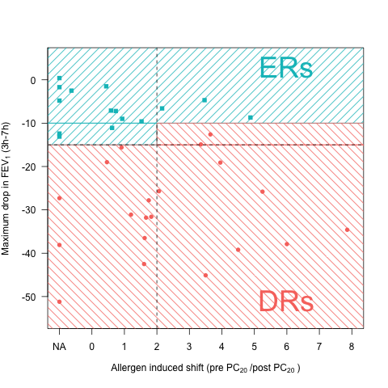
Figure S1: Secondary criteria for asthmatic subject classification used the allergen induced shift. AIS = Methacholine [PC₂₀]_{pre}/[PC₂₀]_{post}. Subjects with a LAR between 10-15% were classified as dual responders if their allergen induced shift was greater than 2.

Figure S2. Heatmap

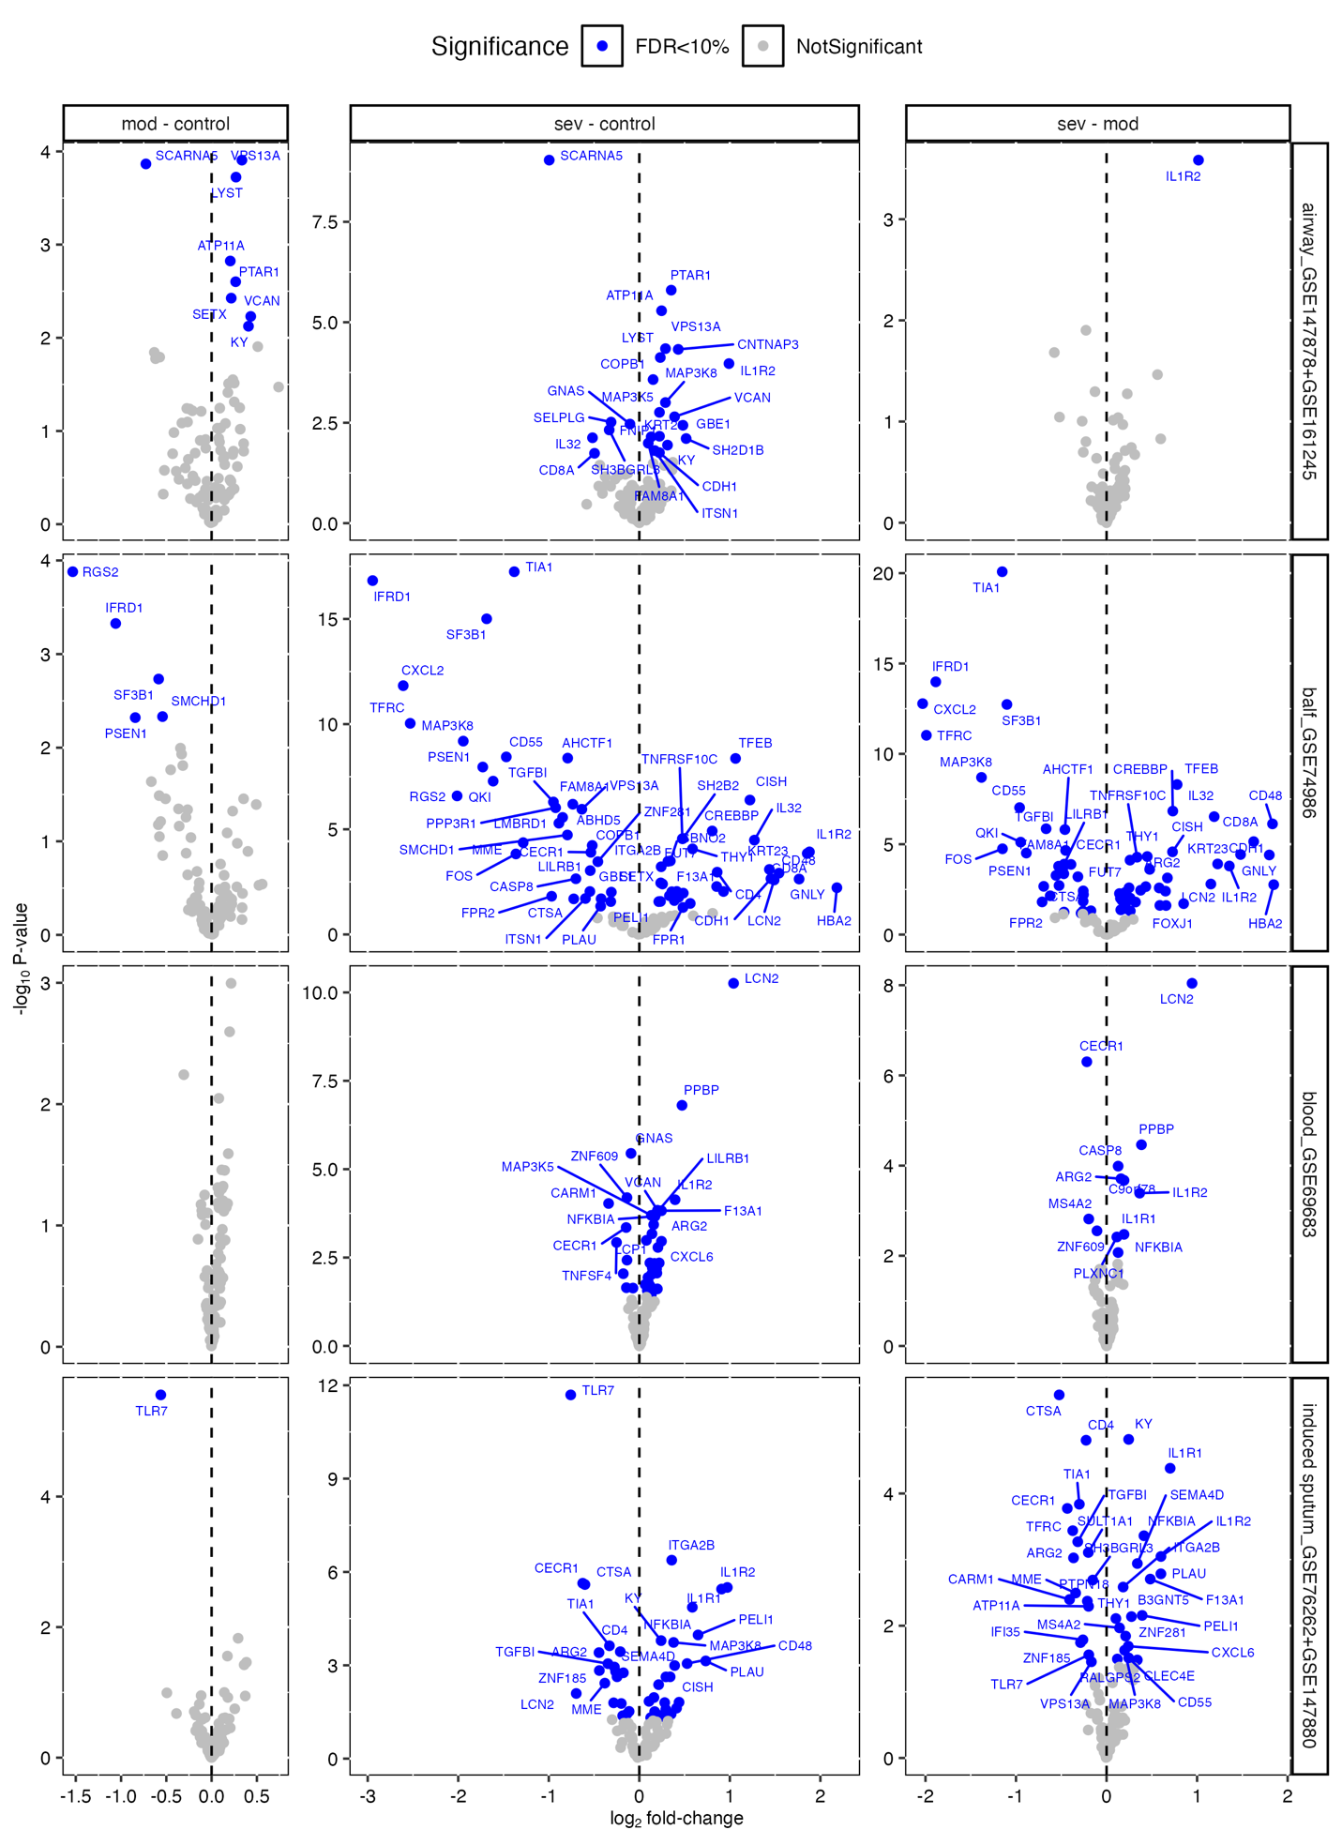
Figure S3. Differential gene expression analysis conducted between final mRNA panel and published dataset GSE19301 with common biomarkers, Quiet vs Exacerbation and Follow-up vs Exacerbation were computed separately. B. Differential gene expression analysis conducted among late-phase response (LAR) mRNA panel and other 6 published datesets via linear regression. LAR biomarkers were modeled and evaluated individually in Healthy controls vs Moderate and Healthy controls vs Severe asthma groups with different sample types (airway, bronchoalveolar lavage, blood, and induced-sputum samples). C.

