We're making some changes to give you more control of your information and help you stay connected. We've simplified the Privacy page and added the ability to set privacy on everything you share, from status updates to photos.
At the same time, we're helping everyone find and connect with each other by keeping some information—like your name and profile picture—publicly available.
The next step will guide you through choosing your privacy settings. You can learn more about how privacy works

Privacy on Facebook
Privacy is built around a few key ideas: You should have control over what you share. It should be easy to find and connect with friends. Your privacy settings should be simple and easy to understand.
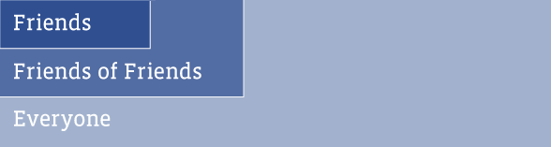
On Facebook, there are three basic levels of privacy: Friends, Friends of Friends, Everyone. You also have a set of publicly available information, which helps your friends find and connect with you. This includes your Name, Profile Picture, Current City, Gender, Networks, Friend List and Pages. You can read our Privacy Policy here.

What these changes mean for you
- You can now control who can see every post you share, from status updates to photo albums.
- Regional networks (like London or Australia) have been removed.
- A common set of information for all users is now publicly available.
- Facebook-enhanced applications and websites now have access to a limited set of information when you use and interact with them: your publicly available information and information you've made visible to Everyone.
- No changes whatsoever to ads on Facebook. We do not give—and have never given—anyone's data or personally identifiable information to advertisers.
From your home page, you will be sent through a transition tool that will help you select your new privacy settings. Remember, you'll always be able to change your privacy settings from the Privacy page. If you have any feedback for us on this, let us know here.

How others see you
If you are ever curious about how your friends see your profile, or what information Everyone can see, use this tool to see how people see you.
View profile as: | Everyone
  or

Recommended settings
We offer recommendations for your privacy settings based on the three levels of privacy: Friends, Friends of Friends, and Everyone.
We recommend Everyone be able to see information that will make it easier for friends to find, identify and learn about you. This includes basic information like your About Me description, Family and Relationships, Work and Education Info, and Website, as well as posts that you create, like photo albums and status updates.
Remember, any information that's visible to Everyone may be seen by everyone on the internet. It will be visible to anyone viewing your profile, and Facebook-enhanced applications and websites that you use will be able to access it. Additionally, it may be visible in search engines or through RSS feeds.
Some information is more personal, so we recommend Friends of Friends be able to see that type of info. This includes the settings for your Birthday, Religious and Political views, Hometown, and Photos and Videos of Me, which is all the photos and videos you've been tagged in.
We recommend that your contact information, like mobile phone number and email address, only be visible to Friends.

Protecting your privacy
We are committed to protecting minors who use Facebook. Until their eighteenth birthday, minors will have their information limited to Friends of Friends and Networks.

Privacy Center
- Facebook Resources
- Privacy Policy
- FAQs
- Videos
- Safety page
- Privacy Settings page
- Security page
- On the Internet
- External Resources

Our thoughts and background on these changes
Every day, millions of people use Facebook to stay connected and share information with the people around them. When we first built Facebook five years ago, we thought hard about incorporating the best privacy settings for enabling people to share with the people they wanted.[read more]
ou can select a privacy setting for every post you make. Whether you are uploading a photo or posting a status update, you control exactly who can see it at the time you create it. Whenever you share something, look for the lock icon. Clicking on it will bring up a menu that lets you choose who will be able to see your post, from Friends, to Friends of Friends, to Everyone.
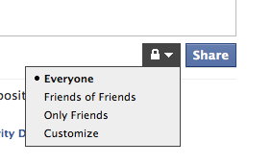
Adjust privacy for anything you share.

Editing your settings
The Privacy page is designed to make it easy to edit your settings. Any changes you make will go into effect immediately. You can select a privacy level or choose to customize your privacy. For example, you may have some information that you only want your family to see. You can easily do this by creating Friend Lists from the Friends page and selecting "Custom Setting" any time you set your privacy.
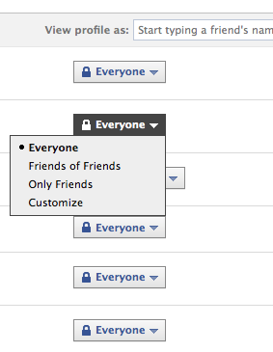
You can suggest a privacy level or customize.

Please update your privacy settings

Facebook's new, simplified privacy settings give you more control over the information you share. We've recommended settings below, but you can choose to apply your old settings to any of the fields.
 | Everyone | Old Settings
About me |  | 
Family and Relationships
Work and Education
Posts I Create
Status Updates, Links, Photos, Videos, and Notes
 | Friends of Friends | Old Settings
Photos and Videos of Me
Birthday
Religious and Political Views
 | Friends | Old Settings
Email Addresses and IM
Phone Numbers
Address
Some important things to remember:
- You can change your settings at any time from your Privacy page and those changes will take effect immediately.Learn more.
- Information you choose to share with Everyone is available to everyone on the internet.
- When you visit a Facebook-enhanced application, it will be able to access your publicly available information, which includes Name, Profile Photo, Gender, Current City, Networks, Friend List, and Pages. This information is considered visible to Everyone.
