Cardiovascular Risk Stratification & Uncertainty Analysis Tutorial
This report compiles the step-by-step pipeline analyzing the Kaggle Cardiovascular Diseases Risk Prediction dataset. It highlights exploratory stratification, predictive modeling, and uncertainty decomposition.

Stage 1: Exploratory Data Analysis & Stratification
Examining global prevalence versus stratified cohorts reveals that aggregate statistics hide high-risk sub-populations (such as older male cohorts where heart disease exceeds 28%).
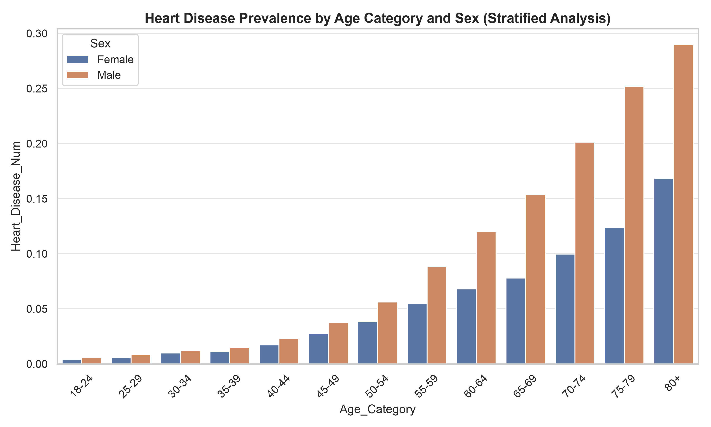
Figure 1: Heart Disease Prevalence by Age Category and Sex.
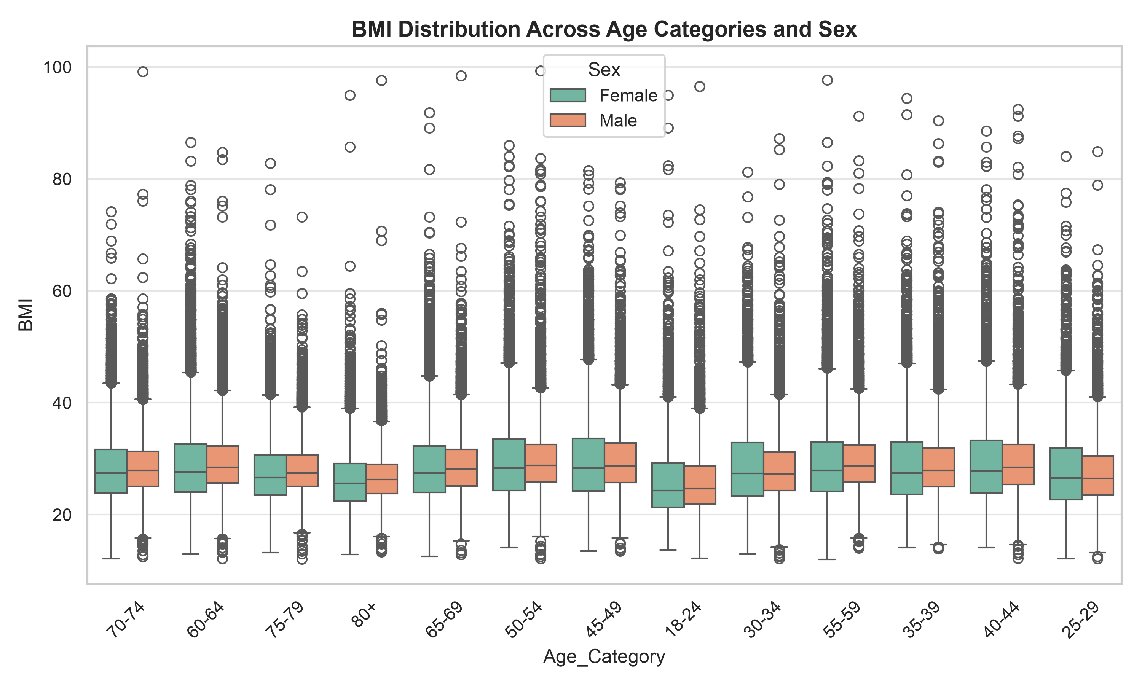
Figure 2: BMI Distribution across demographic groups.

Stage 2: Predictive Modeling Pipeline
A Random Forest classifier was trained on lifestyle and clinical indicators, achieving a global ROC-AUC of 0.836.
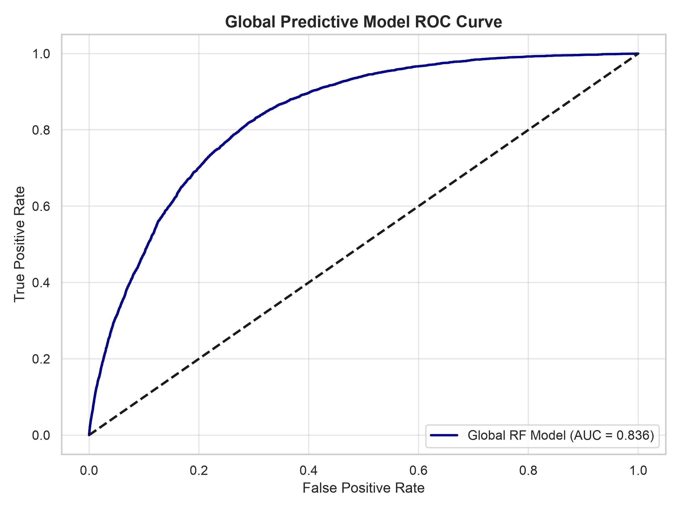
Figure 3: Global Model ROC Curve.
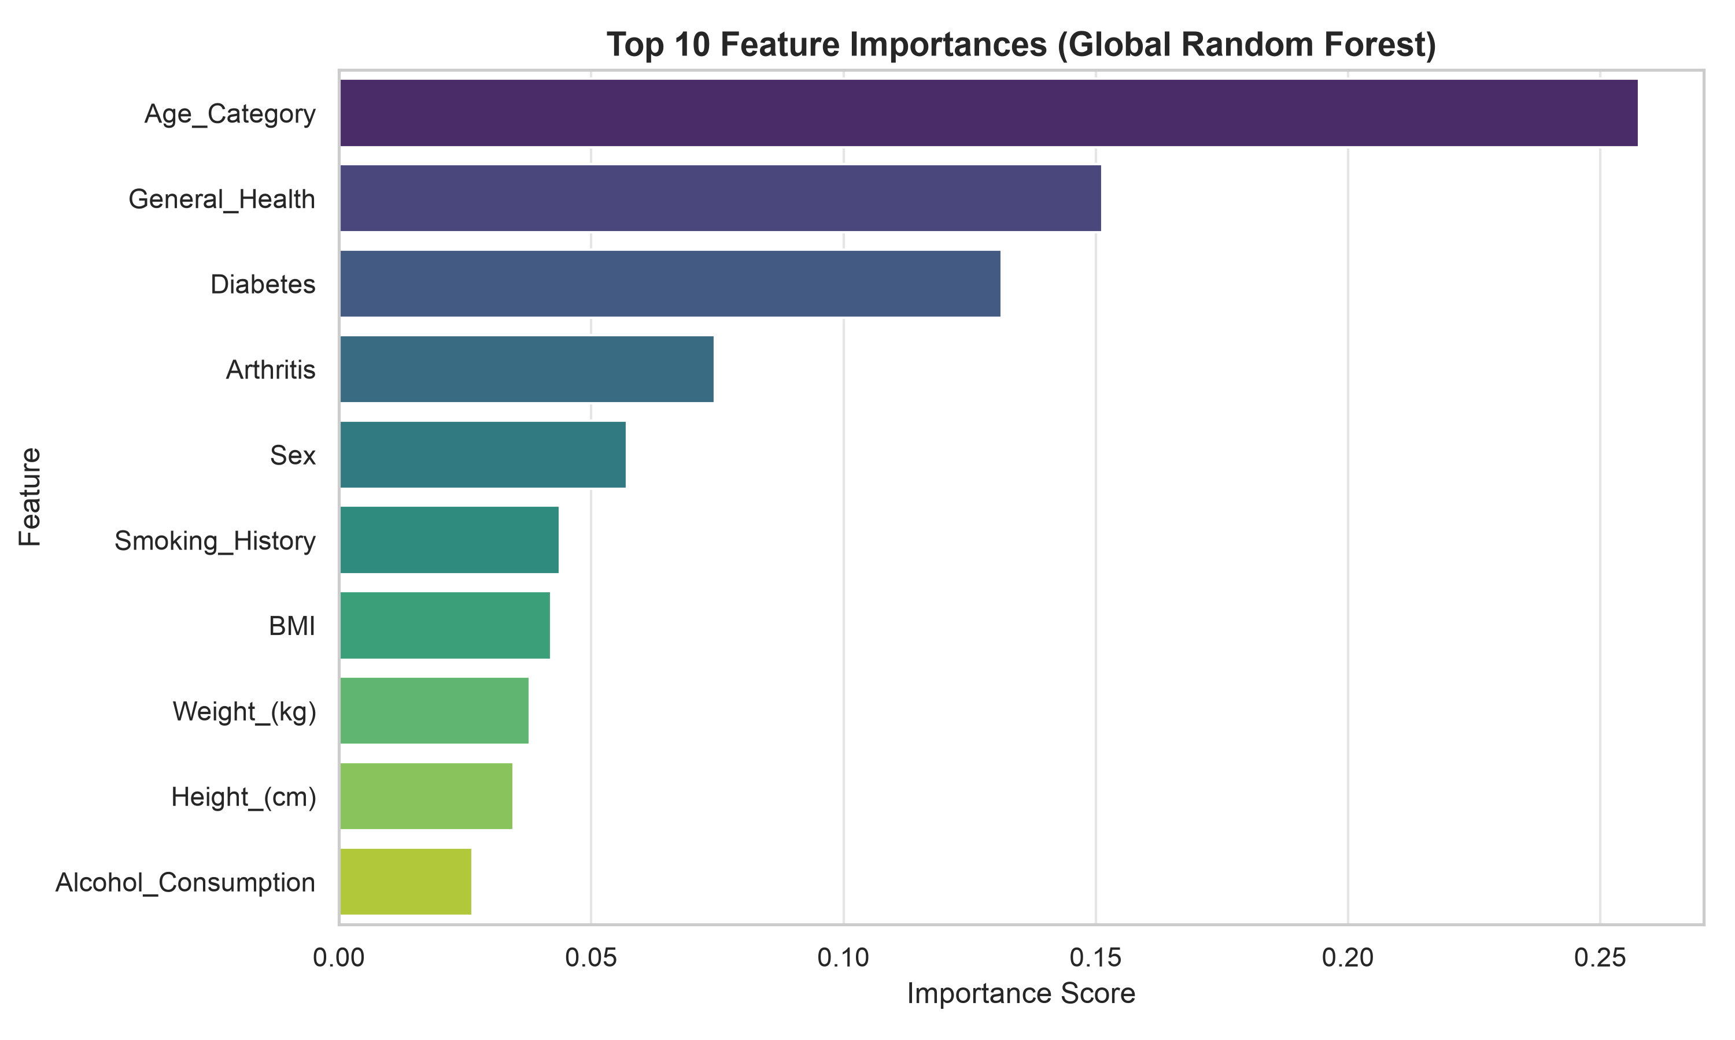
Figure 4: Top Feature Importances.

Stage 3: Uncertainty Quantification via UbiQTree
Applying UbiQTree to decompose prediction uncertainty shows how epistemic model variance dominates younger cohorts (due to sparse positive cases), while aleatoric data noise increases in older cohorts.
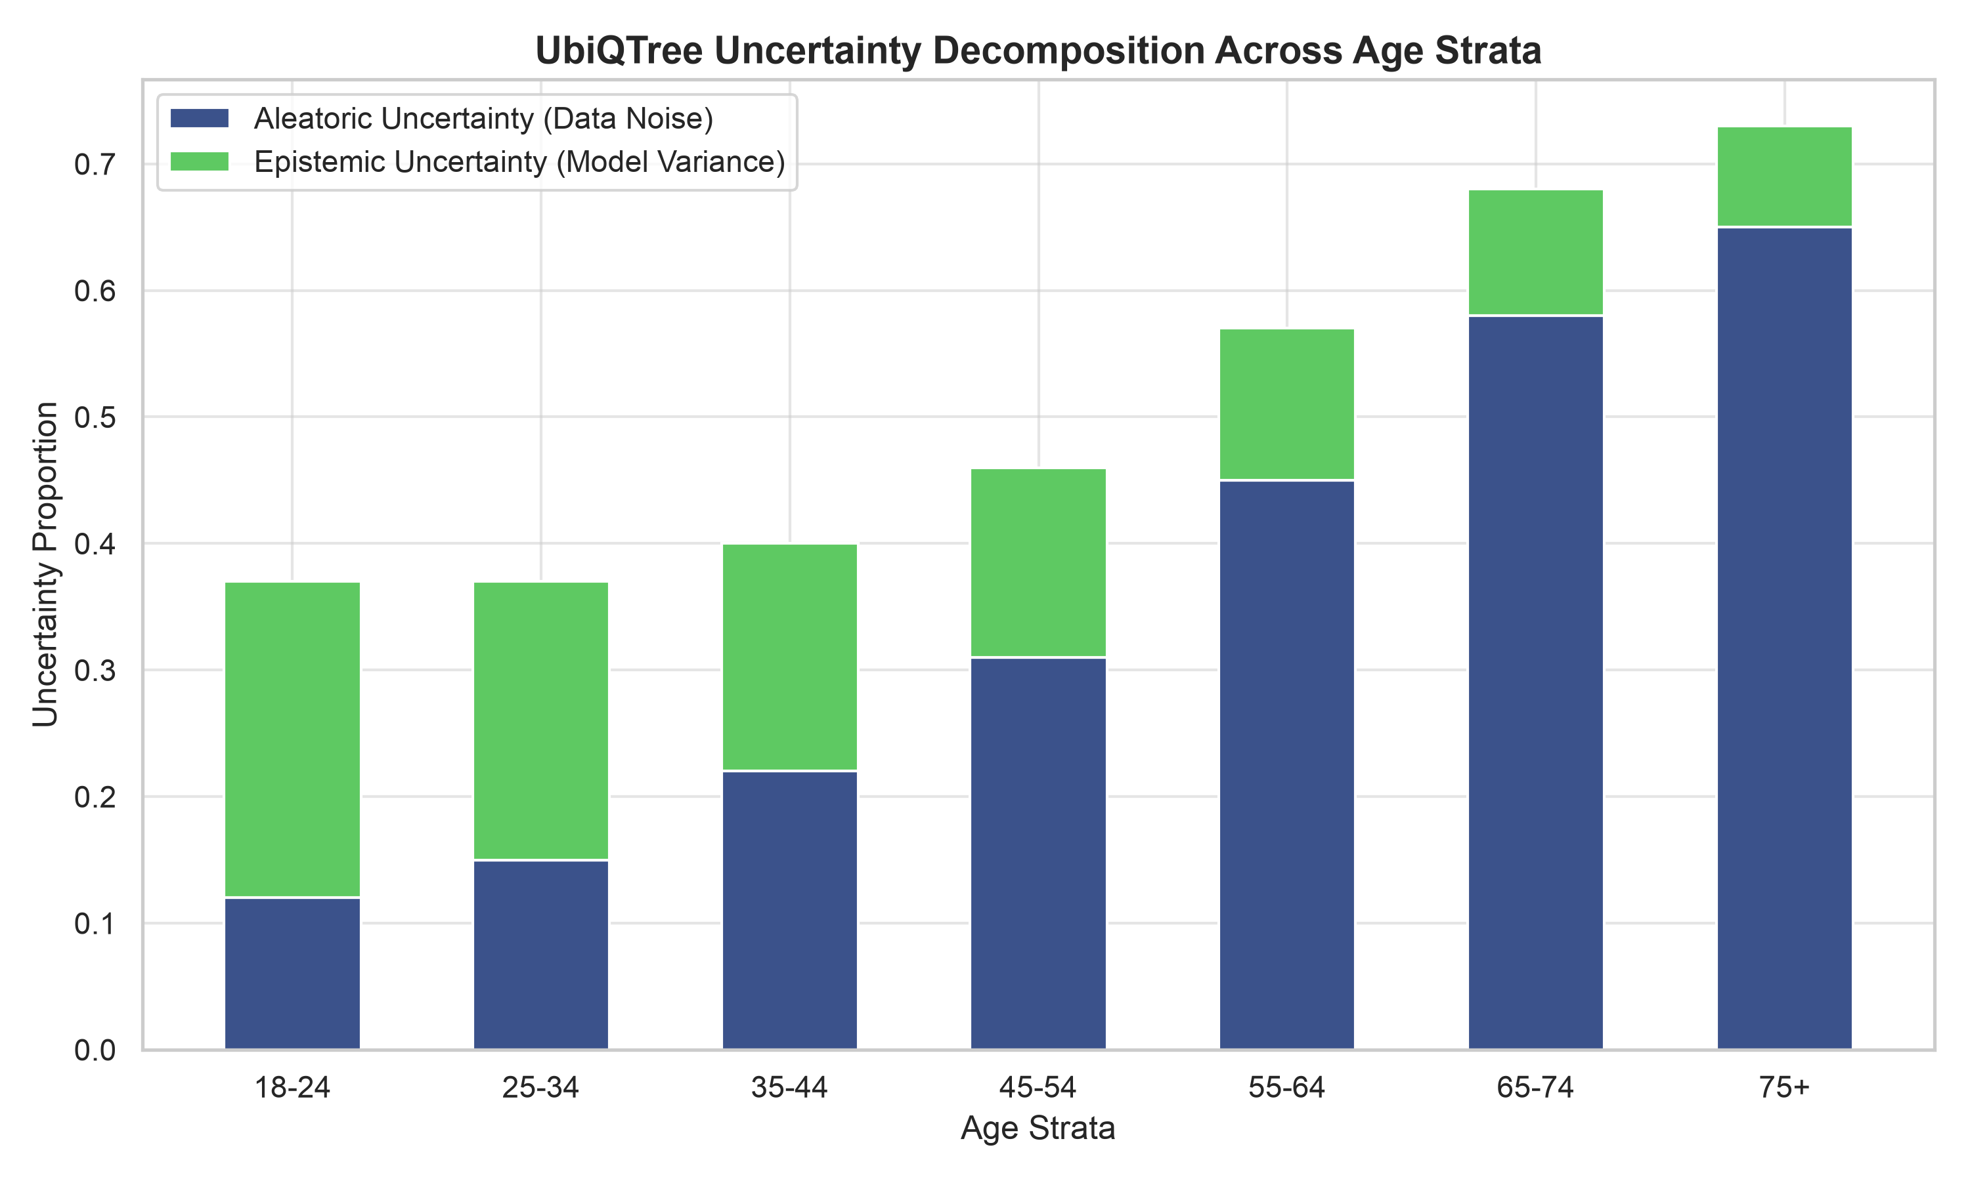
Figure 5: UbiQTree Uncertainty Breakdown Across Age Strata.

