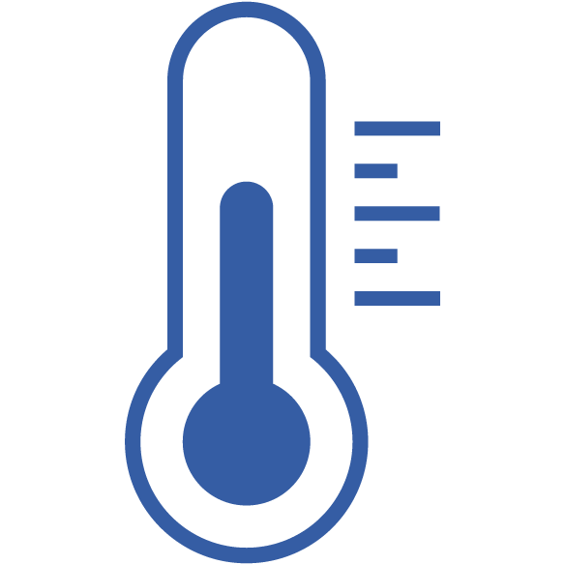

The BME680: Temperature, Humidity, Pressure and VOC

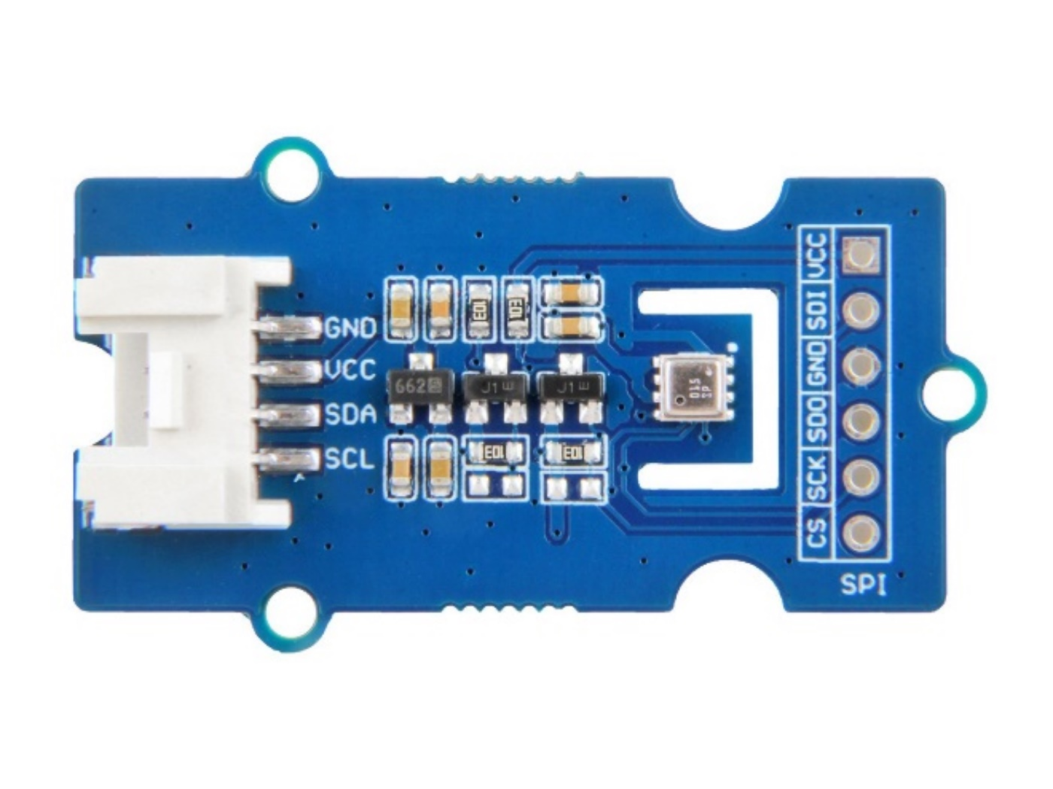

Usages:

* Indoor air quality monitor
* Home automation and control
* IoT device
* Barometer
* Weather forecast system using Arduino
* GPS enhancement(e.g. time-to-first-fix improvement, dead reckoning, slope detection)
* Indoor navigation(change of floor detection, elevator detection)
* Vertical velocity indication(rise/sink speed)

The BME680 is high-precision, low-power combined temperature, humidity, pressure, and Volatile Organic Compound (VOC) sensor. As the atmospheric pressure changes with altitude, it can also measure approximate altitude of a place.

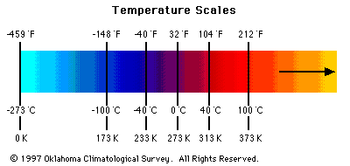

* Temperature sensor measurement range: -40 ℃ to 85 ℃, with ±1.0°C accuracy
* Humidity sensor measurements range: 0% to 100% relative humidity , with ±3% accuracy



* Atmospheric pressure sensor measurement range: 300 to 1100 kPa with ±1.0 kPa accuracy
* VOC measurement range: 1.000 to 300.00 kOhms. With clever bit of maths we can convert this to the Indoor Air Quality (IAQ) Index 0 to 351

